Steps required to implement the Graph API in some Application.

Basically for implementing we need to go through following steps:

1.Connect a Facebook Page to an Instagram Business Account
2.Register your app.
3.Add the Facebook Login product
4.Add the Instagram API product
5.Test your app's settings with the Graph API Explorer.
6.Submit your app for review.

Prerequisites:
Before you begin, you must have:
- a Facebook Page
- a role on that Page
- an Instagram account
You will be connecting the Facebook Page to the Instagram Account, then converting the account to an Instagram Business Account if it isn't one already. You don't have to be the admin of the page, but since you'll be connecting it to an Instagram Business Account, the Page and account should be related in some way.
If you already have a role on a Page that's connected to an Instagram Business Account, then you can skip this step.

I have created a temporary page with name Instag that I will be using for the purpose.
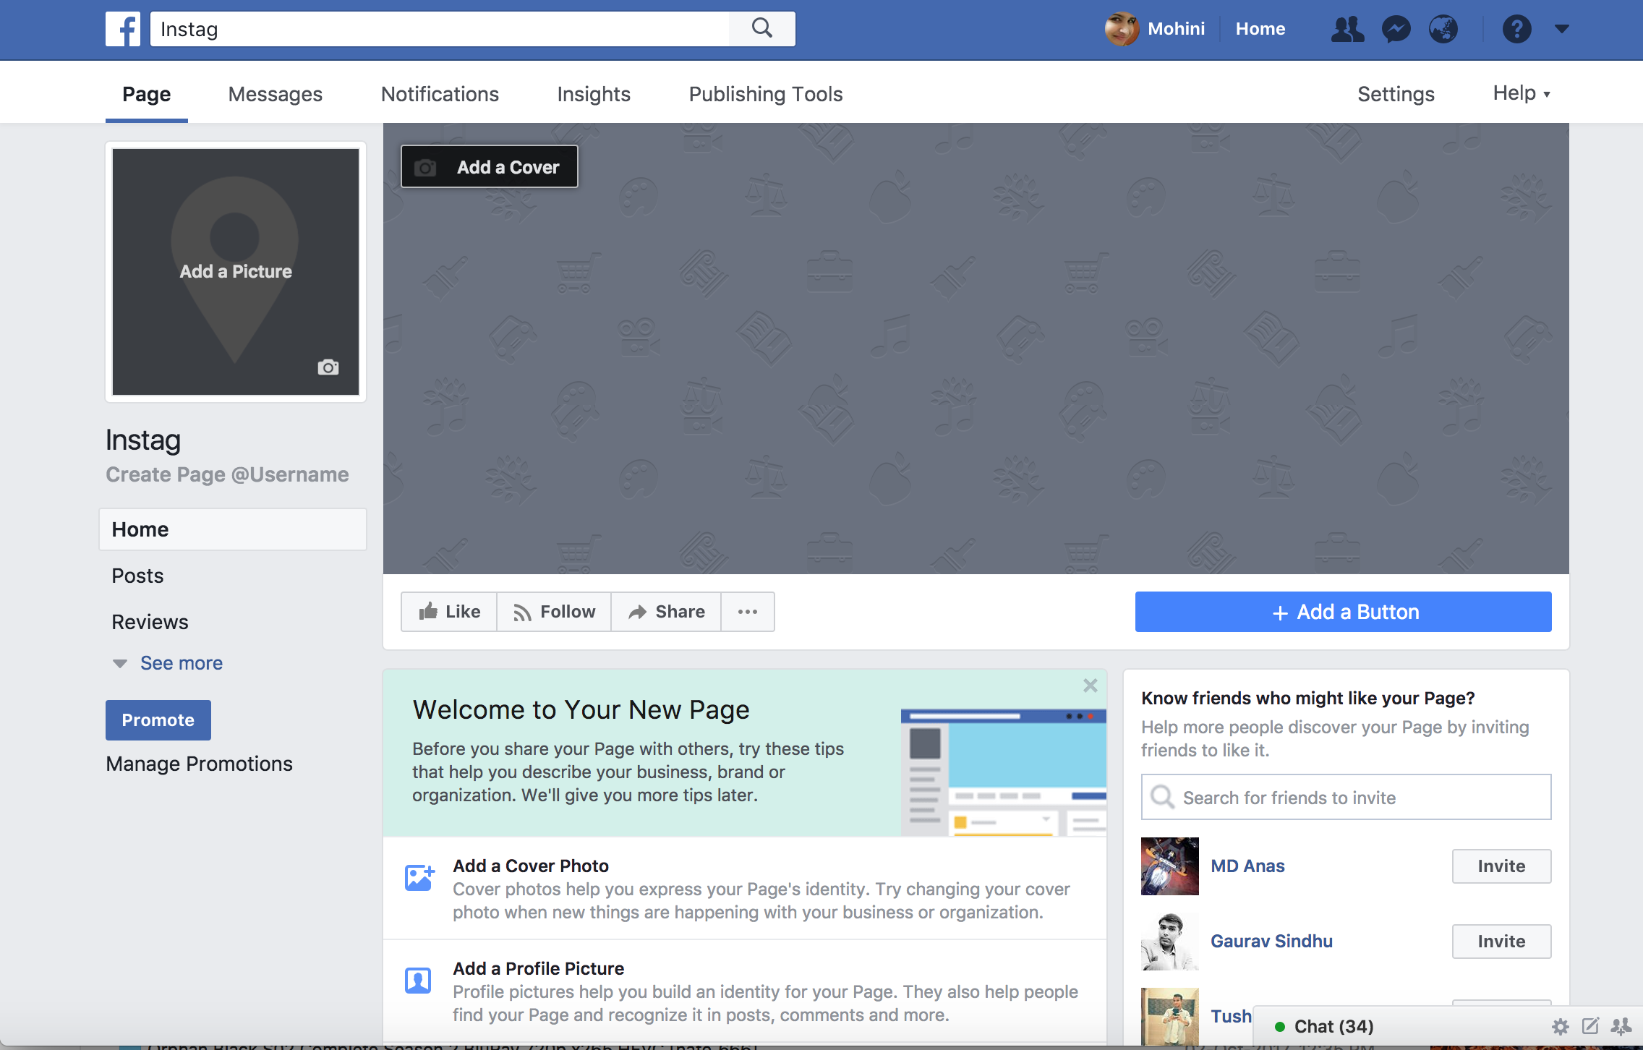

- Connect the Facebook Page to the Instagram Business Account
Go to your Page , then settings and then click on Instagram adds on the left menu bar , this will let you get linked to your Instagram account.
Like I already had one so I connected this with the same or if you do not have one then create one.
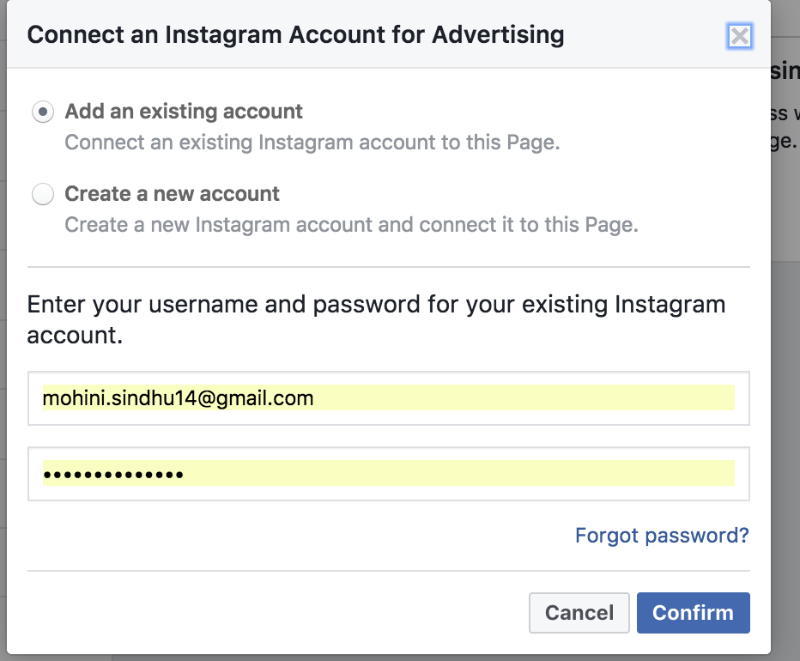

If the account is not an Instagram Business Account, you will be prompted to set up your Business Profile:
Click on continue and it will ask for your email id, phone number etc. And finishing the process will successfully set up your Business profile.
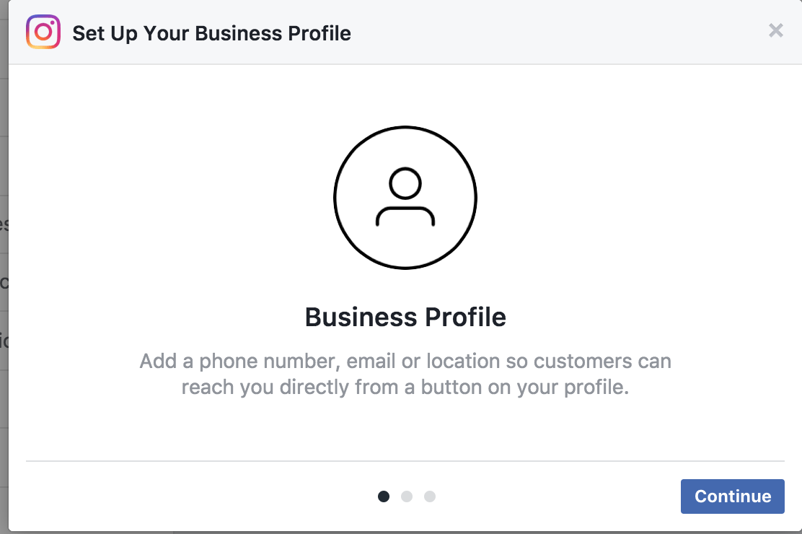

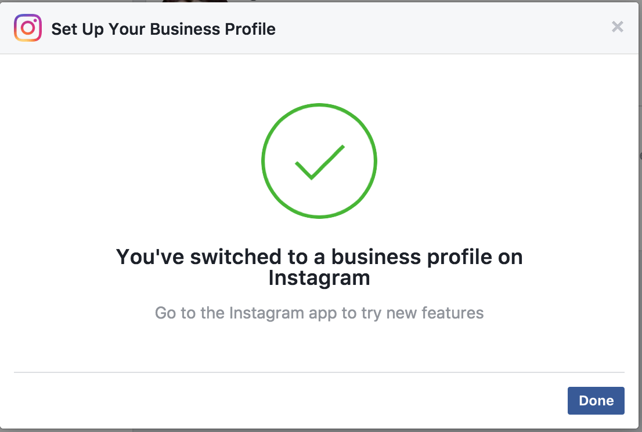
This process will create your FB page, create an instagram account and set up your account to Business profile.

- Register your application.
Follow the following steps in order to do so.
1. Login to Facebook
2. Developer Account
3. Create new Facebook app
4. Choose Platform
5. Choose a Name
6. Follow "Quick Start" Steps
7. App ID
8. Protect your App Secret
9. Contact Email
10. App Details
11. Disable Development Mode

Once you login to your Facebook account, you need to create your developer account if you do not have one
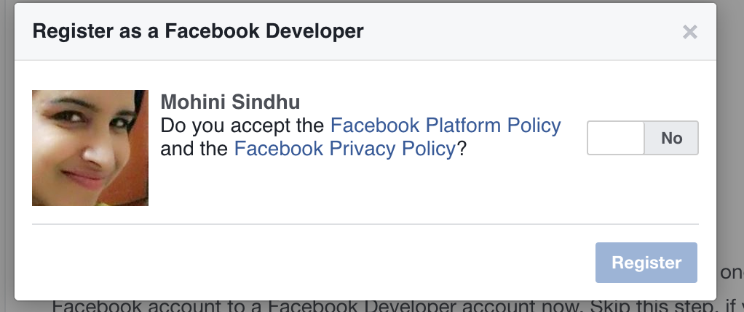
Click on Yes and Press Register. Once you register and create a app ID you will be redirected to below mentioned screen shot.

- Create New facebook app.
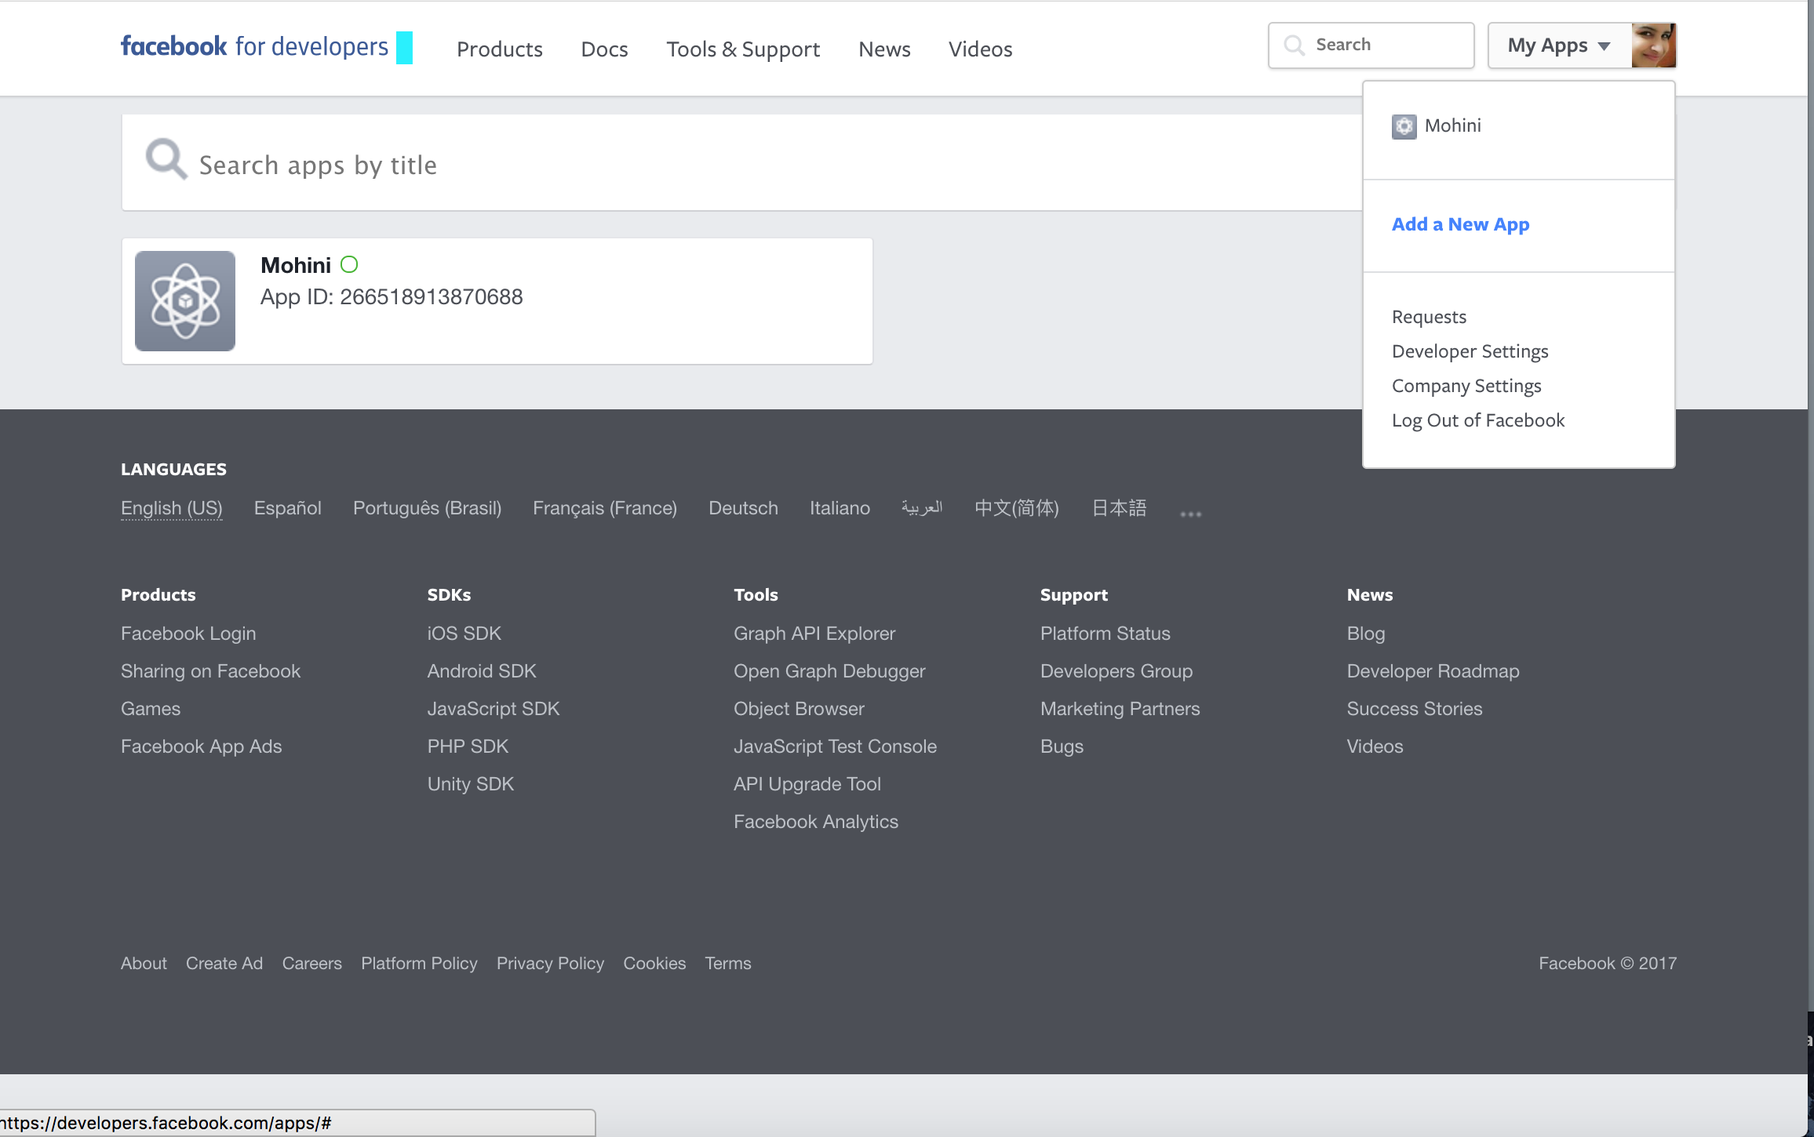
Click on add a new app option.
Below mentioned screen shot will appear then click on “Add product” and then on Facebook login.
Platform options will prompt, select Ios option in it.
NOTE: To use the advance (Graph) features of Facebook, you need to submit the app for review. To submit a Facebook app for review, it needs
● App Icon (1024 x 1024)
●Privacy Policy URL
● Category
However you can still access the basic information like public details of any user/page without submitting it for review.
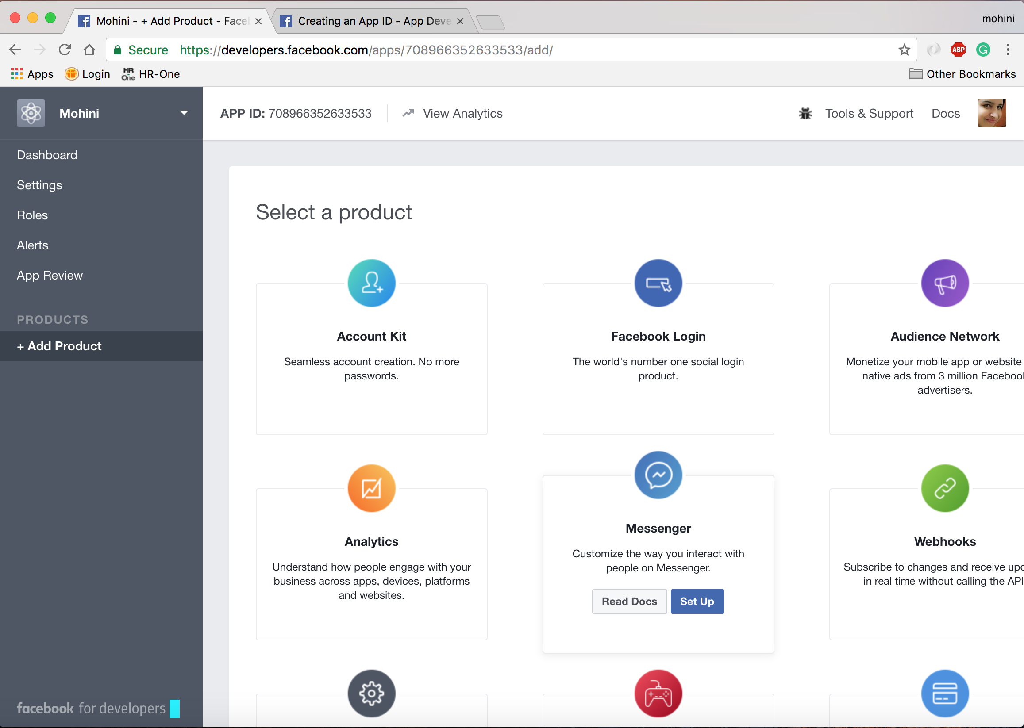
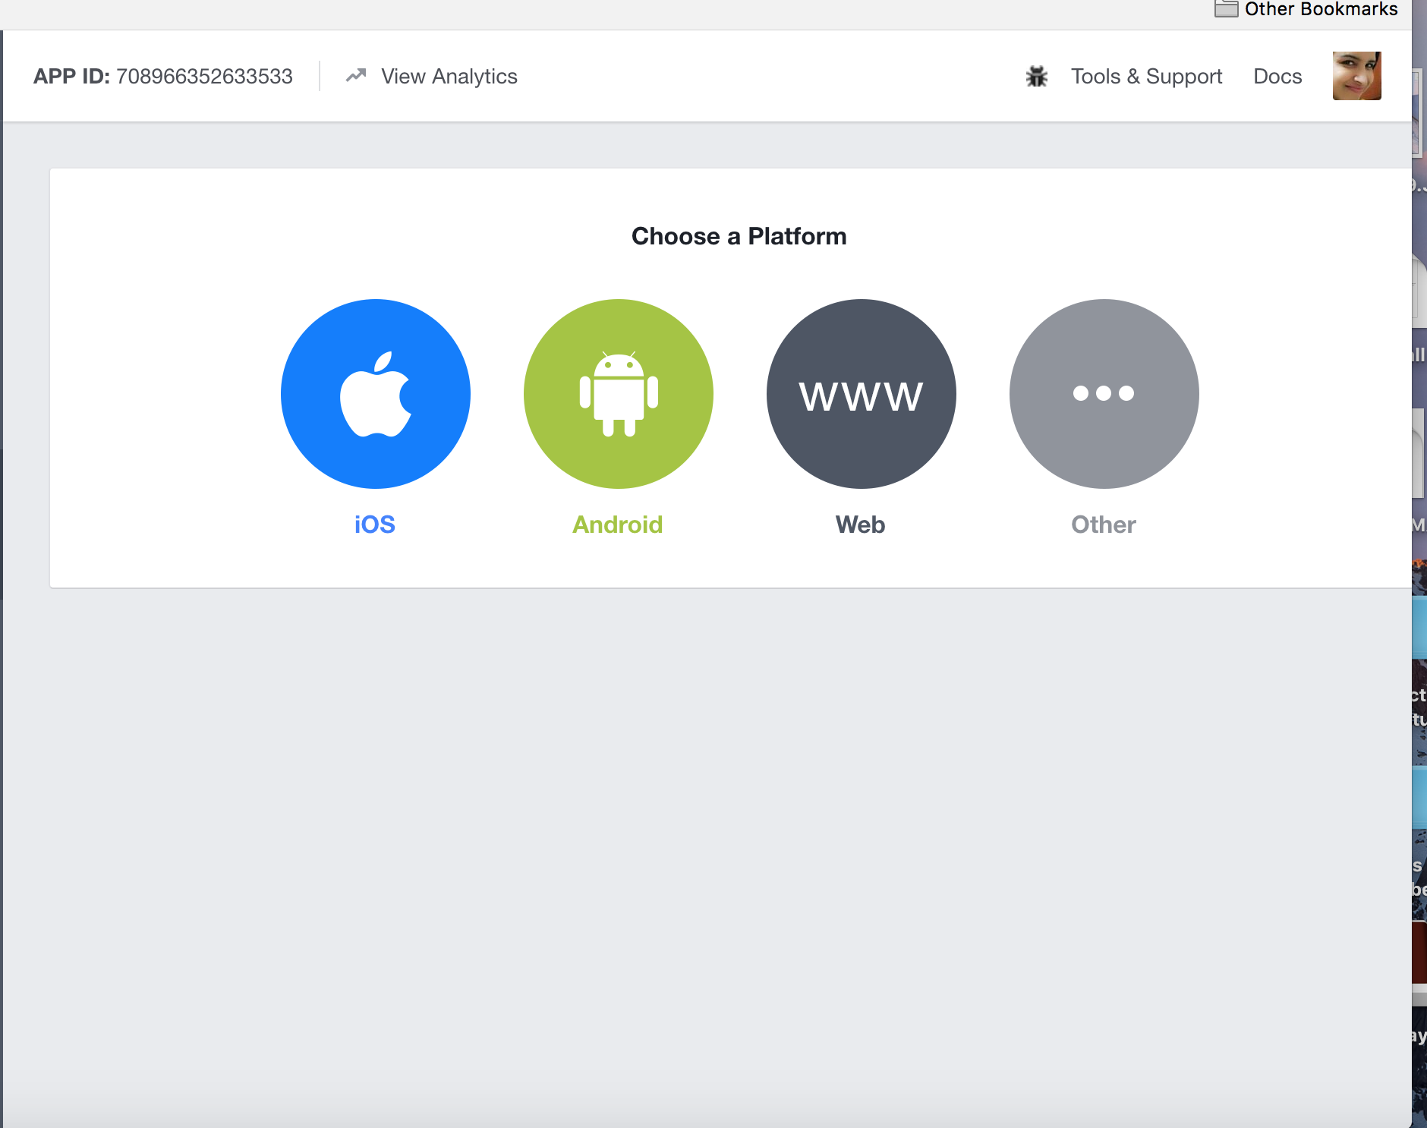

After this you need to setup your application :
1.Install pod and get these dependencies in your project.
pod 'FBSDKCoreKit'
pod 'FBSDKLoginKit'
2.In app delegate replace with this code.
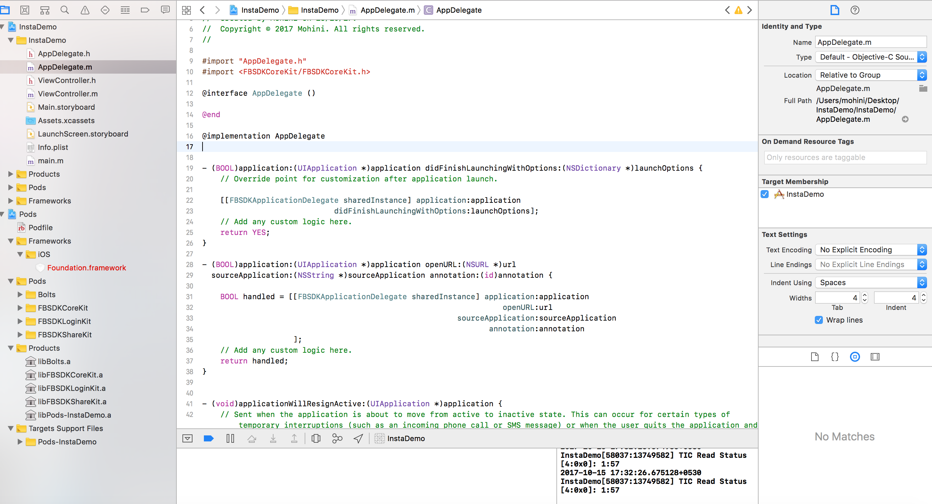
Rest application changes will depend of what work you want to do in your application.
Also the rest settings follow
https://developers.facebook.com/apps/replaceherewithyourappid/fb-login/quickstart

Also the once you let your application do facebook login you can do the desired work.
Demo app showing facebook login can be found on https://github.com/mohini14/InstaDemo.git

4. Add Instagram API
Now you will add the Instagram API product and submit it for review. This submission is separate from your App Review, which you will do later.
- In the App Dashboard, click +Add Product again and this time add the Instagram API product.
- In the App Review for Instagram section, click Add to Submission for each permission you will need from our App's Users. instagram_basic is required. instagram_manage_comments and instagram_manage_insights are optional.
- Scroll to the bottom of the page, and in the Current Submission sub-section, for each submission, click its View Notes link.

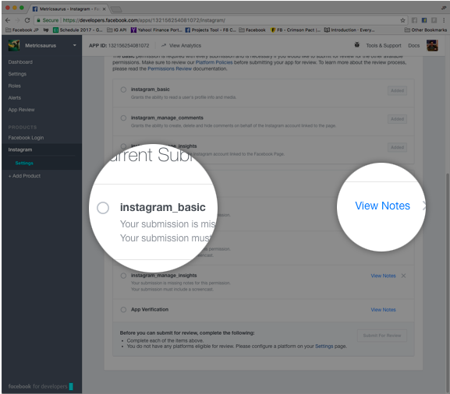
- Permissions Required:
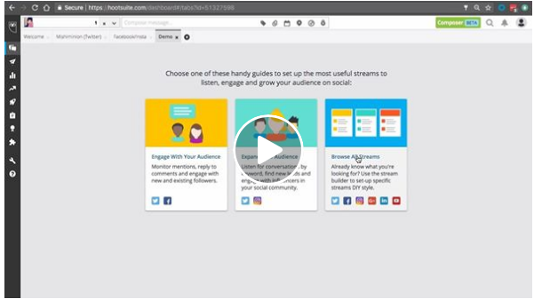
In the View Notes dialogue for each permission submission, provide a description for how you will use the data returned by any endpoints that require the permission and a screencast showing how your app will use the data.
- Screencast: After you've added both Facebook Login and Instagram API products to your app configuration, add Facebook Login to your app and record a screencast showing how you will use data returned by the Instagram API. This is similar to the Facebook Login screencast.
If your screencast covers all the permissions you are requesting, you only have to upload it for one of them.
Once you've completed your notes for all of your permission submissions, click the Submit For Review button at the bottom of the page. Note that this is separate from your App Review, which you will do after testing.
5. Test Your App
Once you've been notified that your Instagram API product submission has been approved, you can use the Graph API Explorer to test your app.
Go to the Graph API Explorer and select your app from the Application dropdown menu:
In the Get Token dropdown menu, select Get User Access Token.
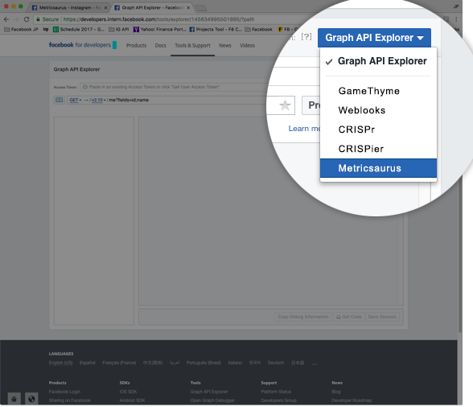
Here you'll see a list of all the permissions you can grant your app as a User. However, the Graph API Explorer is a testing tool, so it shows all of the possible permissions available.
Check the Instagram permissions that a normal User would grant your app, as well as the manage_pages permission. You'll need manage_pages to get your Page's ID, which you can then use to get your Instagram Business Account ID. Click Get Access Token, and complete the flow.
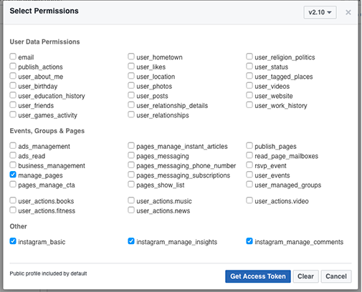
The Access Token field should now display your User access token, which your app will use to make calls to the Instagram API.
The first call you will make is to the Graph API's /user/accounts edge. This will return all of the Pages and their IDs that you have a role on. In the path field, replace me?fields=id,name with me/accounts and click Submit.
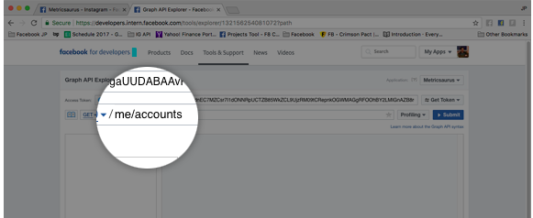
The API should return a list of Pages that you have a Role on, and their IDs, like this:
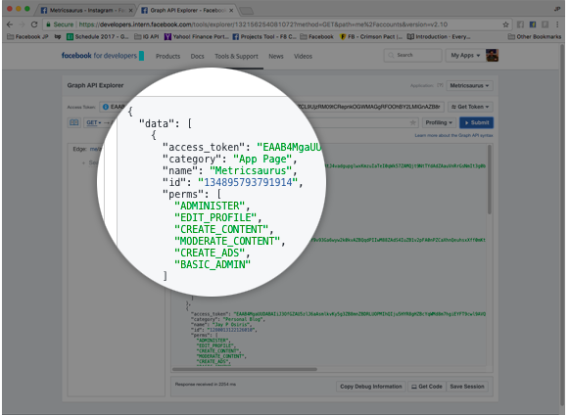
Locate the Page that you connected to the Instagram Business Account and click its ID. This will populate the ID in the path field, automatically perform a GET request, and return the Page's name and ID fields.
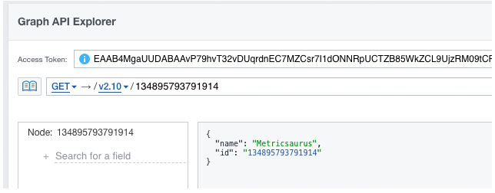
Next, click in Search for a field and type instagram_business_account until it appears in the typeahead dropdown menu.
When you see instagram_business_account, click it. This will append the field in the path using the fields parameter. Submit this new request, and you should get back the Instagram Business Account connected to this page.Now that you have the Business Account's ID, we can use the Instagram API. Click the Business Account's ID and once again, the Graph API Explorer will populate the ID in the path field and automatically execute the query, returning the Instagram Business Account's ID from the Instagram API.
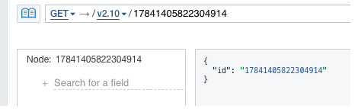
Of course, you already know the ID so this isn't helpful, so instead query the /user/media/ edge by appending /media after the account's ID and submit the query.
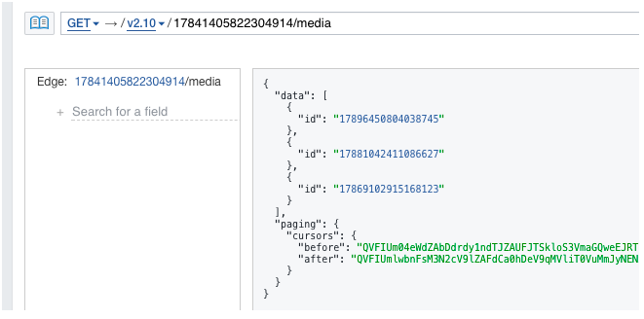
Below Screen shot showing the result of my facebook pages.
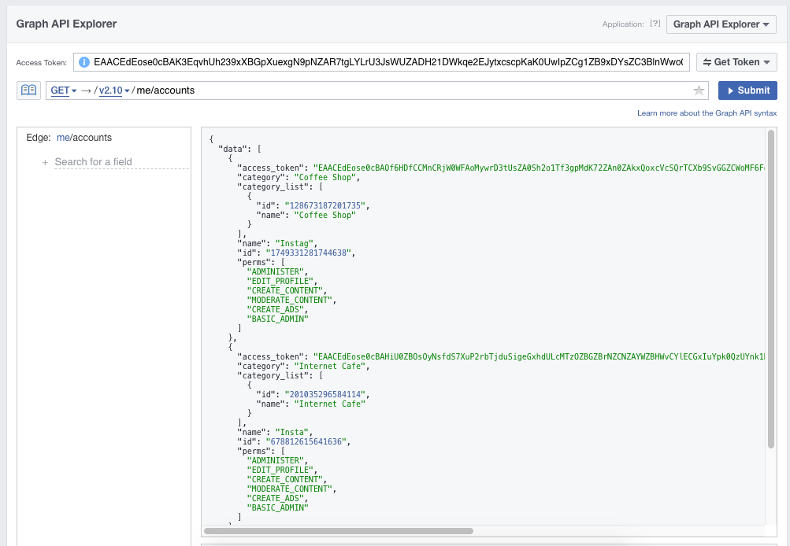
Preview: Instagram Business Account ID Media Retrieval
The Instagram API should return a list of all the media objects in the Instagram Business Account. If it did, your app is set up correctly and you can now submit it for final review. You can also go to your Page's Settings, click Instagram, and see your app listed in the Connected Apps table.
If you are able to use your app in the Graph API Explorer and successfully pull data from your Instagram Business Account, you can submit your app for review.

