AI Mock Interview System - Project Proposal
Introduction
In today's competitive environment, students often lack proper interview preparation and real-time practice. Many candidates face difficulty in expressing their thoughts, handling pressure, and answering questions effectively. This project proposes an AI-based Mock Interview System that simulates real interview scenarios. The system allows users to upload their resume and generates personalized interview questions based on their skills and experience. It provides an interactive platform where users answer questions using voice, and AI evaluates their responses to provide meaningful feedback.
Methodology
The system begins by allowing the user to upload their resume in PDF format. The system processes the document and extracts relevant details such as skills, projects, and educational background. Once extracted, the user initiates the interview by clicking the 'Start Interview' button. The system then requests permission to access the microphone and camera. After permissions are granted, AI generates interview questions based on the resume content. These questions are displayed one by one to the user. The user answers verbally, and the system captures the audio input and converts it into text using speech recognition. The AI then evaluates the answer based on clarity, relevance, and completeness. This process continues for all questions, and finally, the system generates a score and feedback.
Technologies Used
- Frontend: React / JavaScript
- Backend: Java (Spring Boot)
- Resume Processing: PDF Parsing (Apache PDFBox)
- AI Integration: OpenAI API
- Speech Processing: Web Speech API / Whisper
- Camera Access: Browser Media APIs

System Flowchart
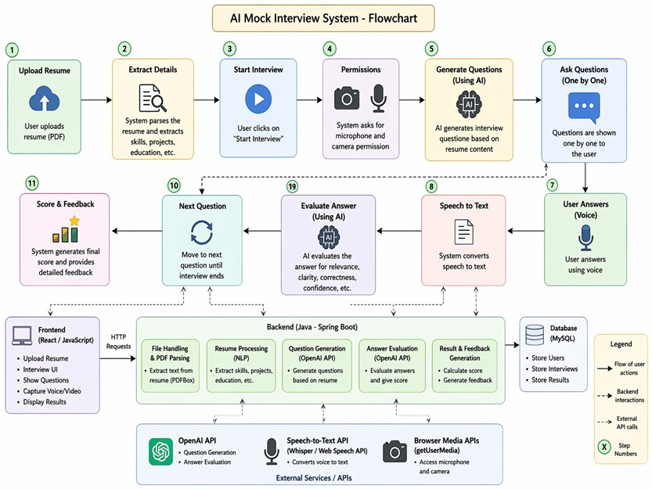
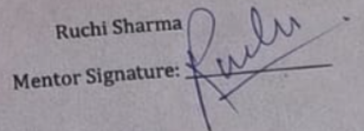
Mentor Signature
__________________

