**Name: Mohini Vilas Narkhede Roll no. 80**

**Practical 1:**

**Set up a GitHub account and send an email message to friend telling to your friend about the account.**

**Create a GitHub account**

If you don't already have a GitHub account, here's how to create one.

1. Open [https://github.com](https://github.com/) in a web browser, and then select **Sign up**
2. **Enter your email** address.

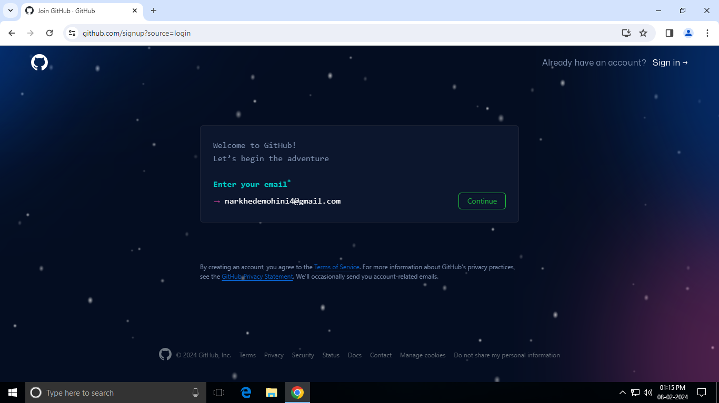

1. **Create a password** for your new GitHub account.

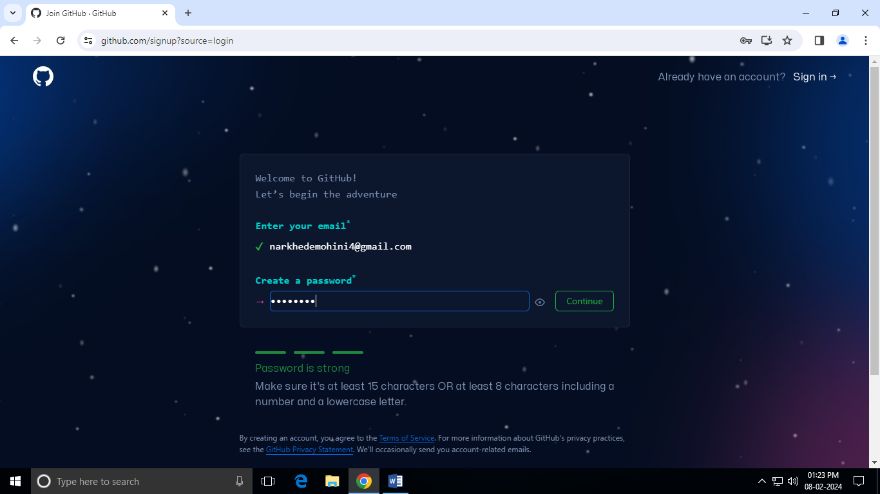

1. **Enter a username**, too. Next, choose whether you want to receive updates and announcements via email, and then select **Continue**.

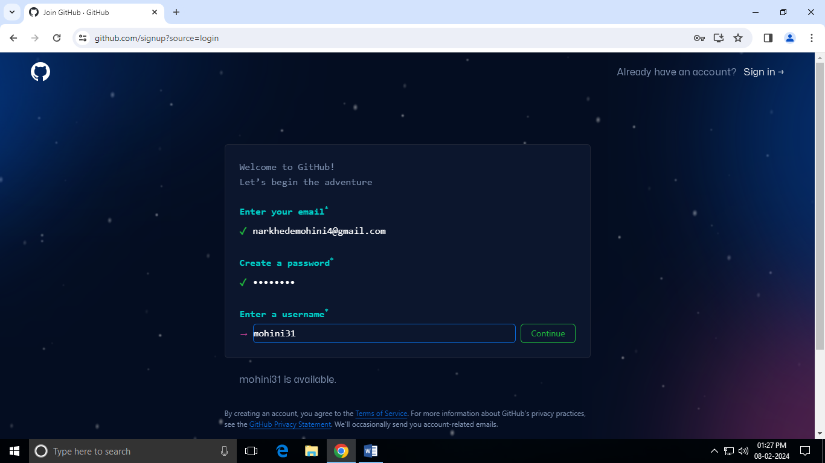

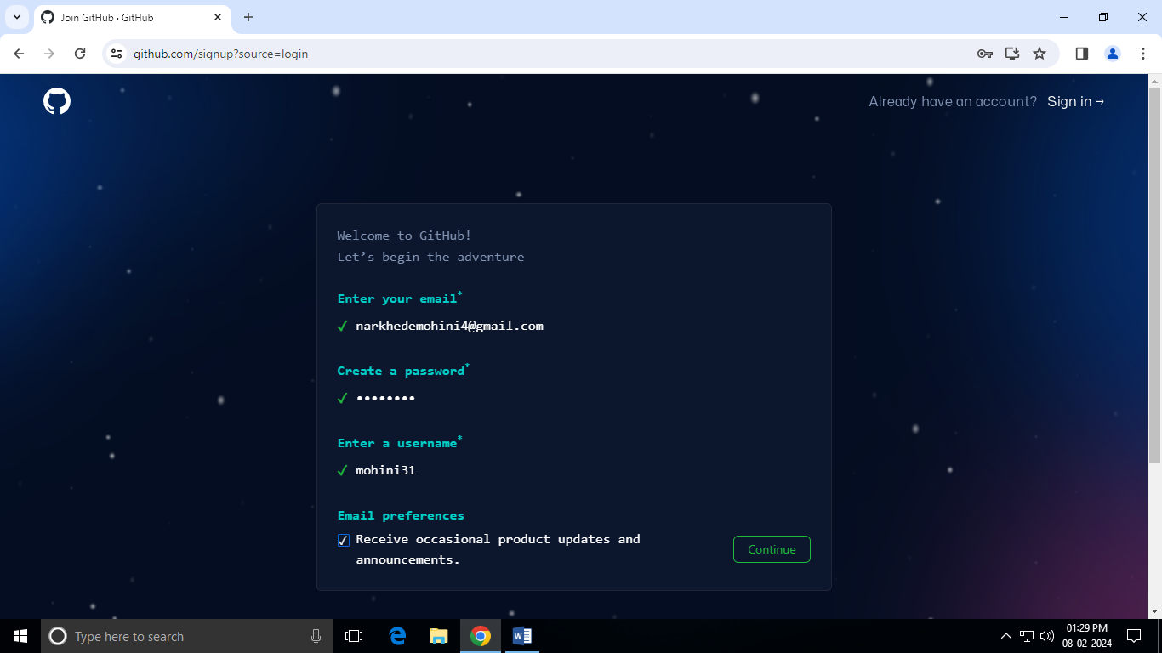

1. **Verify your account** by solving a puzzle. Select the **Start Puzzle** button to do so, and then follow the prompts.

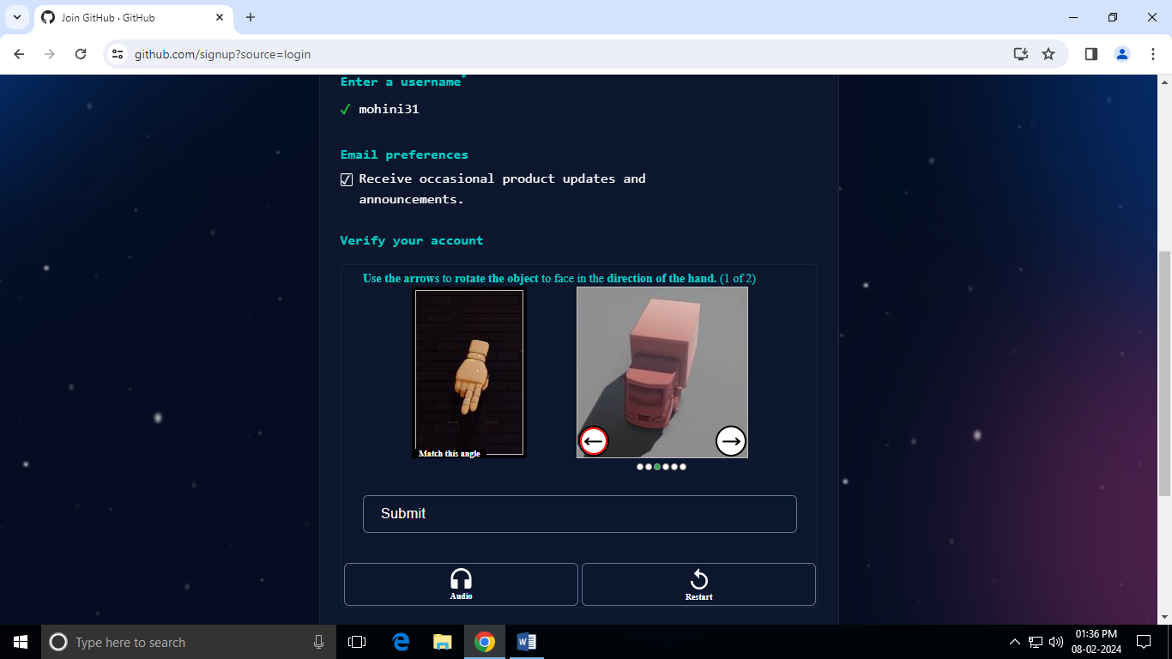

1. After you verify your account, select the **Create account** button.

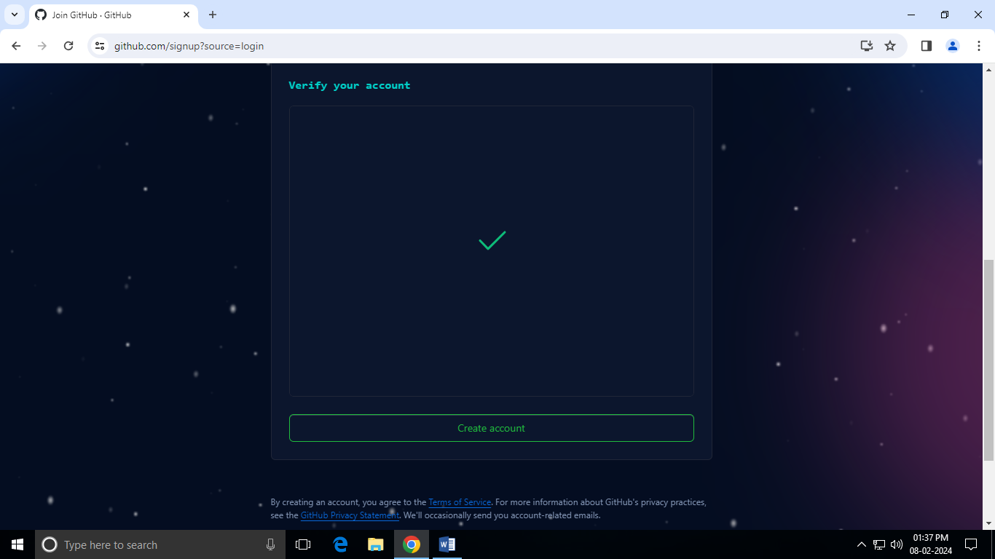

1. Next, GitHub sends a launch code to your email address. Type that launch code in the **Enter code** dialog, and then press **Enter**.

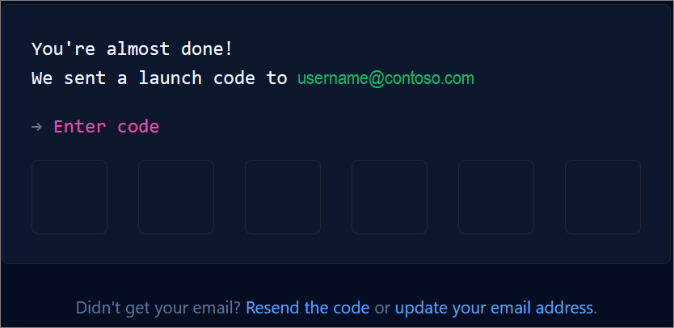

1. GitHub asks you some questions to help tailor your experience. Choose the answers that apply to you in the following dialogs:
   1. **How many team members will be working with you?**
   2. **What specific features are you interested in using?**

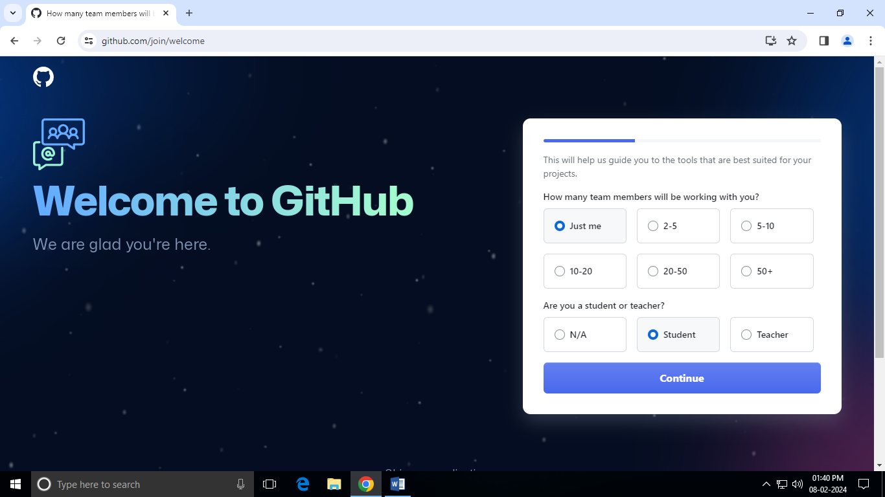

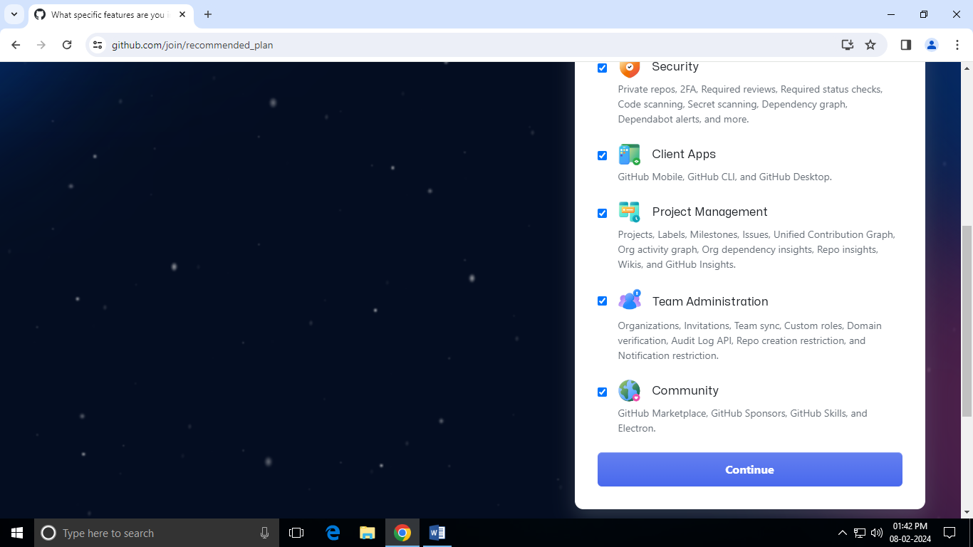

1. Click on **Continue for free.**

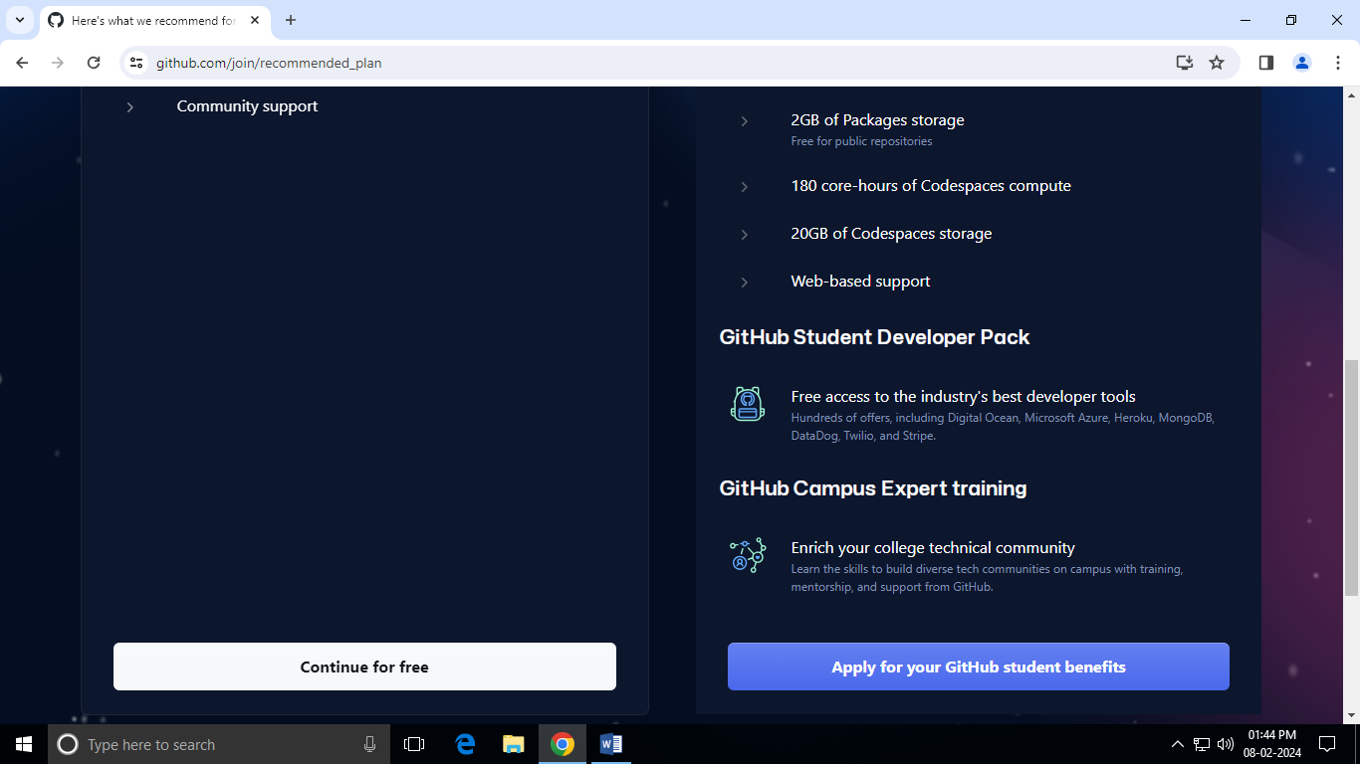

1. On the **Where teams collaborate and ship** screen, you can choose whether you want to use the Free account or the Team account. To choose the **Free** account, select the **Skip personalization** button.

GitHub opens a personalized page in your browser.

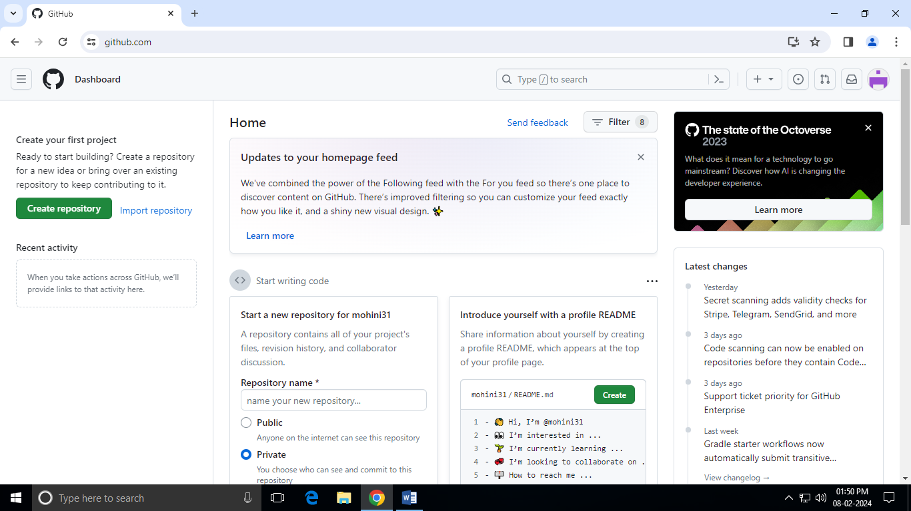

1. Congratulations! You've successfully created your GitHub account.

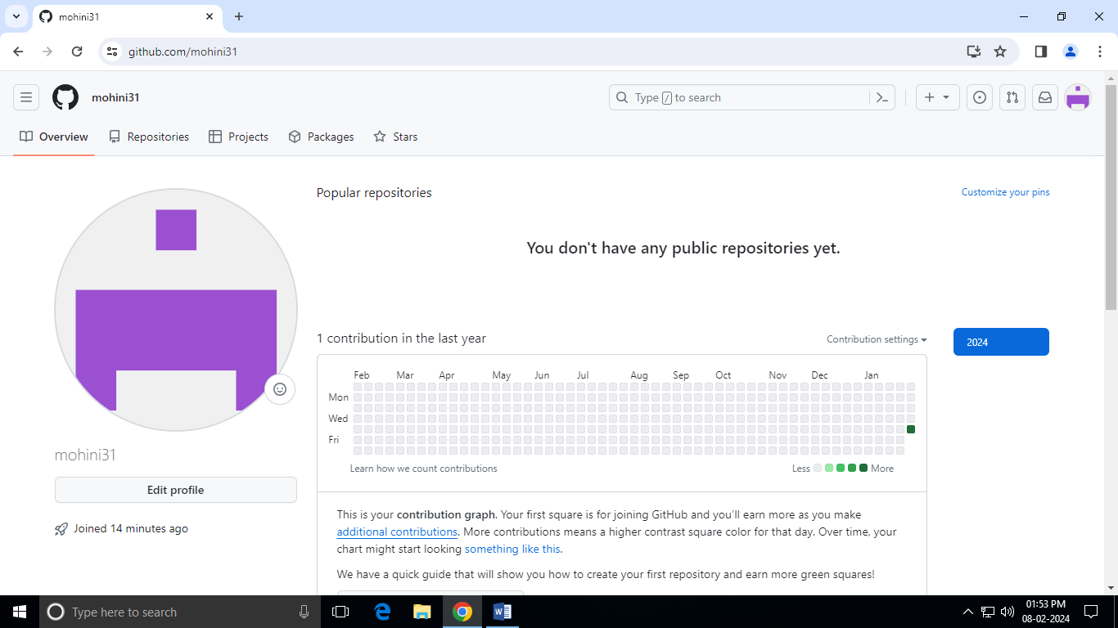

1. **Paste the screen shots of email which you had sended to your friend through Github.**

