Assignment: Group 47

Business Problem Definition
RecoMart, an emerging e-commerce platform, aims to enhance user engagement and increase sales conversions by leveraging personalized product recommendations. Currently, users are exposed to generic product listings, which results in lower interaction rates, reduced session durations, and missed cross-selling opportunities.
The core business problem is:
How to design a data-driven recommendation system that delivers personalized, relevant product suggestions to users in near real-time, thereby improving conversion rates, customer retention, and average order value.

Objectives
The primary objectives of the recommendation system are:
- Increase Conversion Rate
Recommend products that users are most likely to purchase.
- Enhance User Engagement
Improve metrics such as click-through rate (CTR), session duration, and interaction frequency.
- Enable Cross-Selling and Up-Selling
Suggest complementary or higher-value products based on user behavior.
- Provide Real-Time Personalization
Adapt recommendations dynamically based on recent user interactions.

Data Sources
RecoMart collects data from multiple heterogeneous sources. These sources are critical for building a comprehensive user-item interaction ecosystem.
- Clickstream Data (Web & Mobile Logs)
  - Type: Semi-structured (JSON/CSV)
  - Nature: High-volume, near real-time
  - Key Attributes:
    - user_id
    - product_id
    - timestamp
    - event_type (click, view, add_to_cart)
  - Purpose: Captures implicit user behavior and engagement patterns
- Transactional Purchase Data
  - Type: Structured (CSV/Database)
  - Nature: Batch (daily updates)
  - Key Attributes:
    - user_id
    - product_id
    - purchase_amount
    - rating (if available)
    - transaction_timestamp
  - Purpose: Captures explicit feedback and purchase history
- Product Metadata (Catalog Data)
  - Type: Structured (API/Database)
  - Nature: Slowly changing data
  - Key Attributes:
    - product_id
    - category
    - price
    - brand
    - description
  - Purpose: Enables content-based filtering and item similarity
- External API Data (Optional Enrichment)
  - Type: API-based
  - Nature: Periodic fetch
  - Key Attributes:
    - product_id
    - sentiment_score
    - popularity_index
  - Purpose: Enhances recommendations using external signals such as trends or reviews

Recommendation Approach
To solve this problem, the system will adopt a hybrid recommendation strategy:
- Collaborative Filtering
  - Learns from user-item interaction patterns (e.g., purchases, clicks)
  - Captures behavioral similarity across users
- Content-Based Filtering
  - Uses product attributes (category, price, description)
  - Helps recommend items similar to those previously interacted with

This hybrid approach ensures robustness in scenarios such as:
- New users (cold start)
- New products
- Sparse interaction data

Key Entities
The system revolves around the following core entities:
- Users
  - Identified by user_id
  - Associated with behavioral and transactional data
- Items (Products)
  - Identified by product_id
  - Associated with metadata such as category, price, and description
- Interactions
  - Clicks, views, purchases, ratings
  - Timestamped events capturing user behavior

Expected Outcomes
The recommendation system should generate:
- Personalized product rankings for each user
- Top-K recommendations (e.g., Top 5 or Top 10 items)
- Real-time suggestions based on recent activity
The pipeline will generate:
- Clean datasets for exploratory analysis
- Engineered feature tables (user features, item features)
- Trained recommendation model
- Top-K personalized recommendations for users

Success Criteria
The effectiveness of the system will be evaluated using:
- Precision@K – Relevance of top-K recommendations
- Recall@K – Coverage of relevant items
- NDCG (Normalized Discounted Cumulative Gain) – Ranking quality
- CTR (Click-Through Rate) – Engagement metric
- Conversion Rate – Business impact metric

Constraints and Challenges
- Handling large-scale, multi-source data ingestion
- Ensuring data quality and consistency
- Managing sparsity in user-item interactions
- Supporting near real-time data processing
- Maintaining scalability and modularity of the pipeline

Summary
This project focuses on building an end-to-end data pipeline that continuously ingests, processes, and transforms multi-source data into meaningful features for training and serving a scalable recommendation model. The ultimate goal is to deliver accurate, timely, and personalized recommendations that drive measurable business value.

Data Collection and Ingestion

Design Overview
The ingestion layer is responsible for collecting data from multiple heterogeneous sources in both batch and near real-time modes, ensuring reliability, scalability, and traceability.
Key Design Decisions:
- Batch ingestion for:
  - Transaction data (CSV)
- Near real-time ingestion for:
  - Clickstream logs (simulated)
- API ingestion for:
  - Product metadata / external signals
- Idempotent ingestion to avoid duplicates
- Retry + logging mechanisms for robustness

Data Sources and Ingestion Strategy
The data ingestion layer is designed to handle multiple heterogeneous data sources, each with different characteristics in terms of volume, velocity, and structure. Accordingly, different ingestion strategies are selected for each source to balance realism, simplicity, and alignment with assignment constraints.

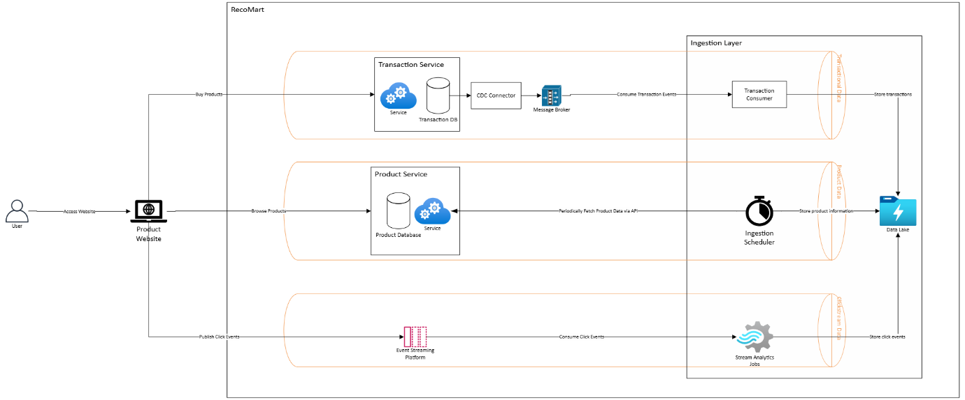
Figure 1: Production Approach (DM4DML-Assignment)
As see above, an ideal product RecoMart ingestion system architecture follows a hybrid model combining CDC-based ingestion for transactional data, streaming ingestion for clickstream events, and batch/API-based ingestion for product metadata. This ensures low latency for high-velocity data while maintaining simplicity and efficiency for slow-changing datasets.
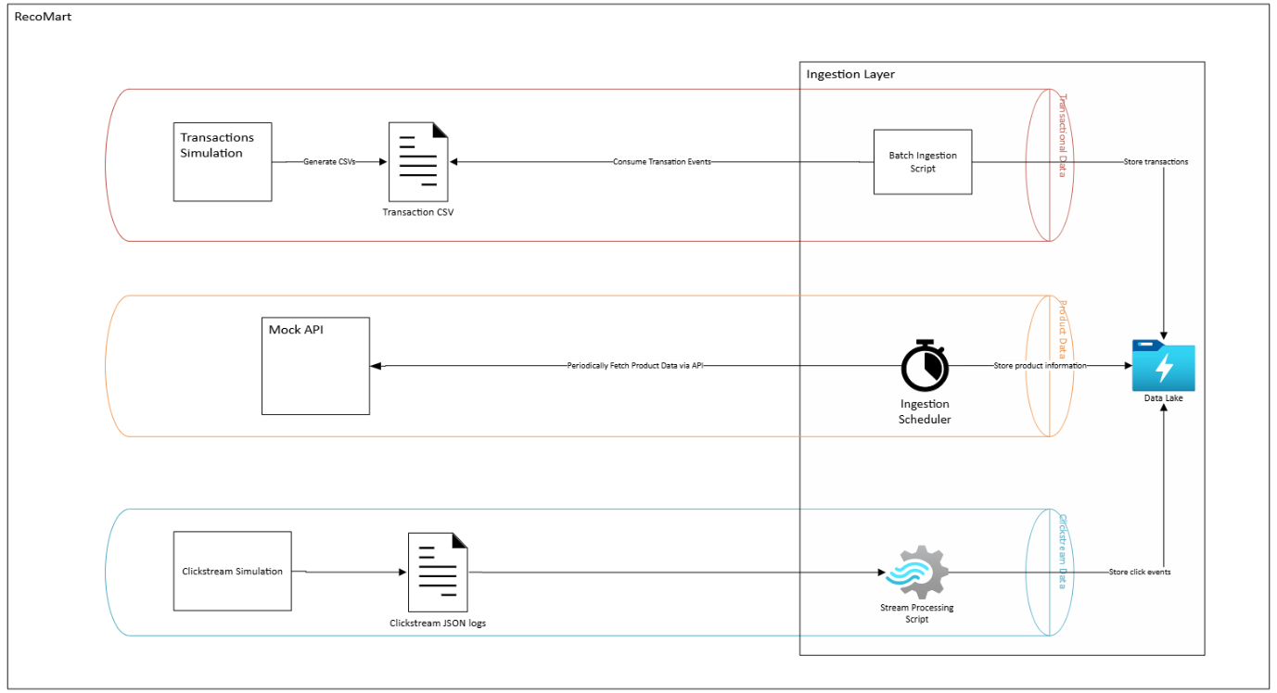
Figure 2: Simulation for Assignments
The production architecture includes CDC and streaming platforms for real-time ingestion. However, for the purpose of this assignment, these components are simulated using batch scripts, JSON-based event logs, and mock APIs to ensure reproducibility and ease of implementation while preserving the conceptual design.

Transactional Purchase Data

Description
Transactional data represents explicit user interactions, specifically product purchases. This data is highly reliable and reflects strong user intent, making it critical for training recommendation models.

Selected Approach: Batch Ingestion
- Data is ingested periodically from CSV files.
- Each batch represents a snapshot of transactions over a fixed time interval (e.g., daily).

Justification
- Transaction data is typically generated in structured systems (e.g., order databases) and is often processed in batches for reporting and analytics.
- The assignment environment does not include a live transactional database, making batch ingestion a practical and reproducible choice.
- Batch processing ensures simplicity, ease of debugging, and deterministic outputs.

Production Approach
- In a real-world system, transactional data would typically be ingested using Change Data Capture (CDC) mechanisms:
  - Tools such as Debezium stream database changes (INSERT/UPDATE events)
  - Events are pushed into streaming platforms like Apache Kafka
  - Enables near real-time updates and consistency across systems

Simulation in Assignment
- A static CSV file (transactions.csv) is used as the data source
- A Python script periodically reads the file and writes it to the raw data lake
- Folder structure is partitioned by date to simulate batch ingestion cycles

Clickstream Data (User Interaction Logs)

Description
Clickstream data captures implicit user behavior, such as product views, clicks, and add-to-cart actions. It is high-volume and continuously generated.

Selected Approach: Simulated Streaming Ingestion
- Events are ingested in near real-time by appending records to JSON files.

Justification
- Clickstream data is inherently streaming in nature and reflects real-time user activity.
- Using a streaming-like ingestion approach demonstrates understanding of real-time pipelines.
- Full streaming infrastructure (Kafka, Flink) is not required for this assignment, so a lightweight simulation is used.

Production Approach
In production environments, clickstream data is handled using event-driven architectures:
- Frontend applications emit events continuously
- Events are ingested via platforms like Apache Kafka or Amazon Kinesis
- Stream processing frameworks (e.g., Spark Streaming, Flink) process data in real time

Simulation in Assignment
- Click events are generated programmatically or manually
- Each event is appended to a JSON log file (events.json)
- This simulates a continuous stream of user interactions without requiring streaming infrastructure

Product Metadata (Catalog Data)

Description
Product metadata includes descriptive attributes such as category, price, brand, and textual descriptions. This data supports content-based recommendation.

Selected Approach: API-Based Ingestion
- Data is fetched using REST API calls

Justification
- Product catalogs are typically managed by backend services and exposed via APIs
- API ingestion demonstrates integration with external systems
- It introduces variability and realism into the pipeline

Production Approach
- Microservices expose product data through REST or GraphQL APIs
- Data pipelines periodically fetch updates or consume change events
- APIs may be backed by catalog databases or search systems

Simulation in Assignment
- A public or mock API endpoint is used (or a local JSON file served as API response)
- Python scripts use HTTP requests to fetch data
- Retrieved data is stored in the raw data layer with timestamp-based partitioning

External Enrichment Data (Optional)

Description
External signals such as sentiment scores or popularity indices enhance recommendation quality.

Selected Approach: Periodic API Fetch

Justification
- External data is typically updated at lower frequency
- API-based ingestion is sufficient and aligns with real-world usage

Production Approach
- Third-party APIs or data providers
- Scheduled ingestion pipelines (e.g., daily/weekly updates)

Simulation in Assignment
- Mock API or static JSON file
- Periodic ingestion script similar to product metadata

