Assignment: Group 47
Source Code: mohiniaiml/recomart-ml-pipeline: BITS DM4DML Assignment
Demo Video
Solution Contributors:
Name | BITS-ID | Contribution Percentage | Contribution/Comments
MOHINI RAHUL JOSHI | 2025AE05288 | 100% | Implemented the complete flow and documentation, recording, etc.
AVINASH SANKAR | 2025AE05213 | 5% | Created a change request, but was not helpful
CHIGULURI HASHA VARDHAN | 2025AE05710 | 0% | Could not contribute due to personal reasons
SHINDE DAMINI RAMDAS | 2025AE05845 | 0% | No communication

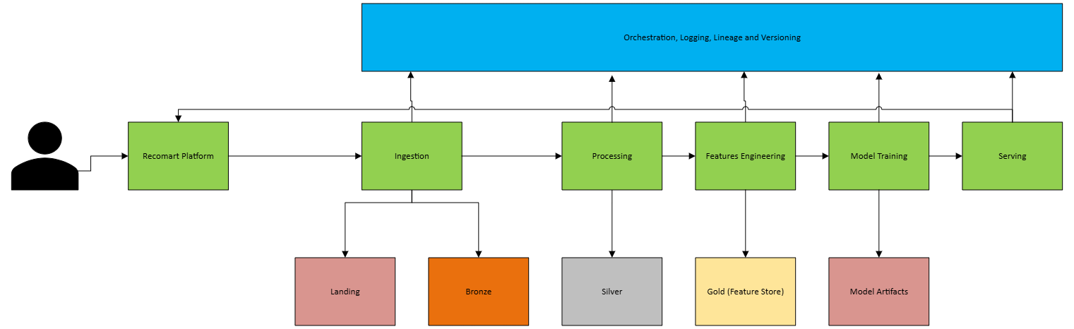
Figure 1: Overall Architecture

Business Problem Definition
RecoMart, an emerging e-commerce platform, aims to enhance user engagement and increase sales conversions by leveraging personalized product recommendations. Currently, users are exposed to generic product listings, which results in lower interaction rates, reduced session durations, and missed cross-selling opportunities.
The core business problem is:
How to design a data-driven recommendation system that delivers personalized, relevant product suggestions to users in near real-time, thereby improving conversion rates, customer retention, and average order value.

Objectives
The primary objectives of the recommendation system are:
- Increase Conversion Rate
Recommend products that users are most likely to purchase.
- Enhance User Engagement
Improve metrics such as click-through rate (CTR), session duration, and interaction frequency.
- Enable Cross-Selling and Up-Selling
Suggest complementary or higher-value products based on user behavior.
- Provide Real-Time Personalization
Adapt recommendations dynamically based on recent user interactions.

Data Sources
RecoMart collects data from multiple heterogeneous sources. These sources are critical for building a comprehensive user-item interaction ecosystem.
- Clickstream Data (Web & Mobile Logs)
  - Type: Semi-structured (JSON/CSV)
  - Nature: High-volume, near real-time
  - Key Attributes:
    - event_id
    - user_id
    - product_id
    - timestamp
    - event_type (click, view, add_to_cart)
  - Purpose: Captures implicit user behavior and engagement patterns
- Transactional Purchase Data
  - Type: Structured (CSV/Database)
  - Nature: Batch (daily updates)
  - Key Attributes:
    - event_id
    - user_id
    - product_id
    - purchase_amount
    - rating (if available)
    - transaction_timestamp
  - Purpose: Captures explicit feedback and purchase history
- Product Metadata (Catalog Data)
  - Type: Structured (API/Database)
  - Nature: Slowly changing data
  - Key Attributes:
    - product_id
    - category
    - price
    - brand
    - description
  - Purpose: Enables content-based filtering and item similarity
- External API Data (Optional Enrichment)
  - Type: API-based
  - Nature: Periodic fetch
  - Key Attributes:
    - product_id
    - sentiment_score
    - popularity_index
  - Purpose: Enhances recommendations using external signals such as trends or reviews

Recommendation Approach
To solve this problem, the system will adopt a hybrid recommendation strategy:
- Collaborative Filtering
  - Learns from user-item interaction patterns (e.g., purchases, clicks)
  - Captures behavioral similarity across users
- Content-Based Filtering
  - Uses product attributes (category, price, description)
  - Helps recommend items similar to those previously interacted with

This hybrid approach ensures robustness in scenarios such as:
- New users (cold start)
- New products
- Sparse interaction data

Key Entities
The system revolves around the following core entities:
- Users
  - Identified by user_id
  - Associated with behavioral and transactional data
- Items (Products)
  - Identified by product_id
  - Associated with metadata such as category, price, and description
- Interactions
  - Clicks, views, purchases, ratings
  - Timestamped events capturing user behavior

Expected Outcomes
The recommendation system should generate:
- Personalized product rankings for each user
- Top-K recommendations (e.g., Top 5 or Top 10 items)
- Real-time suggestions based on recent activity
The pipeline will generate:
- Clean datasets for exploratory analysis
- Engineered feature tables (user features, item features)
- Trained recommendation model
- Top-K personalized recommendations for users

Success Criteria
The effectiveness of the system will be evaluated using:
- Precision@K – Relevance of top-K recommendations
- Recall@K – Coverage of relevant items
- NDCG (Normalized Discounted Cumulative Gain) – Ranking quality
- CTR (Click-Through Rate) – Engagement metric
- Conversion Rate – Business impact metric

Constraints and Challenges
- Handling large-scale, multi-source data ingestion
- Ensuring data quality and consistency
- Managing sparsity in user-item interactions
- Supporting near real-time data processing
- Maintaining scalability and modularity of the pipeline

Summary
This project focuses on building an end-to-end data pipeline that continuously ingests, processes, and transforms multi-source data into meaningful features for training and serving a scalable recommendation model. The ultimate goal is to deliver accurate, timely, and personalized recommendations that drive measurable business value.

Data Collection and Ingestion

Design Overview
The ingestion layer is responsible for collecting data from multiple heterogeneous sources in both batch and near real-time modes, ensuring reliability, scalability, and traceability.
Key Design Decisions:
- Batch ingestion for:
  - Transaction data (CSV)
- Near real-time ingestion for:
  - Clickstream logs (simulated)
- API ingestion for:
  - Product metadata / external signals
- Idempotent ingestion to avoid duplicates
- Retry + logging mechanisms for robustness

Data Sources and Ingestion Strategy
The data ingestion layer is designed to handle multiple heterogeneous data sources, each with different characteristics in terms of volume, velocity, and structure. Accordingly, different ingestion strategies are selected for each source to balance realism, simplicity, and alignment with assignment constraints.

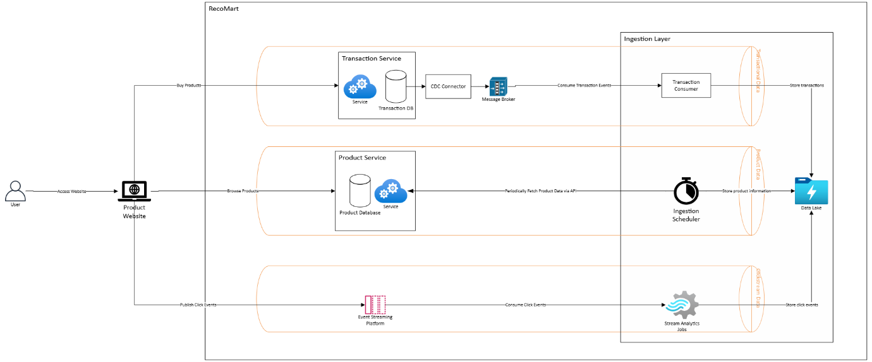
Figure 2: Production Approach
As see above, an ideal product RecoMart ingestion system architecture follows a hybrid model combining CDC-based ingestion for transactional data, streaming ingestion for clickstream events, and batch/API-based ingestion for product metadata. This ensures low latency for high-velocity data while maintaining simplicity and efficiency for slow-changing datasets.
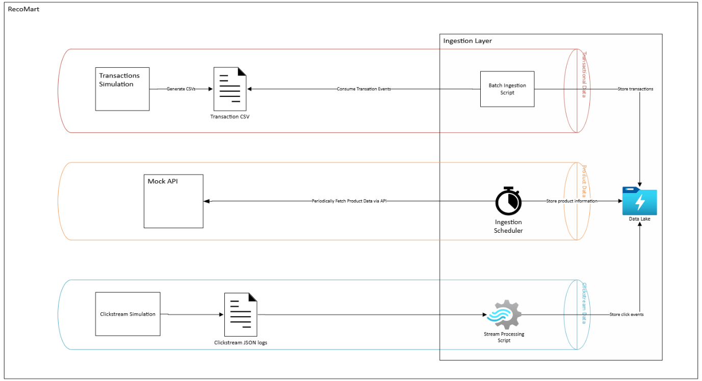
Figure 3: Simulation for Assignments
The production architecture includes CDC and streaming platforms for real-time ingestion. However, for the purpose of this assignment, these components are simulated using batch scripts, JSON-based event logs, and mock APIs to ensure reproducibility and ease of implementation while preserving the conceptual design.

Transactional Purchase Data

Description
Transactional data represents explicit user interactions, specifically product purchases. This data is highly reliable and reflects strong user intent, making it critical for training recommendation models.

Selected Approach: Batch Ingestion
- Data is ingested periodically from CSV files.
- Each batch represents a snapshot of transactions over a fixed time interval (e.g., daily).

Justification
- Transaction data is typically generated in structured systems (e.g., order databases) and is often processed in batches for reporting and analytics.
- The assignment environment does not include a live transactional database, making batch ingestion a practical and reproducible choice.
- Batch processing ensures simplicity, ease of debugging, and deterministic outputs.

Production Approach
- In a real-world system, transactional data would typically be ingested using Change Data Capture (CDC) mechanisms:
  - Tools such as Debezium stream database changes (INSERT/UPDATE events)
  - Events are pushed into streaming platforms like Apache Kafka
  - Enables near real-time updates and consistency across systems

Simulation in Assignment
- A static CSV file (transactions.csv) is used as the data source
- A Python script periodically reads the file and writes it to the raw data lake
- Folder structure is partitioned by date to simulate batch ingestion cycles

Clickstream Data (User Interaction Logs)

Description
Clickstream data captures implicit user behavior, such as product views, clicks, and add-to-cart actions. It is high-volume and continuously generated.

Selected Approach: Simulated Streaming Ingestion
- Events are ingested in near real-time by appending records to JSON files.

Justification
- Clickstream data is inherently streaming in nature and reflects real-time user activity.
- Using a streaming-like ingestion approach demonstrates understanding of real-time pipelines.
- Full streaming infrastructure (Kafka, Flink) is not required for this assignment, so a lightweight simulation is used.

Production Approach
In production environments, clickstream data is handled using event-driven architectures:
- Frontend applications emit events continuously
- Events are ingested via platforms like Apache Kafka or Amazon Kinesis
- Stream processing frameworks (e.g., Spark Streaming, Flink) process data in real time

Simulation in Assignment
- Click events are generated programmatically or manually
- Each event is appended to a JSON log file (events.json)
- This simulates a continuous stream of user interactions without requiring streaming infrastructure

Product Metadata (Catalog Data)

Description
Product metadata includes descriptive attributes such as category, price, brand, and textual descriptions. This data supports content-based recommendation.

Selected Approach: API-Based Ingestion
- Data is fetched using REST API calls

Justification
- Product catalogs are typically managed by backend services and exposed via APIs
- API ingestion demonstrates integration with external systems
- It introduces variability and realism into the pipeline

Production Approach
- Microservices expose product data through REST or GraphQL APIs
- Data pipelines periodically fetch updates or consume change events
- APIs may be backed by catalog databases or search systems

Simulation in Assignment
- A public or mock API endpoint is used (or a local JSON file served as API response)
- Python scripts use HTTP requests to fetch data
- Retrieved data is stored in the raw data layer with timestamp-based partitioning

External Enrichment Data (Optional)

Description
External signals such as sentiment scores or popularity indices enhance recommendation quality.

Selected Approach: Periodic API Fetch

Justification
- External data is typically updated at lower frequency
- API-based ingestion is sufficient and aligns with real-world usage

Production Approach
- Third-party APIs or data providers
- Scheduled ingestion pipelines (e.g., daily/weekly updates)

Simulation in Assignment
- Not implemented as optional

Raw Data Storage
A configuration-driven storage layer was implemented to abstract the storage backend. By selecting the storage type in the configuration, the same pipeline can store Bronze data either locally or in cloud storage while maintaining consistent partitioning and structure.

Storage Structure
Raw data is organized in a data lake with a landing zone (raw/) and a standardized Bronze layer.
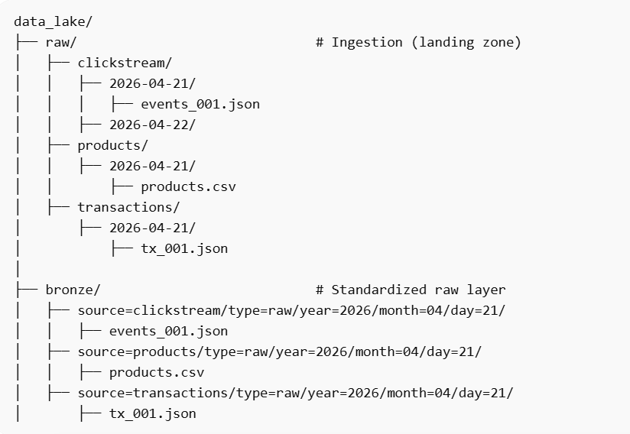
Figure 4: Sample Storage Structure

Partitioning Dimensions
- source: data origin (clickstream, products, transactions)
- type: data category (raw)
- year/month/day: time-based partitions derived from ingestion timestamp folders

Bronze Layer
The Bronze layer represents raw, minimally processed data:
- Stored as-is (no schema enforcement or transformations)
- Preserves original formats (JSON/CSV)
- Maintains full fidelity for reprocessing
- Adds only organizational structure (partitioning)
This aligns with the Medallion architecture:
Raw (Landing) → Bronze (organized raw) → Silver (cleaned) → Gold (aggregated)
- raw/ = landing zone (ingestion output)
- bronze/ = first structured layer

Advantages of this Design
- Efficient Data Access
Partitioning by date and source enables:
  - Faster queries (scan only relevant partitions)
  - Better compatibility with query engines (e.g., Spark)
- Scalability
  - Supports large datasets without performance degradation
  - Easily extendable to cloud storage (e.g., Amazon S3)
- Reproducibility & Lineage
  - Raw data is preserved so pipelines can be re-run
  - Timestamp folders maintain ingestion lineage
- Decoupling of Systems
  - Ingestion writes to raw/
  - Storage script standardizes into bronze/
    - Enables modular pipeline design
- Flexibility (Schema-on-Read)
  - No strict schema enforcement at this stage
  - Supports heterogeneous data formats
  - Schema applied later in Silver layer

Alternatives Considered
- Direct Write to Bronze (No Raw Layer)
Ingestion → Bronze directly
- Rejected because:
    - Loss of original data structure
    - Harder to debug ingestion issues
    - Reduced lineage tracking
- Flat Storage (No Partitioning)
data_lake/
all_files/
  - Rejected because:
    - Poor query performance
    - No scalability
    - Difficult data management
- Schema Enforcement at Raw Stage
Validate + transform during ingestion
  - Rejected because:
    - Violates separation of concerns
    - Risks data loss
    - Reduces flexibility
- Store Only in Cloud (No Local)
Direct S3 ingestion
  - Partially considered
    - Good for production
    - Not ideal for development/testing in assignment

Data Profiling and Validation
The Data Profiling and Validation step ensures that data stored in the Bronze layer meets quality standards before it is used for downstream processing. This step detects inconsistencies, missing values, schema mismatches, and invalid data ranges. It produces a structured data quality report that summarizes the health of the dataset.

Objectives
- Ensure completeness and correctness of data
- Detect anomalies early in the pipeline
- Validate schema consistency across sources
- Provide measurable data quality metrics
- Prevent propagation of poor-quality data into the Silver layer

Input
- Source: data_lake/bronze/
- Data format: JSON and CSV files organized in partitioned directories

Validation Checks Implemented
- Missing Values
- Checked for null or empty values across all columns
- Critical fields such as user_id and product_id are required to be non-null
- Missing optional fields (e.g., rating) are flagged and handled in later stages
- Duplicate Records
- Identified duplicate rows using full row comparison
- Verified uniqueness of key identifiers where applicable (e.g., transaction ID)
- Schema Validation
- Compared actual data types with expected schema definitions
- Detected missing columns and incorrect data types
- Ensured consistency across different data files
- Range Validation
- Applied constraints on numerical fields
- Example: rating values must be within the range [1, 5]
- Format Validation
- Validated timestamp fields for correct datetime format
- Ensured categorical fields contain valid values

Implementation Approach
The validation is implemented using the Great Expectations framework, which provides declarative validation rules and structured output.
Key steps:
- Load Bronze data into a pandas DataFrame
- Convert DataFrame into a Great Expectations dataset
- Apply validation rules (expectations)
- Capture validation results
- Generate a data quality report

Output
- Data Quality Report
- Location: reports/data_quality_report.pdf
- Contains:
  - Summary of validation checks
  - Pass/Fail status for each rule
  - Overview of detected issues
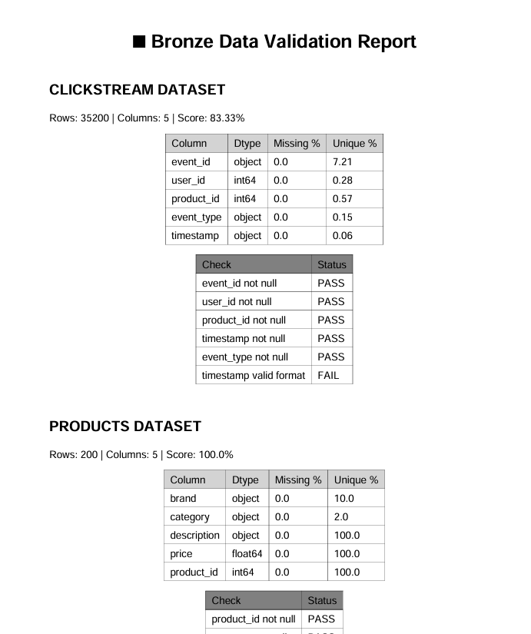
Figure 5: Data Quality Report Sample
- Console Logs
- Displays validation results during execution
- Highlights failures for quick debugging
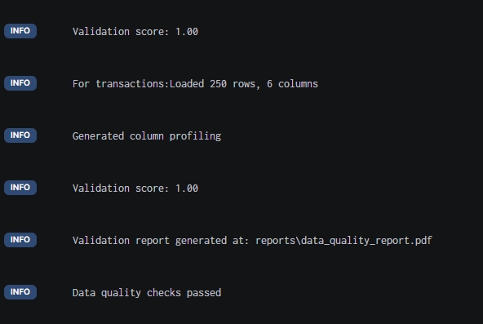
Figure 6: Data Qualit Check Logs

Data Quality Metrics
The following metrics are captured:
- Percentage of missing values per column
- Number of duplicate records
- Count of schema mismatches
- Number of invalid entries (range/format violations)

Cadence
- Batch data:
  - Validation is executed after each ingestion cycle (daily)
- Streaming data:
  - Validation is executed periodically (hourly or per batch window)
- Pre-processing checkpoint:
  - Validation must be completed before Silver layer transformation

Design Considerations
- Validation is performed on the Bronze layer to ensure early detection of issues
- Schema-on-read approach is maintained to preserve raw data flexibility
- Validation results are externalized as reports for auditability
- The system is extensible to include additional rules as data evolves

Alternatives Considered
- Manual Validation using pandas only
    - Simple but lacks structure and scalability
    - No standardized reporting mechanism
- Validation during ingestion
    - Rejected to avoid coupling ingestion with validation logic
    - Preserves raw data integrity
- Using PyDeequ
    - Considered for large-scale distributed validation
    - Not selected due to additional setup complexity

Data Preparation
The Silver layer is responsible for transforming raw Bronze data into a cleaned, structured, and analysis-ready dataset. This step ensures data quality and prepares features for downstream tasks such as recommendation modeling.

Data Preparation Steps
- Data Cleaning
- Removed duplicate records to eliminate redundancy
- Dropped records with missing critical fields (user_id, product_id)
- Imputed missing values for optional fields (e.g., rating using mean)
- Handling Missing User-Item Interactions
- Incomplete interactions were filtered out
- Ensured only valid user-item pairs are retained
- This improves the reliability of recommendation models
- Categorical Encoding
- Categorical attributes (e.g., category) were encoded using label encoding
- Converted non-numeric features into machine-readable format
- Normalization of Numerical Features
- Prices normalized using Min-Max scaling
- Timestamps converted into numerical format (Unix time)
- Exploratory Data Analysis (EDA)
The following analyses were performed:
- Interaction Distribution
  - Histogram of ratings to understand user behavior
- Item Popularity
  - Frequency distribution of top products
- Sparsity Analysis
  - Constructed user-item interaction matrix
  - Calculated sparsity level:
  - Sparsity ≈ 80%
- Heatmap Visualization
  - Visualized subset of interaction matrix
  - Identified sparse interaction patterns

Outputs Generated
Artifact | Location | Description
Cleaned datasets (Silver) | data_lake/silver/<dataset>/<version>/<date>/data.parquet | Cleaned, transformed, and normalized data for each dataset
Validation report | reports/data_quality_report.pdf | Data quality checks with schema validation and profiling
EDA report (interactive) | reports/eda/eda_report.html | Interactive report with distributions, correlation heatmaps, and category analysis

Design Justification
- Ensures high-quality input for modeling
- Reduces noise and inconsistencies
- Enables efficient downstream analytics
- Aligns with Medallion architecture (Silver layer)

Execution Cadence
- Run after Bronze ingestion and validation
- Frequency:
  - Batch data → Daily
  - Streaming data → Per batch window

Feature Engineering and Transformation
Feature engineering is performed using a combination of Python-based transformations and SQL-compatible storage. User-level, item-level, and interaction-level features are derived from raw transactional and clickstream data. The transformed features are stored in a structured SQLite database to simulate a data warehouse, enabling efficient retrieval for downstream modeling tasks.

Features
Feature engineering was performed to derive meaningful user-level, item-level, and interaction-level features from raw transactional and clickstream data. These features capture user behavior, item characteristics, and interaction intensity, enabling effective training of recommendation models.
Feature Name | Entity | Description | Computation Logic | Significance for Recommendation
activity_count | User | Total number of interactions (clicks + purchases) by a user | Count of product_id grouped by user_id | Measures user engagement level; helps identify active vs inactive users
avg_rating | User | Average rating given by a user | Mean of rating grouped by user_id | Captures user preference patterns and sentiment
purchase_count | User | Total number of purchases made by a user | Count of non-null purchase_amount per user_id | Indicates buying propensity; useful for personalization and segmentation
item_popularity | Item | Total number of interactions for a product | Count of user_id grouped by product_id | Identifies trending or popular items for recommendation
avg_rating | Item | Average rating received by a product | Mean of rating grouped by product_id | Reflects product quality and user satisfaction
purchase_count | Item | Total purchases of a product | Count of non-null purchase_amount per product_id | Indicates demand and conversion likelihood
interaction_count | User-Item | Number of times a user interacted with a specific product | Count grouped by (user_id, product_id) | Captures strength of user interest in specific items
co-occurrence (optional) | Item-Item | Frequency of items appearing together in user interactions | Pairwise count of items in same user sessions | Enables similarity-based recommendations (e.g., “customers also bought”)

These features support both collaborative filtering (user-item interactions) and content-based approaches (item characteristics), forming the foundation for hybrid recommendation systems.

Cadence
Component | Production | Assignment
Clickstream | Real-time | Every few seconds
Transactions | CDC / micro-batch | Every 30–60 sec
Products | API periodic | Every few minutes
Features | Batch + streaming | Every 5–10 min

In a production environment, feature engineering pipelines operate at multiple cadences depending on data characteristics:
- Real-time features derived from clickstream data are updated continuously using streaming pipelines.
- Transactional data is processed in micro-batches using CDC mechanisms.
- Aggregated features such as user statistics and item popularity are typically recomputed using daily batch jobs.
In this assignment, a simplified cadence is implemented to simulate production behavior. Feature engineering is executed periodically (every few minutes) using Python-based transformation scripts, with results stored in a structured SQLite database.

Feature Store

Overview
A lightweight feature store is implemented to manage, store, and retrieve engineered features for both training and inference workflows. The feature store is built using a combination of a SQLite database for storage and a custom metadata registry to track feature definitions, sources, and transformations.
This approach ensures simplicity, reproducibility, and alignment with the assignment scope while reflecting key principles of production-grade feature stores.

Architecture
The feature store sits downstream of the feature engineering pipeline and provides a unified interface for accessing features.

Feature Storage
The engineered features are stored in a structured SQLite database (features.db) with the following tables:
- user_features
- item_features
- interaction_features
Each table captures aggregated features derived from transactional and clickstream data.

Feature Metadata Registry
A metadata registry is maintained in a JSON file to document:
- Feature name
- Associated entity (user/item/interaction)
- Source data
- Transformation logic
This ensures traceability and interpretability of features.

Feature Versioning
Feature versioning is implemented using a version identifier (e.g., v1) stored in the metadata registry. This allows:

- Reproducibility of experiments
- Tracking of feature evolution
- Consistent feature usage across training and inference

Feature Retrieval Interface
A custom Python-based API is implemented to retrieve features from the store. The interface supports:
- User-level feature retrieval
- Item-level feature retrieval
- Interaction-level feature retrieval
This abstraction ensures that downstream components can access features without directly querying the database.

Sample Feature Retrieval
The feature store provides programmatic access to features, enabling seamless integration with machine learning workflows.
Example:
- Retrieve user features using user_id
- Retrieve item features using product_id
- Retrieve interaction features using (user_id, product_id)

Design Justification
The implemented feature store design balances simplicity and functionality:
- SQLite provides a lightweight yet structured storage solution
- JSON-based metadata enables easy documentation and extensibility
- Python-based retrieval APIs ensure modularity and usability
While production systems may use tools like Feast, the current implementation captures the essential components of a feature store within the constraints of the assignment.

Summary
The feature store enables centralized management of engineered features, supporting both offline training and online inference use cases. It ensures consistency, traceability, and efficient access to features, forming a critical component of the overall data pipeline.

Data Versioning and Lineage

Overview
Data versioning and lineage tracking are implemented to ensure reproducibility, traceability, and transparency of data transformations throughout the pipeline. The pipeline processes a configurable active version of each dataset. Version selection is controlled via configuration, enabling flexible switching between dataset versions without modifying code. While only the active version is processed during execution, historical versions are preserved in storage for reproducibility and potential backfill processing. The design can be extended to support multi-version processing for backfill and historical analysis scenarios.

Data Versioning Strategy
Datasets are versioned using a combination of:
- Version identifiers (v1, v2, …)
- Date-based partitioning
This approach enables tracking of dataset evolution over time and supports reproducibility of experiments.

Storage Structure
Raw and processed data are stored in a structured format:
- Raw data: data_lake/raw/<dataset>/<version>/<date>/
- Processed data: data_lake/processed/features/<version>/

Lineage Tracking
A custom lineage tracking mechanism is implemented using a JSON-based registry. Each dataset transformation logs metadata including:
- Data source
- Transformation applied
- Output location
- Timestamp

Lineage Workflow
- Data is ingested and stored in versioned raw folders
- Transformation scripts generate processed datasets
- Each step logs metadata to a lineage registry
- The lineage log provides end-to-end traceability
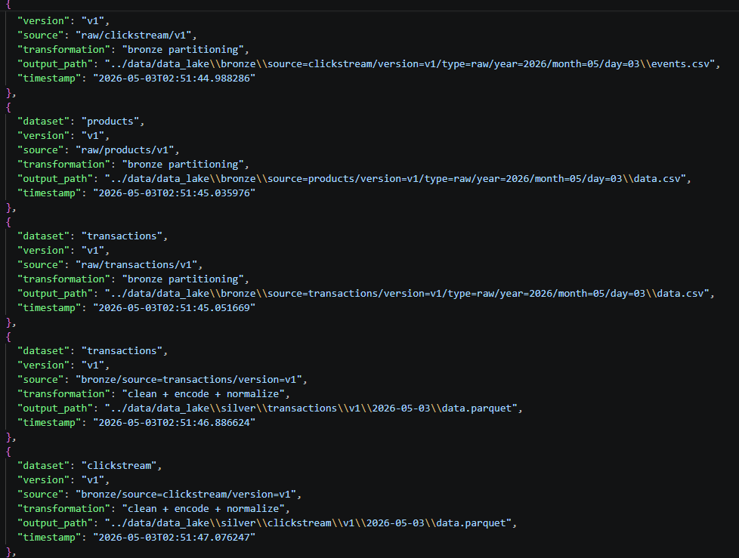
Figure 7: Lineage Logging Example

Tooling and Justification
While tools such as DVC and Git LFS are commonly used for data versioning, a lightweight custom implementation is used in this project to:
- Reduce setup complexity
- Maintain reproducibility
- Align with assignment constraints

Summary
The implemented versioning and lineage framework ensures:
- Reproducibility of datasets and features
- Traceability of transformations
- Transparency in data flow
This forms a critical foundation for reliable machine learning pipelines.

Model Training and Evaluation

Model Selection
A collaborative filtering approach based on Singular Value Decomposition (SVD) is used to model user-item interactions.
This method learns latent representations (embeddings) of users and items from historical interaction data, enabling the system to predict user preferences for unseen items.

Justification:
- Effective for sparse interaction data
- Captures implicit behavioral patterns
- Scalable and widely used baseline for recommendation systems

Input Data
The model is trained using features derived from the feature store (Gold layer), specifically:
- Interaction features (user_id, product_id, interaction_count)
- Item features (category, popularity)
- User behavior signals (activity_count, purchase_count)
These are transformed into a user-item interaction matrix, where each entry represents the strength of interaction between a user and a product.

Training Process
The training workflow consists of the following steps:
- Construct the user-item interaction matrix
- Split data into training and testing sets
- Apply SVD to factorize the matrix into:
  - User latent factors
  - Item latent factors
- Generate predicted interaction scores for unseen user-item pairs

Recommendation Generation
For each user, the trained model generates a ranked list of items based on predicted interaction scores.
- Top-K items (e.g., Top 5) are selected
- Items already interacted with are excluded
- Optional category preference signals may be incorporated to improve relevance
These recommendations are stored and served through the application layer.

Evaluation Metrics
Since recommendation is a ranking problem, the model is evaluated using ranking-based metrics:
- Precision@K
Measures the proportion of recommended items in the top-K list that are relevant.
- Recall@K
Measures the proportion of relevant items that are successfully recommended.
- NDCG@K (Normalized Discounted Cumulative Gain)
Evaluates the quality of ranking by assigning higher importance to correctly ranked items at the top.

Evaluation Results
The model achieved the following performance:
- Precision@5: 0.058
- Recall@5: 0.066
- NDCG@5: 0.073

Interpretation:
- The model demonstrates baseline recommendation capability
- Lower scores are expected due to:
  - High sparsity (~80%) in the interaction matrix
  - Cold-start conditions for new users and items
  - Limited interaction history in the simulated dataset

Key Insight:

Model performance is expected to improve as more user interaction data is accumulated over time.

Experiment Tracking
MLflow is used for tracking experiments, including:
- Model parameters
- Evaluation metrics
- Trained model artifacts
This enables:
- Comparison of multiple runs
- Reproducibility of experiments
- Systematic model improvement
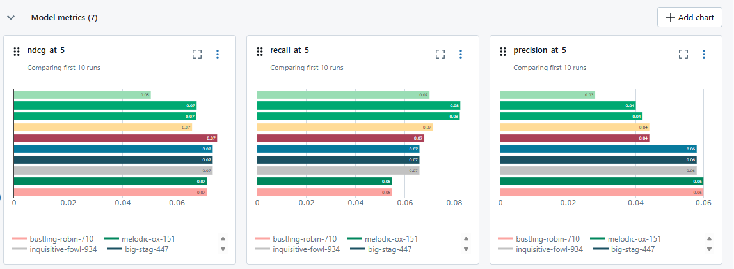
Figure 8: MLFlow Comparisons

Design Considerations
- Simplicity vs performance trade-off:
SVD provides a strong baseline without requiring complex deep learning models
- Scalability:
The approach can be extended to distributed implementations for large datasets
- Extensibility:
The system can incorporate hybrid approaches by combining collaborative filtering with content-based features

Summary
The collaborative filtering model effectively captures user-item interaction patterns and generates personalized recommendations.
By using ranking-based evaluation metrics and experiment tracking, the system ensures both performance measurement and reproducibility, forming a strong foundation for iterative improvement.

Pipeline Orchestration

Overview
The end-to-end machine learning pipeline is orchestrated using Prefect, enabling automated and reliable execution of data processing and model training stages. The orchestration layer coordinates multiple pipeline components, ensuring correct execution order and handling failures gracefully.

Pipeline Structure
The pipeline consists of the following stages:
- Data Ingestion
- Bronze Layer Processing
- Data Validation
- Silver Transformation
- Feature Engineering
- Model Training
These stages are executed sequentially as part of a Prefect flow.
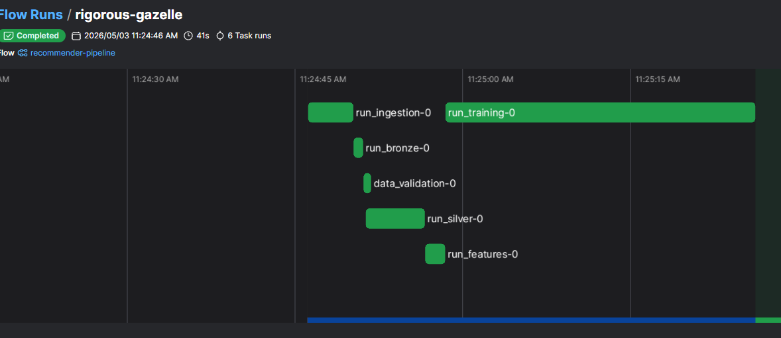
Figure 9: Prefect Flow Run

Task Design
Each pipeline stage is implemented as an independent Prefect task:
- Tasks encapsulate specific functionality
- Tasks are reusable and modular
- Tasks include logging and error handling
This modular design improves maintainability and debuggability.

Workflow Definition
The workflow is defined as a Directed Acyclic Graph (DAG), where tasks are executed in a predefined sequence:
Ingestion → Bronze → Silver → Features → Training
Dependencies between tasks ensure that downstream stages execute only after upstream stages complete successfully.

Logging and Failure Handling
Prefect provides built-in logging and monitoring capabilities:
- Each task logs execution status
- Failures are captured and surfaced clearly
- Pipeline execution stops on critical errors
This ensures reliability and transparency of pipeline execution.

Design Decisions

Choice of Prefect over Airflow/Dagster
Prefect was selected due to:
- Simplicity of setup (no additional infrastructure required)
- Native Python integration
- Lightweight execution model
- Suitable for local development and assignment scope

Sequential Execution Model
A sequential execution model is used instead of parallel processing to:
- Maintain data dependencies
- Ensure correctness of transformations
- Simplify debugging and validation

Script-based Task Execution
Each Prefect task invokes existing pipeline scripts rather than embedding logic directly. This ensures:
- Separation of concerns
- Reusability of scripts outside orchestration
- Minimal refactoring effort

Configuration-driven Pipeline
The pipeline uses a centralized configuration system to manage:
- Data paths
- Dataset versions
- Storage settings
This enables flexibility and avoids hardcoding.

Integration with Versioning and Lineage
The orchestration layer integrates seamlessly with:
- Dataset versioning
- Lineage tracking
Each pipeline stage maintains traceability, ensuring end-to-end visibility of data transformations.

Monitoring and Observability
Prefect supports optional UI-based monitoring, allowing visualization of:
- Task execution status
- Pipeline runs
- Logs and errors
This enhances observability of the pipeline.

Summary
The orchestration layer ensures reliable, automated, and traceable execution of the machine learning pipeline. By leveraging Prefect, the system achieves a balance between simplicity and functionality, making it suitable for both academic and practical applications.

Demo Flow (System Behavior)
- User interacts with system (click simulation)
- Data ingested into pipeline
- Validation and transformation applied
- Features updated in Gold layer
- Model recomputed
- Recommendations refreshed in UI
System demonstrates a feedback-driven recommendation loop
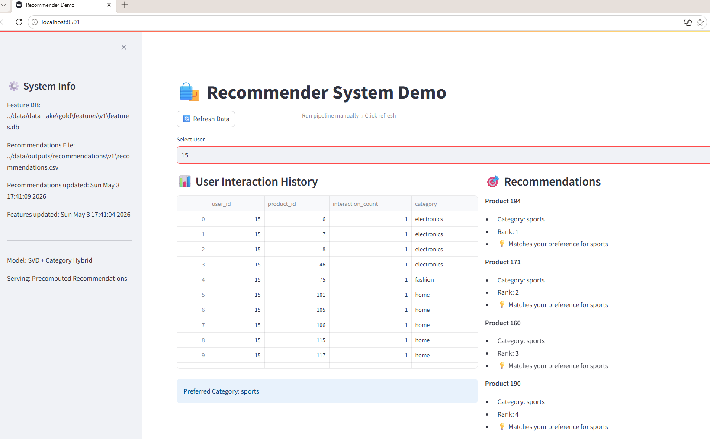
Figure 10: Demo UI

Conclusion
The project implements a complete end-to-end recommendation pipeline, integrating:
- Data engineering (ingestion, validation, transformation)
- Feature engineering and versioning
- Model training and evaluation
- Orchestration and monitoring
The system demonstrates how user interactions drive adaptive recommendations, making it scalable and suitable for real-world applications.

