**WORK BREAKDOWN STRUCTURE OF FOOD ORDERING SYSTEM**

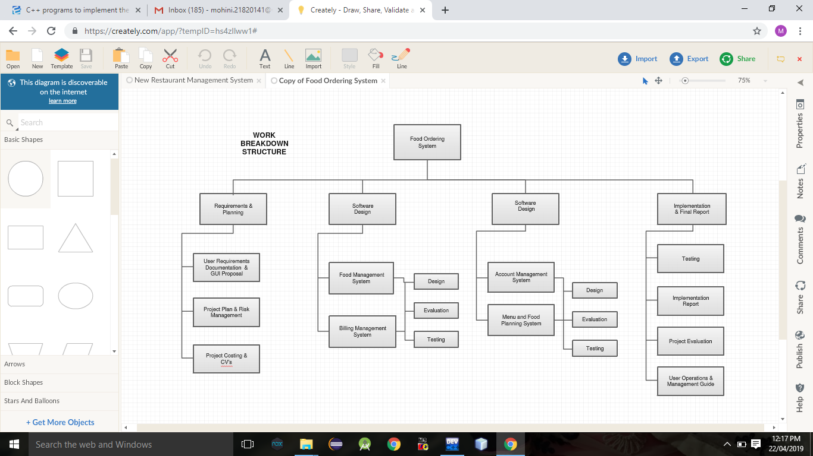

Bansilal Ramnath Agarwal Charitable Trust's

VISHWKARMA INSTITUTE OF INFORMATION TECHNOLOGY, PUNE

DEPARTMENT OF COMPUTER ENGINEERING

**PROJECT SYNOPSIS**

Group Id – 3

BATCH –C3

**STUDENTS-**

1.Mohini Kale -223072

2.Abhishek Som – 223055

3.Prem Waghela – 223061

4.Akash Zombade – 223075

**PROJECT TITLE : FOOD ORDERING SYSTEM**

**Guide: D.S.Wankhede mam**

**Problem statement-**

Making it easy for people to order food at anytime,from anywhere.

**Abstract:**

Our proposed system is an food ordering system that enables ease for the customers. It overcomes the disadvantages of the traditional queueing system. Our proposed system is a medium to order online food hassle free from restaurants as well as mess service. This system improves the method of taking the order from customer. The food ordering system sets up a food menu online and customers can easily place the order as per their wish. Also with a food menu, customers can easily track the orders. This system also provides a feedback system in which user can rate the food items. Also, the proposed system can recommend hotels, food, based on the ratings given by the user, the hotel staff will be informed for the improvements along with the quality. The payment can be made by pay-on-delivery system.

Due to lack of a full fledge application that can fulfill the customer requirements by providing him food from restaurants as well as from mess service, there is a need for the system. This proposed system will be used by the people who keep shifting from cities to cites. As well as, it will be useful for the students studying in different cities.