📱 Paytm vs PhonePe: What the Data Tells Us About India's Top UPI Apps

💡 Why I Did This Project  
We all use digital wallets like Paytm and PhonePe almost daily — for paying bills, groceries, or even splitting chai with friends. But I wanted to go a step further and ask:  
"What do users really think of these apps? Are they happy, frustrated, ignored? And who's winning the UPI war in India?"  
So, I decided to dig deep into user reviews and UPI transaction data — and here’s what I discovered 👇

# 🔍 The Data I Used

1. User Reviews from both Play Store apps — containing:  
- App name (Paytm or PhonePe)  
- Ratings (1–5 stars)  
- Sentiment (positive, negative, neutral)  
- Reply time (how quickly the app team responded)  
- Date of review  
  
2. UPI Transaction Data – Monthly figures showing how much money was moved through each app (in ₹ crores).

# 💬 What People Are Saying (Sentiment Analysis)

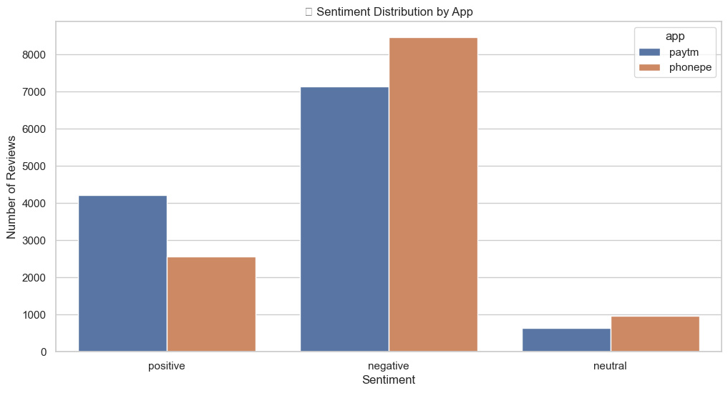

One of the most surprising things I found:  
🔹 PhonePe got more negative reviews than Paytm.  
🔹 Meanwhile, Paytm had more balanced feedback with a healthy chunk of positive reviews.  
So while PhonePe may be popular, people don’t seem as happy using it compared to Paytm.

# ⏱ How Fast Do They Respond to Users?

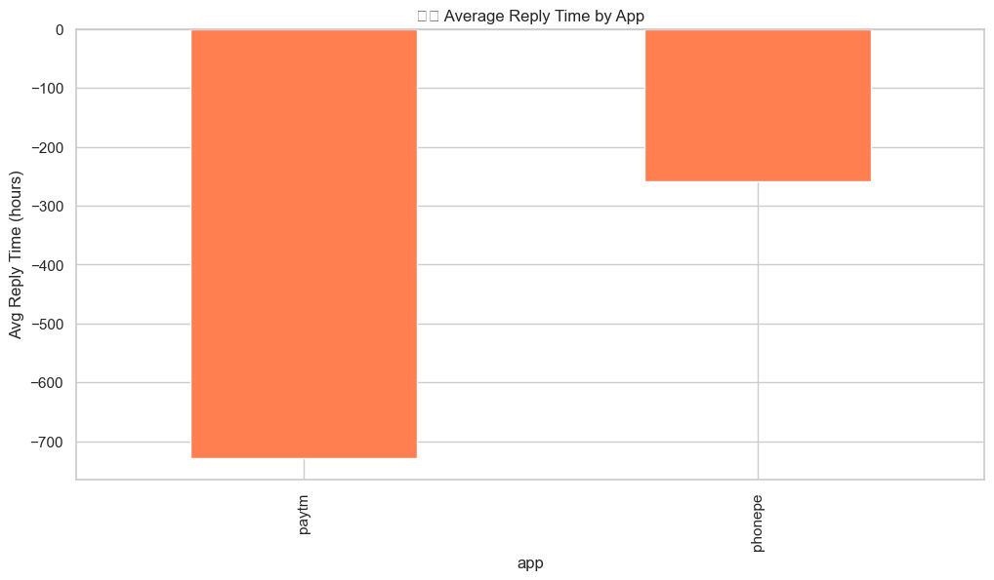

Another thing I looked at was how quickly companies respond to users when they leave reviews.  
📍 PhonePe is much faster at replying than Paytm.  
📍 Paytm’s replies are delayed, which could hurt customer satisfaction even if the app experience is decent.

# 📈 Who's Winning the UPI Race?

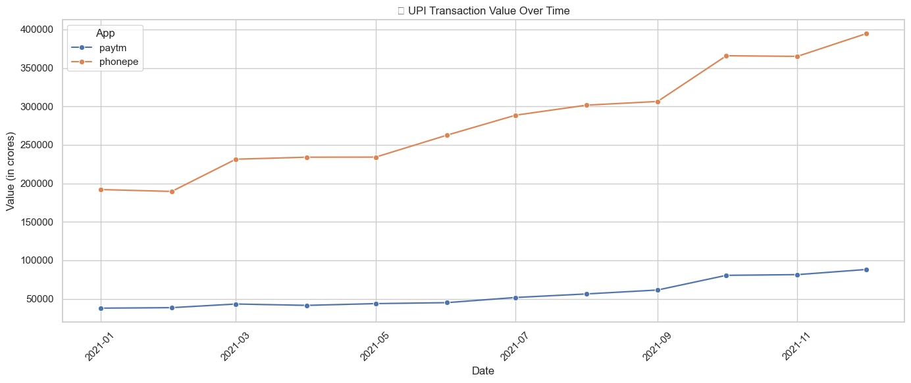

This one’s big.  
Even with more negative reviews, PhonePe is leading massively in UPI transactions. It’s growing fast and has higher monthly transaction volumes compared to Paytm.  
So clearly, user satisfaction doesn’t always equal market dominance — people still use PhonePe more, maybe due to offers, bank partnerships, or brand trust.

# 📌 What This Tells Us

|  |  |  |
| --- | --- | --- |
| Aspect | Winner | Why |
| ⭐ Sentiment | Paytm | Better reviews, fewer complaints |
| 🚀 UPI Volume | PhonePe | Higher usage, more transactions |
| 💬 Reply Speed | PhonePe | Faster responses to customers |

# 💡 My Takeaways

- Paytm needs to improve its customer support speed. People like the app — they just want to be heard faster.  
- PhonePe has nailed reach and usage, but the team should listen more to user pain points reflected in negative reviews.  
- Businesses should balance customer growth with customer happiness — both matter in the long run.