**PROJECT REPORT- *UNIVERSITY FINANCIALDATABASE MANAGEMENT SYSTEM***

**Submitted by:**Mohit

**Problem statement:**

To create a system using PL/SQL for a University Financial Record Keeping and Management functionalities.

**Description of problem:**

The University Finances Management System is designed to help universities manage their finances efficiently. It helps in tracking income and expenses, managing scholarships and funding, and maintaining fee records. This system is developed using PL/SQL, which is a procedural language designed specifically for the Oracle Database. It provides powerful features like stored procedures, functions, triggers, cursors, and packages, which can be used to build complex systems.

**Proposed Entity-Relationship Diagram**

|  |
| --- |
| # The following is ER relationship types.   1. A Transaction record belongs to one   and only one of Expenditure,  Scholarship, Fees, or Tax records  (**one-to-one relationship**).   1. Each Transaction belongs to only one   Expenditure record, but an Expenditure record can have multiple Transactions. (**many-to-one relationship**).   1. A Scholarship record can have multiple   Transactions, but each Transaction belongs to only one Scholarship record (**one-to-many relationship**).   1. A User can have multiple Funding records,   but each Funding record belongs to  only one User  (**one-to-many relationship**). |

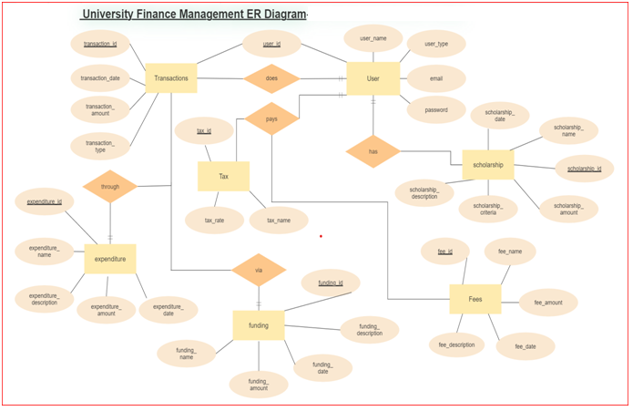

**DATABASE DESIGN:**

Tables are pre-normalised and don’t need normalisation:

* **Transactions**: Records of all incoming and outgoing financial transactions, including transaction type (e.g. received or sent), amount, date, and any related metadata (e.g. account number, user ID).
* **Tax**: Information about taxes applicable to the university, including tax rates, payment due dates, and any relevant legislation.
* **Users:** Information about individuals associated with the university, including their name, email address, account number, scholarship amounts, authorisation level, GPA, and any other relevant details.
* **Fees**: Details about fees paid by users, including the amount, date, and reason for the fee.
* **Funding**: Information about grants or other funding received by the university, including the source, amount, and intended use.
* **Expenditure**: Records of all expenses incurred by the university, including the amount, date, category (e.g. salaries, equipment, supplies), and any other relevant information.

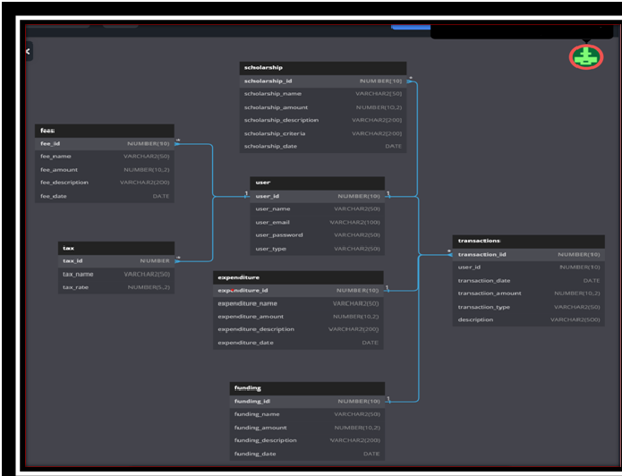

Contains the following procedures and functions:

* **calculate_expenditure**: takes start and end date as input and returns total expenditure for

that period.

* **insert_transaction**: inserts a new transaction record into the transactions table.
* **University Financials:** Function thatreturns a summary of key financial metrics as a

formatted string for display or export. Calculates values based on data in the Transactions,

Tax, Users, Fees, Funding, and Expenditure tables.

* **add_user:** This procedure takes several parameters to insert a user record into the users table.
* **delete_user:** This procedure takes a user ID and deletes the user record from the users table.
* **Update User Info:** Allows administrators to update any of the fields associated with a specific

user record in the Users table using input prompts to determine which fields to update and

collect new values for those fields.

It is integrated with a triggerwhich fires after a new record is inserted into the transactions table and performs the following tasks:

1. **update_expenditure_info**- Determines, if the transaction type is "sent", inserts a new record into the expenditure table with the same transaction ID and other details.
2. **update_relevant_tables**- Updates the scholarship, tax, funding or fees tables based on the transaction description.
3. **update_total_transactions**- It updates the total transactions for the user associated with the new transaction record.

Finally, the code defines a sequence "transactions_seq" that is used to generate new transactionIDs.

Indexes:

* **Transaction ID**: To quickly locate specific transactions by ID.
* **User ID**: To quickly retrieve all transactions associated with a particular user.
* **Transaction Type**: To quickly retrieve all transactions of a particular type (received, sent).
* **Date**: To allow quick retrieval of transactions within a specific date range.

IMPLEMENTATION:

**CREATE TABLE transactions (**

**transaction_idNUMBER(15) PRIMARY KEY,**

**transaction_date DATE,**

**transaction_amountNUMBER(10,2),**

**transaction_type VARCHAR2(20) DEFAULT 'RECEIVED',**

**transaction_accountNUMBER(9) DEFAULT 102103388,**

**transaction_usernumber(9),**

**description VARCHAR2(100)**

**);**

**CREATE TABLE users (**

**user_idNUMBER(9) NOT NULL PRIMARY KEY,**

**user_name VARCHAR2(50) ,**

**user_email VARCHAR2(100) UNIQUE,**

**user_account_numberNUMBER(9),**

**user_scholarship_amount number DEFAULT NULL,**

**user_authorisation_type VARCHAR2(50),**

**user_gpaNUMBER(3,2),**

**total_transactionsNUMBER(10,2) DEFAULT 0**

**);**

**CREATE TABLE fees (**

**fee_idNUMBER(15) NOT NULL PRIMARY KEY REFERENCES transactions(transaction_id),**

**fee_name VARCHAR2(50) ,**

**fee_amountNUMBER(10,2) ,**

**fee_description VARCHAR2(200),**

**fee_dateDATE ,**

**user_id_for_feeNUMBER(9) REFERENCES users(user_id)**

**);**

**CREATE TABLE funding (**

**funding_idNUMBER(15) NOT NULL PRIMARY KEY REFERENCES transactions(transaction_id),**

**funding_name VARCHAR2(50) ,**

**funding_amountNUMBER(10,2) ,**

**funding_description VARCHAR2(200),**

**funding_dateDATE );**

**CREATE TABLE scholarship (**

**scholarship_idNUMBER(2) NOT NULL PRIMARY KEY,**

**scholarship_user_idNUMBER(9) REFERENCES users(user_id),**

**scholarship_name VARCHAR2(50) ,**

**scholarship_amountNUMBER(10,2) ,**

**scholarship_description VARCHAR2(200),**

**scholarship_criteria VARCHAR2(200)**

**);**

**CREATE TABLE expenditure (**

**expenditure_idNUMBER(15) NOT NULL PRIMARY KEY REFERENCES transactions(transaction_id),**

**expenditure_name VARCHAR2(50),**

**expenditure_amountNUMBER(10,2),**

**expenditure_description VARCHAR2(200),**

**expenditure_date DATE**

**);**

**CREATE TABLE tax (**

**tax_idNUMBER(10) NOT NULL PRIMARY KEY,**

**tax_name VARCHAR2(50),**

**tax_amount NUMBER,**

**tax_rateNUMBER(5,2)**

**);**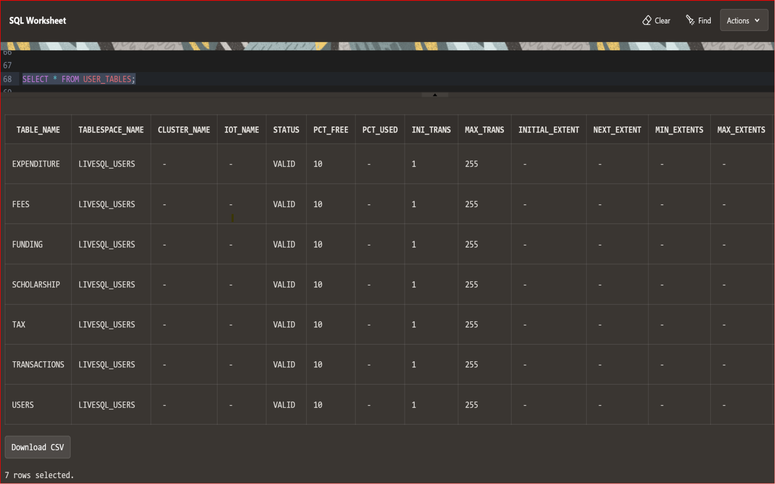

* **THE CALCULATE_EXPENDITURE PROCEDURE**

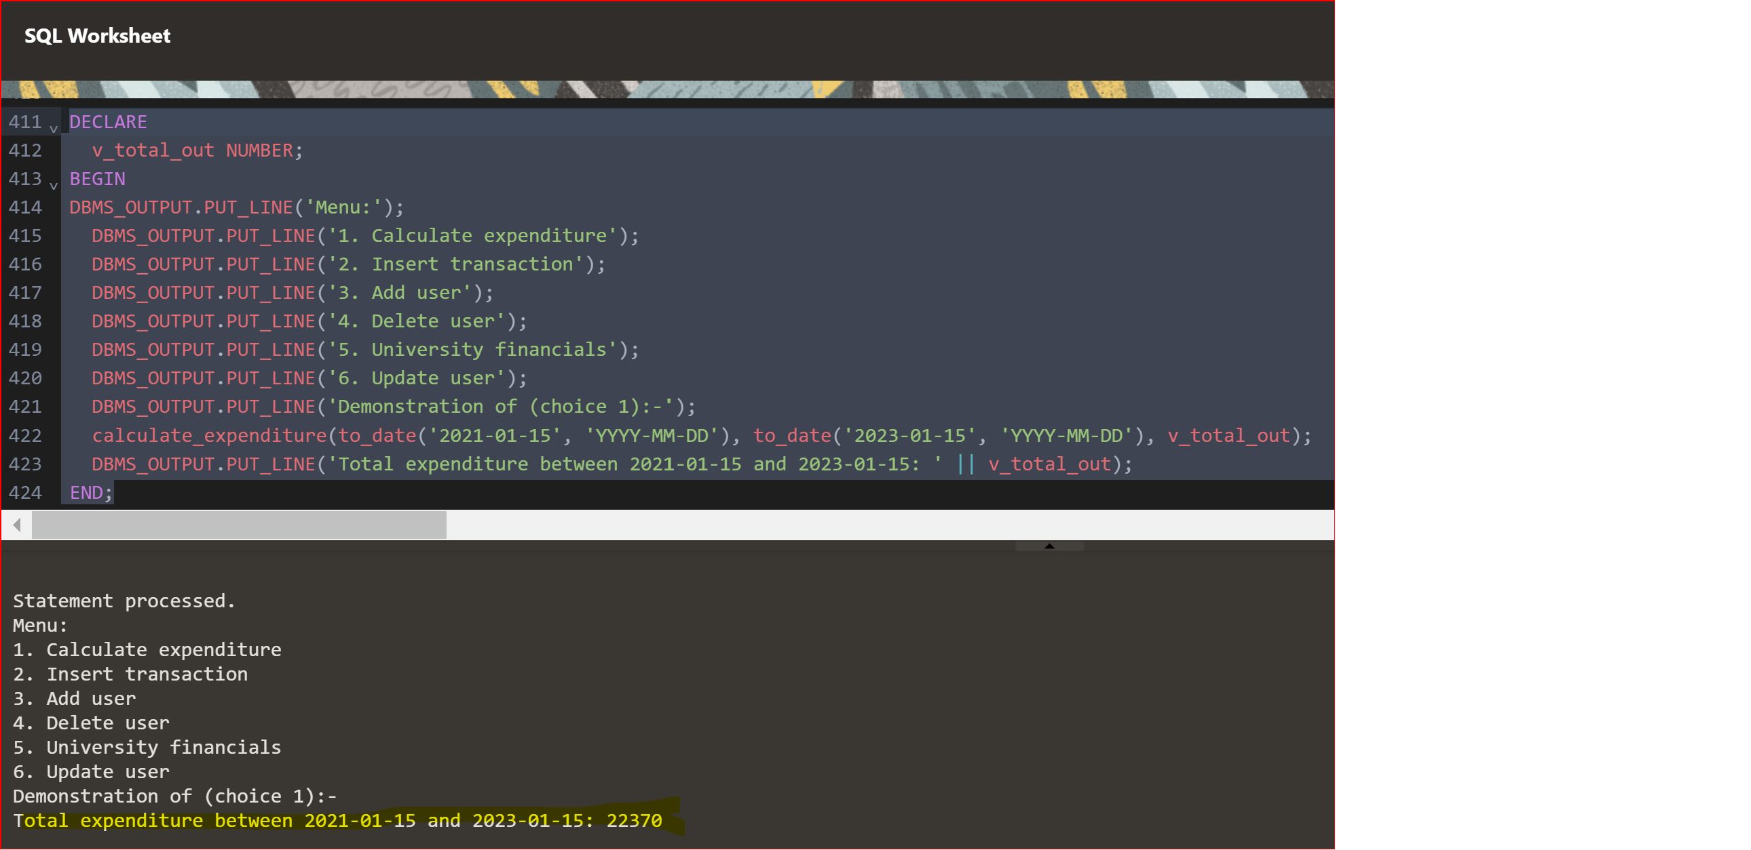

* This stored procedure is VERY useful in calculating transaction based financial analysis or expenditurebreakdown, as it provides a quick and efficient way to calculate total expenditure within a given date range.

**CREATE OR REPLACE PROCEDURE calculate_expenditure (**

**p_start_date IN DATE,**

**p_end_date IN DATE,**

**p_total_out OUT NUMBER) IS**

**v_total_outNUMBER(10,2) := 0;**

**v_expenditure_nameexpenditure.expenditure_name%TYPE;**

**v_expenditure_amountexpenditure.expenditure_amount%TYPE;**

**v_expenditure_dateexpenditure.expenditure_date%TYPE;**

**CURSOR c_expenditures IS**

**SELECT expenditure_name, expenditure_amount, expenditure_date**

**FROM expenditure**

**WHERE expenditure_date>= p_start_date AND expenditure_date<= p_end_date;**

**BEGIN**

**FOR c_expense IN c_expenditures LOOP**

**v_total_out := v_total_out + c_expense.expenditure_amount;**

**END LOOP;**

**p_total_out := v_total_out;**

**EXCEPTION**

**WHEN NO_DATA_FOUND THEN**

**DBMS_OUTPUT.PUT_LINE('No expenditure found within specified date range.');**

**WHEN OTHERS THEN**

**DBMS_OUTPUT.PUT_LINE('An error occurred: ' || SQLERRM);**

**END;**

**FEATURES**

* This is a PL/SQL procedure for calculating the total expenditure for a university during a specified date range. The procedure takes in two date parameters, p_start_date and p_end_date, which define the start and end dates of the expenditure period to be analyzed. The procedure then uses a cursor to retrieve all expenditures within the specified date range from a table called expenditure.
* For each expenditure, the procedure adds the expenditure amount to a running total, v_total_out. Once all expenditures have been added up, the final total expenditure is returned through the OUT parameter, p_total_out.
* This is a PL/SQL procedure called takes in two input parameters: "p_start_date" and "p_end_date," both of which are of type DATE. The procedure also has one output parameter "p_total_out," which is the required calculation.
* **THE INSERT_TRANSACTIONPROCEDURE AND TRANSACTION_TRIGGERS**

**CREATE OR REPLACE PROCEDURE insert_transaction (**

**p_transaction_date IN DATE,**

**p_transaction_amount IN NUMBER,**

**p_transaction_type IN VARCHAR2,**

**p_transaction_account IN NUMBER DEFAULT 102103388,**

**p_transaction_user IN NUMBER,**

**p_description IN VARCHAR2 DEFAULT NULL) IS**

**v_transaction_idNUMBER(15);**

**v_countNUMBER(1);**

**v_transaction_rowtransactions%ROWTYPE; -- Declare a variable of type transactions%ROWTYPE**

**BEGIN**

**-- Generate a transaction ID**

**LOOP**

**v_transaction_id := TRUNC(DBMS_RANDOM.VALUE(100000000000000, 999999999999999));**

**SELECT COUNT(*) INTO v_count FROM transactions WHERE transaction_id = v_transaction_id;**

**EXIT WHEN v_count = 0;**

**END LOOP;**

**-- Insert the transaction record**

**INSERT INTO transactions (transaction_id, transaction_date, transaction_amount, transaction_type,**

**transaction_account, transaction_user, description)**

**VALUES (v_transaction_id, p_transaction_date, p_transaction_amount, p_transaction_type,**

**p_transaction_account, p_transaction_user, p_description);**

**-- Get the inserted record**

**SELECT * INTO v_transaction_row FROM transactions WHERE transaction_id = v_transaction_id;**

**-- Display the inserted record**

**DBMS_OUTPUT.PUT_LINE('Transaction ID: ' || v_transaction_row.transaction_id);**

**DBMS_OUTPUT.PUT_LINE('Transaction Date: ' || v_transaction_row.transaction_date);**

**DBMS_OUTPUT.PUT_LINE('Transaction Amount: ' || v_transaction_row.transaction_amount);**

**DBMS_OUTPUT.PUT_LINE('Transaction Type: ' || v_transaction_row.transaction_type);**

**DBMS_OUTPUT.PUT_LINE('Transaction Account: ' || v_transaction_row.transaction_account);**

**DBMS_OUTPUT.PUT_LINE('Transaction User: ' || v_transaction_row.transaction_user);**

**DBMS_OUTPUT.PUT_LINE('Description: ' || v_transaction_row.description);**

**END;**

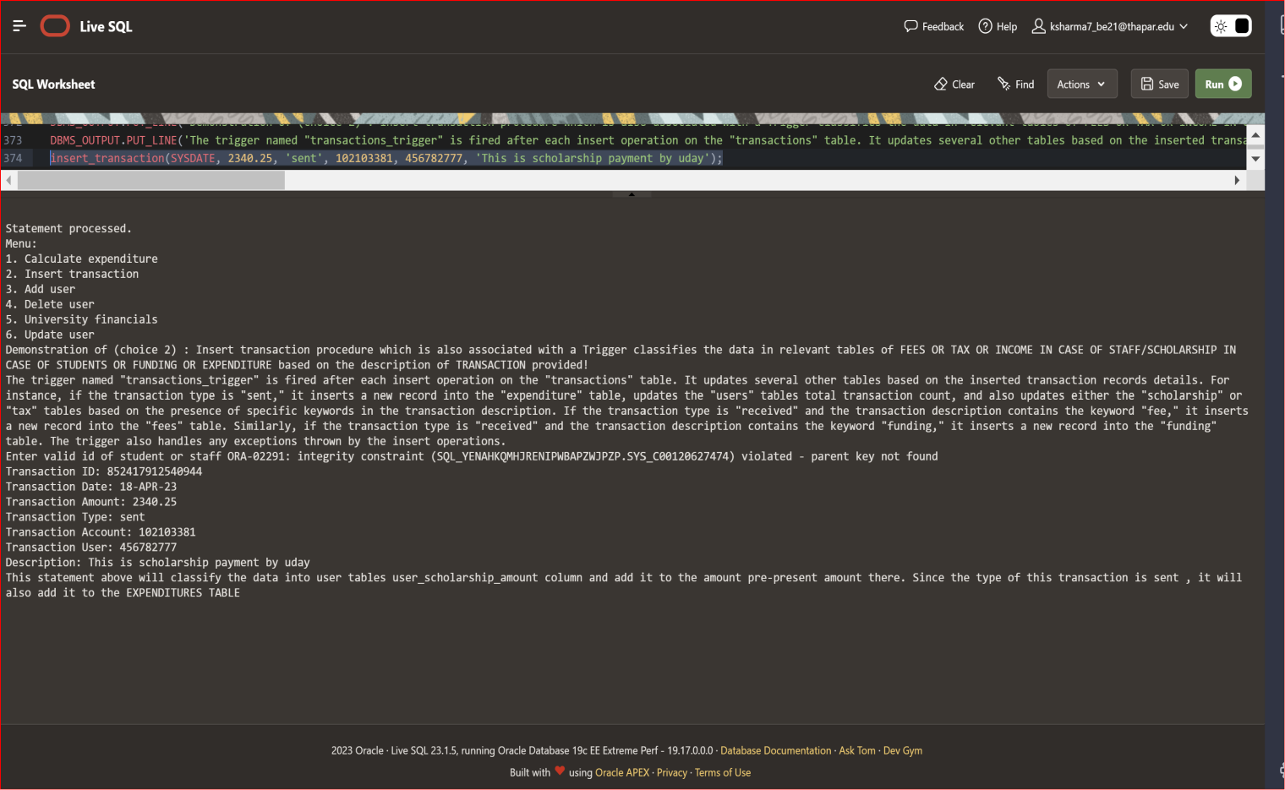

* Notice how the addition of transaction type as ‘sent’ has also added it to EXPENDITURE

TABLE aswell. This will help calculate and keep track of expenditures.

* The transaction_description column will help to classify whether the transaction will be

added to ‘fees’, ‘funding’ table (tables in which the university receives money in form of

fees paid by students or funding received from government) or if the transaction will be

added to ‘tax’ or ‘scholarship/income’ table.

* This classification is not exhaustive and there will be some transactions which wont be

classified in any other tables except transaction.

* In our example we have updated transactions such that transaction_type is ‘sent’,

hence it’ll be automatically TRIGGERED into EXECUTION TABLE.

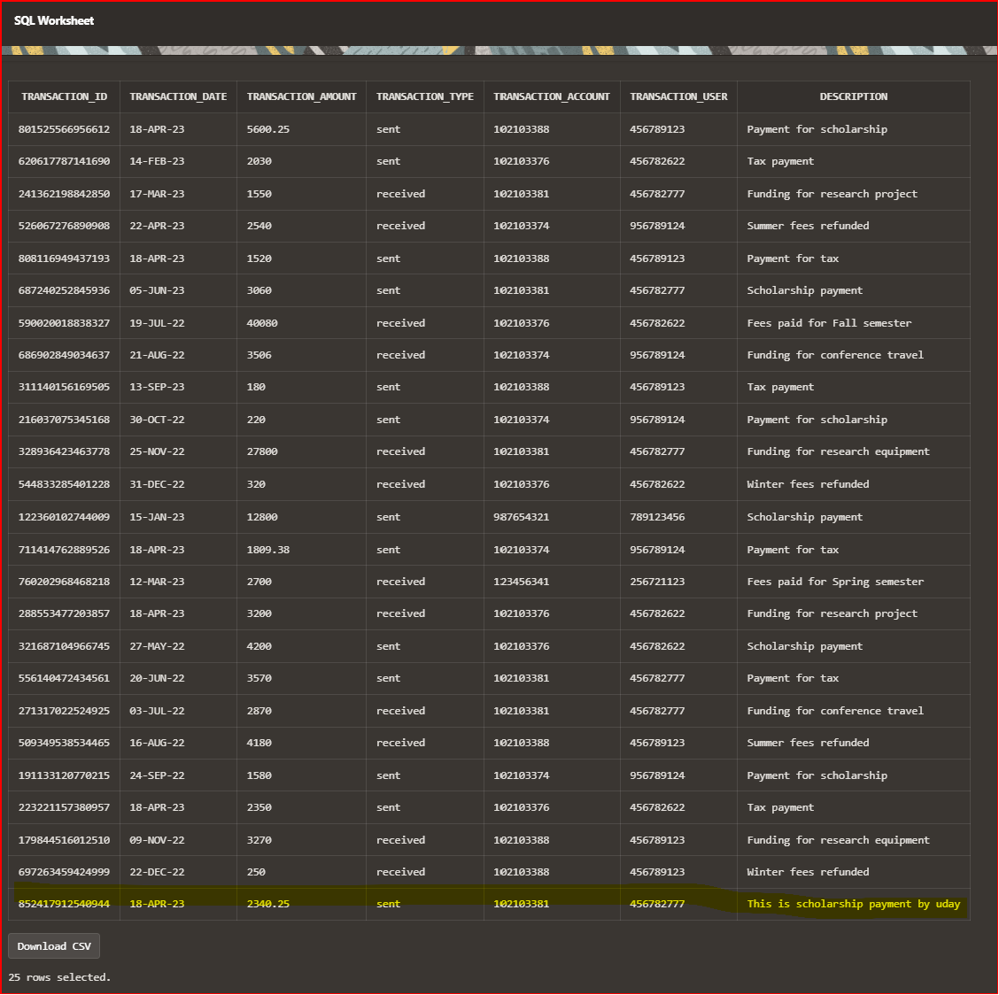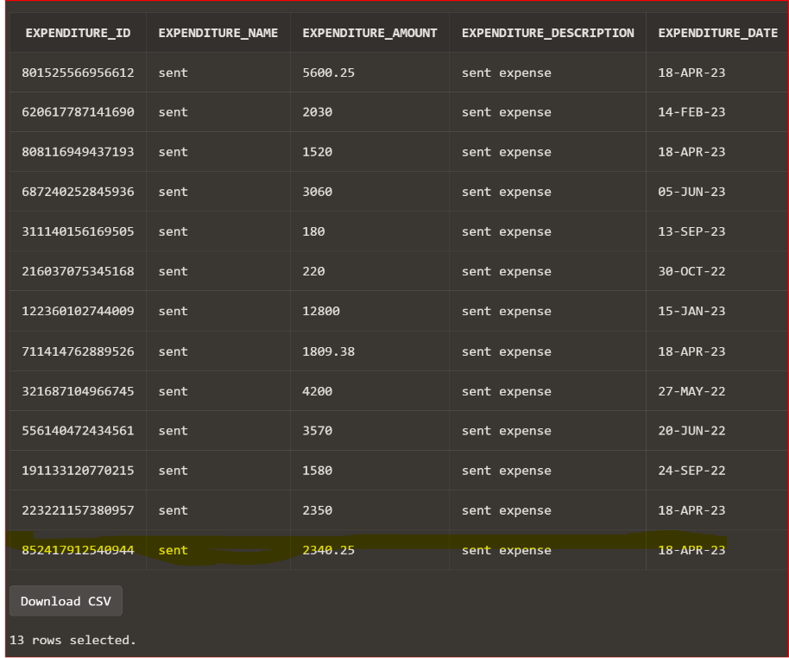

**TRANSACTION_TRIGGERS CODE DEFINITION**

**CREATE OR REPLACE TRIGGER transactions_trigger**

**AFTER INSERT ON transactions**

**FOR EACH ROW**

**BEGIN**

**-- Update expenditure table**

**IF (LOWER(:NEW.transaction_type) = 'sent') THEN**

**INSERT INTO expenditure (expenditure_id, expenditure_name, expenditure_amount,**

**expenditure_description, expenditure_date)**

**VALUES (:NEW.transaction_id, :NEW.transaction_type, :NEW.transaction_amount,**

**:NEW.transaction_type || ' expense', :NEW.transaction_date);**

**UPDATE users SET total_transactions = (total_transactions+1) WHERE user_id =**

**:NEW.transaction_user;**

**-- Update scholarship and tax tables**

**IF (LOWER(:NEW.description) LIKE '%scholarship%') THEN**

**UPDATE users SET user_scholarship_amount = NVL(user_scholarship_amount, 0) +**

**:NEW.transaction_amount WHERE user_id = :NEW.transaction_user;**

**INSERT INTO scholarship (scholarship_id, scholarship_user_id, scholarship_name,**

**scholarship_amount, scholarship_description, scholarship_criteria)**

**VALUES (99, :NEW.transaction_user, 'Scholarship', :NEW.transaction_amount, 'Scholarship**

**award', 'Bonus');**

**ELSIF (LOWER(:NEW.description) LIKE '%tax%') THEN**

**INSERT INTO tax (tax_id, tax_name, tax_amount, tax_rate)**

**VALUES (:NEW.transaction_id, 'Transaction Tax', :NEW.transaction_amount, 0.2);**

**END IF;**

**END IF;**

**-- Update fees table**

**IF (LOWER(:NEW.transaction_type) = 'received' AND :NEW.description IS NOT NULL AND**

**LOWER(:NEW.description) LIKE '%fee%') THEN**

**INSERT INTO fees (fee_id, fee_name, fee_amount, fee_description, fee_date, user_id_for_fee)**

**VALUES (:NEW.transaction_id, 'FEE paid', :NEW.transaction_amount , :NEW.description,**

**:NEW.transaction_date, :NEW.transaction_user);**

**END IF;**

**-- Update funding table**

**IF (LOWER(:NEW.transaction_type) = 'received' AND :NEW.description IS NOT NULL AND**

**LOWER(:NEW.description) LIKE '%funding%') THEN**

**INSERT INTO funding (funding_id, funding_name, funding_amount, funding_description,**

**funding_date)**

**VALUES (:NEW.transaction_id, 'Funding', :NEW.transaction_amount, 'Funding received',**

**:NEW.transaction_date);**

**END IF;**

**EXCEPTION**

**WHEN OTHERS THEN**

**DBMS_OUTPUT.PUT_LINE('Enter valid id of student or staff ' || SQLERRM);**

**END;**

**ADD USER PROCEDURE DEFINITION:**

**CREATE OR REPLACE PROCEDURE add_user (**

**p_user_id IN NUMBER,**

**p_user_name IN VARCHAR2,**

**p_user_email IN VARCHAR2,**

**p_user_account_number IN NUMBER,**

**p_user_scholarship_amount IN NUMBER DEFAULT NULL,**

**p_user_authorisation_type IN VARCHAR2 DEFAULT NULL,**

**p_user_gpa IN NUMBER DEFAULT NULL**

**) IS**

**BEGIN**

**INSERT INTO users (user_id, user_name, user_email, user_account_number, user_scholarship_amount,**

**user_authorisation_type, user_gpa)**

**VALUES (p_user_id, p_user_name, p_user_email, p_user_account_number, p_user_scholarship_amount,**

**p_user_authorisation_type, p_user_gpa);**

**COMMIT;**

**DBMS_OUTPUT.PUT_LINE('User added successfully.');**

**EXCEPTION**

**WHEN DUP_VAL_ON_INDEX THEN**

**DBMS_OUTPUT.PUT_LINE('User email already exists.');**

**WHEN OTHERS THEN**

**DBMS_OUTPUT.PUT_LINE('An error occurred while adding user.');**

**END;**

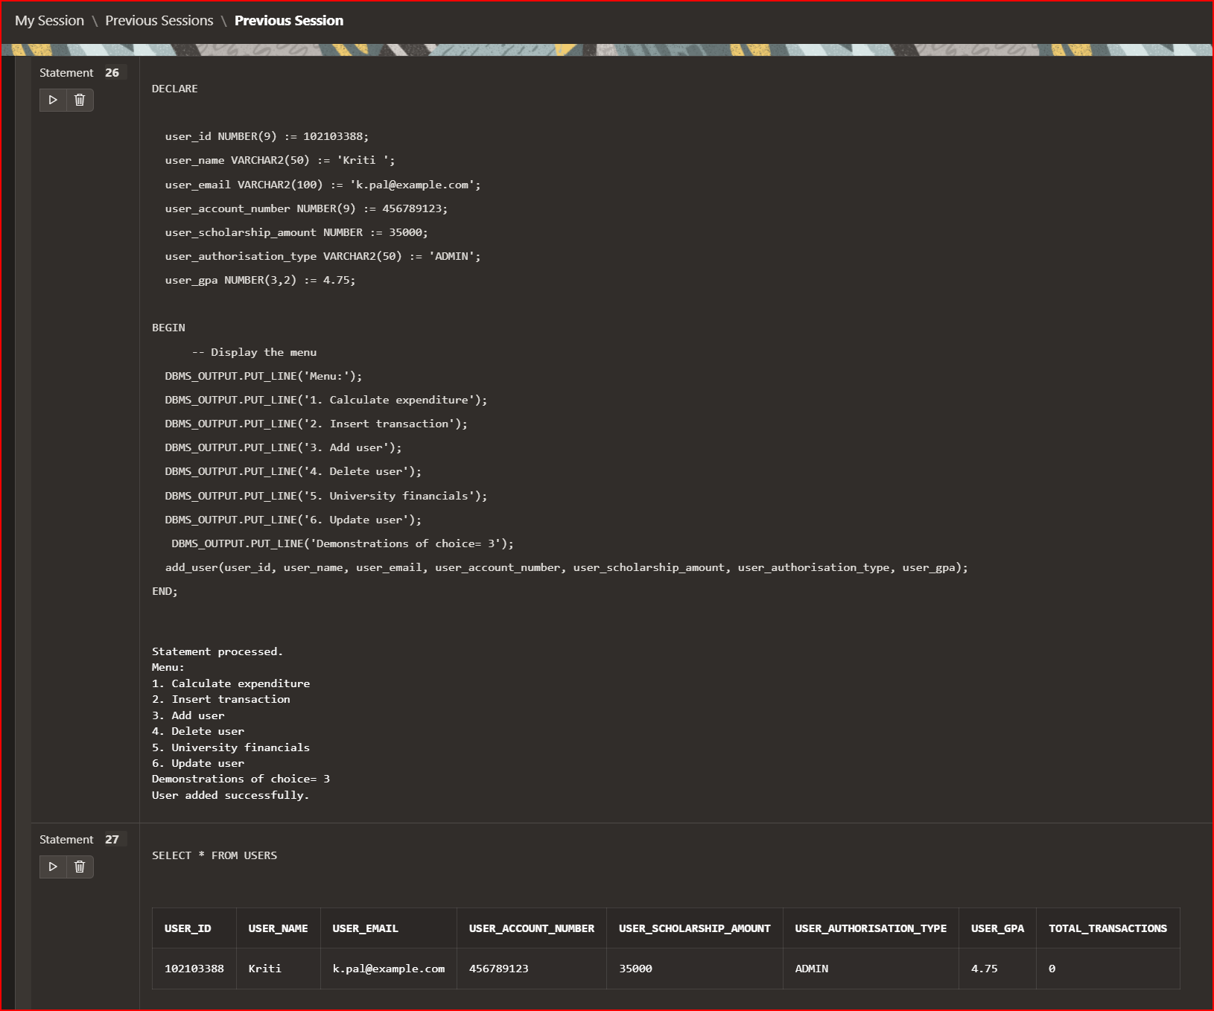

**FEATURES:**

* This procedure is useful for adding new users to a database table in a controlled manner and with error handling to ensure data integrity.
* This procedure is designed for use by a university's financial management system to add new users to the system.
* If the error is due to a duplicate id/email address, the procedure will output a message indicating that the user id/ email already exists.

**UPDATE USER PROCEDURE DEFINITION:**

**CREATE OR REPLACE PROCEDURE update_user_info(p_user_id IN NUMBER)**

**IS**

**v_user_nameusers.user_name%TYPE;**

**v_user_emailusers.user_email%TYPE;**

**v_user_account_numberusers.user_account_number%TYPE;**

**v_user_scholarship_amountusers.user_scholarship_amount%TYPE;**

**v_user_authorisation_typeusers.user_authorisation_type%TYPE;**

**v_user_gpausers.user_gpa%TYPE;**

**v_total_transactionsusers.total_transactions%TYPE;**

**v_choice VARCHAR2(1);**

**BEGIN**

**SELECT user_name, user_email, user_account_number, user_scholarship_amount,**

**user_authorisation_type, user_gpa, total_transactions**

**INTO v_user_name, v_user_email, v_user_account_number,**

**v_user_scholarship_amount, v_user_authorisation_type, v_user_gpa,**

**v_total_transactions**

**FROM users**

**WHERE user_id = p_user_id;**

**DBMS_OUTPUT.PUT_LINE('Current User Details:');**

**DBMS_OUTPUT.PUT_LINE('User Name: ' || v_user_name);**

**DBMS_OUTPUT.PUT_LINE('User Email: ' || v_user_email);**

**DBMS_OUTPUT.PUT_LINE('User Account Number: ' || v_user_account_number);**

**DBMS_OUTPUT.PUT_LINE('User Scholarship Amount: ' || v_user_scholarship_amount);**

**DBMS_OUTPUT.PUT_LINE('User Authorisation Type: ' || v_user_authorisation_type);**

**DBMS_OUTPUT.PUT_LINE('User GPA: ' || v_user_gpa);**

**DBMS_OUTPUT.PUT_LINE('Total Transactions: ' || v_total_transactions);**

**DBMS_OUTPUT.PUT_LINE('Choose which fields to update:');**

**DBMS_OUTPUT.PUT_LINE('1. User Name');**

**DBMS_OUTPUT.PUT_LINE('2. User Email');**

**DBMS_OUTPUT.PUT_LINE('3. User Account Number');**

**DBMS_OUTPUT.PUT_LINE('4. User Scholarship Amount');**

**DBMS_OUTPUT.PUT_LINE('5. User Authorisation Type');**

**DBMS_OUTPUT.PUT_LINE('6. User GPA');**

**DBMS_OUTPUT.PUT_LINE('7. Total Transactions');**

**DBMS_OUTPUT.PUT_LINE('Enter Choice (1-7):');**

**v_choice := '&choice';**

**CASE v_choice**

**WHEN '1' THEN**

**SELECT '&user_name' INTO v_user_name FROM dual;**

**WHEN '2' THEN**

**SELECT '&user_email' INTO v_user_email FROM dual;**

**WHEN '3' THEN**

**SELECT '&user_account_number' INTO v_user_account_number FROM dual;**

**WHEN '4' THEN**

**SELECT '&user_scholarship_amount' INTO v_user_scholarship_amount FROM dual;**

**WHEN '5' THEN**

**SELECT '&user_authorisation_type' INTO v_user_authorisation_type FROM dual;**

**WHEN '6' THEN**

**SELECT '&user_gpa' INTO v_user_gpa FROM dual;**

**WHEN '7' THEN**

**SELECT '&total_transactions' INTO v_total_transactions FROM dual;**

**ELSE**

**DBMS_OUTPUT.PUT_LINE('Invalid Choice');**

**END CASE;**

**UPDATE users**

**SET user_name = v_user_name,**

**user_email = v_user_email,**

**user_account_number = v_user_account_number,**

**user_scholarship_amount = v_user_scholarship_amount,**

**user_authorisation_type = v_user_authorisation_type,**

**user_gpa = v_user_gpa,**

**total_transactions = v_total_transactions**

**WHERE user_id = p_user_id;**

**DBMS_OUTPUT.PUT_LINE('User details updated successfully.');**

**END;**

**FEATURES AND EXECUTION:**

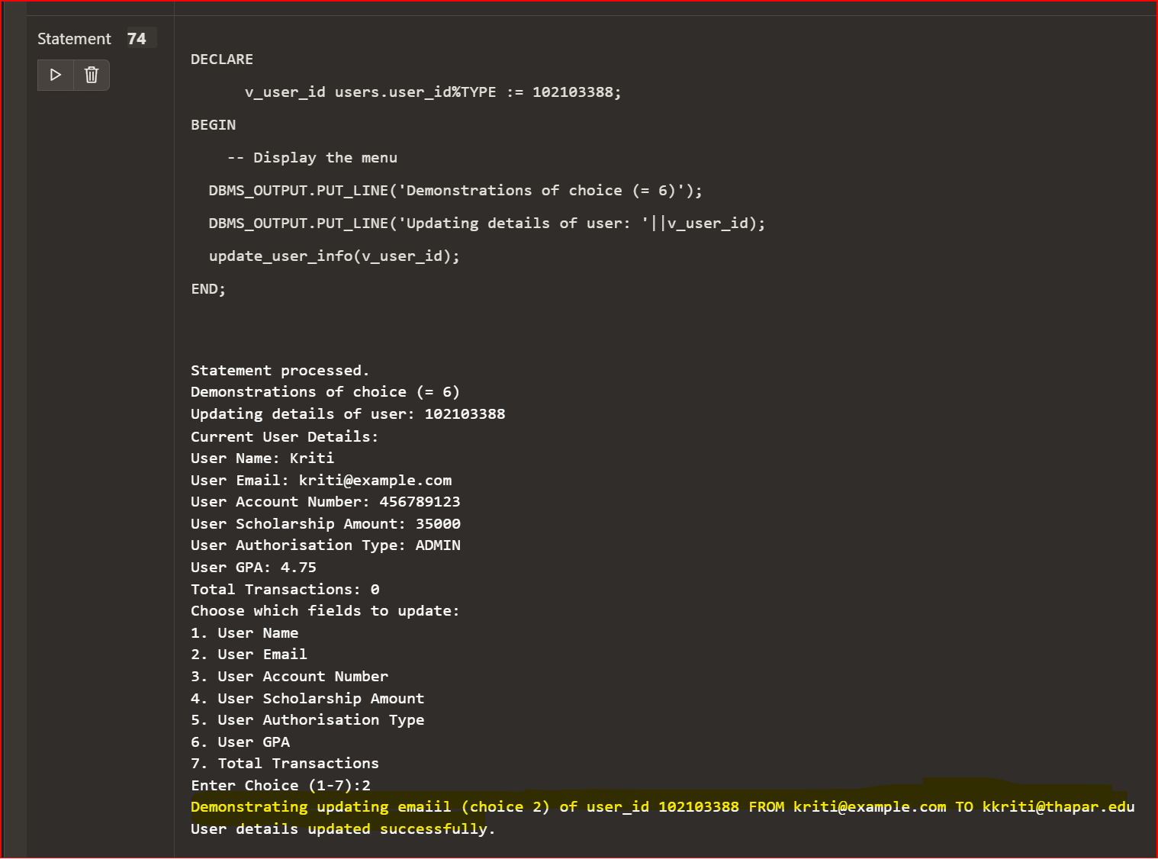

* **This is a PL/SQL stored procedure that updates user information in the users table of a University Financial Management System.**
* **The procedure takes a user ID as input and prompts the user to choose which fields to update. The available fields are user name, email, account number, scholarship amount, authorisation type, GPA, and total transactions.**
* **The procedure then updates the selected fields for the specified user ID.**

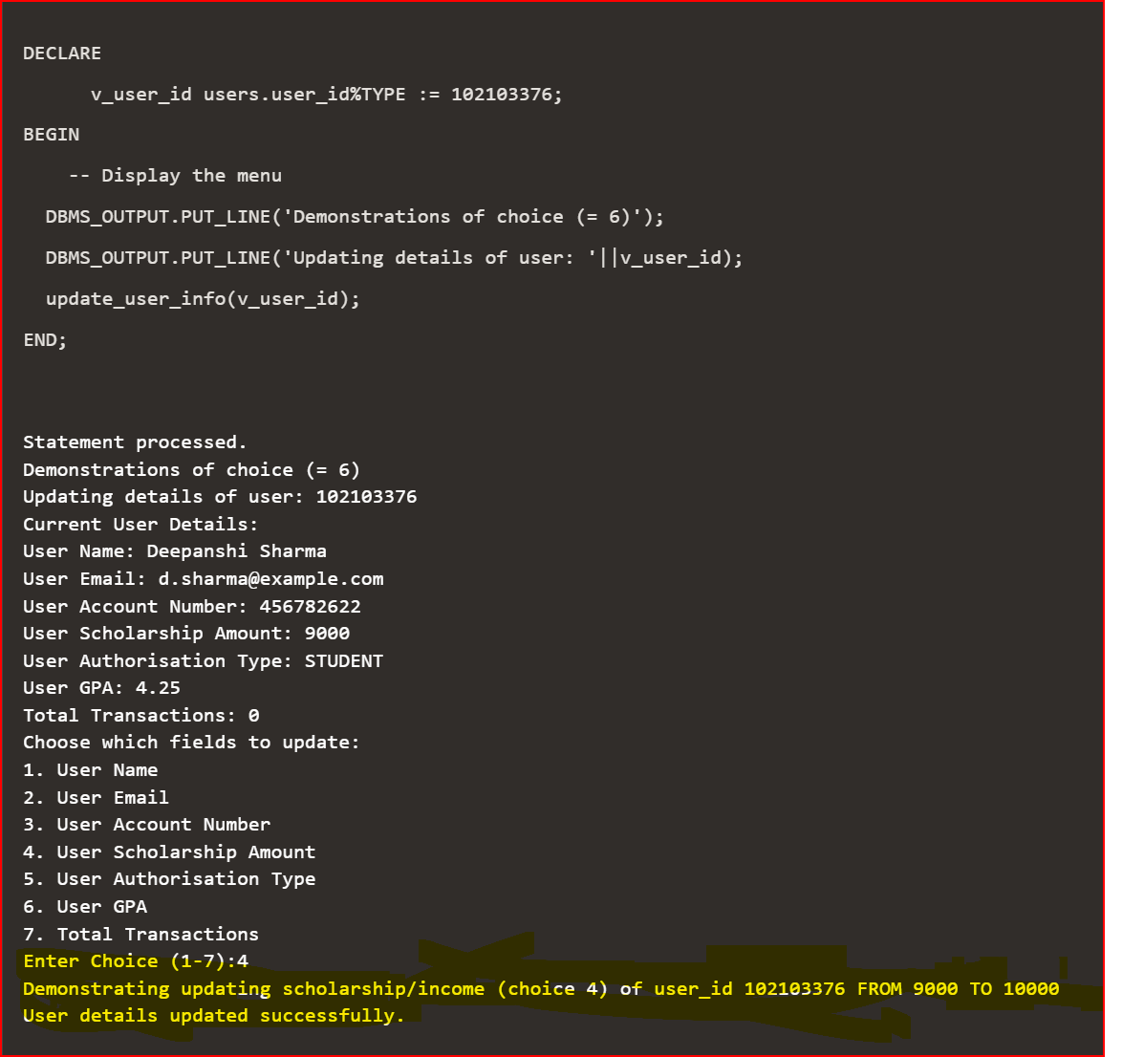

* **The procedure takes in one input parameter p_user_id which is the unique identifier for the user whose details need to be updated. It then fetches the current user details from the users table .**
* **After fetching the user details, the procedure displays them on the console. It then prompts the user to choose which fields they want to update by displaying a menu of options from 1 to 7.**
* **The procedure uses a CASE statement to determine which field the user wants to update based on their input choice. For each field, the procedure prompts the user to enter the new valueS.**

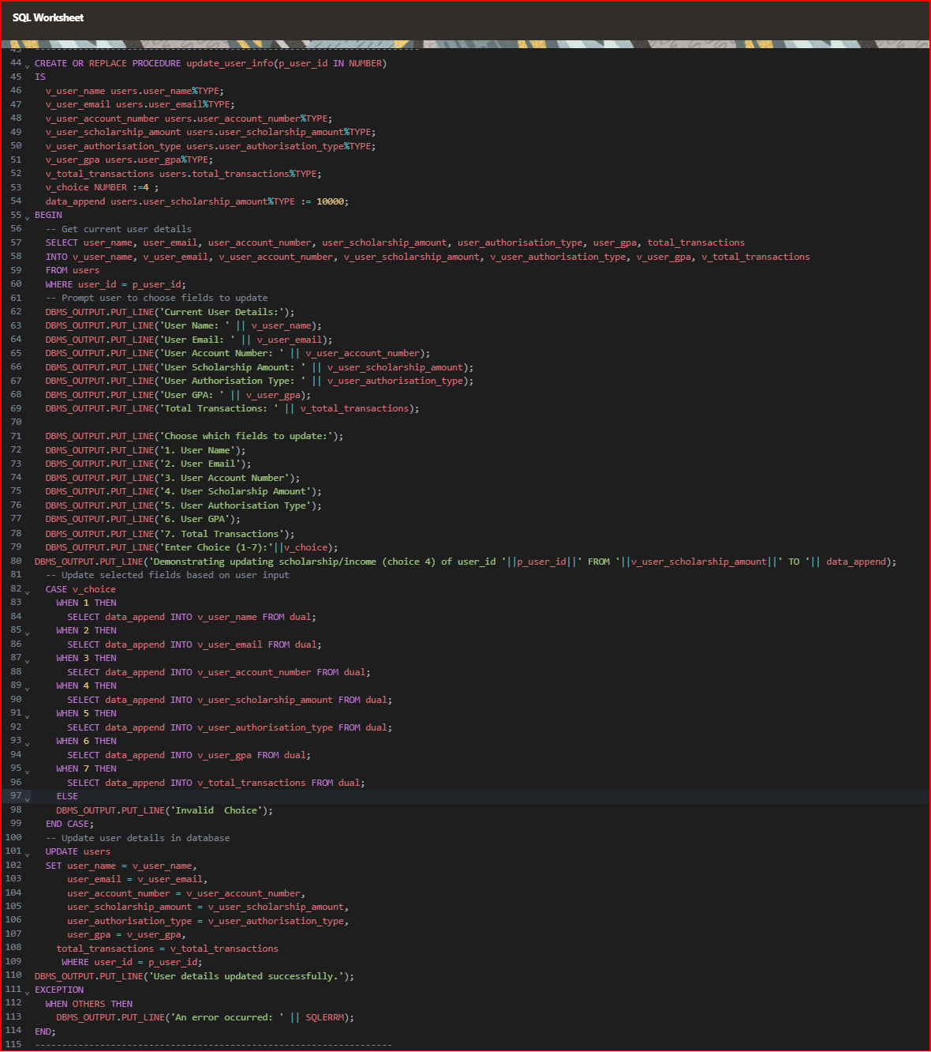**UNIVERSITY FINANCIAL SUMMARY FUNCTION DEMONSTRARION:**

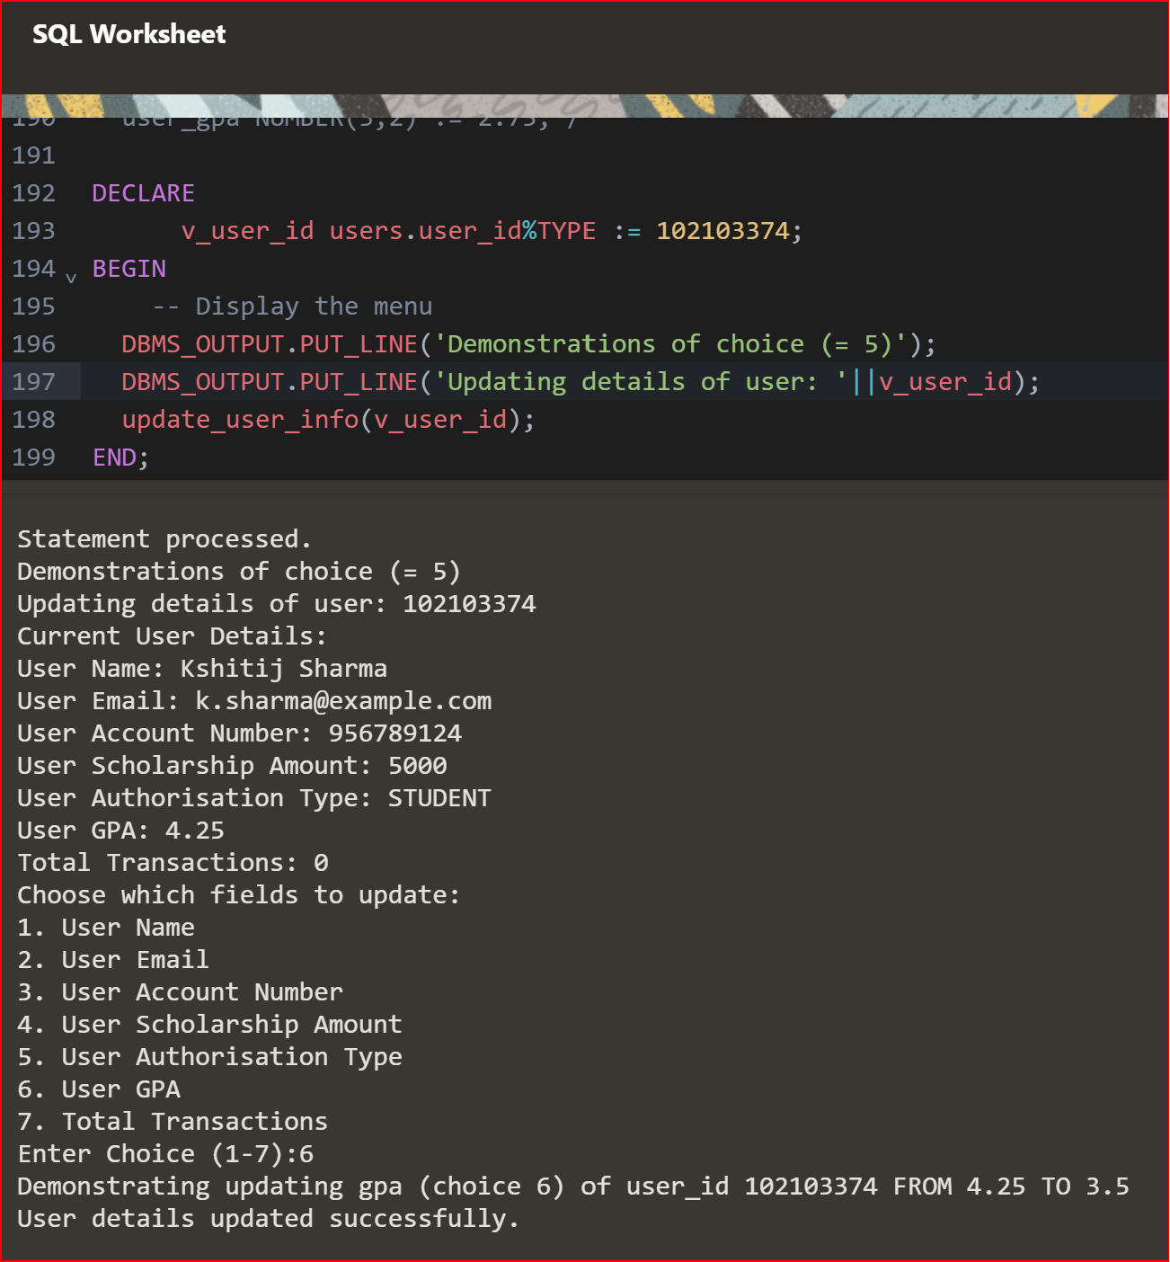

**CREATE OR REPLACE FUNCTION university_financials RETURN VARCHAR2 AS**

**total_received_transactionsNUMBER(10,2);**

**total_received_amountNUMBER(10,2);**

**total_sent_transactionsNUMBER(10,2);**

**total_sent_amountNUMBER(10,2);**

**total_tax_amountNUMBER(10,2);**

**total_user_scholarshipsNUMBER(10,2);**

**total_feesNUMBER(10,2);**

**total_fundingNUMBER(10,2);**

**total_expenditureNUMBER(10,2);**

**net_scholarships_givenNUMBER(10,2);**

**net_expenditure_after_scholarshipsNUMBER(10,2);**

**net_state_of_financialsNUMBER(10,2);**

**profit_loss_label VARCHAR2(20);**

**BEGIN**

**-- Calculate total received transactions and amount**

**SELECT COUNT(*), SUM(transaction_amount)**

**INTO total_received_transactions, total_received_amount**

**FROM transactions**

**WHERE transaction_type = 'RECEIVED';**

**-- Calculate total sent transactions and amount**

**SELECT COUNT(*), SUM(transaction_amount)**

**INTO total_sent_transactions, total_sent_amount**

**FROM transactions**

**WHERE transaction_type = 'SENT';**

**-- Calculate total tax amount**

**SELECT SUM(tax_amount * tax_rate)**

**INTO total_tax_amount**

**FROM tax;**

**-- Calculate total user scholarships**

**SELECT SUM(user_scholarship_amount)**

**INTO total_user_scholarships**

**FROM users;**

**-- Calculate total fees**

**SELECT SUM(fee_amount)**

**INTO total_fees**

**FROM fees;**

**-- Calculate total funding**

**SELECT SUM(funding_amount)**

**INTO total_funding**

**FROM funding;**

**-- Calculate total expenditure**

**SELECT SUM(expenditure_amount)**

**INTO total_expenditure**

**FROM expenditure;**

**-- Calculate net state of financials**

**net_state_of_financials := total_received_amount - total_sent_amount–**

**total_tax_amount ;**

**-- Determine if the university made a profit or a loss**

**IF net_state_of_financials> 0 THEN**

**profit_loss_label := 'Profit';**

**ELSE**

**profit_loss_label := 'Loss';**

**END IF;**

**RETURN 'Financial aspects of the university:' || CHR(10) ||**

**'Total received transactions: '||total_received_transactions||CHR(10)||**

**'Total received amount: ' || total_received_amount || CHR(10) ||**

**'Total sent transactions: ' || total_sent_transactions || CHR(10) ||**

**'Total sent amount: ' || total_sent_amount || CHR(10) ||**

**'Total tax amount: ' || total_tax_amount || CHR(10) ||**

**'Total user scholarships: ' || total_user_scholarships || CHR(10) ||**

**'Total fees: ' || total_fees || CHR(10) ||**

**'Total funding: ' || total_funding || CHR(10) ||**

**'Total expenditure: ' || total_expenditure || CHR(10) ||**

**'Net state of financials: ' || net_state_of_financials || CHR(10) ||**

**'Profit/Loss: ' || profit_loss_label;**

**END;**

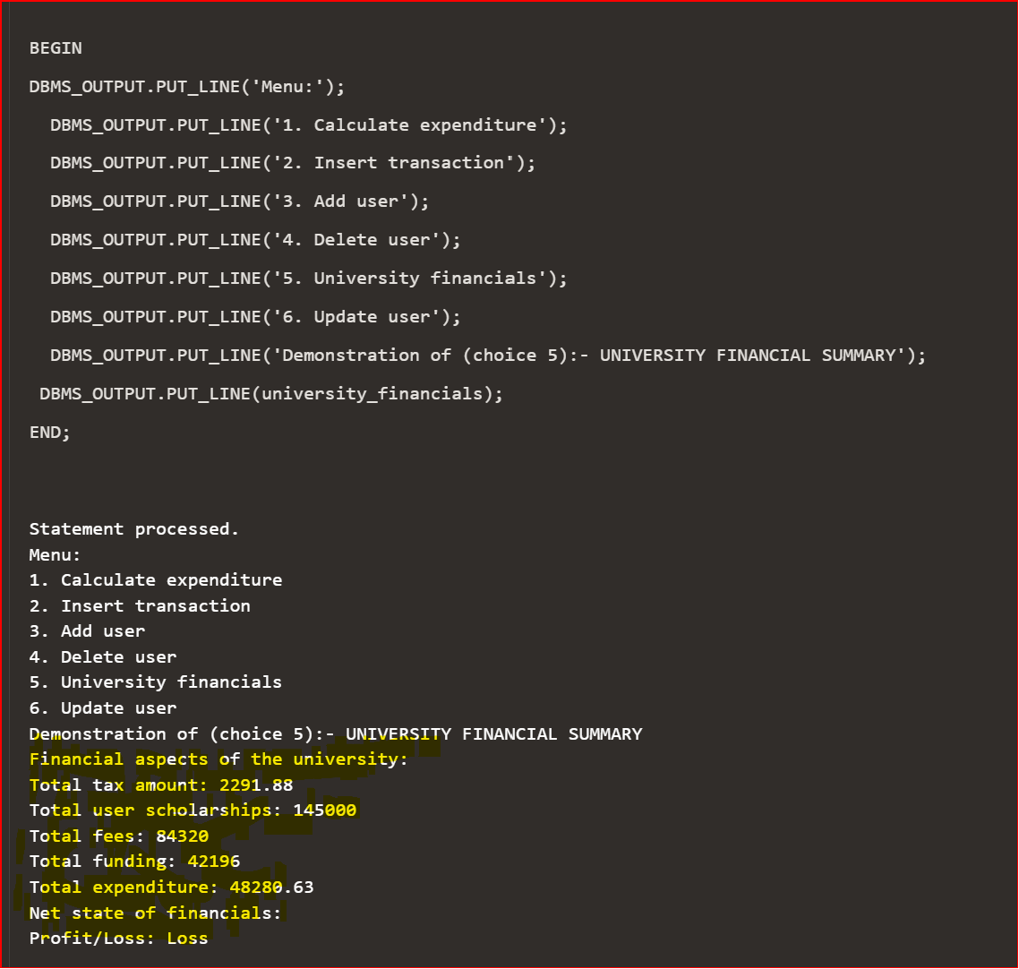





Overview of what the function does:

1. Declares a number of variables to hold various financial metrics.
2. Executes several SQL queries to calculate the values of these variables. For example, it calculates the total number and amount of transactions received and sent, the total tax amount, the total user scholarships, the total fees, the total funding, and the total expenditure.
3. Calculates the net state of financials by subtracting the total amount of sent transactions and the total tax amount from the total amount of received transactions.
4. Determines whether the university made a profit or a loss based on the net state of financials.
5. Constructs a string that includes all the calculated financial metrics and returns it.

This function can be useful for financial management purposes, as it provides a quick and easy way to get an overview of the university's financial situation.

**CHOICE ‘4’ DEMONSTRARION:**

**CREATE OR REPLACE PROCEDURE delete_user(p_user_id IN NUMBER) IS**

**BEGIN**

**DELETE FROM users WHERE user_id = p_user_id;**

**DBMS_OUTPUT.PUT_LINE('User deleted successfully');**

**EXCEPTION**

**WHEN NO_DATA_FOUND THEN**

**DBMS_OUTPUT.PUT_LINE('User with ID ' || p_user_id || ' not found');**

**END;**

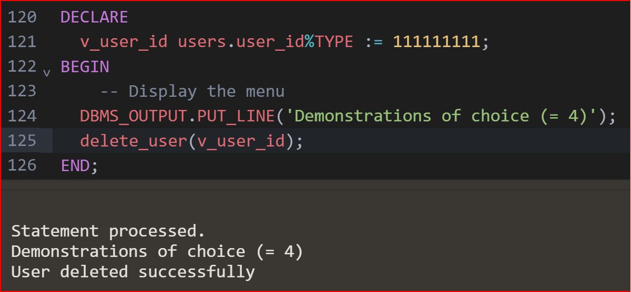

**CODE FOR MENU:**

**DECLARE**

**choice NUMBER;**

**BEGIN**

**DBMS_OUTPUT.PUT_LINE('Menu:');**

**DBMS_OUTPUT.PUT_LINE('1. Calculate expenditure');**

**DBMS_OUTPUT.PUT_LINE('2. Insert transaction');**

**DBMS_OUTPUT.PUT_LINE('3. Add user');**

**DBMS_OUTPUT.PUT_LINE('4. Delete user');**

**DBMS_OUTPUT.PUT_LINE('5. University financials');**

**DBMS_OUTPUT.PUT_LINE('6. Update user');**

**choice := &choice;**

**CASE choice**

**WHEN 1 THEN**

**DECLARE**

**start_date DATE;**

**end_date DATE;**

**total_outNUMBER(10,2);**

**BEGIN**

**DBMS_OUTPUT.PUT_LINE('Enter start date (yyyy-mm-dd):');**

**start_date := TO_DATE('&start_date', 'yyyy-mm-dd');**

**DBMS_OUTPUT.PUT_LINE('Enter end date (yyyy-mm-dd):');**

**end_date := TO_DATE('&end_date', 'yyyy-mm-dd');**

**calculate_expenditure(start_date, end_date, total_out);**

**DBMS_OUTPUT.PUT_LINE('Total expenditure: ' || total_out);**

**WHEN 2 THEN**

**DECLARE**

**transaction_date DATE;**

**transaction_amount NUMBER;**

**transaction_type VARCHAR2(50);**

**transaction_account VARCHAR2(50);**

**transaction_user VARCHAR2(50);**

**description VARCHAR2(200);**

**BEGIN**

**DBMS_OUTPUT.PUT_LINE('Enter transaction date (yyyy-mm-dd):');**

**transaction_date := TO_DATE('&transaction_date', 'yyyy-mm-dd');**

**DBMS_OUTPUT.PUT_LINE('Enter transaction amount:');**

**transaction_amount := &transaction_amount;**

**DBMS_OUTPUT.PUT_LINE('Enter transaction type:');**

**transaction_type := '&transaction_type';**

**DBMS_OUTPUT.PUT_LINE('Enter transaction account:');**

**transaction_account := '&transaction_account';**

**DBMS_OUTPUT.PUT_LINE('Enter transaction user:');**

**transaction_user := '&transaction_user';**

**DBMS_OUTPUT.PUT_LINE('Enter transaction description:');**

**description := '&description';**

**insert_transaction(transaction_date, transaction_amount, transaction_type,**

**transaction_account, transaction_user, description);**

**END;**

**WHEN 3 THEN**

**DECLARE**

**user_id NUMBER;**

**user_name VARCHAR2(50);**

**user_email VARCHAR2(100);**

**user_account_number NUMBER;**

**user_scholarship_amount NUMBER;**

**user_authorisation_type VARCHAR2(50);**

**user_gpa NUMBER;**

**BEGIN**

**DBMS_OUTPUT.PUT_LINE('Enter user ID:');**

**user_id := &user_id;**

**DBMS_OUTPUT.PUT_LINE('Enter user name:');**

**user_name := '&user_name';**

**DBMS_OUTPUT.PUT_LINE('Enter user email:');**

**user_email := '&user_email';**

**DBMS_OUTPUT.PUT_LINE('Enter user account number:');**

**user_account_number := &user_account_number;**

**DBMS_OUTPUT.PUT_LINE('Enter user scholarship amount:');**

**user_scholarship_amount := &user_scholarship_amount;**

**DBMS_OUTPUT.PUT_LINE('Enter user authorisation type:');**

**user_authorisation_type := '&user_authorisation_type';**

**DBMS_OUTPUT.PUT_LINE('Enter user GPA:');**

**user_gpa := &user_gpa;**

**add_user(user_id, user_name, user_email, user_account_number,**

**user_scholarship_amount, user_authorisation_type, user_gpa);**

**END;**

**WHEN 4 THEN**

**DECLARE**

**user_idNUMBER(9);**

**DBMS_OUTPUT.PUT_LINE('Enter user ID:');**

**user_id := &user_id;**

**delete_user(user_id);**

**WHEN 5 THEN**

**BEGIN**

**DBMS_OUTPUT.PUT_LINE(university_financials());**

**END;**

**WHEN 6 THEN**

**DECLARE**

**v_user_id NUMBER;**

**BEGIN**

**DBMS_OUTPUT.PUT_LINE('Enter User ID:');**

**v_user_id := '&user_id';**

**update_user_info(v_user_id);**

**END;**

**ELSE**

**DBMS_OUTPUT.PUT_LINE('Invalid input. Please enter a number between 1 and 6.');**

**END CASE;**

**END;**

THANKYOU!