I07

**Group Id**

**Project Title:** Semantic Indoor Object Identification and Labeling Using RGB-D Camera

**Domain (Area of Project):** Image Processing

|  |  |  |  |
| --- | --- | --- | --- |
|  | **C:\Users\MOHIT\Desktop\mohit-kaduskar.jpg** | C:\Users\TEMP.WDC.000\Downloads\3c02a84.jpg | C:\Users\TEMP.WDC.000\Downloads\2.jpg |
| *Akshay Loke* | *Mohit Kaduskar* | *Chaitanya Koparkar* | *Srinivas Sangishetty* |
| [*akshay.loke@vit.edu.in*](mailto:akshay.loke@vit.edu.in) | [*mohit.kaduskar@vit.edu.in*](mailto:mohit.kaduskar@vit.edu.in) | [*chaitanya.koparkar@vit.edu.in*](mailto:chaitanya.koparkar@vit.edu.in) | [*srinivas.sangishetty@vit.edu.in*](mailto:srinivas.sangishetty@vit.edu.in) |
|  | *+919773474674* | *+919819579034* | *+919029420570* |

**Brief Idea of the Project:**

We consider the problem of high level scene understanding for personal robots. One of the original goals of computer vision was to fully understand a natural scene. This requires solving several sub-tasks simultaneously, including object detection, labeling of meaningful regions, and 3D reconstruction.

**Screenshots of the Project /Photos of Working Model:**

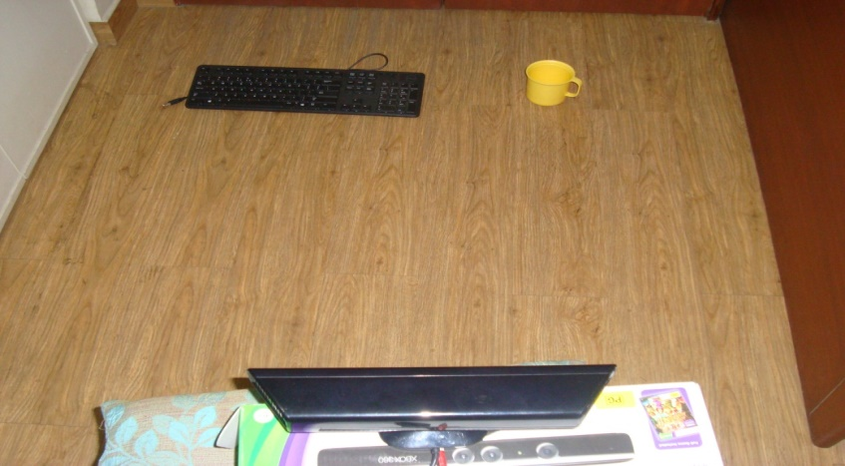

Kinect capturing the objects in order to identify and label them (Setup)

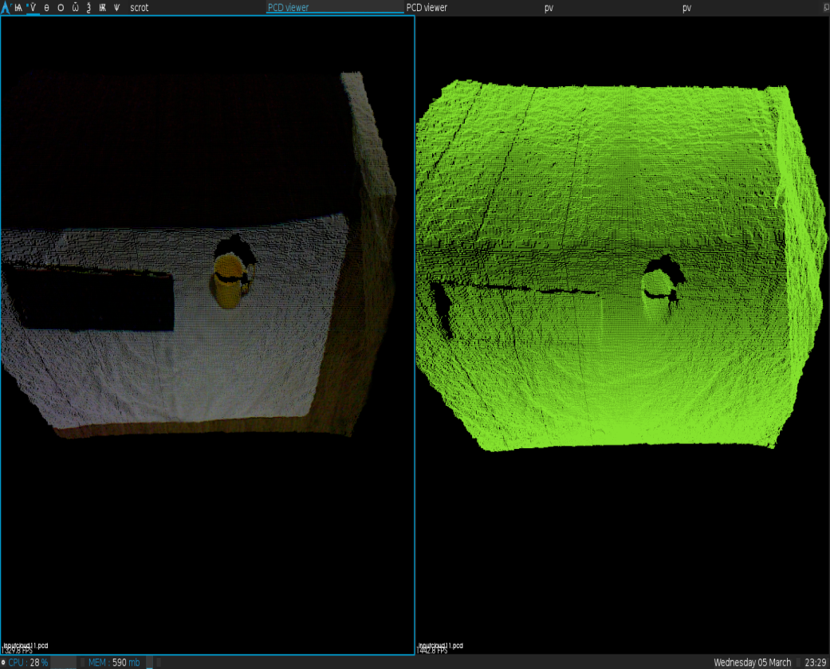

Left: Color Information captured by Kinect

Right: Depth Information captured by Kinect

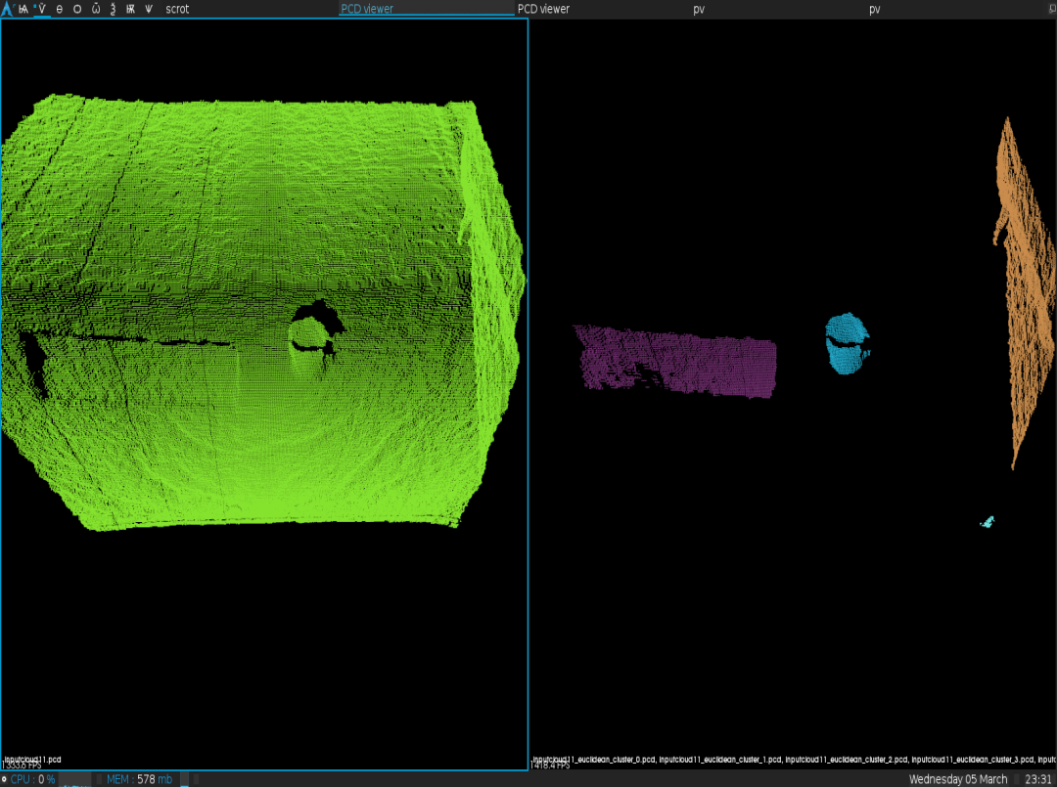

Right: Objects segmented from the input

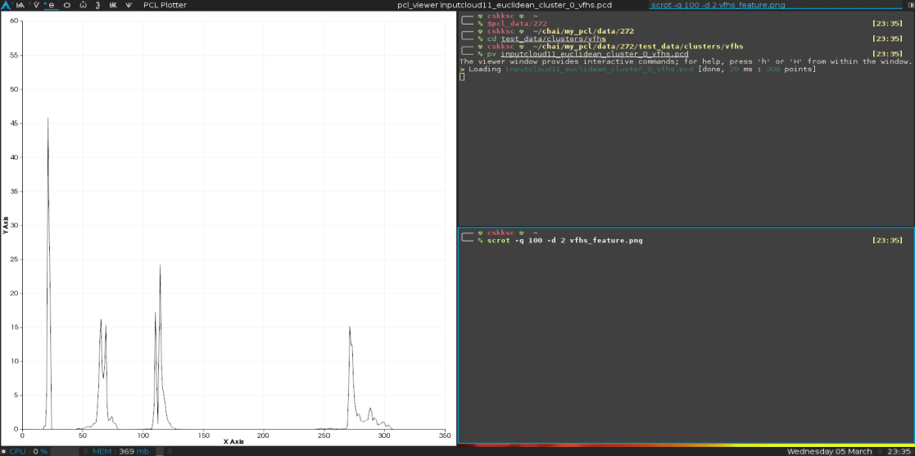

Feature of each individual cluster extracted and represented on left

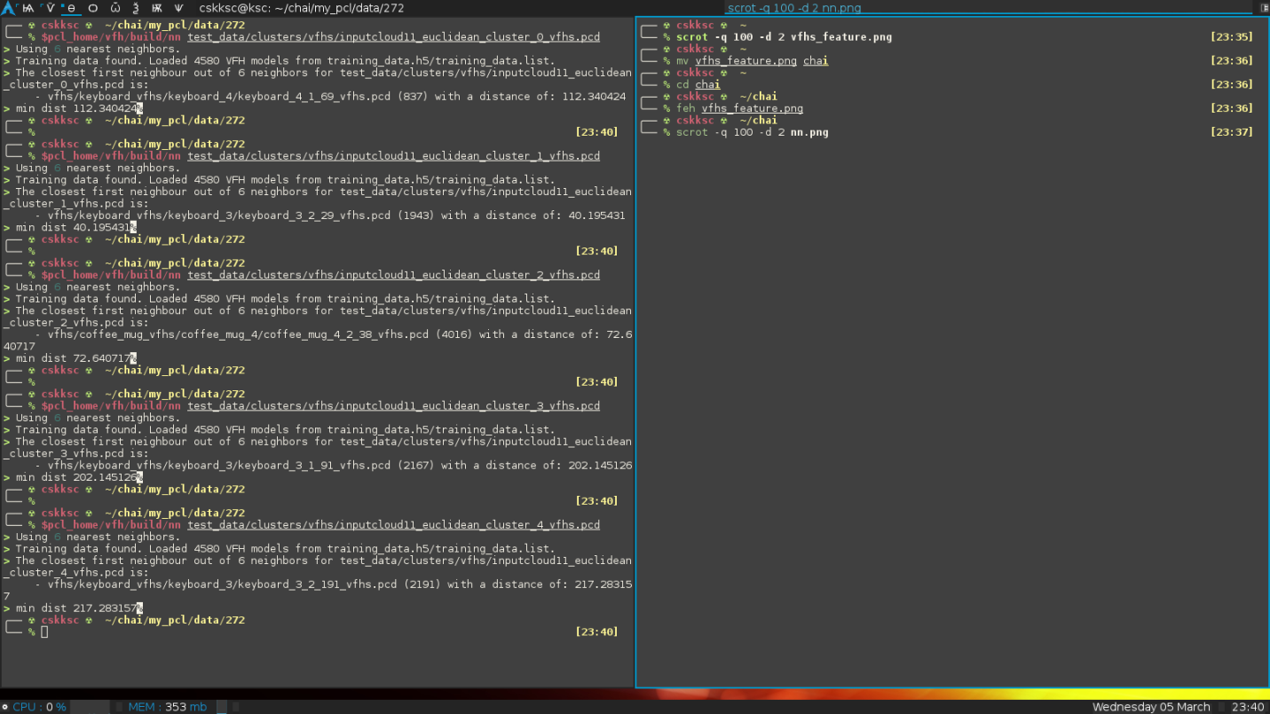

Feature comparison of individual segments with training set and segment with minimum distance determined

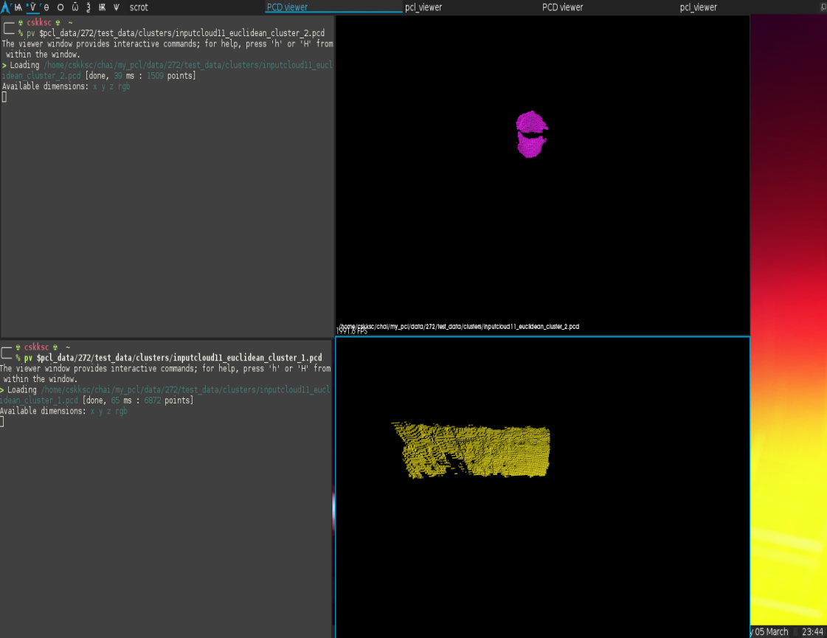

Verification: Minimum distance is of clusters representing clusters

**Applications:**

1. Personal Robotics
2. Content Based Image Retrieval

**Awards if Any for TPP/Competitions/Paper Publication/ Any Other Pls. Specify:**

N/A