**COMMANDS**

**Azure VM - jupyter notebook**

Step 1: ssh commands (basically logging in the machine through local) ; {use logout command for closing connection}

1. ssh username@IP_machine (shared privately)
2. Enter the prompted password now (shared confidentially)

You are now logged in to the instance !!

Step 2: Activate the Virtual environment

1. source virtual_env_name/bin/activate (ACTIVATED)
2. deactivate (For Deactivation)

Step 3 : setting up a name in bash for loading jupyter through vm

1. alias jp='jupyter notebook --no-browser --port=8888'
   1. **jupyter notebook** : simply fires up your **notebook**.
   2. --no-**browser** : this **starts** the **notebook without opening a browser**.
   3. --port=XXXX : this sets the port for **starting your notebook** where the default is 8888 . When it's occupied, it finds the next available port.
2. alias |grep jupyter

Now you will see the above value with this command

1. Write command : **jp** (when you write this command notebook will load)
2. 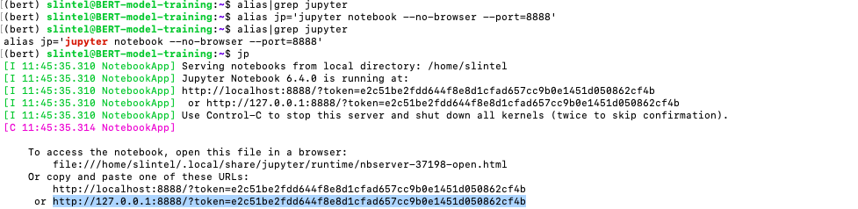
3. Copy the highlighted http address somewhere in your notepad

Step 4 : Now open local terminal in a different window

1. Use command : ssh -N -f -L localhost:8889(can be any port no/listener port):localhost:8888 username@IP_machine
   1. This is ssh command with listener and speaker ports for notebook
2. Use Step3, point 5 (copied http link) and paste in the browser.
   1. Make Sure to change value of listener(in my case here it is 8889), so change it to 8889 in place of 8888(copied originally)

GOOD TO GO !!

Linux Commands -

1. **lshw - List Hardware  
   htop - show machine stats**

**free -m (**Check the amount of used, free and total amount of RAM on the system with the free command.**)**

nvidia-smi -l 1 ( show 1 s interval GPU stats)

1. **Show where memory is allocated sudo du -x -h / | sort -h | tail -40**

In my case, when I run **df -i** it shows me that my number of inodes are full and then I have to delete some of the small files or folder. Otherwise it will not allow us to create files or folders once inodes get full.

1. Shows device space : **df -h**

**Tmux**

1. **Kill terminal -** tmux kill-window -t 9 [tmux kill-window -t window-number]
2. **tmux ls**
3. **tmux attach -t 0**
4. **If you prefer to give your sessions a more meaningful name (instead of a numerical one starting with 0) you can create your next session using**

**tmux new -s database**

1. **tmux rename-session -t 0 database**
2. **Close : Ctrl-d**
3. **Ctrl-b % :split screen**
4. [**Link to commands**](https://linuxize.com/post/getting-started-with-tmux/)