T MOHIT REDDY CSE_D set2

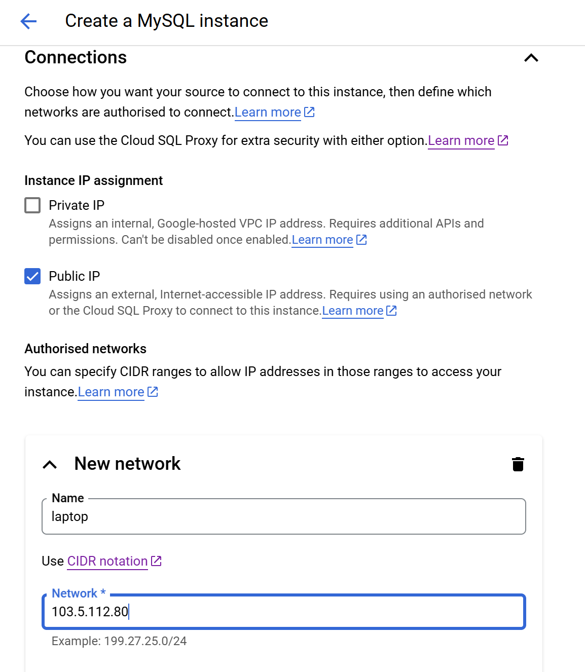

Adding device to the cloud sql instance

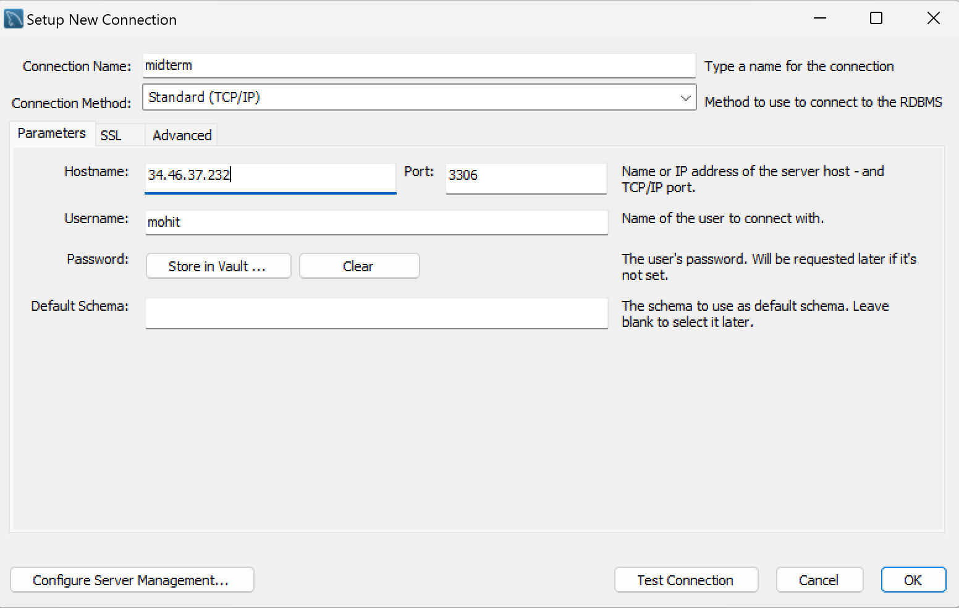

Adding the connection to MySQL using public ID of the instance

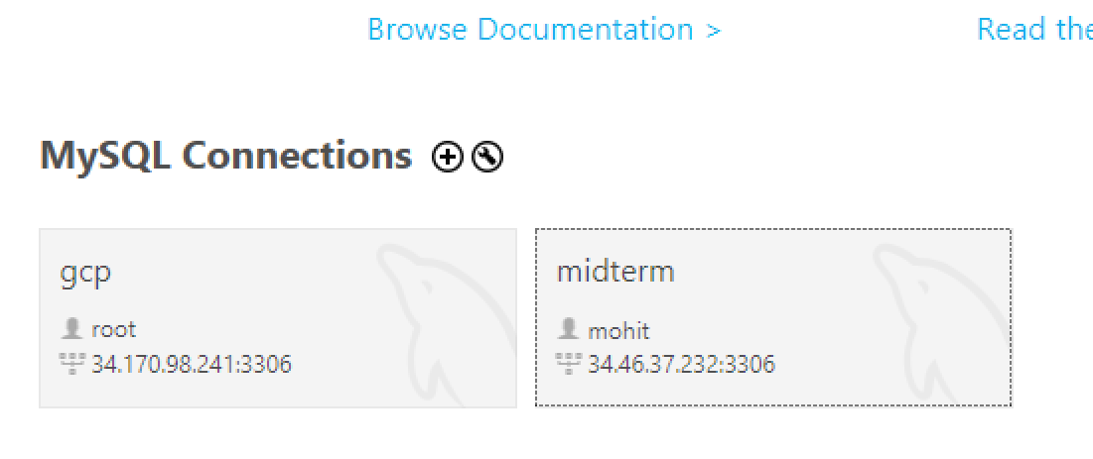

Connection added

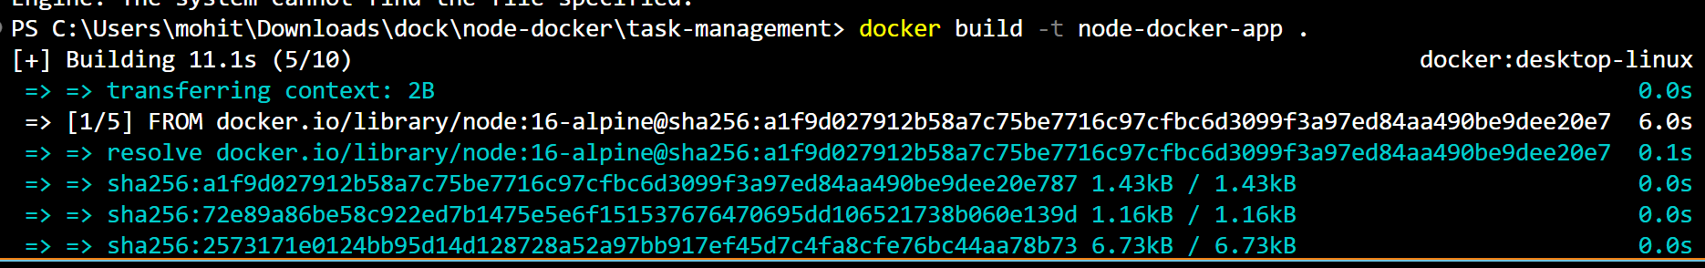

Building docker for backend with CRUD



Docker has been run

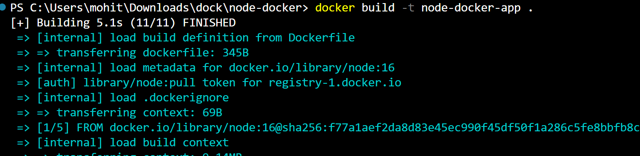

Building the front end docker



Front end docker successfully ran

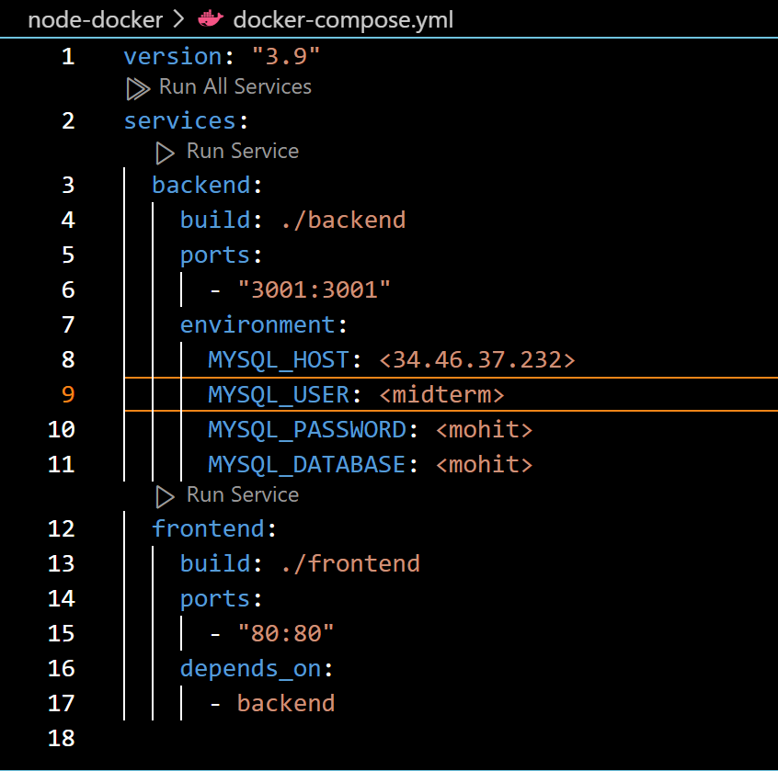

Docker yml code with the backend and frontend integration

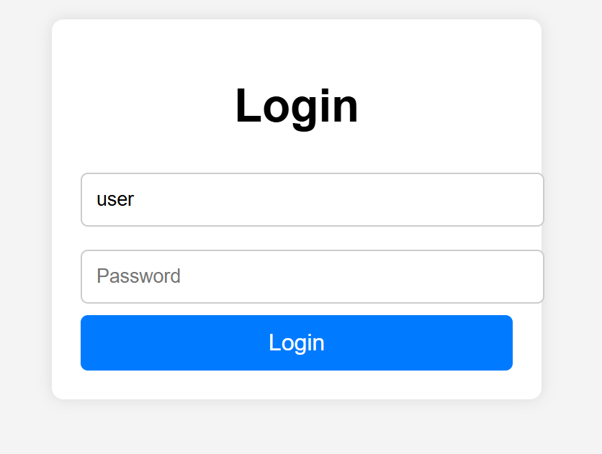

Login page



When wrong password is typed

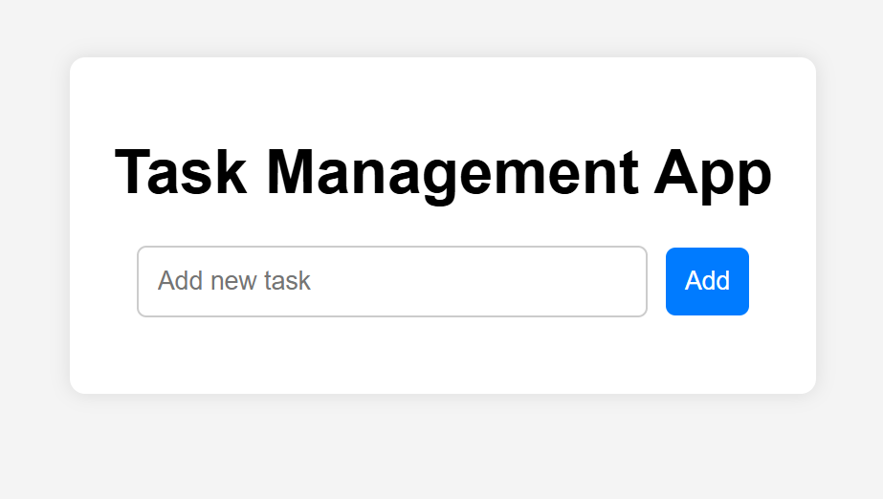

After login takes you to this page.

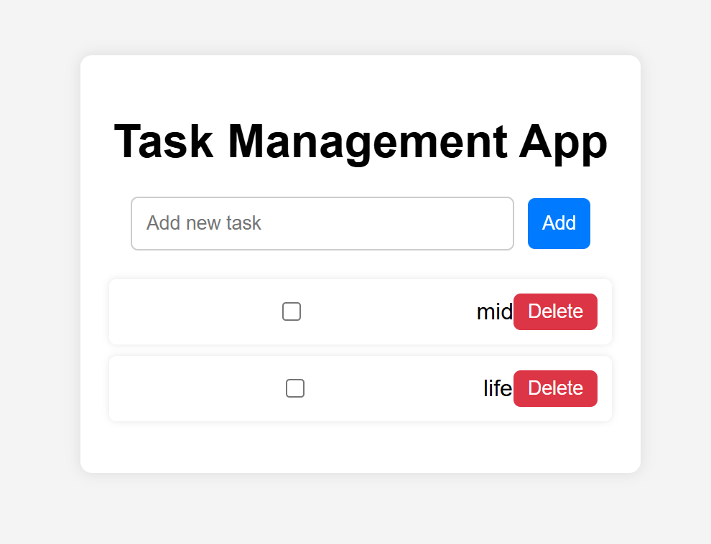

Can add new task

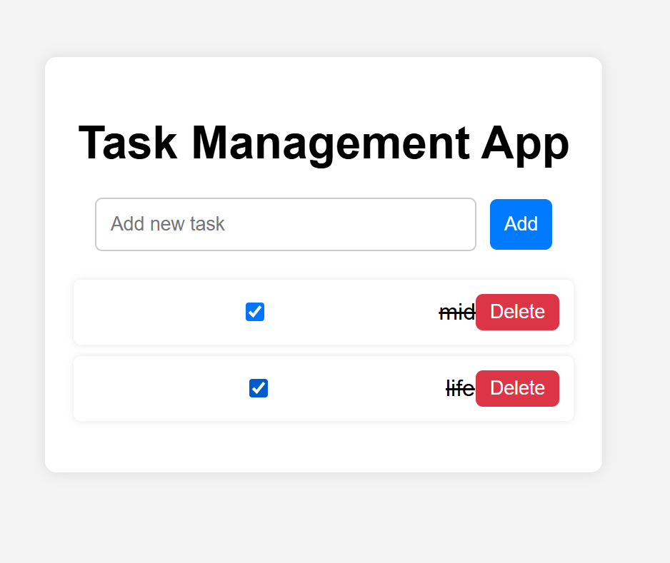

Can mark task as completed