Use BigQuery and solve the following queries using covid19_open_data dataset.

1. Identify the worst affected cases in a particular date

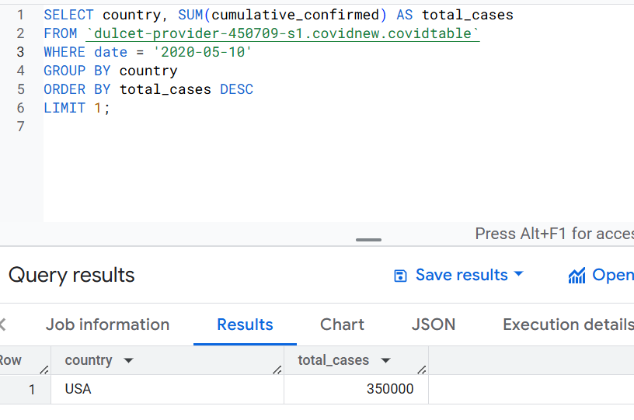

1. Identify the most affected city on a particular date

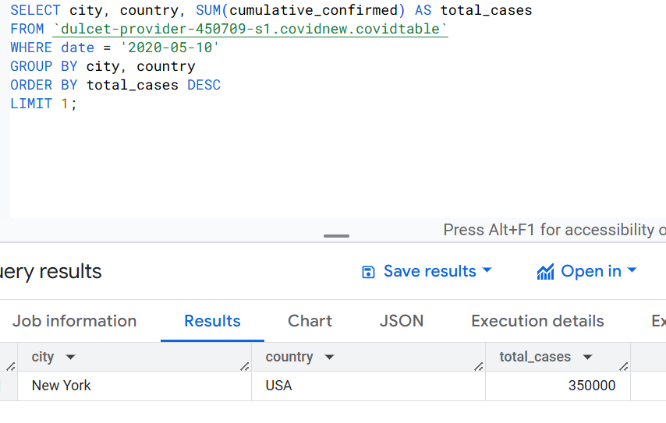

1. *Find the days with zero new cases*

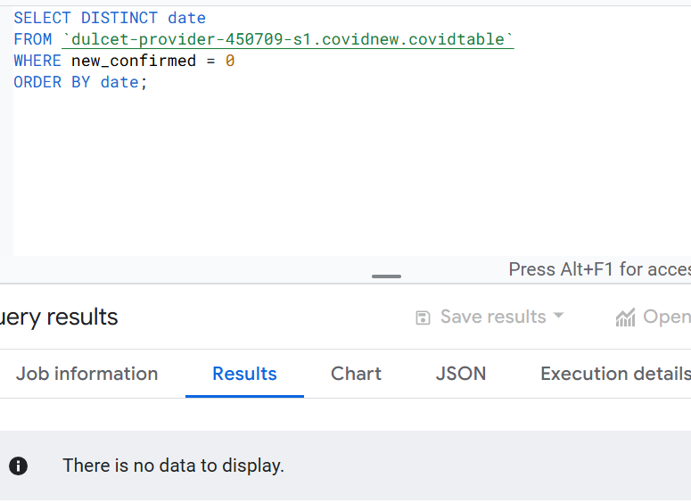

1. Which 10 countries with more than 50,000 confirmed cases had the highest recovery rate as of May 10, 2020?

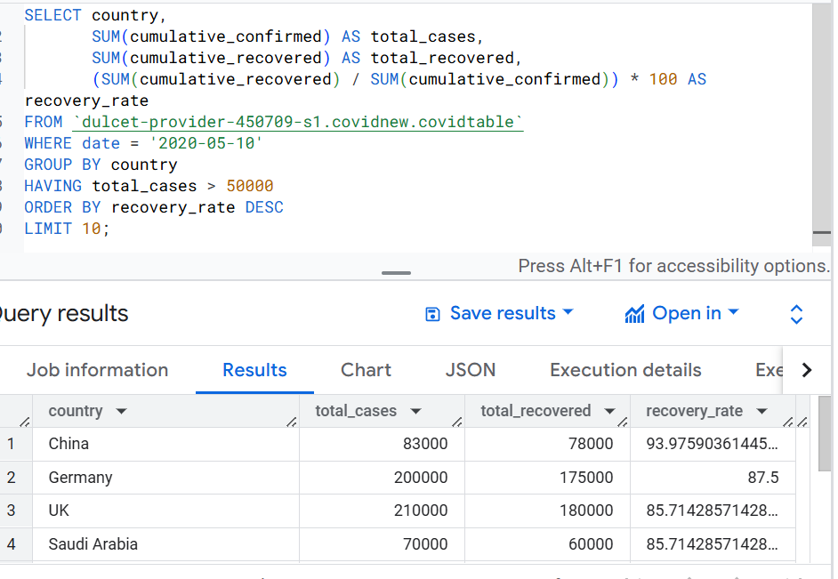

1. What was the Compounded Daily Growth Rate (CDGR) of COVID-19 cases in France between January 24, 2020, and May 10, 2020?

