Table of Contents

Tips: 1

Tenant, Subscription & Directory Services 1

Resource Hierarchy in Azure 2

LAB-Management Group: 4

LAB-Subscription: 5

LAB-Resource Group: 5

# Tips:

1. Destroy resources immediately after practice.
   1. Public IP
   2. VMs
   3. VPN Gateway
   4. Firewall
   5. Queue Vault
   6. Azure file resources
   7. Storage
2. No need to destroy Free resources
   1. RG (Resource group)
   2. NSG (Network Security group0
   3. vNet (virtual network)
3. Some resource we can not delete
   1. i.e Domain controller

For such cases we can create with least specs, HDD ets to reduce our billing

# Tenant, Subscription & Directory Services

Tenant:

* It represents an organization
* It automatically created when you/Org signs up for MS cloud services - example below
  + Azure
  + Intune
  + M365

Subscription:

* It is a logical container used to provision resources in Azure – below are the example
  + Subscription 1 – For hosting the VMS (Separate billing)
  + Subscription 2 – for M365 Services (Separate billing)
* All Subscriptions will come under the single tenant

Example:

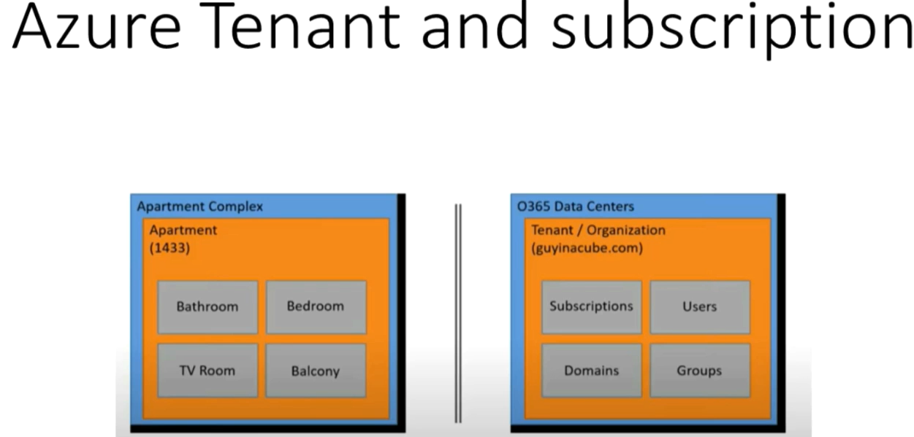

Directory Services:

* To manage the tenant there is a directory services which provides a Identity and Access management Service.
* By Default, tenant comes with Azure Active directory Service
  + Controls identity and access management to all our subscription which comes under the tenant
* When ever we subscribe any MS cloud services the tenant will have a default directory which will be linked to all the subscriptions.
* If we don’t want to use default directory then we can create our own Azure Active directory (AAD).
* Any Subscription only have relation with only one AAD and canot have linked with multiple AAD (Entra ID).

# Resource Hierarchy in Azure

1. Management Group
2. Subscription
3. Resource Group
4. Resources

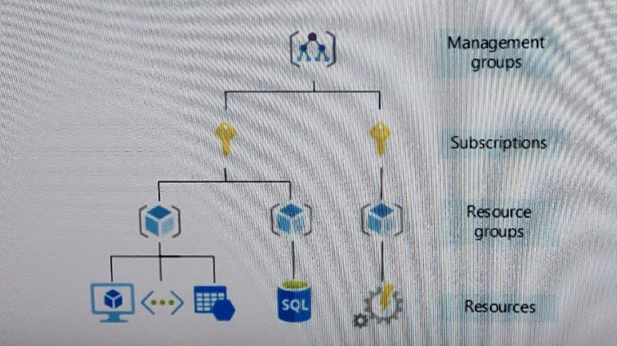

**Policy Precedency: MG > Subs > RG > R**

1. **Management Group**: It is a Top level entity
   1. Manage access
   2. Policies
   3. Compliance for multiple subscription
   4. All subscriptions in MG automatically inherit the condition applied to the MG.
   5. Generally used for grouping subscriptions by internal department or geographical region.
   6. Any type of policy like access, restrictions etc… will applied hierarchically from top to bottom i.e. MG > Subscription > RG > recourses
2. **Subscription**: It is a billing Unit to use manage cost and recourses that created by Users, Teams and projects. In which we can deployed our all the recourses through RG.
   1. Billing
   2. Quota (Limits of each Recourse type)
3. **Resource Group:** Logical container in which azure resources be deployed and managed.
   1. VMs
   2. WebApp
   3. DBs
   4. Storage accounts
   5. Etc….!

Also, any policy can be define and access control can also be defined at Resource group level as well. If we apply at RG level it will inherit toward the resources as well.

1. **Resources**: Instance of services that we create
   1. VMs
   2. Storage
   3. DBs
   4. Etc….

Also, any policy can be define and access control can also be defined at Resource level

## LAB-Management Group:

How to create Management group

1. Got Search box type <management group>
2. By default we will see a “Tenant Root Group” (It create automatically when we subscribe any AZ service) it is a default management group.
3. To create new MG group click on “Create”
4. Type the ID like <1> into the “management group ID”
5. Type the any name like <Prod MG Group> in to the “management group display name”
6. Click on “Submit”

How to move any subscription from one MG to another MG (i.e. from default MG to “Prod MG Group”)

1. Click on “Prod MG Group” > Click on “+ Add subscription”
2. In New window select the subscription from the dropdown list and then click on “Save”
3. Now check the subscription which will be moved from default MG to “Prod MG group’

## LAB-Subscription:

How to create subscription

1. Got Search box type <Subscription>
2. Click on “+ Add”
   1. Subscription Name < prod>
   2. No need to type in “Billing account & Billing profile”
   3. Click on “Review + Create”

View :

* Overview
* Activity Logs
* Access Control (IAM)
  + Can provide access at Subs level
    - Owner Role
    - Contributor role
    - Reader
    - …. Etc!
* Tags (Usefull for Billings and Policy applied… etc)
* Locks (very much important for accidental deletion of resources)
  + How to create/Add Locks
    - Click on “+ Add”
      * Lock Name* <Donotdelete>
      * Lock type* <D/D ‘Read only’ or **Delete’**>
      * Notes <*Optional*>
      * Click on “OK”
    - “OK”
  + Now check to delete “RG” for testing
* Cost
* Policy
* Usage + quota (default 4 CPU – top increase it need to raise request with MS)
* RG
* resources
* …. Etc… !

## LAB-Resource Group:

How to create subscription

1. Got Search box type <Resource Group>
2. Click on “+ Create”
   1. Type RG name in Recourse group* <VDI>
   2. Region* <Drop Down “central US”>
   3. Click “Review + Create” >> “Create”

View :

* Overview
* Activity Logs
* Access Control (IAM)
  + Can provide access at Subs level
    - Owner Role
    - Contributor role
    - Reader
    - …. Etc!
  + Check access
  + Role assignments
  + Roles
  + Deny Assignment
  + Classic Administrator
* Tags
* Cost
* Policy
* Usage + quota (default 4 CPU – top increase it need to raise request with MS)
* RG
* resources
* …. Etc… !