Table of Contents

Session-1: 2

Tips: 2

Tenant, Subscription & Directory Services 2

Resource Hierarchy in Azure 3

LAB-Management Group: 5

LAB-Subscription: 6

LAB-Resource Group: 6

Session-2: 7

Azure Virtual Network “VNet” 7

LAB-Azure Virtual Network (VNet) 8

# Session-1:

# Tips:

1. Destroy resources immediately after practice.
   1. Public IP
   2. VMs
   3. VPN Gateway
   4. Firewall
   5. Queue Vault
   6. Azure file resources
   7. Storage
2. No need to destroy Free resources
   1. RG (Resource group)
   2. NSG (Network Security group0
   3. vNet (virtual network)
3. Some resource we can not delete
   1. i.e Domain controller

For such cases we can create with least specs, HDD ets to reduce our billing

# Tenant, Subscription & Directory Services

Tenant:

* It represents an organization
* It automatically created when you/Org signs up for MS cloud services - example below
  + Azure
  + Intune
  + M365

Subscription:

* It is a logical container used to provision resources in Azure – below are the example
  + Subscription 1 – For hosting the VMS (Separate billing)
  + Subscription 2 – for M365 Services (Separate billing)
* All Subscriptions will come under the single tenant

Example:

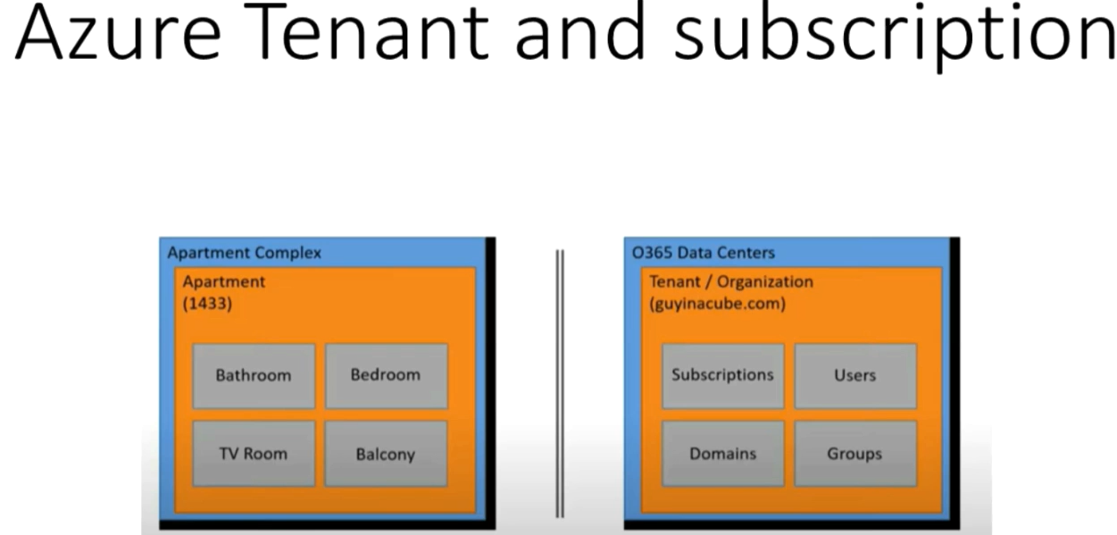

Directory Services:

* To manage the tenant there is a directory services which provides a Identity and Access management Service.
* By Default, tenant comes with Azure Active directory Service
  + Controls identity and access management to all our subscription which comes under the tenant
* When ever we subscribe any MS cloud services the tenant will have a default directory which will be linked to all the subscriptions.
* If we don’t want to use default directory then we can create our own Azure Active directory (AAD).
* Any Subscription only have relation with only one AAD and canot have linked with multiple AAD (Entra ID).

# Resource Hierarchy in Azure

1. Management Group
2. Subscription
3. Resource Group
4. Resources

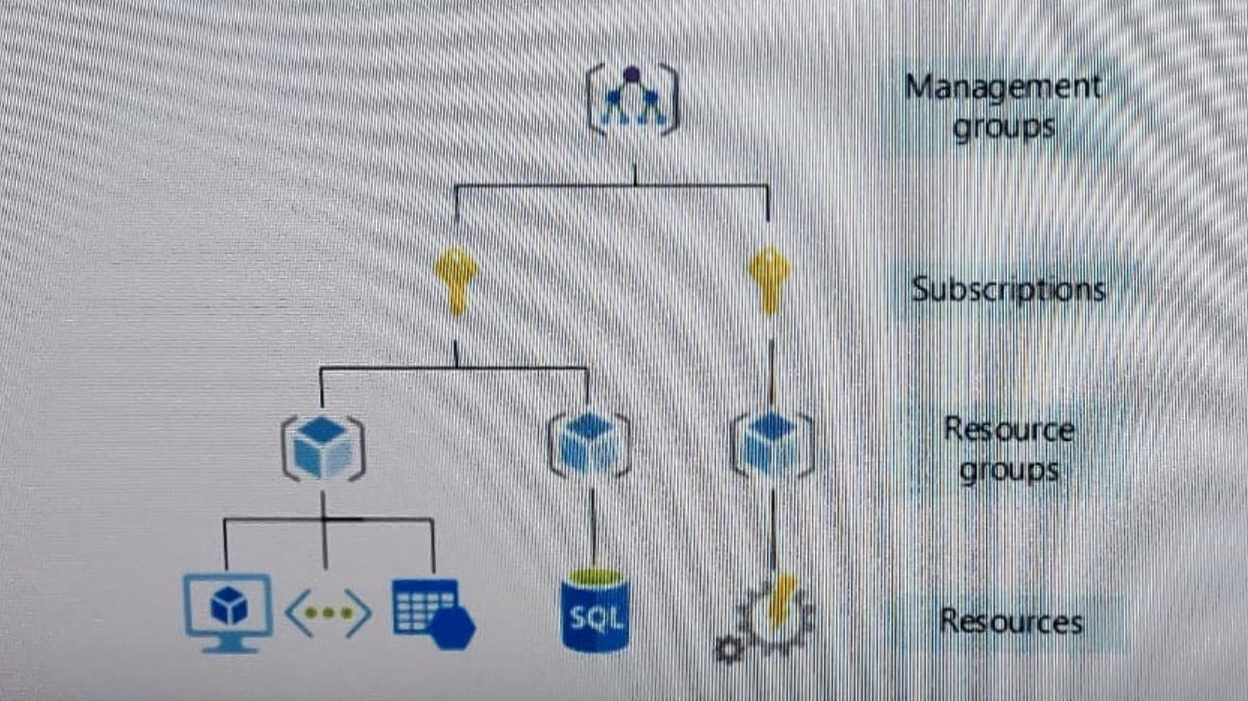

**Policy Precedency: MG > Subs > RG > R**

1. **Management Group**: It is a Top level entity
   1. Manage access
   2. Policies
   3. Compliance for multiple subscription
   4. All subscriptions in MG automatically inherit the condition applied to the MG.
   5. Generally used for grouping subscriptions by internal department or geographical region.
   6. Any type of policy like access, restrictions etc… will applied hierarchically from top to bottom i.e. MG > Subscription > RG > recourses
2. **Subscription**: It is a billing Unit to use manage cost and recourses that created by Users, Teams and projects. In which we can deployed our all the recourses through RG.
   1. Billing
   2. Quota (Limits of each Recourse type)
3. **Resource Group:** Logical container in which azure resources be deployed and managed.
   1. VMs
   2. WebApp
   3. DBs
   4. Storage accounts
   5. Etc….!

Also, any policy can be define and access control can also be defined at Resource group level as well. If we apply at RG level it will inherit toward the resources as well.

1. **Resources**: Instance of services that we create
   1. VMs
   2. Storage
   3. DBs
   4. Etc….

Also, any policy can be define and access control can also be defined at Resource level

## LAB-Management Group:

How to create Management group

1. Got Search box type <management group>
2. By default we will see a “Tenant Root Group” (It create automatically when we subscribe any AZ service) it is a default management group.
3. To create new MG group click on “Create”
4. Type the ID like <1> into the “management group ID”
5. Type the any name like <Prod MG Group> in to the “management group display name”
6. Click on “Submit”

How to move any subscription from one MG to another MG (i.e. from default MG to “Prod MG Group”)

1. Click on “Prod MG Group” > Click on “+ Add subscription”
2. In New window select the subscription from the dropdown list and then click on “Save”
3. Now check the subscription which will be moved from default MG to “Prod MG group’

## LAB-Subscription:

How to create subscription

1. Got Search box type <Subscription>
2. Click on “+ Add”
   1. Subscription Name < prod>
   2. No need to type in “Billing account & Billing profile”
   3. Click on “Review + Create”

View :

* Overview
* Activity Logs
* Access Control (IAM)
  + Can provide access at Subs level
    - Owner Role
    - Contributor role
    - Reader
    - …. Etc!
* Tags (Usefull for Billings and Policy applied… etc)
* Locks (very much important for accidental deletion of resources)
  + How to create/Add Locks
    - Click on “+ Add”
      * Lock Name* <Donotdelete>
      * Lock type* <D/D ‘Read only’ or **Delete’**>
      * Notes <*Optional*>
      * Click on “OK”
    - “OK”
  + Now check to delete “RG” for testing
* Cost
* Policy
* Usage + quota (default 4 CPU – top increase it need to raise request with MS)
* RG
* resources
* …. Etc… !

## LAB-Resource Group:

How to create subscription

1. Got Search box type <Resource Group>
2. Click on “+ Create”
   1. Type RG name in Recourse group* <VDI>
   2. Region* <Drop Down “central US”>
   3. Click “Review + Create” >> “Create”

View :

* Overview
* Activity Logs
* Access Control (IAM)
  + Can provide access at Subs level
    - Owner Role
    - Contributor role
    - Reader
    - …. Etc!
  + Check access
  + Role assignments
  + Roles
  + Deny Assignment
  + Classic Administrator
* Tags
* Cost
* Policy
* Usage + quota (default 4 CPU – top increase it need to raise request with MS)
* RG
* resources
* …. Etc… !

# Session-2:

# Azure Virtual Network “VNet”

It is representation of our own network into the cloud, logical isolation of Azure cloud dedicated to our subscription and it is a service from Azure which to our resource (VMs, Storage account, Key Vault, …etc) can communicate with internet, on-prem and internally.

* Generally, it has two type of IP Address
  + Private IP Address
    - Communication with in Azure and On-Prem
  + Public IP Address
    - Communicate with Internet
* Address space : IP Range of the entire network

Suppose we need 200 IP address of Address Space

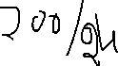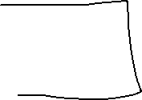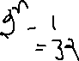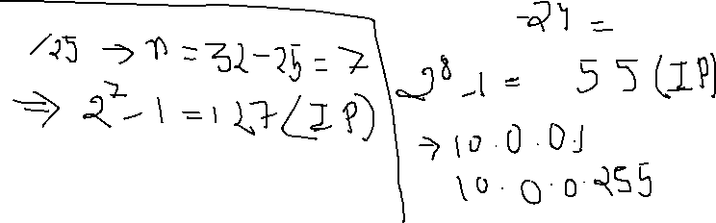

* Subnet: It’s a range of IP addresses in the vNet.

Smaller Chunks of IP Address of Address Space

* + Suppose we need 100 IP address from 200 Ips from the address Space
    - 100 IPs for Prod
    - 100 IPs for Non-Prod
    - Ex.
      * 10.0.0.0/24 (10.0.0.1 – 10.0.0.255) (255 IPs)
      * Break it in two portion
        + Subnet – 1

10.0.0.0/25 (Pool – 1)

10.0.0.1 – 10.0.0.127

* + - * + Subnet – 2

10.0.0.128/25 (pool – 2)

10.0.0.128 – 10.0.0.255

* + - * + Similarly, we can further divide these IPs into more subnet

Ex.

/26 – 64 IPs , /27 - 32 IPs, /28 – 16 IPS, . /29 – 8 IPs.

## LAB-Azure Virtual Network (VNet)

How to create VNET

1. Got Search box type <Virtual Network>
2. Click on “+ Create”
   1. Basic
      1. Select Subscription (Select from D/D)
         1. Resource Group (Select from D/D)
      2. Name* <Give the Name of the Virtual Network>
      3. Region* (Select from D/D)
   2. IP Addresses
      1. IPv4 address space (By Default Azure provide some IPs but in prod need to avoid default and provide our own IPs)
         1. Ex. 10.196.0.0/23 (512 IPs)
      2. Subnet
         1. “+ Add subnet”
            1. Subnet Name* <ex. Prod-VDI-subnet>
            2. Subnet Address range* <ex. 10.196.0.0/24> (256 IPs from the above address space) or for 128 IPs then take /25
            3. “+ Add”
   3. Security
      1. Keep Default

In prod infra it will be according to the Organization’s policies.

* 1. Tags
     1. If wanted to give tags then give else “next”
  2. “Review + Create”

1. “Create”

View:

Go to the Newly Created VNet

* Overview
* Activity Logs
* Access Control (IAM)
* Tags

**Settings**

* Address space
  + If we wated to increase the Range
    - Go to the “Address space” and change the “/24” range to desire one
    - Ex. 10.196.0.0/22 (now we have 1024 IP Addresses)
    - “Save”
  + Also, we can add another range of Address space
    - Ex.
      * Go to the Box “Add additional address space”
      * 10.125.0.0/22
      * “save”
      * Now we have another 1024 IP addresses
* Subnets
  + Prod-VDI-Subnet (251 IPs) (Some IPs reserved by Azure)
  + If we wanted to one more Subnet
    - “+ Subnet”
      * Name* <ex. callcenter-vdi>
      * Subnet Address Range* <10.196.1.0/25>
        + Range (10.196.1.0 – 10.196.1.127) (123+5 Azure reserve address)
      * “Save”
  + Now we can see two Subnets

# Azure Virtual Machine Service and Availability Options

Provide On-demand & Scalable computing resources with usage-based pricing.

* Type of Azure VMs
  + A Series VMs (Entry Level VMs)
  + B Series VMs (Economical VMs)

D Series VMs (General Purpose Compute – AVD, Citrix. etc)

* + E Serise VMs (Optimized for in-memory “high” application – SAP, HANA workload, Multi session VDI… etc..!)
  + F Series VMs (Compute optimized “High CPU” machines – Gaming and analytics…etc)
  + G Series VMs (Memory and Storage optimized VMS – Large SQL, DBs, ERP, data warehousing. etc)
  + H Series VMs (High Performance computing – rendering, quantum simulation.. etc)
  + L Series VMs (Storage Optimized VMs – MongoDB, Large transactional DBs.. etc)
  + M Series VMs (Memory Optimized VMs – Large in-memory business workload and massive parallel computing)
  + N Series VMs (GPU enabled VMs- CAD or Graphics intensive application)
  + …..!

:- At Any time we change the VM type from one series to another series based on requirement.

* SLA (Azure Service level agreement)

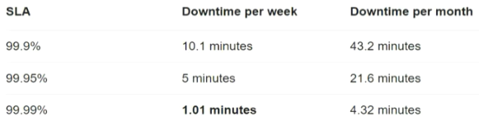

* + Azure VMs: 99.90% SLA Uptime (.10% Downtime)
  + Availability Set: 99.95% SLA Uptime (Only .05% downtime)
    - Logical grouping two or more VMs that helps to keep application hosted in Azure cloud during planned and unplanned outage.
    - There is concept of Fauth domain (Racks) and Update domain (where VMs are deployed in to the racks or we can say deployed VMs)
    - Each Azure Datacentre could have 3 fault domain and 20 Update domain.

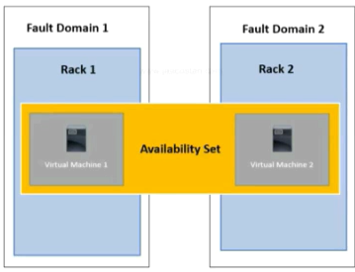

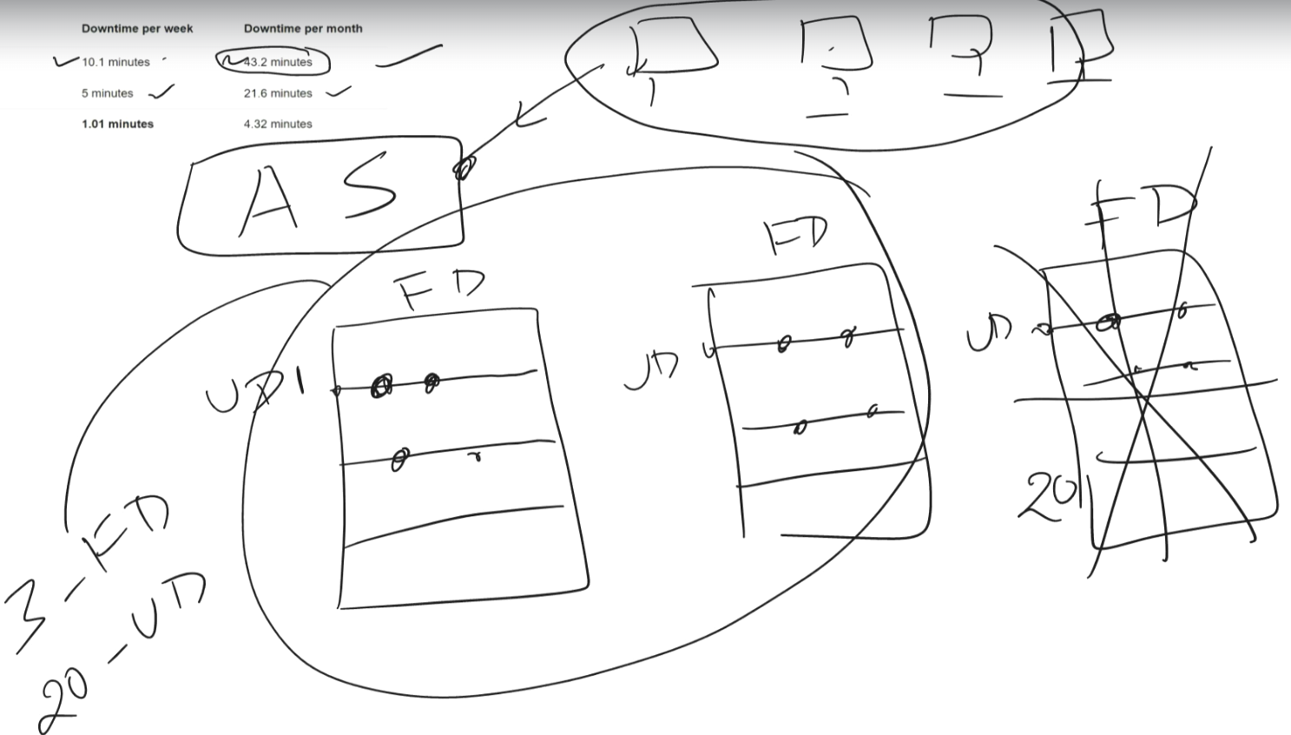

* + Availability Zone: 99.99% SLA (Only .01% downtime)
    - Physically separated location within each Azure region to tolerant local failure.

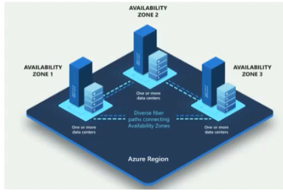

Region



Zone 1

Zone 2

Zone 3

