Process Scheduler :
There are three types of process scheduler.
1. Long Term or job scheduler
It bring the new process to the ‘New State’. It controls Degree of Multi-programming, i.e., number of process present in ready state at any point of time.
2. Short term ot CPU scheduler:
It is responsible for selecting one process from ready state for scheduling it on the running state. Note: Short term scheduler only selects the process to schedule it doesn’t load the process on running.(Important for interview)
--------------------------------------------------------------------
Dispatcher is responsible for loading the selected process by Short Term scheduler on the CPU (Ready to Running State) Context switching is done by dispatcher only. A dispatcher does following:
1) Switching context.
2) Switching to user mode.
3) Jumping to the proper location in the newly loaded program.
---------------------------------------------------------------
3. Medium term scheduler
It is responsible for suspending and resuming the process. It mainly does swapping (moving processes from main memory to disk and vice versa).
Process Scheduling :
---------------------------------------------------------------
Below are different time with respect to a process.
Arrival Time: Time at which the process arrives in the ready queue.
Completion Time: Time at which process completes its execution.
Burst Time: Time required by a process for CPU execution.
Turn Around Time: Time Difference between completion time and arrival time.
Turn Around Time = Completion Time - Arrival Time
Waiting Time(W.T): Time Difference between turn around time and burst time.
Waiting Time = Turn Around Time - Burst Time
-------------------------------------------------------------------
Why we need scheduling ??
(uniprocessor = system with only one cpu/processor)
A typical process involves both I/O time and CPU time. In a uni programming system like MS-DOS, time spent waiting for I/O is wasted and CPU is free during this time. In multi programming systems, one process can use CPU while another is waiting for I/O. This is possible only with process scheduling.
Objectives of Process Scheduling Algorithm
---------------------------------------------------------
1)Max CPU utilization [Keep CPU as busy as possible]
2)Fair allocation of CPU.
3)Max throughput [ Throughput means - Number of processes that complete their execution per time unit]
4)Min turnaround time [Turnaround time = Time taken by a process to finish execution]
5)Min waiting time [Time a process waits in ready queue]
6)Min response time [Time when a process produces first response]
--------------------------------------------------------------------------
Operating Systems: It is the interface between the user and the computer hardware.
Type’s of OS:
Batch OS:
A set of similar jobs are stored in the main memory for execution. A job gets assigned to the CPU, only when the execution of the previous job completes.
Multiprogramming OS:
The main memory consists of jobs waiting for CPU time. The OS selects one of the processes and assigns it the CPU time. Whenever the executing process needs to wait for any other operation (like I/O), the OS selects another process from the job queue and assigns it the CPU. This way, the CPU is never kept idle and the user gets the flavor of getting multiple tasks done at once.
Multitasking OS:
Multitasking OS combines the benefits of Multiprogramming OS and CPU scheduling to perform quick switches between jobs. The switch is so quick that the user can interact with each program as it runs
Time Sharing OS:
Time sharing systems require interaction with the user to instruct the OS to perform various tasks. The OS responds with an output. The instructions are usually given through an input device like the keyboard.
Real Time OS :
Real Time OS are usually built for dedicated systems to accomplish a specific set of tasks within deadlines.

Context Switching
Process of saving the context of one process and loading the context of other process is known as Context Switching. In simple term it is like loading and unloading of process from running state to ready state.
When does Context switching happen?
1. When a high priority process comes to ready state, compared to priority of running process
2. Interrupt Occurs
3. User and Kernel mode switch: (It is not necessary though)
4. Preemptive CPU scheduling used.
Context Switch vs Mode Switch
*******************************************
A mode switch occurs when CPU privilege level is changed, for example when a system call is made or a fault occurs. The kernel works in more privileged mode than a standard user task. If a user process wants to access things which are only accessible to kernel, a mode switch must occur. The currently executing process need not to be changed during a mode switch.
A mode switch typically occurs for a process context switch to occur. Only the Kernel can cause a context switch.
(Hope u know kernel and Difference between kernel and OS ,if No let me know ..i will update another post on it)
CPU Bound vs I/O Bound Processes:
*********************************************************
A CPU Bound Process requires more amount of CPU time or spends more time in the running state.
I/O Bound Process requires more amount of I/O time and less CPU time. I/O Bound process more time in the waiting state.

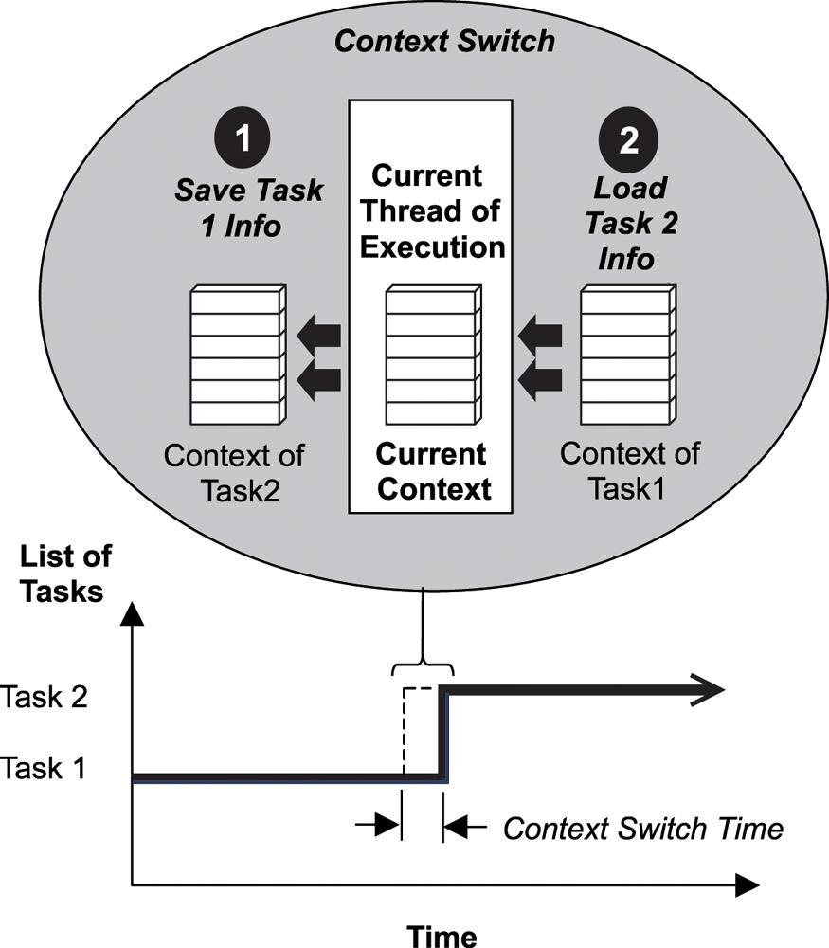

OS Interview Questions :
1)What is a process and process table? What are different states of process
2)What is a Thread? What are the differences between process and thread?
3)What is deadlock?
4)What are the necessary conditions for deadlock?/Why deadlocks happen ?
5)What is Virtual Memory? How is it implemented?
6)What is Thrashing?`

