WEEK 4 PROJECT REPORT
Predictive Modeling and Optimization in Logistics Systems
Yuvaintern Data Analytics Internship

1. Objective
The objective of this project is to use shipment information to predict transit duration and demonstrate how predictive insights can support logistics planning. The same logistics shipment dataset used for the previous analysis task is used here to keep the internship project consistent.

2. Dataset and Target Variable
The dataset contains 2,000 shipment records and 11 columns. The target variable is Transit_Days, representing recorded shipment transit duration. Input features are origin warehouse, destination, carrier, weight, cost, distance, shipment month, and shipment day of week. Delivery_Date and Status are intentionally excluded from the predictors because they can reveal information that would not be available at prediction time or can introduce target leakage.
Shipment_Date is converted to a date type and transformed into month and day-of-week features. Numeric missing values are imputed with the median and categorical missing values with the most frequent category, within a scikit-learn preprocessing pipeline. Categorical variables are one-hot encoded.

3. Methodology
- Load the CSV and check the required columns and target values.
- Create date-derived features from Shipment_Date.
- Split the data into 80% training and 20% testing sets with random_state=42.
- Train two regression models: Linear Regression and Random Forest Regressor.
- Evaluate both models on the same held-out test set using MAE, RMSE, and R².
- Select the model with the lower test MAE for the main result and generate visualizations.

4. Model Evaluation
Model | MAE (days) | RMSE (days) | R²
Linear Regression | 0.950 | 1.242 | 0.559
Random Forest | 0.970 | 1.271 | 0.538
Linear Regression achieved a test MAE of 0.950 days, RMSE of 1.242 days, and R² of 0.559. Random Forest achieved a test MAE of 0.970 days, RMSE of 1.271 days, and R² of 0.538. Since lower MAE and RMSE indicate smaller errors, Linear Regression performed slightly better on this split and was selected as the primary model. R² indicates that the model explains about 55.9% of the variation in the held-out transit-day values. These results are estimates on this test split, not a guarantee of performance on future shipments.

5. Visualization Results

Model comparison
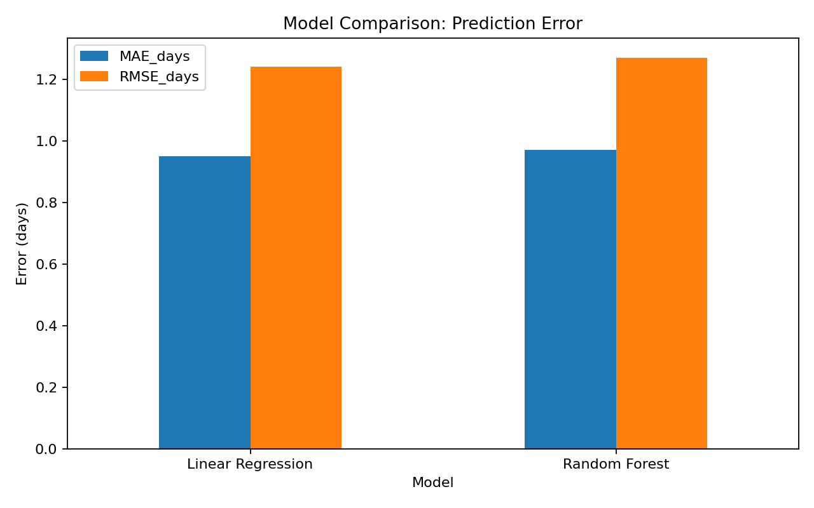
Compares the MAE and RMSE of the two models. Linear Regression has slightly lower errors on the test set.

Actual vs predicted transit days
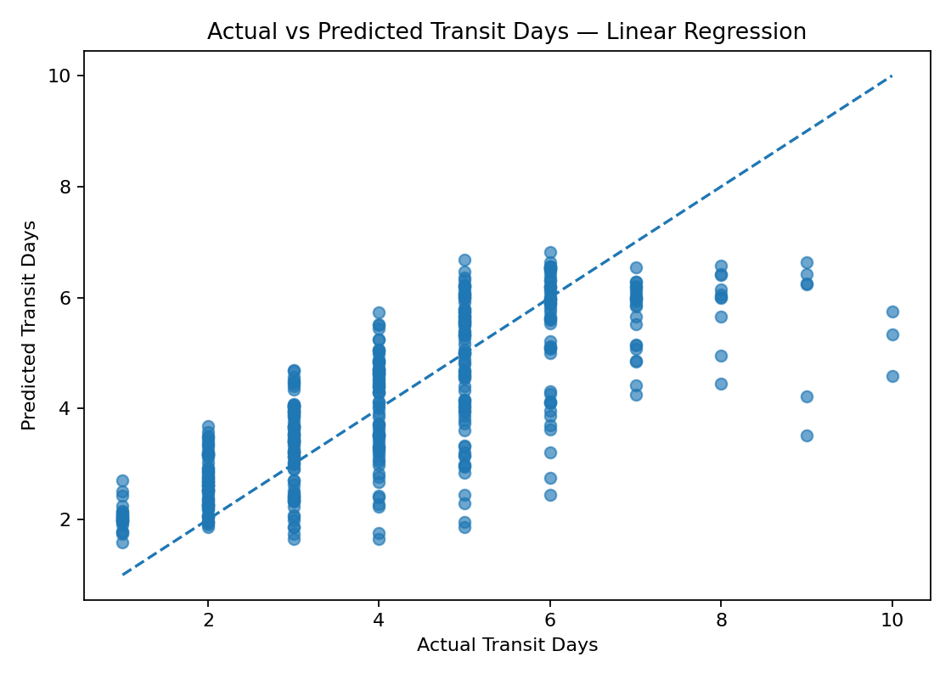
Points closer to the diagonal represent predictions closer to recorded transit duration.

Prediction residuals
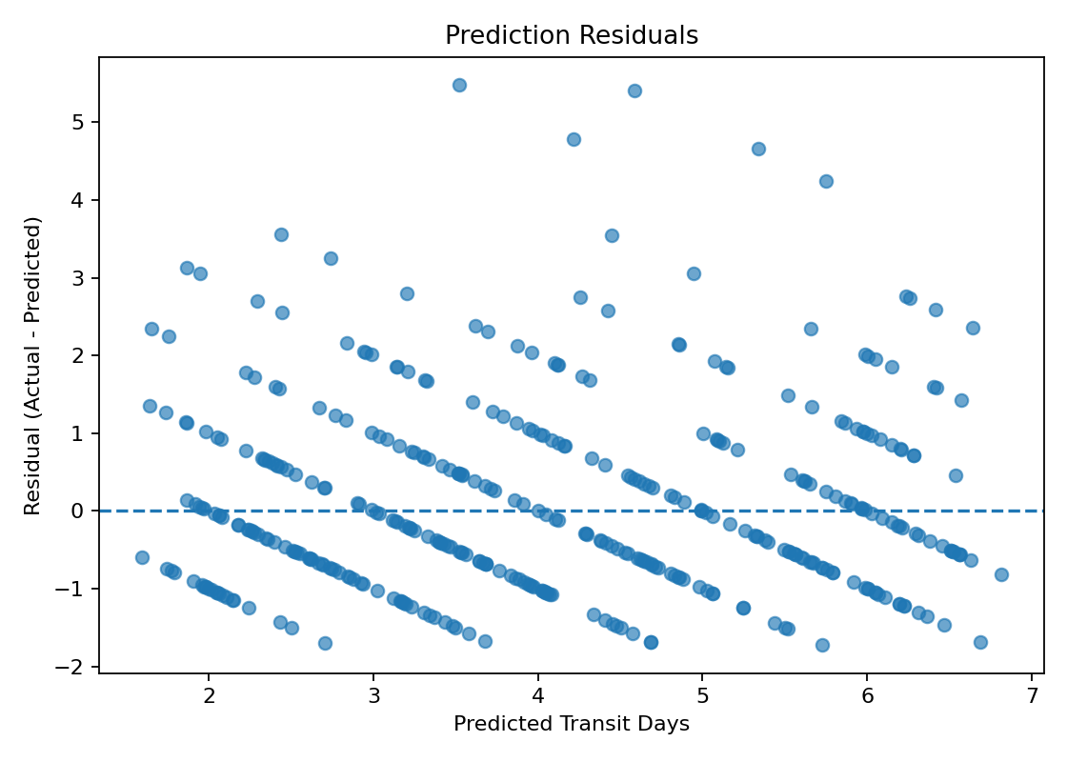
Residuals are actual minus predicted transit days. A pattern in residuals can indicate systematic prediction errors.

6. Optimization Recommendations
- Use predicted transit duration as a planning estimate and flag shipments whose predicted duration exceeds the service target.
- Review delays by carrier, origin warehouse, destination, and distance before changing carrier allocation.
- Compare cost and transit performance together; avoid choosing a carrier on speed or price alone.
- Investigate high-error cases and improve data quality, particularly missing costs, dates, and inconsistent transit records.
- Retrain and monitor the model periodically as routes, carrier performance, seasons, and shipping volumes change.
These are operational recommendations based on the analysis. This project does not calculate a mathematically optimal route or prove that a specific cost reduction will occur; those would require route/network constraints, service-level targets, and a dedicated optimization model.

7. Reproducibility
The Python script is included with the dataset. Install the dependencies with 'pip install pandas numpy matplotlib scikit-learn' and run 'python week4_predictive_model.py'. The script produces model_evaluation.csv, test_set_predictions.csv, and three chart images in the charts folder.

8. Conclusion
This project demonstrates a complete basic predictive-modelling workflow for logistics: feature preparation, train/test splitting, comparison of two regression models, error evaluation, visualization, and practical recommendations. On the current test split, Linear Regression performed slightly better than Random Forest. Further improvements could include cross-validation, additional shipment history, richer route features, and monitoring model errors after deployment.

