WEEK 3 PROJECT REPORT
Advanced Data Analysis
and Visualization in Logistics
Yuvaintern — Data Analytics Internship
Dataset | logistics_shipments_dataset.csv
Records / Fields | 2,000 rows / 11 columns
Tools | Python • pandas • NumPy • Matplotlib

1. Executive Summary
This report presents exploratory data analysis (EDA) and visualizations for a logistics shipment dataset containing 2,000 records and 11 fields. The analysis summarizes shipment status, transit time, shipping cost, carrier patterns, and relationships among numeric variables. Five charts are included to make patterns easier to interpret. The results are descriptive and should be used as a starting point for further investigation.

2. Objectives
- Inspect the dataset and calculate descriptive statistics.
- Summarize shipment status and operational performance metrics.
- Compare average transit time across carriers.
- Explore the relationship between shipping cost and distance.
- Measure correlations among weight, cost, distance, and transit days.
- Communicate findings and practical recommendations with visualizations.

3. Dataset and Preparation
The source dataset contains 2,000 rows and 11 columns. Important fields include Shipment_ID, Origin_Warehouse, Destination, Carrier, Shipment_Date, Delivery_Date, Weight_kg, Cost, Status, Distance_miles, and Transit_Days.
Initial checks found 41 missing Cost values and 32 missing Delivery_Date values. For analyses that require cost, missing Cost values were filled with the median in a separate column named Cost_Analysis. The original Cost column was retained unchanged. Missing delivery dates were not invented or imputed.

4. Descriptive Statistics
Metric | Result
Total shipments | 2,000
Delivered | 1,648 (82.4%)
Delayed | 199 (10.0%)
In Transit | 76
Lost | 45
Returned | 32
Mean transit time | 4.18 days
Median transit time | 4.00 days
Mean weight | 30.18 kg
Mean distance | 1275.87 miles
Mean cost for analysis | 204.98 (dataset currency units not specified)
Cost–distance correlation | 0.43
Cost–weight correlation | 0.02
Transit–distance correlation | 0.76

5. Visualizations and Interpretation

Figure 1. Shipment Count by Status
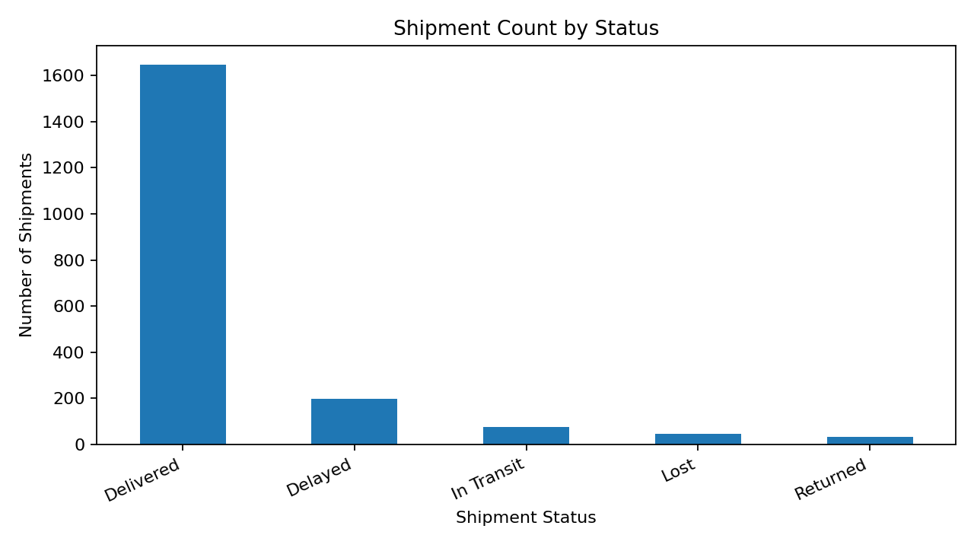
Delivered is the largest status group (1648 shipments), while 199 shipments are labelled Delayed. Lost and Returned shipments are smaller groups but deserve separate operational review. Status counts show volume, not necessarily the cause of each outcome.

Figure 2. Average Transit Days by Carrier
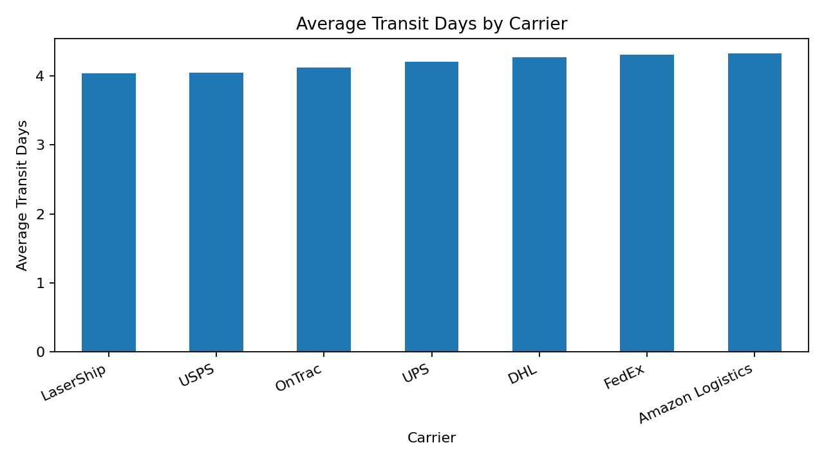
This chart compares average recorded transit duration by carrier. Differences may reflect routes, distances, shipment mix, or carrier performance; therefore, comparisons should be interpreted alongside those factors rather than used as a stand-alone carrier ranking.

Figure 3. Shipping Cost versus Distance
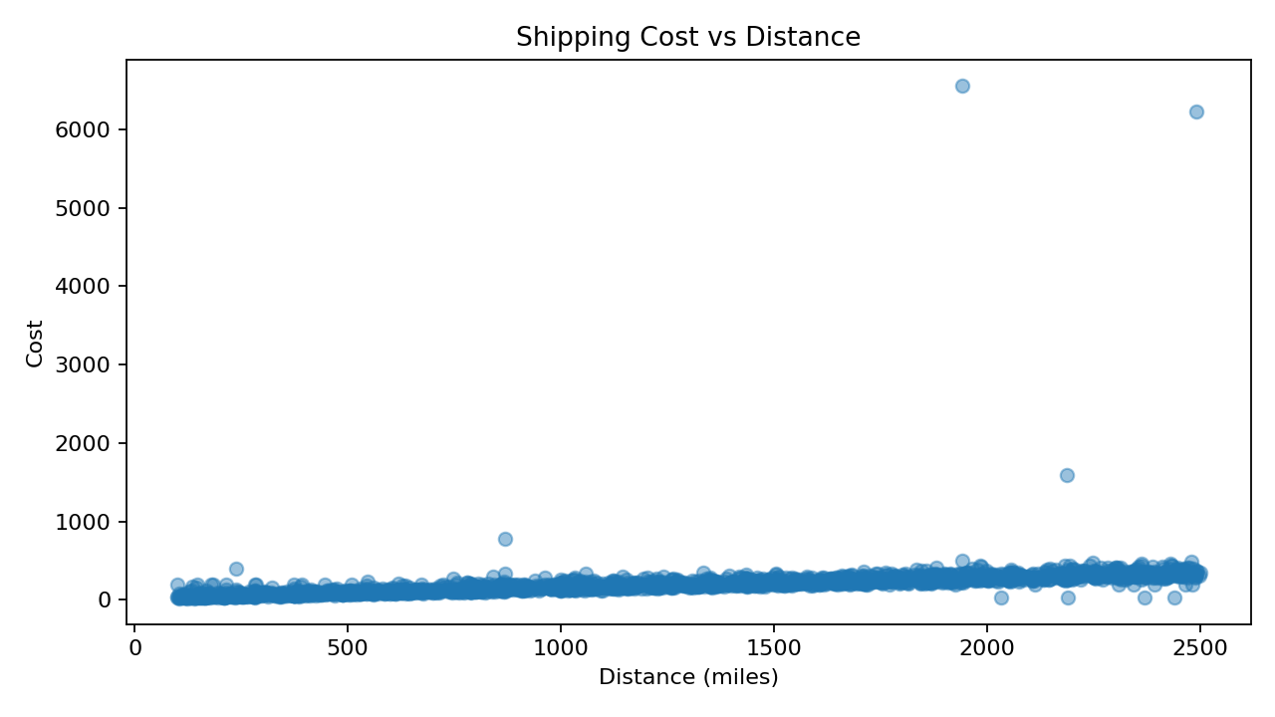
The scatter plot explores whether longer routes tend to have higher costs. The Pearson correlation between distance and cost in the analysis data is 0.43. Correlation describes association, not causation; weight, carrier, route, and service level may also affect cost.

Figure 4. Distribution of Transit Days
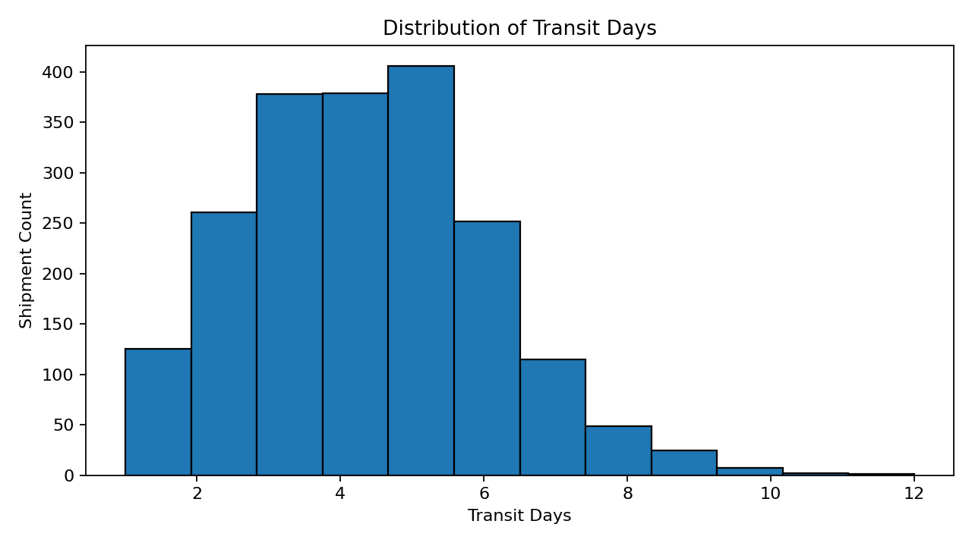
Transit durations have a mean of 4.18 days and a median of 4.00 days. The histogram shows how shipment durations are distributed and helps identify common transit-time ranges and unusual long-duration records.

Figure 5. Correlation Heatmap
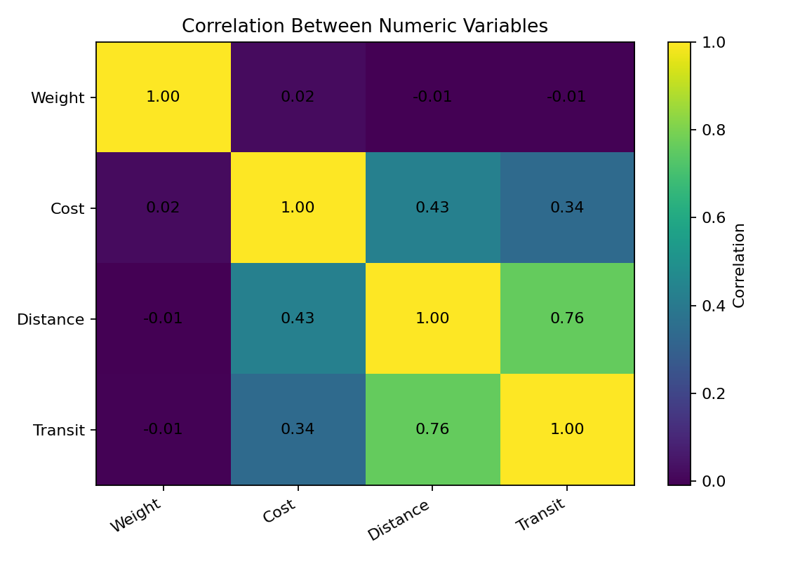
The heatmap summarizes pairwise linear correlations among weight, cost, distance, and transit days. Values nearer +1 indicate stronger positive linear association; values near 0 indicate weaker linear association. Correlation alone does not prove a causal relationship.

6. Analytical Insights
- Shipment status: 82.4% of records are marked Delivered and 10.0% are marked Delayed. A useful next step is to investigate delayed shipments by carrier, warehouse, destination, and distance.
- Transit duration: the mean is 4.18 days and the median is 4.00 days. Comparing these values and viewing the distribution helps assess whether a smaller number of longer shipments may influence the average.
- Cost drivers: cost and distance have a correlation of 0.43. This indicates the observed direction and strength of a linear relationship in this dataset, but other variables may contribute.
- Carrier comparison: average transit duration by carrier can help prioritize deeper review. Fair comparisons should control for route length, service type, shipment weight, and destination mix.
- Data limitations: cost values were median-imputed only for analysis; delivery dates remain missing where unavailable. Status and transit days are recorded fields and may not always tell the full story of a shipment.

7. Recommendations
- Review delayed shipments by carrier, origin warehouse, destination, and distance to locate recurring bottlenecks.
- Track the percentage of delayed, lost, and returned shipments over time in a dashboard.
- Use cost per mile and cost per kilogram as additional comparison metrics, while checking for differences in service levels and shipment types.
- Validate records with missing delivery dates before calculating delivery-time KPIs.
- Investigate unusually high or low costs and transit durations with operational context before excluding records.
- Repeat the analysis periodically and compare trends across time windows rather than relying on one snapshot.

8. Python Tools and Reproducibility
The accompanying script week3_logistics_analysis.py uses pandas for grouping and descriptive statistics, NumPy for derived calculations, and Matplotlib for charts. It exports summary CSV files and saves five chart images to the charts folder.
Install dependencies: pip install pandas numpy matplotlib
Run: python week3_logistics_analysis.py
Keep the script and logistics_shipments_dataset.csv in the same folder. Re-run the script whenever the input data changes.

9. Limitations
The dataset is a supplied logistics dataset and its currency, service-level definitions, and operational context are not specified. This analysis is exploratory, not causal. Correlations and carrier averages can be influenced by route and shipment mix. Missing cost values are imputed only for selected calculations, and missing delivery dates are not fabricated.

10. Conclusion
The analysis demonstrates how descriptive statistics and visualizations can summarize shipment outcomes, compare transit duration, explore cost-distance relationships, and highlight areas for operational review. The accompanying charts, Python script, and summary files provide a reproducible basis for further logistics analysis and data-driven decision-making.

