**RECRUITMENT HELPER**

**A PROJECT REPORT**

***Submitted by***

**KHUBCHANDANI ASHISH J. [1519BECE30134]**

**PUNJABI MAYUR L. [1519BECE30060]**

**KHATRI HITESH T. [1519BECE30038]**

***In fulfillment for the award of the degree***

***Of***

**BACHELOR OF ENGINEERING**

**In**

**COMPUTER ENGINEERING**



**LDRP INSTITUTE OF TECHNOLOGY AND RESEARCH, GANDHINAGAR**

**Kadi Sarva Vishwavidyalaya, Gandhinagar**

**2015 - 2019**

**LDRP Institute of Technology and Research**

Computer Engineering Department



**CERTIFICATE**

This is to certify that the Project Work entitled **“Recruitment Helper”** has been carried out by **Khubchandani Ashish J. , Punjabi Mayur L. , Khatri Hitesh T.** under my guidance in fulfilment of the degree of Bachelor of Engineering in Computer Engineering (7th Semester) of Kadi Sarva Vishwavidyalaya University, Gandhinagar during the academic year 2018-19.

**Guide:**

**Prof. Hitesh Patel Prof. Hiren B Patel**

Internal Guide, H.O.D. CE Dept.,

LDRP-ITR. LDRP ITR.

**ACKNOWLEDGEMENT**

We express our unfathomable sense of pleasure towards ***Mrs.Gargi Rajpara*** Principle of *LDRP-ITR*, who gave us a chance to work. She frequently came to motivate and provided such an extraordinary infrastructure and resources to work in her premises.

We express our deep sense of gratitude and indebtedness to our internal guide ***Mr. Hitesh Patel*** for accepting us to work under her training and supervision. She took prolonged interest in our work and directed to us toward the predefined goal. She has shown us a way to pursue excellence. She has been a big factor of motivation in our project.

We are also very thankful to our HOD of CE/IT department ***Prof. Hiren B Patel*** and all the faculty members who provided to be a constant motivation for the knowledge acquisition and the moral support throughout the whole project.

We sincerely thank our Computer Engineering Department, ***LDRP-ITR*** for the academic advancement it has provide to us during the whole Engineering degree and provided an opportunity for project training.

Last but not the least my heartily thanks is to my friends and batch mates, who have provided us with innumerable discussions on many technicalities and friendly tips.

We would like to express our heartiest gratitude to our family and friends who has always guided us towards the path of success and those entire people who have directly or indirectly helped us in making this project work successful.

**KHUBCHANDANI ASHISH J.**

**(1519BECE30134)**

**PUNJABI MAYUR L.**

**(1519BECE30060)**

**KHATRI HITESH T.**

**(1519BECE30038)**

**ABSTRACT**

Recruitment Helper is a Django and Machine Learning based Webapp that predicts whether or not an applicant can get placed in a company for the technology he wishes (e.g.: Java, Python, Android, iOS) and also allows company him/her to apply for that job if he/she meets the citeria. The flow starts from the company posting a job in a particular technology. An applicant can predict for the job and his data (marks, cpi etc.) will be analyzed by the Machine Learning Algorithm and tells whether the results are in his favor or not (he might get placed or not). All this happens using the predefined Machine Learning Algorithm and the data of the Students already placed in that technology in that company. Consisting of two modules 1)Placement Predictor and 2)Recruitment Helper, this webapp combinedly can help student and recruiter in making recruitment process easier.

**TABLE OF CONTENTS:**

Acknowledgement iii

Abstract iv

Table of Contents v

List of Figures vi

List of Tables vii

1. **Introduction 1**
   1. Introduction 2
   2. Scope 2
   3. Project summary and Purpose 2
   4. Objectives 3
2. **Technology and Literature Review 4**
   1. About Tools and Technology 5
   2. Brief History of Work Done 5
3. **System Requirements Study 6**
   1. User Characteristics 7
   2. Software Requirements 7
   3. Constraints 7
      1. Parallel Operations 7
      2. Reliability Requirements 8
      3. Criticality of the Application 8
      4. Safety and Security Consideration 8
      5. Hardware Limitations 8
      6. Regulatory Policies 8
   4. Assumptions and Dependencies 9
4. **System Analysis 10**
   1. Study of Current System 11
   2. Feasibility Study 11
   3. Requirements Validation 13
   4. Class Diagram 13
   5. System Activity(Use case and/or scenario diagram) 15

4.6 Sequence Diagram 18

1. **System Design 20**
   1. Database Design 21
   2. Data Flow Diagram 23
2. **Bibliography 26**

**LIST OF FIGURES**

|  |  |  |
| --- | --- | --- |
| **NO** | **NAME** | **PAGE NO** |
|  |  |  |
| 1 | Class Diagram | 14 |
| 2 | Use case for System | 16 |
| 3 | Use case for Prediction | 17 |
| 4 | Sequence Diagram | 19 |

5 DD for auth_user Details 21

6 DD for Userdata Details 21

7 DD for Student Details 22

8DD for Company Details22

9 DD for Post Details 23

10Level-0 DFD for System23

11Level-1 DFD for Student 24

12Level-2 DFD for Company 25

13Level-3 DFD for Graduated Students 25

**LIST OF TABLES**

|  |  |  |
| --- | --- | --- |
| **NO** | **NAME** | **PAGE NO** |
|  |  |  |
| 1 | Auth_user Details | 21 |
| 2 | Userdata Details | 21 |
| 3 | Student Details | 22 |
| 4 | Company Details | 22 |

5 Post Details 23

|  |
| --- |
|  |

# 1 INTRODUCTION

* **INTRODUCTION**
* **SCOPE**
* **PROJECT SUMMARY AND PURPOSE**
* **OBJECTIVES**

* 1. **Introduction**

Recruitment Helper is a Webapp made for Students and Company. It helps students by informing them about different Companies who want to Recruit. Students can also check whether they are eligible for particular job in particular company. Companies can add or remove any Job Post which will appear on Students’ screen. Company can also shortlist students. Also recommendation is available to company through which they can have best candidate for job. On the other hand Student can predict the chances of him getting placed and also he can then apply in that job. Our machine learning models Predict whether the Student is eligible to be Recruited or not and provide necessary functionalities which are helpful for Shortlisting and Recommendations.

* 1. **Scope**

**1.2.1 Current Scope**

The system is calibrated for marking of CPI, Project Marks, Marks in various Technologies, Aptitude Marks. The system is currently working for particular institute. At present only 5-6 Subjects or Technologies are added. The system works for Company and the Students who are either graduated or not.

**1.2.2 Future Scope**

In future we will include better accuracy comparison in ML model. More branches and more technologies related to those branches will be added. We will generalize this system in future. Will add more technologies and more branches. We will also implement notification system in which student is notified for a job as soon as it is posted.

* 1. **Project summary and Purpose**
     1. **Project Summary**

The project “Recruitment Helper” is a system build to help students to know whether they are eligible to be recruited for a particular company or not and companies to get connected to directly with students. It basically gives prediction to student about his stats are either favorable to apply for a particular company in a particular technology or not and then based on that prediction students can apply for a job. On companies’ side, a company can get recommendations based on profile of student and from that result company can shortlist students. These modules are based on ML algorithms.

* + 1. **Purpose**

The purpose of this project is to make placement or recruitment systems easy. This system provides estimate for students to know that for which company they are eligible to apply based on given technology. As this is estimate or prediction the students can know their capabilities prior of recruitments and can work hard for companies of their choice to get recruited.

* 1. **Objectives**

There are objectives that specify how the system should work for fulfilling the purpose of developing it. Below are the objectives for Placement Predictor:

* The system should provide good user interface.
* This system should minimize complexity and should provide efficiency.
* The application should consume less memory space and should fit in any device without taking much time for loading.
* This system should provide security as we are dealing with the databases.
* This system should be flexible enough of being updated.
* The system should provide better prediction.

# 2 TECHNOLOGY AND LITERATURE REVIEW

* **TOOLS AND TECHNOLOGY**

**2.1 Tools and Technology**

**2.1.1 HTML, CSS and JS:**

HTML stands for Hypertext Markup Language and CSS stands for Cascading Style Sheets are the crucial technologies for creating web pages. HTML supplies the structure of the page, and CSS the layout, for diversity of devices. Together with scripting and graphics, HTML and CSS are the fundamental of building Web Applications and Web pages. Javascript is a dynamic computer programming language. It is lightweight and most commonly used as a part of web pages, whose implementations allow client-side script to interact with the user and make dynamic pages. It is an interpreted programming language with object-oriented capabilities.

**2.1.2 Python:**

Python is a high-level, interpreted, interactive and object-oriented scripting language. Python is designed to be highly readable. It uses English keywords frequently where as other languages use punctuation, and it has fewer syntactical constructions than other languages.

**2.1.3 Django:**

Django is a high-level Python web framework that enables rapid development of secure and maintainable websites. Built by experienced developers, Django takes care of much of the hassle of web development, so you can focus on writing your app without needing to reinvent the wheel. It is free and open source, has a thriving and active community, great documentation, and many options for free and paid-for support.

**2.1.4 Machine Learning**

Machine learning is a field of [computer science](https://en.wikipedia.org/wiki/Computer_science) that uses statistical techniques to give [computer systems](https://en.wikipedia.org/wiki/Computer_systems) the ability to "learn" (e.g., progressively improve performance on a specific task) with [data](https://en.wikipedia.org/wiki/Data), without being explicitly programmed.

# 3 SYSTEM REQUIREMENTS STUDY

* **USER CHARACTERISTICS**
* **HARDWARE AND SOFTWARE REQUIREMENTS**
* **CONSTRAINTS**
* **ASSUMPTIONS AND DEPENDENCIES**

**3.1 User Characteristics**

Students and companies that recruit students can use this system. No prior knowledge needed to operate this website although:

* User must have a device either PC or Mobile phone.
* User must have any kind web browser.
* User must have Internet connection.

**3.2 Software Requirements**

Software Requirements are used to describe the minimum hardware and software requirements to run the Software. These requirements are described below.

**3.2.1 Software Requirements**

* **User**
* Web Browser: Any JS Compliant Browser
* Technologies: HTML, CSS, JS
* **Server:**
* Operating System: WINDOWS or LINUX OS
* Database MySQL
* Technologies: Django, Python

**3.3 Constraints**

**3.3.1 Parallel Operations**

The project is on basis of multi-user. This is used for carrying out updating as well as entry by preventing the redundancy of the data.

**3.3.2 Reliability Requirements**

Reliability requirements of the system are one of the prime ones in the list. The system is needed to be highly reliable in terms of performance and capable of delivering robust performance. If the reports are generated within 5 seconds then the system is said to be reliable.

**3.3.3 Criticality of the Application**

The system can stop working on computers with very low internet connection. Other than that there won’t be any issues. Apart from these the system should be able to make updates at regular time intervals.

**3.3.4 Safety and Security Consideration**

Safety and security too are other major concerns of any system. It is necessary to provide safety and security as the system is web application and might be intrude by security threats from the internet. Thus, the code needs to be encrypted and any transaction needs to be done securely.

**3.3.5 Hardware Limitations**

Hardware Limitations are other constraint of the system. Hardware Limitations should be overcome for better performance of the system. This can be achieved by using minimum and only necessary hardwares.

**3.3.6 Regulatory Policies**

**Regulatory policy** is about achieving organization’s objectives through the use of regulations, laws, and other instruments to deliver better economic and social outcomes and thus enhance the life of business. Thus the system should be developed by using these regulations to provide better outcome to the company.

**3.4 Assumptions and Dependencies**

**3.4.1 Assumptions**

• Database transactions are assumed to be secure and reliable.

• User is the person having enough knowledge to operate a device.

• We will provide a user friendly interface so that any user can easily navigate through the system, but he/she should be capable of providing valid credentials for successful login.

• The server used for data storing is always secured.

**3.4.2 Dependencies**

• The system is dependent upon the user’s valid credentials. If user inputs wrong username or password, he/she will not be allowed to login to the system.

• This application depends on the server and internet as all the information is collected and then stored in the server through secure internet connection.

# 4 SYSTEM ANALYSIS

* **STUDY OF CURRENT SYSTEM**
* **FEASIBILITY STUDY**
* **REQUIREMENTS VALIDATION**
* **CLASS DIAGRAM**
* **SYSTEM ACTIVITY(USECASE DIAGRAM)**
* **SEQUENCE DIAGRAM**

**4.1 Study of current system**

* In current system, there is no such system to predict or estimate the eligibility of the Student in Placements.
* All things are done manually and Students are informed about a company visiting Campus only by the Placement Officer.
* So, the students can’t prepare well before their interviews.
* There is no direct communication between the Company and Student.

**4.2 Feasibility Study**

An important outcome of the preliminary investigation is the determination that the system requested is feasible. The feasibility study is carried out to examine the likelihood that the system will be useful to the organization.

There are three aspects in the feasibility study namely:

* Operational Feasibility
* Technical Feasibility
* Economic Feasibility

**4.2.1 Technical Feasibility:**

The main purpose of checking Technical Feasibility is to examine whether the current technology is sufficient for the development of the system.

The outcomes of the technical feasibility are as follows:

* The application developed in Django ( Python Framework ) can run on any of the web browser like Opera, Fire-Fox, Chrome, Safari etc.
* Back end we can use MySQL Database for database connection.
* It provides faster response to the user.

So, this application is Technically Feasible.

**4.2.2 Operational Feasibility:**

The main purpose of checking Operational Feasibility is to find out whether the system will be functional after its development and installation or not.

The outcomes of the operational feasibility are as follows:

* This application provides Basic Interface for the Students to Predict about their Placement.
* The Application can be accessed remotely from anywhere but requires Internet Connection.
* So, it is supposed to improve the current Scenario of Recruitment System in Colleges.

So, this application is operationally feasible.

**4.2.3 Economic Feasibility:**

The main purpose of checking Economical Feasibility is to examine whether the financial investment in the system will meet the organization’s requirements or not.

The outcomes of the technical feasibility are as follows:

* Proposed System is developed as web application which is freely available on WWW.
* It uses HTML, CSS, JS in front end that is also freely available and in the backend, Django is used which is free for usage.
* The advantages of the system nullify its development cost as the scope and effect of the system are very large.

So, this application is economically feasible.

**4.3 Requirements Validation**

The Basic validation from user side is to detect wrong information or blank information:

* When the user has entered correct username and password, then he/she is allowed to enter information or to see the information either into the database or from the database.
* If any field from username or password remains blank, then user will not be allowed to enter into the system.
* If a user leaves some fields blank in signup form then he/she does not allowed submitting his/her information.
* If user has entered wrong data then accordingly message will generate automatically.
* The passwords that has Student’s name or Username as substring are not allowed.
* All numbers are not allowed in the Password.
* Commonly used password are not allowed.

**4.4 Class Diagram**

A class diagram is a graph of classified elements connected by their various static relationships. It is shown here for Client Support System. This includes the System and the End-users as its main classes. Here are three different fields: Class, Attributes, and Operations.

Class shows the class name, i.e., System, End-user, Data and Sign Clip. They are connected with each other through links and their relation with each other is shown through the numbers represented on the link; here **\*** indicates zero or more multiplicity. Here Data class is connected to System through a Composition link which is the collaboration of all participants are part of one composite class.

Attributes provide the details of the Class while Operations show all possible operations respective class can do in the system.

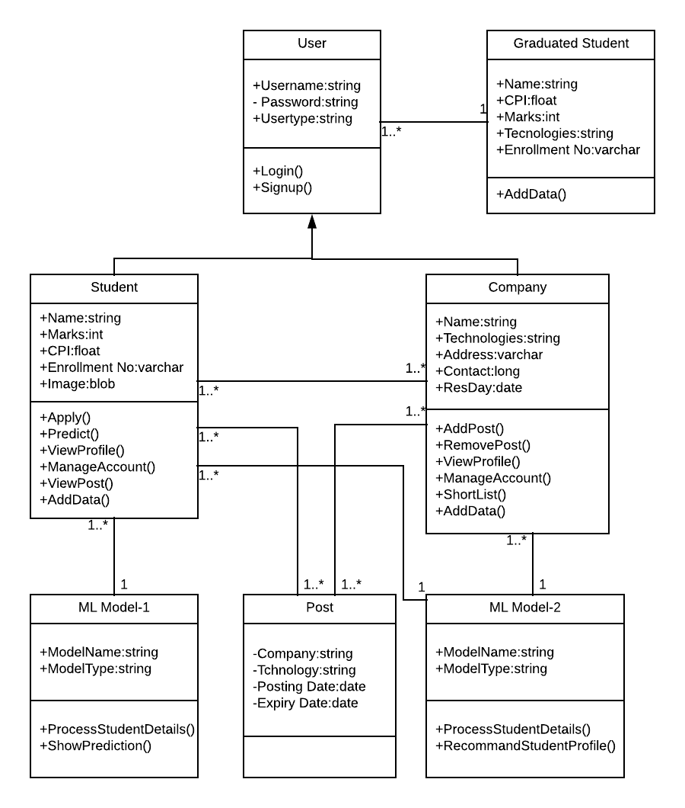

Figure 4.4(a): Class Diagram for Placement Predictor

**4.5 System Activity**

A use case diagram shows the relationship among actors and use cases within a system. Hence it provides the characteristics of the actors whose behavior and relationships can be well understood using the diagrams elaborated here.

An end-user can perform various tasks on the application; he may use signs or upload a new sign o his own. On the other hand, the system would respond to the operations done by the user. It would display the sign clips and store the uploaded sign to the defined category. Also it would provide a message whenever needed for confirmation.

Here the rectangle indicates system boundary, out of which there are actors found who perform various operations on the system which are the end-user and the system here. An elliptical shape shows the use-case while the connecting links between an actor and a use case are said to be communicates.

* **Use Case Diagram for System**

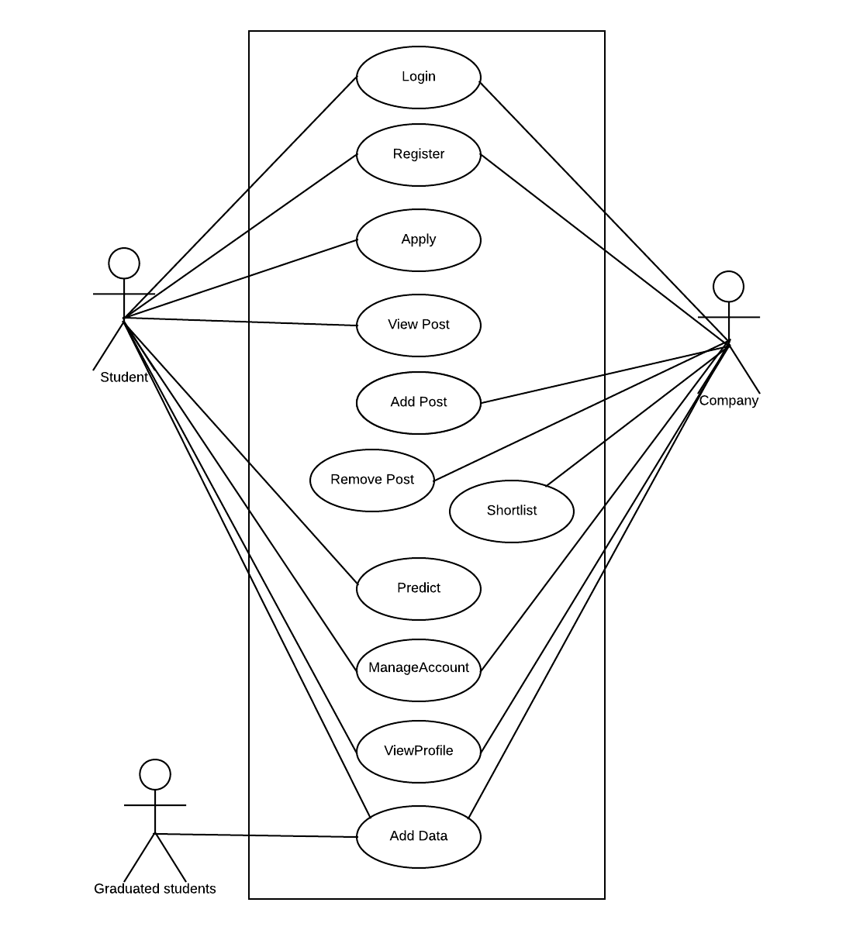

Figure 4.5(a): Use case diagram for System

* **Use Case Diagram for Prediction**

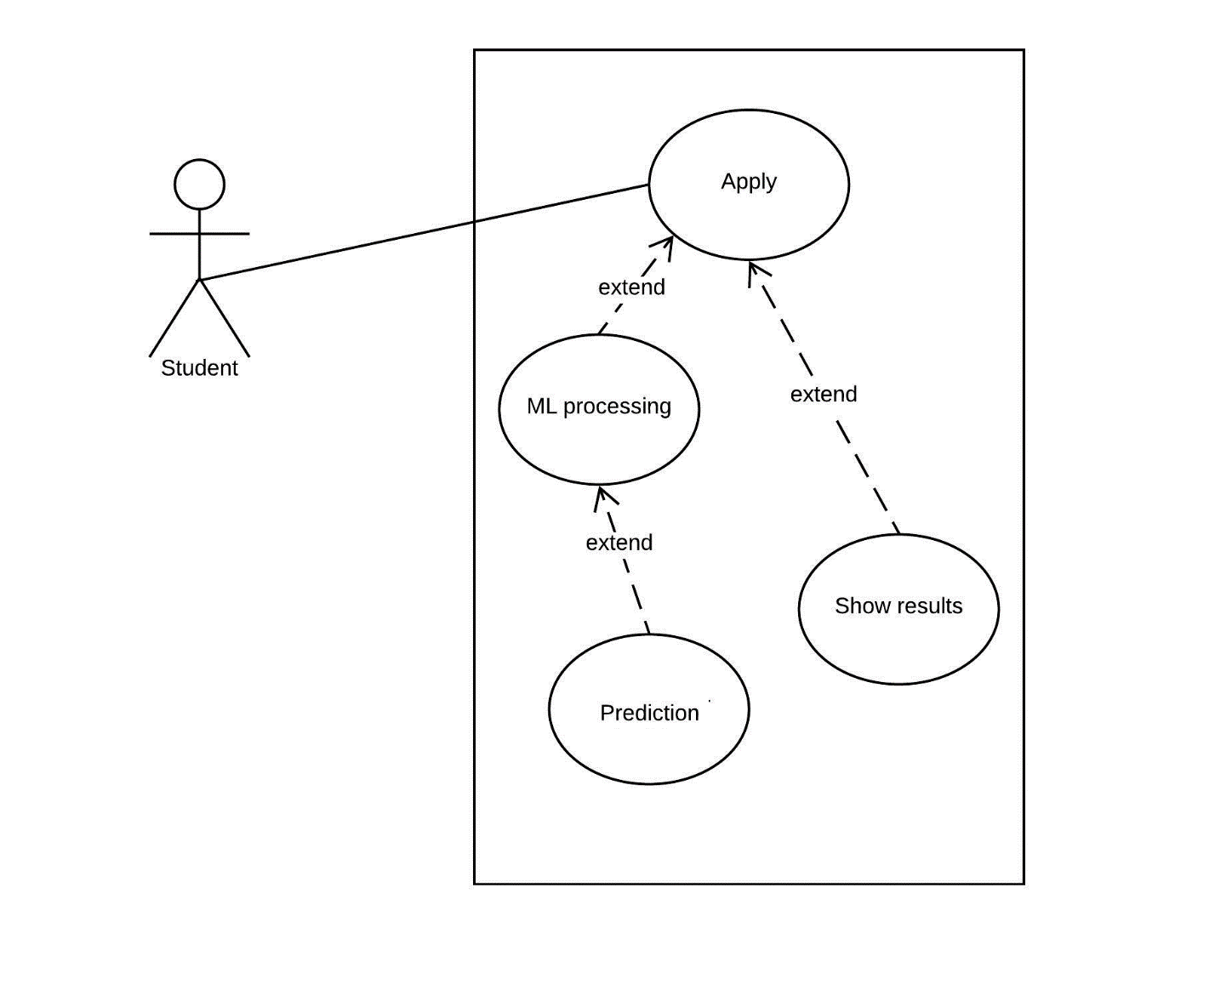

Figure 4.5(b): Use case diagram for Prediction

**4.6 Sequence Diagram**

A sequence diagram represents an Interaction, which is a set of messages exchanged among objects within collaboration to effect a desired operation or result. Here are the sequence diagrams for various interactions among the user, system and the data storage. It must be noted that the rectangle box on the top of the diagram indicates the object or actor and dashed lines beneath to it shows an object’s lifeline. Another rectangles following and followed by the dashed lines in a vertical manner show the activation period of the object or actor when it performs some actions. A solid arrow conveys a message while the dashed arrow gives return message. These message names are written along with their respective arrows as shown further in the diagram.

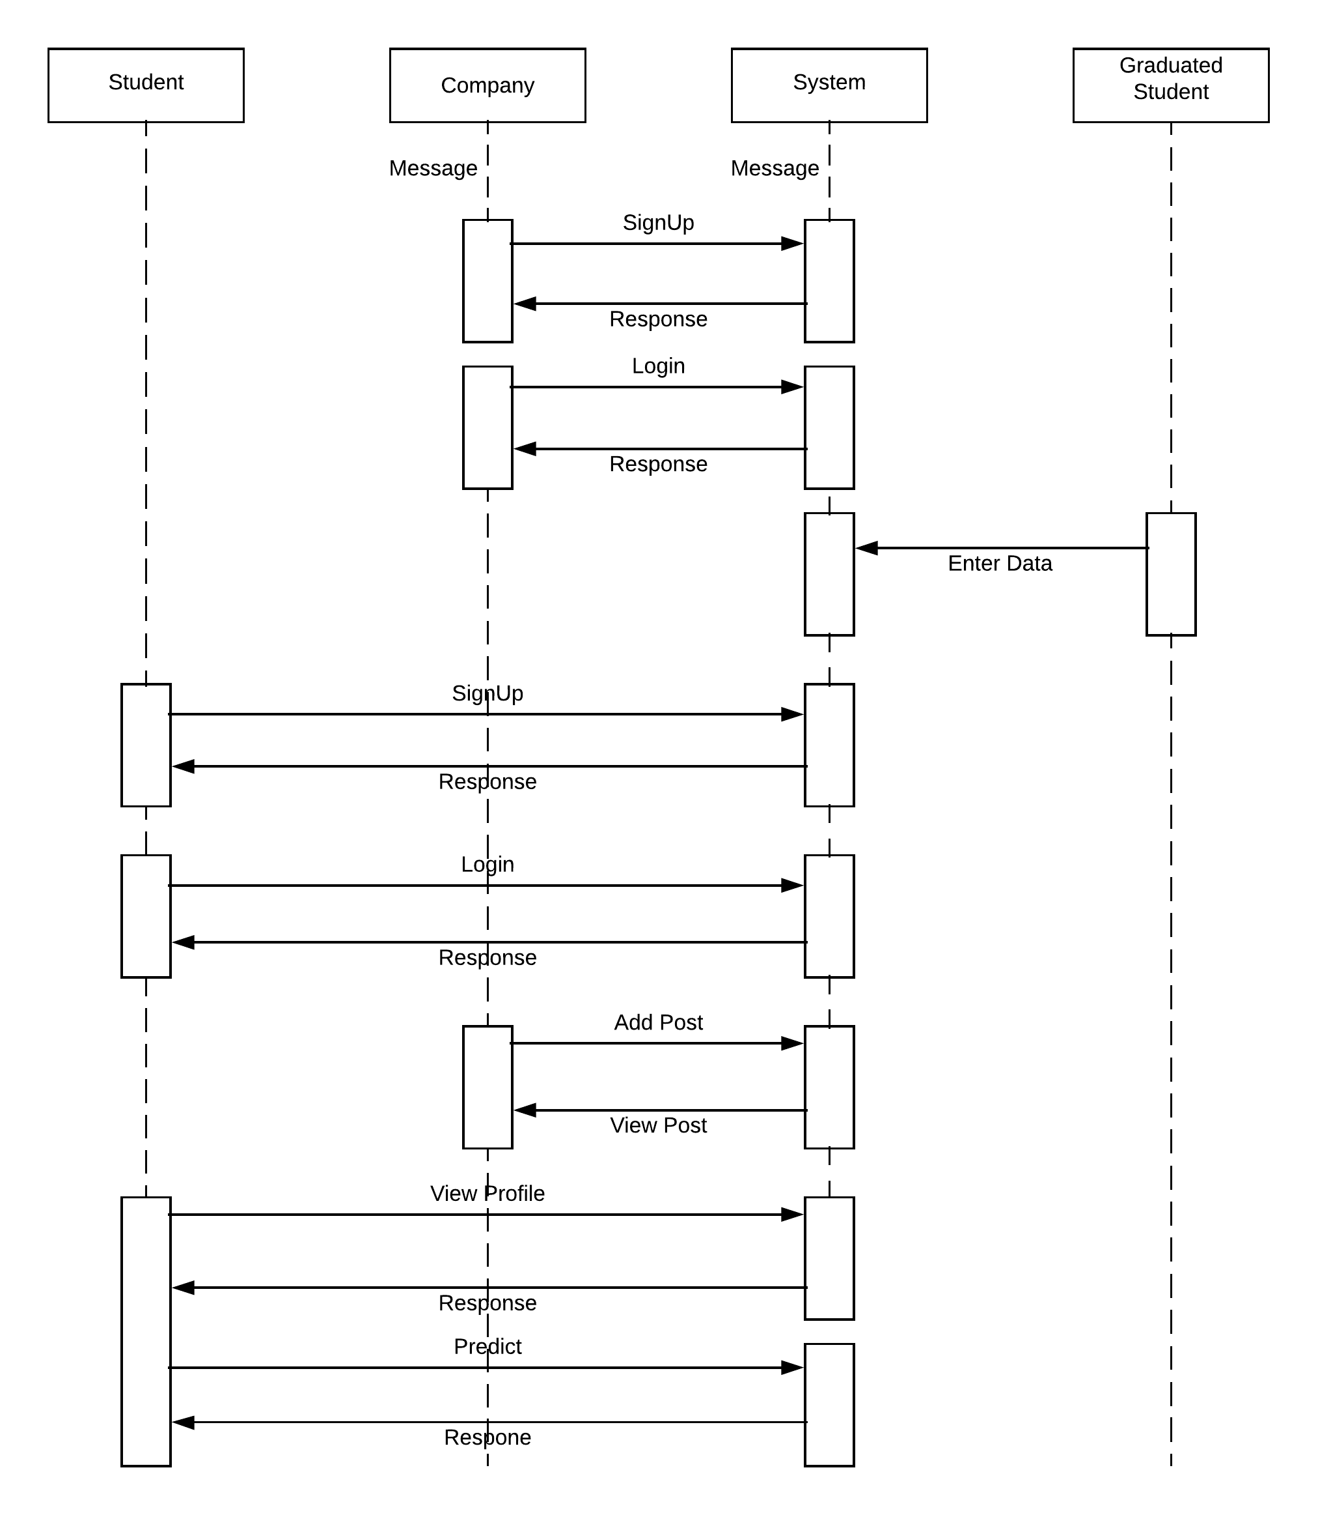

Figure 4.6(a): Sequence Diagram for Placement Predictor

# 

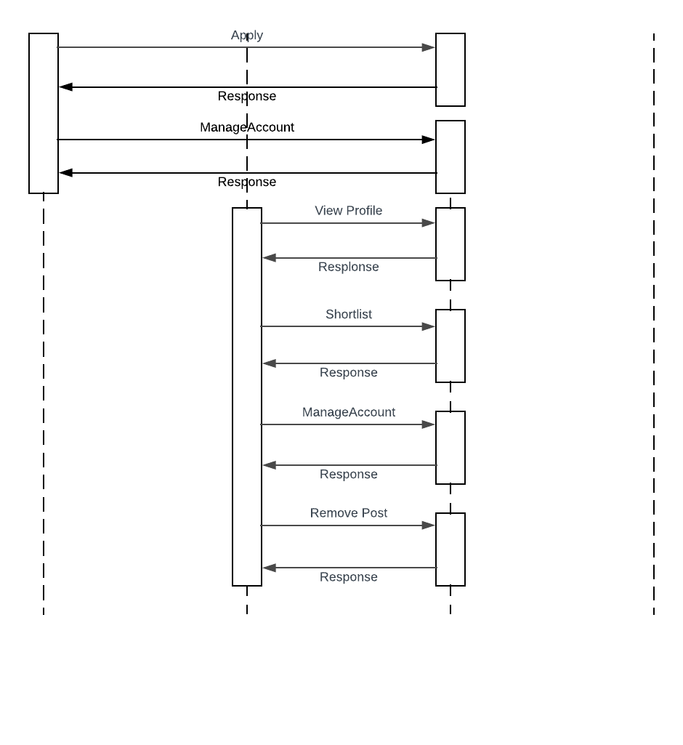

Figure 4.6(a): Sequence Diagram for Placement Predictor

# 5 SYSTEM DESIGN

* **DATABASE DESIGN**
* **DATA FLOW DIAGRAM**

**5.1 Database Design**

The current web application uses Oracle Database to store, access and retrieve the data.

Following is the data dictionary that describes the required tables along with their fields.

**5.1.1 Auth_user Details:**

The following table is used to store login details

|  |  |  |  |
| --- | --- | --- | --- |
| **Field** | **Data Type** | **Length** | **Constraint** |
| username | varchar2 | 150 | not null |
| Password | varchar2 | 128 | not null |
| id | int | 11 | Primary key |

Table 5.1(a) Login Details

**5.1.2 Userdata Details:**

The following table is uses to store consultant details

|  |  |  |  |
| --- | --- | --- | --- |
| **Field** | **Data Type** | **Length** | **Constraint** |
| name | varchar2 | 150 | Not null |
| cpi | float | 5 | not null |
| projectmarks | int | 5 | not null |
| marks | int | 5 | not null |
| recruitment | int | 1 | not null |

Table 5.1(b) User Details

**5.1.3 Student Details:**

The following table is uses to store client details:

|  |  |  |  |
| --- | --- | --- | --- |
| **Field** | **Data Type** | **Length** | **Constraint** |
| id | int | 11 | Primary Key |
| name | varchar | 150 | not null |
| username | varchar | 150 | not null |
| cpi | float | 5 | not null |
| projectmarks | int | 11 | not null |
| aptitudemarks | int | 11 | not null |
| java | int | 11 | not null |
| android | int | 11 | not null |
| python | int | 11 | not null |
| ios | int | 11 | not null |

Table 5.1(c) Student Details

**5.1.4 Company Details:**

The following table is uses to store client contact details:

|  |  |  |  |
| --- | --- | --- | --- |
| **Field** | **Data Type** | **Length** | **Constraint** |
| id | int | 11 | Primary Key |
| name | varchar | 150 | Foreign Key |
| username | varchar | 150 | not null |
| android | tinyint | 1 | not null |
| java | tinyint | 1 | not null |
| ios | tinyint | 1 | not null |
| python | tinyint | 1 | not null |

Table 5.1(d) Company Details

**5.1.5 Post Details:**

The following table is uses to store call log details:

|  |  |  |  |
| --- | --- | --- | --- |
| **Field** | **Data Type** | **Length** | **Constraint** |
| id | int | 11 | Primary Key |
| company | varchar | 150 | not null |
| android | tinyint | 1 | not null |
| java | tinyint | 1 | not null |
| python | tinyint | 1 | not null |
| ios | tinyint | 1 |  |

Table 5.1(e) Post Details

**5.2 Data Flow Diagram**

**5.2.1 Context Level**

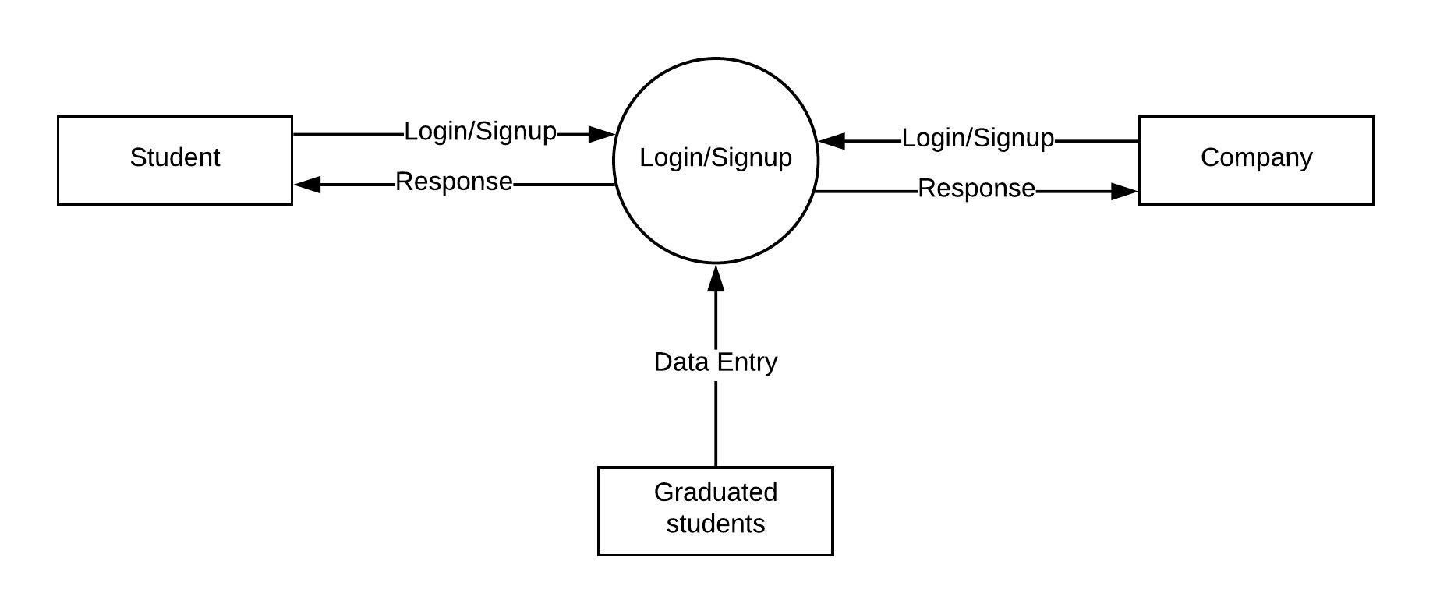

Figure 5.2(a): Level-0 DFD for System

**5.2.2 Level-1 DFD for Student**

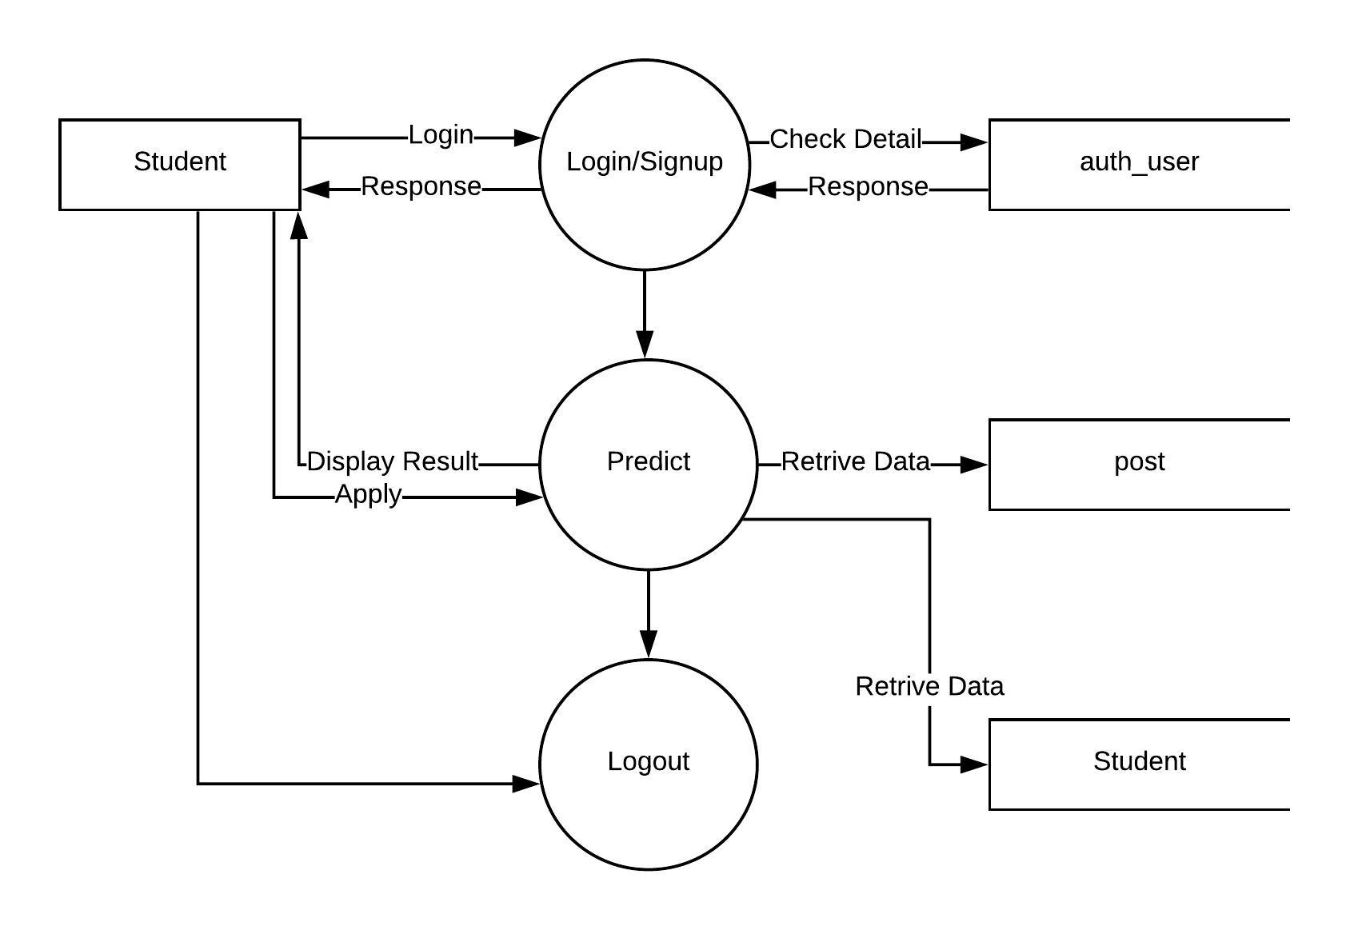

Figure 5.2(b): Level-1 DFD for Student

**5.2.3 Level-2 DFD for Company**

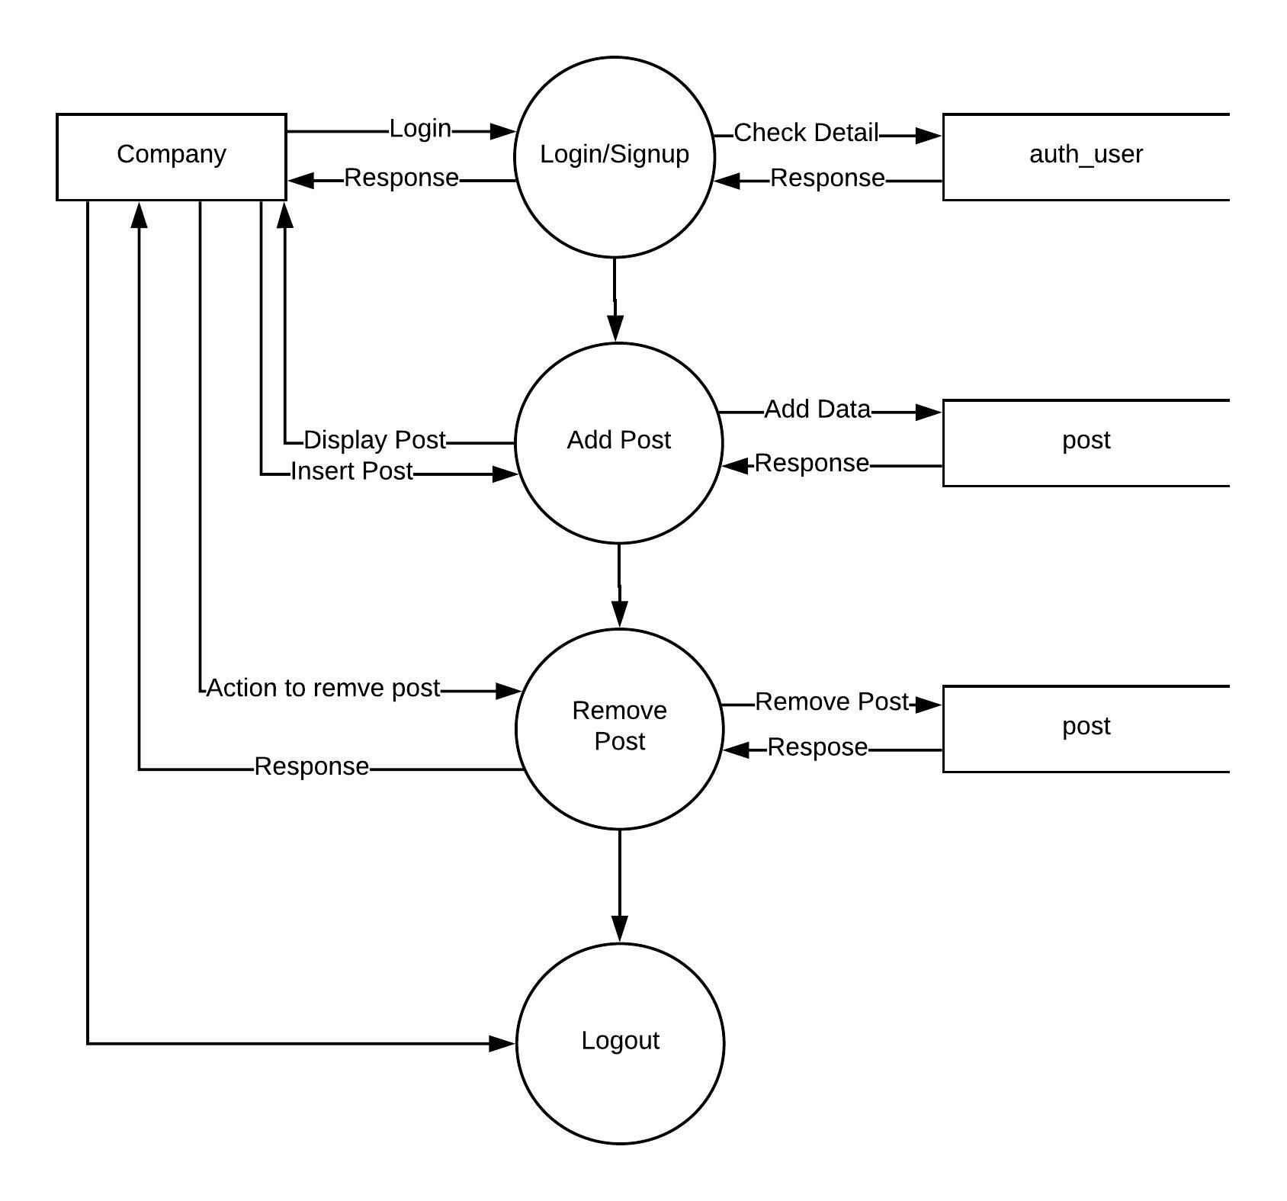

Figure 5.2(c): Level-2 DFD for Company

**5.2.4 Level-3 DFD for Graduated Students**

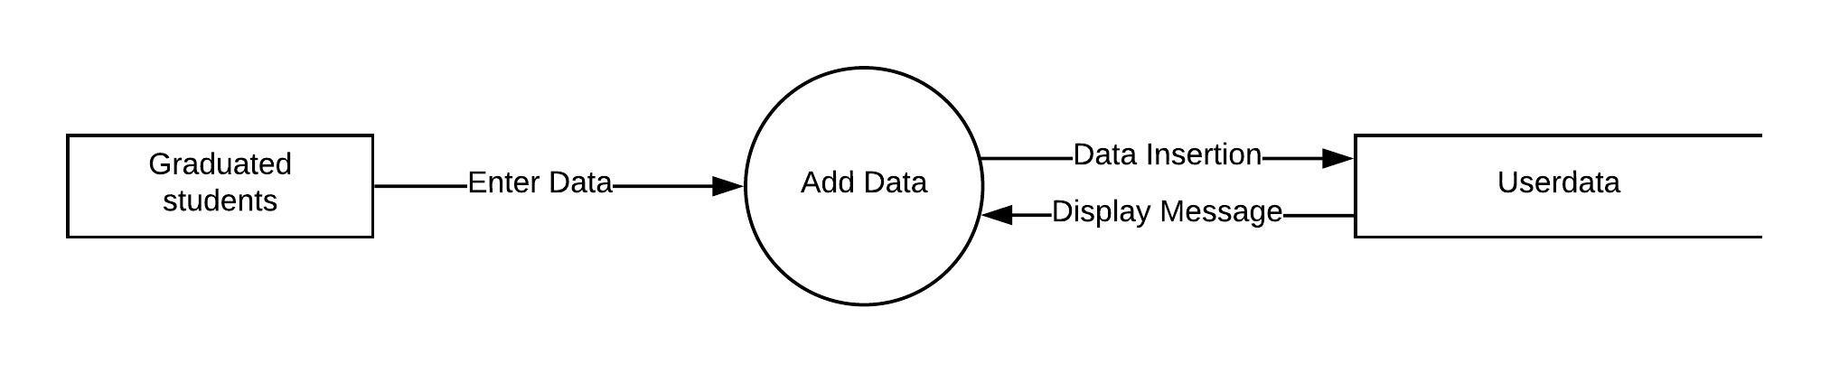

Figure 5.2(d): Level-3 DFD for Graduated Students

# 6 BIBLIOGRAPHY

* **CONCLUSION**
* **BIBLIOGRAPHY**

**6.1 Conclusion**

Recruitment Helper is a Django and Machine Learning based Webapp that predicts whether or not an applicant can get placed in a company for the technology he wishes (e.g.: Java, Python, Android, iOS).

The flow starts from the company posting a job in a particular technology. An applicant can predict for the job and his data (Marks in Technologies, Cpi, Aptitude Marks etc.) will be analyzed by the Machine Learning Algorithm and tells whether the results are in his favor or not (he might get placed or not).

All this happens using the predefined Machine Learning Algorithm and the data of the Students already placed in that technology in that company.

Thus, the Portal gives a vague idea to the applicant about where he can get recruited or where he should work hard to get recruited.

**6.2 Bibliography**

**Web Resources**

* [www.developer.mozilla.org](http://www.developer.mozilla.org)
* [www.mysql.com](http://www.mysql.com)
* [www.stackoverflow.com](http://www.stackoverflow.com)
* [www.djangoproject.com](http://www.djangoproject.com)

**Books**

* SQL, PL/SQL by Ivan Bayross, BPB Publications
* Object Oriented Modelling and Design with UML (second edition)

by Michael Blaha and James Rambaugh

* Software Engineering by Roger S. Pressman
* Software Engineering by K.K. Agrawal