Input

import 'package:flutter/material.dart';  
  
void main() {  
 runApp(const MaterialApp(  
 debugShowCheckedModeBanner: false,  
 home: SafeArea(  
 child: Center(  
 child: Text("Hello\n\n\n\n\n\nDart\n\n\n\n\n\nflutter"),  
 ),  
 ),  
 ));  
}

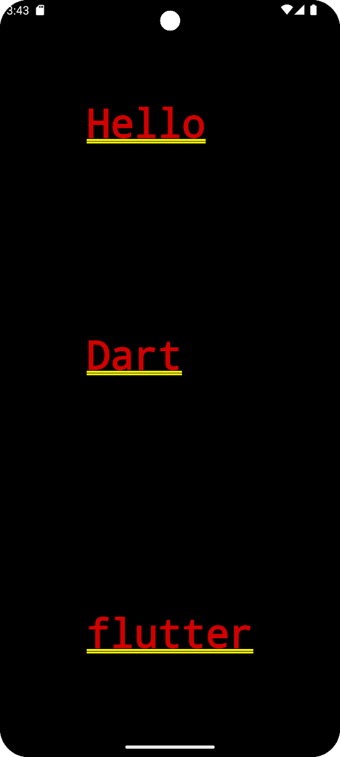Output