PROJECT DOCUMENTATION
Retail Policy Intelligence &
Decision Support System
An SLO-bound, multi-agent compliance question-answering platform built on FastAPI, LangGraph and LlamaIndex. This document describes the complete project — its architecture, agents, evidence paths, data model, security model, service-level objectives and evaluation.
Attribute | Value
Project type | Capstone — Agentic AI (SLO-bound autonomous system)
Author | Mohit Madireddy
Date | September 2026
Runtime | Python 3.12, FastAPI, LangGraph, LlamaIndex
Models | Azure OpenAI gpt-4o (strong) + gpt-4o-mini (small)
Data | PostgreSQL + pgvector; 7 policy documents; 4 domain tables
Evidence paths | 5 — RAG, NL2SQL, hybrid, agentic, high-risk panel
RBAC roles | 5
Automated tests | 730+ test functions · 53-query golden set
Contents
1. Executive summary 4
1.1 Key takeaways 4
1.2 Documents in this set 4
2. Problem statement and objectives 5
2.1 Background 5
2.2 The problem 5
2.3 Objectives 5
2.4 Scope 5
3. System architecture 6
3.1 Layer responsibilities 6
3.2 Cross-cutting concerns 7
3.3 Design principles 7
4. End-to-end agent workflow 8
4.1 Request lifecycle 8
4.2 Terminal outcomes 9
4.3 SLO measurement points 9
5. Agent catalogue 10
5.1 Intent Classification Agent 10
5.2 Retrieval Agent 10
5.3 Risk Assessment Agent 10
5.4 Planner and Intelligent Router 10
5.5 Compliance Validation Agent 10
5.6 High-Risk Multi-Agent Panel 10
5.7 Escalation Manager Agent 11
6. Risk assessment 12
6.1 Three-layer fusion 12
6.2 Mandatory high-risk scenarios 12
7. Intelligent routing and evidence paths 13
7.1 The five evidence paths 13
7.2 Deterministic path policy 13
7.3 Evidence-preserving degradation 13
8. Knowledge layer: ingestion and retrieval 14
8.1 Policy corpus 14
8.2 Ingestion pipeline 14
8.3 Hybrid retrieval 14
9. Structured data and safe SQL 15
9.1 Data model 15
9.2 Two-tier SQL 15
9.3 Time is a literal 15
10. Validation, confidence and the release gate 16
10.1 Confidence scoring 16
10.2 Release gate 16
11. Human-in-the-loop 17
11.1 Escalation flow 17
11.2 Context package 17
12. Security and governance 18
12.1 Authentication and RBAC 18
12.2 Guardrails 18
13. SLOs, reliability and observability 19
13.1 Service-level objectives 19
13.2 Budgets and deadlines 19
13.3 Observability and audit 19
14. Cost and latency optimisation 20
15. Frontend console 21
16. Testing and evaluation 22
16.1 Automated tests 22
16.2 Golden-set evaluation 22
17. API reference 23
18. Technology stack and deployment 24
19. Limitations and roadmap 25
20. Conclusion 26
Appendix A. Repository map 27
Appendix B. Glossary 28

1. Executive summary
The Retail Policy Intelligence & Decision Support System is an SLO-bound, multi-agent question-answering platform for retail policy and compliance. Employees ask questions such as “Can we still share customer emails with Vertex Marketing Partners?” The system locates the governing policy clause, checks the live operational record in the compliance database, reconciles the two, and releases an answer only when that answer can be certified. Anything it cannot certify is routed to a human reviewer — never hedged and never guessed.
The backend is a FastAPI service orchestrated by a LangGraph state machine. A knowledge layer built on LlamaIndex and PostgreSQL with pgvector serves seven policy documents, and a structured compliance database holds vendors, audit findings, retention obligations and review history. Every request passes through guardrails, intent and risk analysis, an explicit evidence plan, one of five evidence paths, a validation and reflection cycle, signal-based confidence scoring and a release gate. A React 19 console authenticated through Auth0 provides the chat, reviewer, dashboard, SLO and corpus-administration screens.

1.1 Key takeaways
- Certification, not fluency. The release gate requires confidence ≥ 0.75, risk not High, and no unresolved conflict. Everything else escalates with its full context.
- Routing is deterministic. Intent fixes the admissible set of evidence paths; the planner may only refine inside it. Every routing decision is logged.
- Risk is fused, not averaged. A lexical floor, an LLM classifier and SQL reality probes are combined by max(), so a confirmed data probe always wins.
- Human review is part of the graph. Escalation checkpoints the run; a reviewer decision resumes it through the same output guardrail a machine answer faces.
- Security is enforced in code and data. RBAC is applied as vector-store metadata filters and SQL table grants, never as a prompt instruction. The audit log is append-only at the database level.
- Behaviour is asserted by tests. More than 730 automated test functions across 37 modules, plus a 53-query golden evaluation set, cover routing, risk, SQL safety, confidence and guardrails.

1.2 Documents in this set
Artefact | Purpose
This document | Full project description — architecture, agents, data, security, SLOs and evaluation
Retail_Policy_Intelligence_Project_Presentation.pptx | 20-slide project presentation
System Architecture v4 / End-to-End Agent Workflow v4 | The two reference diagrams (reproduced in sections 3 and 4)
backend/README.md, docs/AGENT_WORKFLOW.md, DATABASE_DIAGRAM.md | Engineering reference, graph diagram and database design notes in the repository
Swagger runbook (PDF) and /docs | Step-by-step API walkthrough and live OpenAPI UI

2. Problem statement and objectives

2.1 Background
Retail employees face policy questions every day: whether customer data may be shared with a partner, how long a record type must be retained, whether a vendor can be onboarded, or whether a supplier's gift may be accepted. The answers live in two places that are rarely read together — a set of policy documents and regulations, and a live compliance database that records the actual state of vendors, findings and retention obligations.

2.2 The problem
Compliance answers fail in a specific way: a fluent, well-cited response that quotes the policy and never checks the record. A plain retrieval-augmented chatbot will answer confidently even when the operational data contradicts the clause, when a vendor is under an open critical finding, or when the question itself is high-risk. In this domain a wrong answer is not a user-experience defect; it is a regulatory, legal and financial exposure.

2.3 Objectives
- Understand each question — intent, entities, multi-turn context and a Low / Medium / High risk classification.
- Route dynamically to the right evidence: policy retrieval, structured SQL, a hybrid of both, an agentic tool-using path, or a multi-agent panel for high-risk cases.
- Return every answer with citations, structured validation output, a confidence score, a risk classification and an uncertainty note.
- Escalate to a human reviewer on low confidence, high risk, clause conflict or an explicit legal request — with full context transferred.
- Operate inside defined service-level objectives for task success, latency, SQL correctness, PII leakage and cost per query.

2.4 Scope
In scope | Out of scope
Seven-document policy corpus and four-table compliance database | Proprietary or production customer data
Backend agents, orchestration, guardrails, SLO measurement | Automated legal decisions without human review
Reviewer workflow and enterprise web console | Native mobile clients
Deployment on Render with a PostgreSQL + pgvector database | Multi-region, multi-instance scaling

3. System architecture
The architecture is organised into ten numbered layers, an offline ingestion pipeline, and four cross-cutting concerns. Layers 1–3 run before any LLM call; layers 4–9 are LangGraph nodes operating over one shared typed state; layer 10 always closes with an append-only audit record.
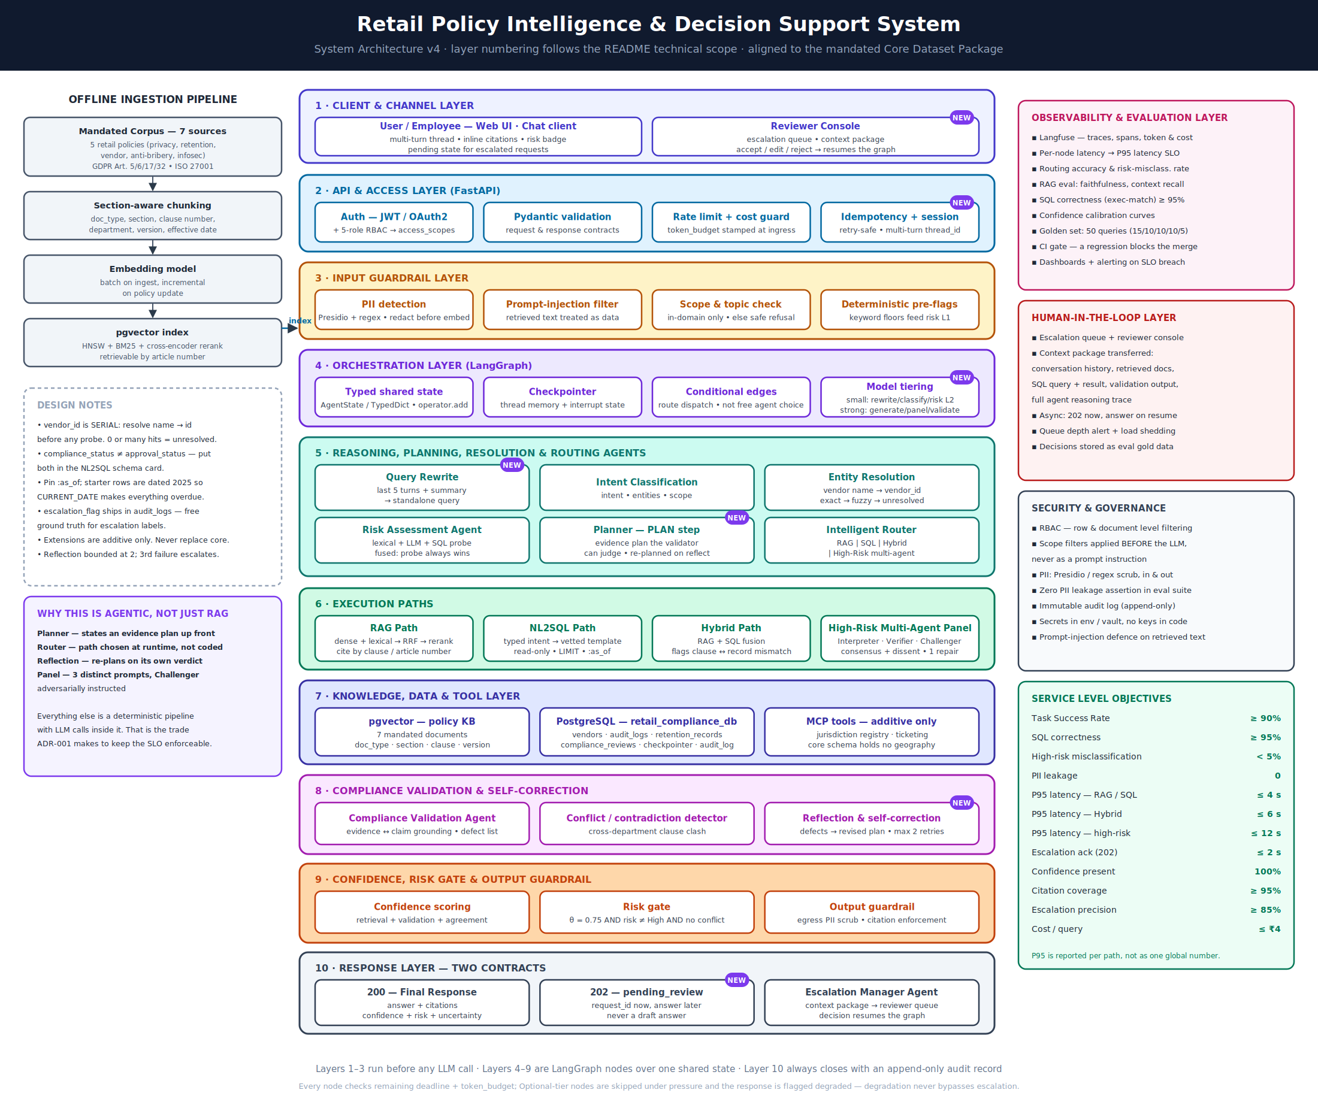
Figure 1 — System Architecture v4

3.1 Layer responsibilities
# | Layer | Responsibility
1 | Client & Channel | Web chat (multi-turn thread, inline citations, risk badge, pending state) and the reviewer console
2 | API & Access (FastAPI) | Auth0 JWT with five-role RBAC, Pydantic contracts, rate limit and cost guard, idempotency and session
3 | Input Guardrail | PII detection and redaction, prompt-injection filter, scope check, deterministic keyword pre-flags
4 | Orchestration (LangGraph) | Typed shared state, checkpointer, conditional edges, small/strong model tiering
5 | Reasoning, Planning & Routing | Query rewrite, intent classification, entity resolution, risk assessment, planner, router
6 | Execution Paths | RAG, NL2SQL, hybrid, agentic ReAct and the high-risk multi-agent panel
7 | Knowledge, Data & Tools | pgvector policy KB, PostgreSQL compliance database, MCP tools (additive only)
8 | Compliance Validation | Evidence grounding, conflict detection, bounded reflection and self-correction
9 | Confidence, Risk Gate & Output | Signal-based confidence, risk gate, egress PII scrub and citation enforcement
10 | Response | 200 final response or 202 pending_review, via the escalation manager

3.2 Cross-cutting concerns
- Observability & evaluation — Langfuse traces, per-node latency, routing accuracy, RAG faithfulness, confidence calibration, golden set, CI gate.
- Human-in-the-loop — escalation queue, reviewer console, context package, asynchronous 202 with answer on resume.
- Security & governance — RBAC at row and document level, PII scrub in and out, immutable audit log, secrets outside code.
- Service-level objectives — per-path latency, correctness, zero PII leakage and cost per query (section 13).

3.3 Design principles
- Risk does not choose the path; intent does. Only High risk forces a path (the panel).
- The model proposes; the code disposes. Every hard rule is enforced in code after the model returns.
- Escalation is a node, not a return code. It writes a durable review-queue row before the graph checkpoints.
- Degradation never bypasses escalation. Under budget pressure the system produces a worse answer or no answer — never an uncertified one.
- Retrieved text is data, never instruction. Chunks are neutralised and delimited; MCP output is clamped.
- Nothing reads the wall clock. Retrieval and SQL use a pinned as-of date so every answer is reproducible.

4. End-to-end agent workflow
Every request follows the same sequence: Query → Guardrail → Rewrite → Intent → Entity → Risk → Plan → Route → Evidence → Validate → Reflect → Confidence → Respond or Escalate. The diagram below is the v4 workflow the implementation follows.
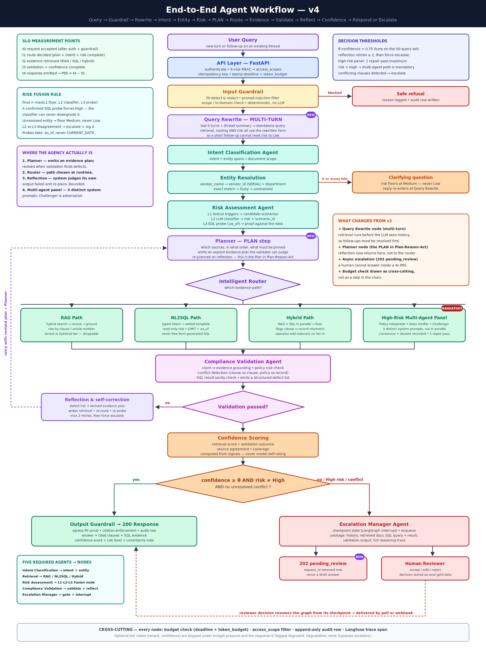
Figure 2 — End-to-End Agent Workflow v4

4.1 Request lifecycle
# | Stage | Component | Outcome
1 | Authenticate and validate | FastAPI, Auth0, Pydantic | Role, access scopes, deadline and token budget stamped
2 | Input guardrail | guardrail node | Blocked → safe refusal with audit row
3 | Multi-turn rewrite | query_rewrite | Standalone question from last 5 turns + summary
4 | Intent classification | intent_classification | Intent, entity spans, document scope
5 | Entity resolution | entity_resolution | 0 or many hits → clarifying question
6 | Risk assessment | risk_assessment | Fused Low / Medium / High with scenario
7 | Plan and route | planner + path policy | Evidence plan and one admissible path
8 | Gather evidence | rag / nl2sql / hybrid / agentic / panel | Chunks, SQL evidence, draft answer
9 | Validate | validation | Defect list; reflection returns to planner (≤ 2)
10 | Score and gate | confidence + release gate | Release or escalate
11 | Respond | output guardrail / escalation | 200 answered or 202 pending_review

4.2 Terminal outcomes
Outcome | HTTP | When | Caller receives
answered | 200 | Evidence verified, confidence ≥ 0.75, risk not High | Answer, cited clauses, SQL executed, confidence, risk, timings
pending_review | 202 | High risk, failed validation, low confidence or conflict | request_id and poll URL — no draft answer
refused | 200 | Blocked by guardrail or out of scope | Reason
clarification_required | 200 | Entity could not be resolved | The question that must be answered first
not_found | 200 | Evidence does not contain the answer | An honest “I don’t know”

4.3 SLO measurement points
Each node stamps a cumulative mark: t0 request accepted (after auth and guardrail), t1 route decided, t2 evidence retrieved, t3 validation and confidence complete, t4 response emitted. P95 latency is t4 − t0, reported separately for each evidence path.

5. Agent catalogue
The brief requires five agents. Each is implemented as one or more LangGraph nodes in src/nodes/, with prompts held separately in src/prompts/. Agency is concentrated in four places — the planner, the router, reflection and the multi-agent panel. Everything else is a deterministic pipeline with LLM calls inside it, which is what keeps the SLOs enforceable.

5.1 Intent Classification Agent
Nodes: query_rewrite → intent_classification → entity_resolution
The query rewrite runs first so that a short follow-up (“what about for Vertex?”) inherits the thread's context and cannot reset risk to Low. Intent classification returns the intent, entity spans and document scope. Entity resolution maps a vendor name to its vendor_id through exact, then trigram-fuzzy matching; zero or many hits produce a clarifying question and floor the risk at Medium.

5.2 Retrieval Agent
Nodes: rag_path, nl2sql_path, hybrid_path, agentic_rag
Executes the evidence path selected by the planner under the caller's access scope. RAG cites by clause or article number; SQL returns rows with disclosures; hybrid runs both in parallel and flags clause-versus-record mismatches; the agentic path is a LlamaIndex ReAct agent with policy, SQL and MCP tools for questions whose evidence cannot be named up front.

5.3 Risk Assessment Agent
Node: risk_assessment — L1 · L2 · L3 fusion (section 6)
Combines a lexical floor, a constrained LLM classifier and SQL reality probes into a single risk level and scenario identifier.

5.4 Planner and Intelligent Router
Nodes: planner with path_policy.py, route_evidence_path
The planner emits an explicit evidence plan — which sources, in what order, and what must be proved — that the validator can later judge. The path it proposes is clamped into the admissible set for the intent; substitutions are recorded in path_decision and logged.

5.5 Compliance Validation Agent
Nodes: validation → reflection
Checks claim-to-evidence grounding, citation set membership, SQL result sanity and cross-department clause conflicts. It produces a structured defect list and never rewrites the answer, because a critic that can edit patches claims instead of reporting missing evidence. Reflection turns defects into a revised plan (widen retrieval, re-route, re-probe) and returns to the planner, bounded at two retries.

5.6 High-Risk Multi-Agent Panel
Node: multi_agent_panel — strong model tier, mandatory when risk is High
Three agents with distinct system prompts run in parallel: a Policy Interpreter, a Data Verifier and an adversarially instructed Challenger. Their consensus and any dissent are recorded; one repair pass is allowed.

5.7 Escalation Manager Agent
Node: escalation — gate + LangGraph interrupt
Builds the context package, writes the review-queue row, interrupts the graph at a checkpoint and returns 202. A reviewer's decision resumes the graph (section 11).

6. Risk assessment

6.1 Three-layer fusion
Layer | Mechanism | Role
L1 — Lexical floor | Keyword triggers (gift, hospitality, cross-border, legal hold, …) | Sets a minimum level and candidate scenarios
L2 — LLM classifier | Constrained structured output: risk level + scenario_id | May raise above the floor, never lower it
L3 — SQL probe | Queries the compliance DB at the pinned as-of date | Proof against the data; a confirmed probe forces High

final = max(L1_floor, L2_classifier, L3_probe)

unresolved entity -> floor Medium, never Low
L2 vs L3 disagreement -> escalate and log
probes take :as_of -> never CURRENT_DATE
src/nodes/risk_assessment.py — fuse()
The three layers fail in different directions — the lexicon over-triggers, the classifier can be talked down, the probe only sees what the data records. Averaging them would let those failures cancel, so the fusion is a maximum with no weighting.

6.2 Mandatory high-risk scenarios
Scenario | Where it is caught
Cross-border transfer to a restricted jurisdiction | Lexical trigger → L1 floor; L2 vendor_data_sharing; high-risk-band and escalated-finding probes
Deletion request under active legal hold | L2 data_erasure; legal_hold_present probe; legal_hold_flag disclosure
Approval override for a Critical-risk vendor | L2 vendor_engagement; not-approved, high-risk-band and severe-open-finding probes
Gifts / hospitality involving overseas suppliers | Lexical triggers (gift, hospitality, brib, overseas) → High floor
Audit findings overdue beyond target date | L2 audit_finding; vendor_overdue_remediation probe
Conflicting policy clauses across departments | Validation CLAUSE_CONFLICT defect → escalate
Vendor onboarding with unresolved findings | L2 vendor_engagement; severe-open-finding probe
High-severity issue marked Closed without evidence | Remediation-status probes; panel Data Verifier lists what the data is silent on

Risk is gated independently of confidence
High risk escalates even at 0.97 confidence. Confidence measures whether the answer is right; risk measures the cost if it is not.

7. Intelligent routing and evidence paths

7.1 The five evidence paths
Path | Used for | How it works
RAG | Policy interpretation | Dense + BM25 → Reciprocal Rank Fusion → FlashRank rerank; cites by clause / article
NL2SQL | Record lookup | Vetted role-scoped template; guarded generated SQL only on a catalogue miss
Hybrid | Clause versus record | RAG and SQL in parallel, fused; flags clause ↔ record mismatch
Agentic ReAct | Evidence not nameable up front | LlamaIndex ReAct agent with policy, SQL and MCP tools
High-Risk Panel | Risk = High (mandatory) | Interpreter · Data Verifier · Challenger; consensus + dissent

7.2 Deterministic path policy
src/graph/path_policy.py holds one rule per intent: the default path, the admissible set, the fallback, and which evidence the answer turns on. The planner's proposal is clamped into the admissible set and the substitution is recorded, so the same question always routes the same way and a record lookup can never be answered from policy text alone.

7.3 Evidence-preserving degradation
Under budget pressure a path may degrade — but only toward the source the question turns on. Hybrid falls back to NL2SQL for vendor and retention questions and to RAG for incident guidance. The agentic path degrades to hybrid below its minimum time. RAG and NL2SQL do not degrade; they escalate.

8. Knowledge layer: ingestion and retrieval

8.1 Policy corpus
Document | doc_type
Retail Data Protection & Privacy Policy | privacy_policy
Data Retention & Archival Policy | retention_policy
Supplier / Vendor Compliance Policy | vendor_policy
Anti-Bribery & Ethical Conduct Policy | anti_bribery_policy
Information Security Access Control Policy | infosec_policy
GDPR — selected articles (5, 6, 17, 32) | gdpr
ISO 27001 Access Control Summary | iso_27001

8.2 Ingestion pipeline
router LlamaParse vs LlamaIndex, decided from probe evidence
-> loaders clean markdown
-> extractors clauses, tables, rasters, drawn figures (no model calls)
-> processors semantic split -> bounded recursive fallback;
table summaries; vision captions
-> metadata closed enums, single stamping point, validated
-> pgvector insert, then supersede previous versions
src/ingestion/ — layered by the question each layer answers
- Clause-aware sectioning runs first. The clause number is the unit of citation, so it is the outermost split; tables are extracted per clause and inherit its number.
- Drawn figures are detected geometrically. The corpus contains no embedded raster images — every flowchart is vector drawing — so figures are found by clustering drawing operators and then captioned.
- The metadata contract is enforced. doc_type is never guessed; a missing value stops ingestion of that file, because it is the key every role's scope filter matches on.
- Ingestion is idempotent and safe. Files are keyed by hash, and an embedding-model mismatch with the existing vector table fails loudly.

8.3 Hybrid retrieval
scope filter (role grant ∩ requested scope, applied in the vector store)
-> dense leg (pgvector, cosine) + lexical leg (BM25, in scope)
-> Reciprocal Rank Fusion
-> current-version / as-of filter
-> FlashRank cross-encoder (optional tier)
src/retrieval/ — QueryFusionRetriever(mode="reciprocal_rerank")
Reciprocal Rank Fusion is used because cosine and BM25 scores are not comparable; after fusion an absolute similarity cutoff is meaningless, so narrowing is the reranker's job. The scope filter can only narrow a caller's access, never widen it.

9. Structured data and safe SQL

9.1 Data model
Table | Contents | Rows
vendors | Risk score and band, compliance and approval status, onboarding, last audit, next review due | 75
audit_logs | Findings: severity, remediation status, target and resolution dates, escalation flag | ~150
retention_records | Department retention obligations and legal-hold flag | 60
compliance_reviews | Review history per vendor | 60
system_audit_log | One row per node decision; UPDATE/DELETE refused by database rules | —
escalation_queue | Human handoff keyed by request_id, JSONB context package | —

The three child tables reference vendors without cascading deletes, so a vendor with any finding cannot be deleted. policy_reference in audit_logs holds a clause identifier that also exists in the corpus — the bridge the hybrid path uses to set a finding beside the clause it breached.

9.2 Two-tier SQL
Tier | Mechanism | Safeguards
1 — Vetted templates | 17 reviewed, role-scoped queries; the model selects a template_id and typed parameters | Values bound by psycopg; vendor_id from entity resolution; enum spelling normalised
2 — Generated SQL | LlamaIndex NL2SQL with role-scoped schema; fires only on a catalogue miss | Mutation-intent regex, fail-closed intent classifier, SELECT/WITH shape check, table-scope assertion

All execution runs in a read-only transaction with a statement timeout and a row cap. A generated query must be disclosed in the answer and costs 0.15 confidence: the gates prove the query is safe, but nothing proves it is correct — a query reading the wrong column passes every safety check and returns a confident wrong answer.

9.3 Time is a literal
Seed data is dated 2025, so any read of the database clock would mark everything overdue and fire every risk probe. All probes and generated SQL use the pinned as-of date (2025-12-31); CURRENT_DATE, NOW() and the other clock functions are rejected by the SQL guard.

10. Validation, confidence and the release gate

10.1 Confidence scoring
Confidence is computed from evidence signals — never from the model rating itself.
Signal | Weight | Measures
Retrieval | 0.30 | Strength of the evidence, normalised per score family (cross-encoder, RRF, cosine, SQL)
Validation | 0.30 | Outcome of the compliance validation defect list
Source agreement | 0.20 | Whether the sources the plan required actually arrived and agree
Coverage | 0.20 | How much of the question the cited evidence covers
Adjustments | −0.10 / −0.15 | Degraded run / generated SQL

10.2 Release gate
release if confidence >= 0.75
AND risk != High
AND no validation conflict
AND no unresolved panel conflict
otherwise escalation_manager -> 202 pending_review
after_confidence — the certification rule
Lesson learned
An early scoring defect capped a perfect policy answer at 0.7512 against a 0.75 threshold, so every ordinary answer escalated. The fix was to normalise each score family on its own terms — not to lower the threshold, which would have hidden a scorer that had stopped discriminating.

11. Human-in-the-loop

11.1 Escalation flow
- POST /ask — the release gate refuses to certify the answer.
- The escalation manager writes the escalation_queue row, checkpoints the graph and returns 202 pending_review with a request_id and poll URL — never a draft answer.
- A reviewer (compliance officer, legal reviewer or admin) opens GET /review/queue and inspects the context package.
- POST /review/{request_id} with accept, edit or reject resumes the checkpointed graph.
- The reviewed answer passes the same output guardrail — PII scrub and citation enforcement — as a machine answer.
- The caller retrieves the final answer from GET /requests/{request_id}.

11.2 Context package
- Conversation history and the rewritten question
- Retrieved documents with clause numbers
- SQL query and result, including disclosures
- Validation output, panel verdict and dissent
- Evidence plan and the full agent reasoning trace

The package is stored in the queue row rather than reassembled at review time, because the reviewer needs to see what the agent saw at the moment it gave up. request_id is the primary key, which makes the queue naturally idempotent. Reviewer decisions are stored as labelled data for the escalation-precision objective, and High-risk escalations can notify reviewers by e-mail.

12. Security and governance

12.1 Authentication and RBAC
Auth0 issues JWTs that the backend validates against JWKS; roles are read from a namespaced claim. Azure OpenAI credentials are entered on the console's login screen rather than stored in configuration. Scope is enforced inside the vector-store query and the SQL table grant — never as a prompt instruction.
Role | Policy documents | SQL tables | Screens
store_associate | Privacy, infosec, anti-bribery, retention | None | Chat
store_manager | + vendor policy | vendors (Low/Medium), compliance_reviews | Chat, dashboard
compliance_officer | All seven | All four domain tables | Chat, dashboard, review, SLO
legal_reviewer | All seven | All four domain tables | Chat, review, SLO
admin | All seven | All four domain tables | All + corpus admin

Store associates and managers are further restricted to their own department's retention records. Rows removed by these post-execution filters are counted and disclosed, so a partial result is reported as a floor, never as a total.

12.2 Guardrails
Control | Implementation
Prompt injection | Screened before PII redaction so evidence of an attack is not mangled
PII in | Presidio + regex redaction before any embedding or model call
PII out | Guardrails AI DetectPII + Presidio + regex; fails closed — an error withholds the answer
Citations | Only clauses actually retrieved may be cited
Retrieved text and tools | Chunks neutralised and delimited; MCP tools allow-listed and output-clamped
Audit | Append-only system_audit_log; circuit breaker protects the request path
Idempotency | Per-user Idempotency-Key prevents duplicate escalations on retry

13. SLOs, reliability and observability

13.1 Service-level objectives
Objective | Target
Task success rate | ≥ 90%
Structured SQL correctness (exec-match) | ≥ 95%
High-risk misclassification | < 5%
PII leakage | 0
P95 latency — RAG / SQL · Hybrid · High-risk | ≤ 4 s · ≤ 6 s · ≤ 12 s
Escalation acknowledgement (202) | ≤ 2 s
Confidence present · citation coverage | 100% · ≥ 95%
Escalation precision | ≥ 85%
Cost per query | ≤ ₹4

13.2 Budgets and deadlines
Every node runs under a wall-clock deadline and a token budget carried in graph state and checked before the node body executes. Deadlines widen with the route and are always computed from the original start time, so a late widening never restarts the clock.
Tier | Nodes | Under pressure
Optional | Reranker, thread summary, confidence calibration | Skipped; response flagged degraded (−0.10)
Required | Everything that gathers or judges evidence | Not run; request escalates with a named budget_stop
Release | Output guardrail, escalation manager, refusal, clarification | Never budget-checked — the system must always be able to escalate

13.3 Observability and audit
- Langfuse traces with one span per node, including token and cost usage.
- GET /metrics/slo — P50 / P95 / P99 per t0–t4 stage and per path, with breached stages and paths named.
- One request_id shared by every log line, audit row, trace and the X-Request-ID header.
- Escalation reasons name the real cause: retries exhausted, time exhausted, tokens exhausted, or retrieval no-match.

14. Cost and latency optimisation
Mechanism | Detail
Response cache | Keyed on access scope + normalised question; semantic hits at cosine ≥ 0.95. Stores only certified answers; never shared across roles or used for follow-ups
Retrieval cache | Skips embedding, search, fusion and reranking for repeated queries in the same scope (TTL 10 minutes)
LLM cache | TTL / LRU completion cache for temperature-0 calls
Model routing | Fixed small (rewrite, intent, risk, planner, selector, reflection); fixed strong (panel); routable (generation, validation, agentic)
Routing strategies | heuristic (default), cost_saver, quality_first, static; High risk exempt from downgrade
Cost ledger | Billed tokens priced per model; trace.llm_usage per request, /metrics/optimization process-wide
Gateway | Optional LiteLLM proxy lets the small tier be swapped without code changes

15. Frontend console
The console is a Vite + React 19 + TypeScript application using @auth0/auth0-react. Screens are gated by role through the same SCREENS table the backend exposes on /auth/me.
Screen | Purpose | Roles
Chat | Streaming answers with citations, risk badge and a view of the multi-agent workflow | All
Dashboard | Vendor and compliance overview | store_manager, compliance_officer, admin
Reviewer console | Escalation queue, context package, accept / edit / reject | compliance_officer, legal_reviewer, admin
SLO dashboard | Latency per stage and per path | compliance_officer, legal_reviewer, admin
Corpus admin | Upload, status and rebuild of the policy index | admin

16. Testing and evaluation

16.1 Automated tests
The suite contains more than 730 test functions across 37 modules. Unit tests need no database and no model; model calls are faked so each test states a scenario and asserts the outcome.
- Path policy clamps the planner and every routing decision is logged.
- Risk fusion never lets the classifier downgrade a confirmed probe.
- Generated SQL rejects NOW(), CURRENT_DATE and write verbs, without false positives on columns like now_status.
- Confidence discriminates strong from weak evidence and escalates missing records.
- Reviewer decisions resume through the output guardrail; the review loop is bounded.
- PII redaction, injection screening, idempotency, caching and model routing.

16.2 Golden-set evaluation
Expected path | Queries
RAG | 15
NL2SQL | 10
Hybrid | 10
High-risk panel | 10
Refusal, clarification and edge cases | 8
Total | 53

cd backend
uv run pytest # unit and integration tests
uv run python evals/run_eval.py # 53-query golden set
uv run python evals/run_eval.py --ci # non-zero exit on SLO breach
uv run ruff check .
Commands

17. API reference
Method | Endpoint | Role | Purpose
GET | /health | public | Database, audit writer and queue status
GET | /auth/me | any | Identity, role, scopes and screens
POST | /auth/azure | any | Supply Azure OpenAI credentials from the login screen
POST | /ask | any | Submit a question; returns one terminal state
GET | /requests/{id} | any | Poll an escalated request
GET | /review/queue | reviewer | Pending escalations with context packages
GET / POST | /review/{id} | reviewer | Inspect / decide (accept, edit, reject); resumes the graph
POST | /ingest | admin | Upload one policy document
GET | /ingest/status | admin | Index state and per-document node counts
POST | /ingest/rebuild | admin | Re-index the corpus
GET | /metrics/slo | reviewer | P50/P95/P99 per stage and path
GET | /metrics/optimization | reviewer | Cache hit rates, routing share, spend
POST | /cache/invalidate | admin | Clear caches

Every /ask response carries timings, trace.path_decision, trace.llm_usage and the SQL evidence used, so a single call is self-explanatory.

18. Technology stack and deployment
Layer | Technologies
Runtime & API | Python 3.12, uv, FastAPI, Uvicorn, Pydantic
Orchestration | LangGraph — typed state, conditional edges, PostgresSaver checkpointing, interrupts
Knowledge | LlamaIndex (QueryFusionRetriever, BM25Retriever, SemanticSplitterNodeParser, ReActAgent), LlamaParse
Models | Azure OpenAI gpt-4o (strong), gpt-4o-mini (small), vision and embedding deployments
Data | PostgreSQL with pgvector and pg_trgm; FlashRank cross-encoder
Guardrails | Guardrails AI, Microsoft Presidio, regex fallbacks
Tools & observability | MCP (DuckDuckGo server), Langfuse, LiteLLM gateway
Frontend & auth | Vite, React 19, TypeScript, Auth0, react-router, react-markdown

The backend deploys to Render from render.yaml as a native Python service; the MCP server runs as a child process, so no second service is required. In production BOOTSTRAP_FAIL_FAST=true stops a container without an indexed corpus from reporting healthy. The source is public at github.com/mohit0415/retail_capstone_project.

19. Limitations and roadmap
Known gap | Next step
Cold multi-agent runs exceed the 4–12 s diagram targets; runtime deadlines are 30–90 s per path | Report per-path targets explicitly; lean on cache hits and small-tier routing
SLO evaluation report not yet committed from a live run | Run the golden set against the live stack and commit the report with a /metrics/slo snapshot
SQL correctness scored on template selection only | Add expected rows / ids to the record-lookup cases
PII leakage unit-tested but not probed end to end | Add golden cases that plant PII and assert it never appears in answers
Caches are process-local | Move to a shared store for multi-instance deployments
LlamaIndex calls outside the cost ledger | Instrument the agentic path and generated SQL
No container recipe | Add docker-compose for PostgreSQL + pgvector + API

20. Conclusion
The Retail Policy Intelligence & Decision Support System replaces the question “does this answer sound right?” with “can this answer be certified?”. Intent-driven routing sends each question to the evidence it actually turns on; three-layer risk fusion lets the data overrule the model; a validator reports defects instead of hiding them; and a release gate either certifies the answer or hands it — with everything the agent saw — to a human reviewer whose decision resumes the same graph.
The functional architecture of the brief is implemented end to end, with security, auditability and cost controls enforced in code and in the database. What remains is evidence rather than engineering: a committed evaluation report, observability captures and a container recipe.

Appendix A. Repository map
retail_capstone_project/
├── backend/
│ ├── configs/ settings, model tiering, database pool
│ ├── data/ policy corpus and SQL schema / seed
│ ├── evals/ golden set and SLO evaluation runner
│ ├── scripts/ init_db, ingest_policies, diagnostics
│ ├── src/
│ │ ├── api/ routes, escalation queue service
│ │ ├── auth/ JWT decoding, RBAC scope tables
│ │ ├── cache/ response / retrieval / LLM caches
│ │ ├── core/ budget guard, audit writer, idempotency
│ │ ├── graph/ typed state, graph builder, edges, path policy
│ │ ├── guardrails/ PII, injection, scope, SQL guard, output guard
│ │ ├── ingestion/ router, loaders, extractors, processors, metadata
│ │ ├── llm_routing/ heuristics, strategies, cost ledger
│ │ ├── nodes/ one file per LangGraph node
│ │ ├── retrieval/ fusion retriever, postprocessors
│ │ ├── sqlpath/ vetted templates, selector, NL2SQL engine
│ │ └── tools/ policy, SQL and MCP tools
│ ├── tests/
│ └── main.py
├── frontend/ React 19 + TypeScript console
├── swagger-docs/ API runbook and walkthroughs
└── render.yaml Render deployment manifest

Appendix B. Glossary
Term | Meaning
RAG | Retrieval-augmented generation — answering from retrieved document chunks
NL2SQL | Translating a natural-language question into a SQL query
RRF | Reciprocal Rank Fusion — merging ranked lists by rank rather than score
HITL | Human-in-the-loop — a human reviewer certifies what the system cannot
SLO | Service-level objective — a measurable target for quality, latency or cost
RBAC | Role-based access control
MCP | Model Context Protocol — a standard interface for external tools
As-of date | The pinned evaluation date (2025-12-31) used instead of the system clock
Context package | Everything the agent saw, handed to the reviewer on escalation

