AWS:

Traditional Infra Vs Cloud
Traditional Infra:
We need to setup our own server and bear the maintainance cost.
If more traffic is coming then we need to setup more servers and if less trafic is coming, we need less servers. These were the challenges of Traditional infra.

AWS:
AWS provided all the infra and maintainance in exchange of a small fee and we just need to focus on the application. Both Time and Money was saved.

Service Models:
Cloud Services can belong to any of the following categories:
Infra as a Service: Cloud will provide Hardware + OS, cloud will provide Networking, Storage, Server, Visualisation and we need to handle only Middleware, Runtime, Data, Applications. Ex: EC2 is IaaS.

Platform as a Service: It will provide whatever IaaS is providing + It will also install softwares like Database and configure them with highest security and we need to manage only data and applications. RDS is PaaS.

Software as a Service: We do not have to manage anything. Use service and do payments. Ex:ERP, CRM etc.

Deployment Model of Cloud:
3 types of cloud: public, private and hybrid. Public cloud can be acessed by anyone from anywhere.
Private cloud can be accessed by authorised people in a company and they can’t access it from the outside of the organisation. Hybrid is combination of both.

How AWS charges?
Compute: CPU Utilisation. If we have taken 8 cores cpu then it will have a price, if we have taken 16 cores CPU then the price will be higher.
Storage: Price will be based on how much space are we using.
Data Transfer: How much data have we transferred outside of AWS Cloud. How much network have we utilised.

Global Infrastructure: A Region has normally 3 (multiple)Availability Zones and 1 availability zone can have multiple Data Centres. All regions are connected through a private network.

Why do we have multiple regions?
-> Cost Effective: Electricity bill or rent of land may be more in other regions.
-> For Lower Latency, Indian will be able to access quickly if resources are available in India as compared to when data is available in America.
-> If the requirement of the user is that my data should remain in India then Indian region will be storing the data.
-> Disaster Recovery: If our one of the Region is destroyed like flood has come and Mumbai region data centres have drowned then the data will be lost. To do disaster recovery, this data will also be copied to other Region Data Centre so that data will be available. Not all the services will be available in all the regions, some services may be available in region1 but not in region2. There is a code associated with every Region.

Availability Zones: Region is divided into multiple Available Zones. If

You can deploy your applications in multiple AWS Regions to serve your global customers. Deploying applications in multiple regions improves customer experience by serving the customers from the closest application endpoint, and it increases the resiliency of your application.

Data Centre:

Local Zones:
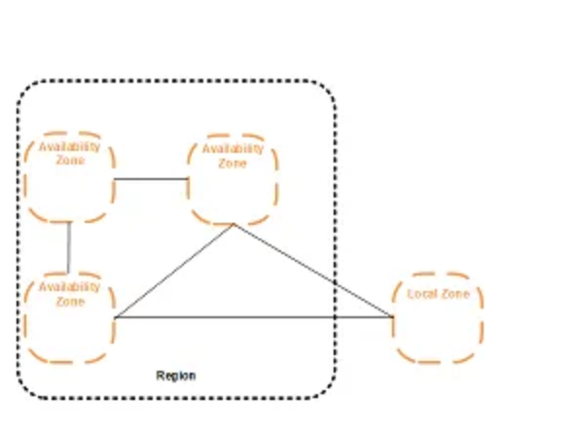

Local Zones is a AWS Infrastructure deployment where we can keep services close to our end users.

EC2: In EC2, we create machines. We choose RAM, Storage, CPU, OS etc. We can also provide bootstrap script in the advanced option under User Data. This script will run first whenever the machine will start.
Security Groups in EC2: It is a firewall that will be applied on the instance. What traffic will come in and what will go out, we can configure it in security group. We can write rule only to allow something but not to deny something. Rules can be inbound rule and outbound rules.
Same security group can be attached to multiple instances and vice-versa. We can apply security group when the instance is running.

There are some EC2 instance types.

