Accessing Key Vault via Spring Boot using Spring Cloud Azure:

Add dependency:

<dependencies>
<dependency>
<groupId>com.azure.spring</groupId>
<artifactId>spring-cloud-azure-starter-keyvault-secrets</artifactId>
</dependency>
</dependencies>

Configure Key Vault endpoint in properties:

spring.cloud.azure.keyvault.secret.endpoint=https://<kv-name>/vault....

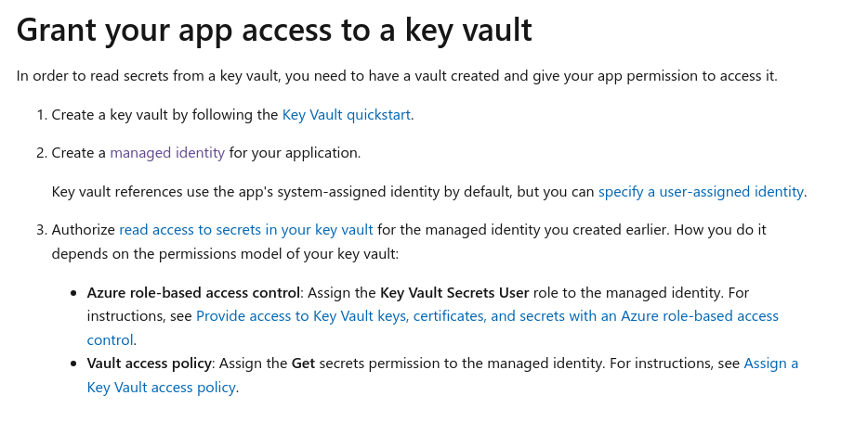

Autowire SecretClient in app and we can use like below:

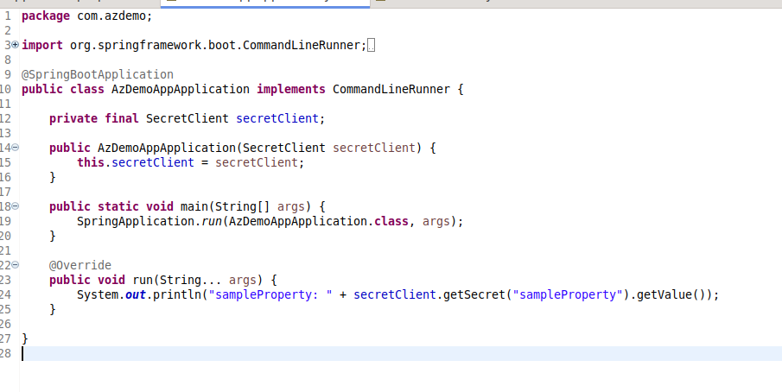

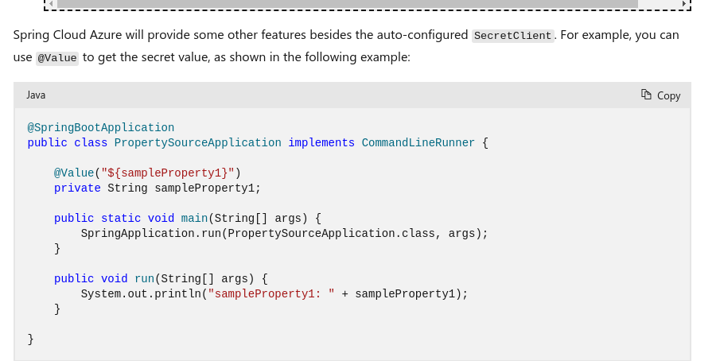

We can directly read the values from key vault into our properties file:

configure vault url in application.properties file: spring.cloud.azure.keyvault.secret.endpoint=https://<kv-name>/vault....

spring.datasource.url=${mysqlurl}

mysqlurl is name of the secret in key vault. It will be populated automatically.

