Azure AD / Entra ID:

It is central identity and access management cloud service.
Used to manage access to thousands of app. Used to manage access in azure portal and to resources including our own apps in portal. It is secure.

Features:
MFA
Conditional Access
Device management
Hybrid Identity
Identity Protection
Monitoring And Reports

Control Access to Azure Resources: By setting up users, groups, roles.
We can use Azure AD to add authentication in our apps. This can also be done using Azure AD B2C.

Tenants: A tenant is specific instance of Azure AD containing accounts and groups. It is also called Directory. It is not part of subscription hierarchy. It exists besides subscription. For new subscription a new tenant is created automatically.

A tenant can be assigned to multiple subscription.

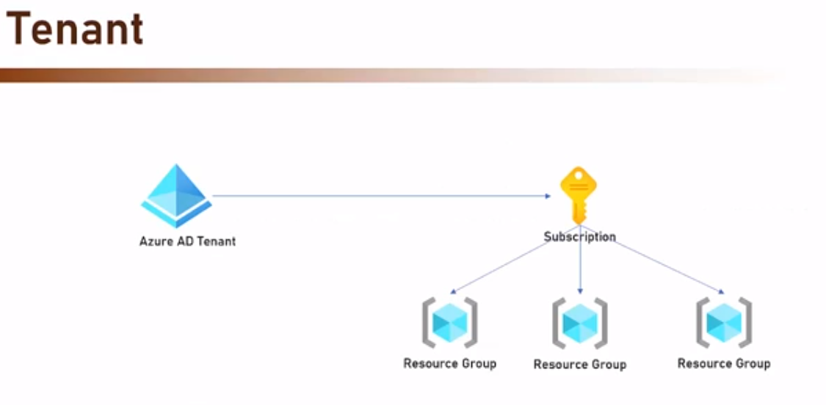

We can create users and groups under tenants and assign them roles. Azure AD manages users, groups and roles.

We can create a new user under tenant but when this user will try to login into portal, he will not be able to create any resources because account is not attached to any subscription.

Instead of creating new users, we can also invite users to tenant.

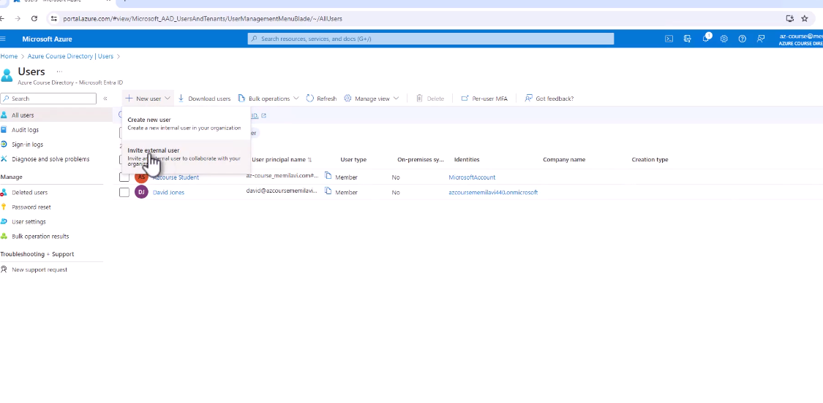
Different Azure AD licenses:

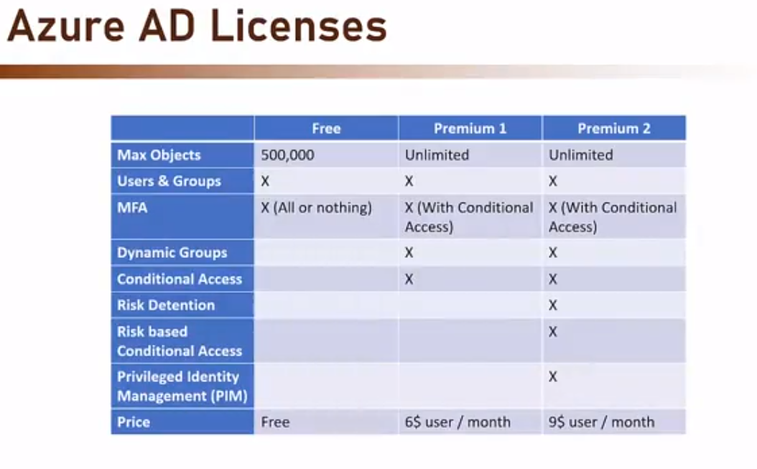

MFA: Auth with something you know(password) and something you have(OTP). Make sure authentication engine supports MFA. Should not require development.

Azure AD Security Default:
Increase protection of the organisation in the free tier. All users will use MFA. Adds preconfigured security.

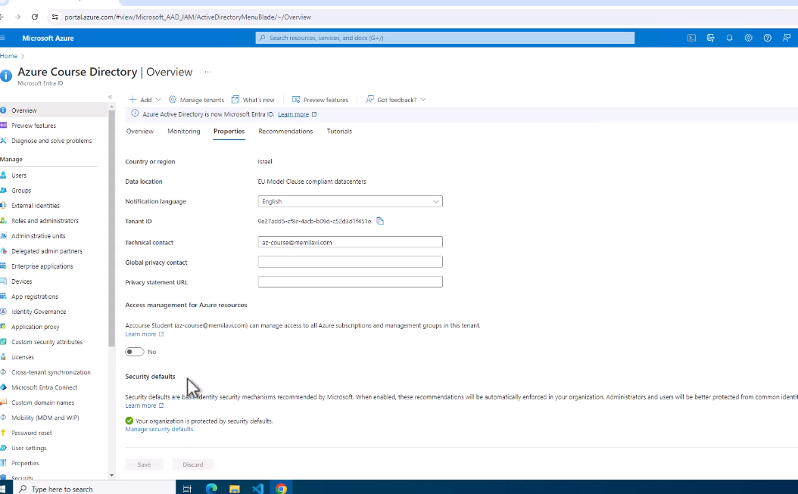

RBAC: Role Based Access Control.

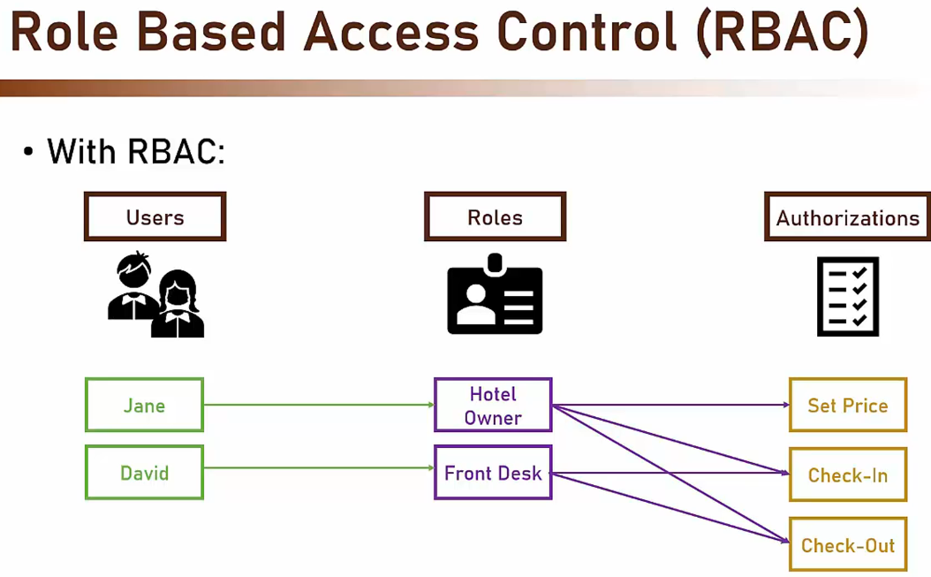

Azure Roles:

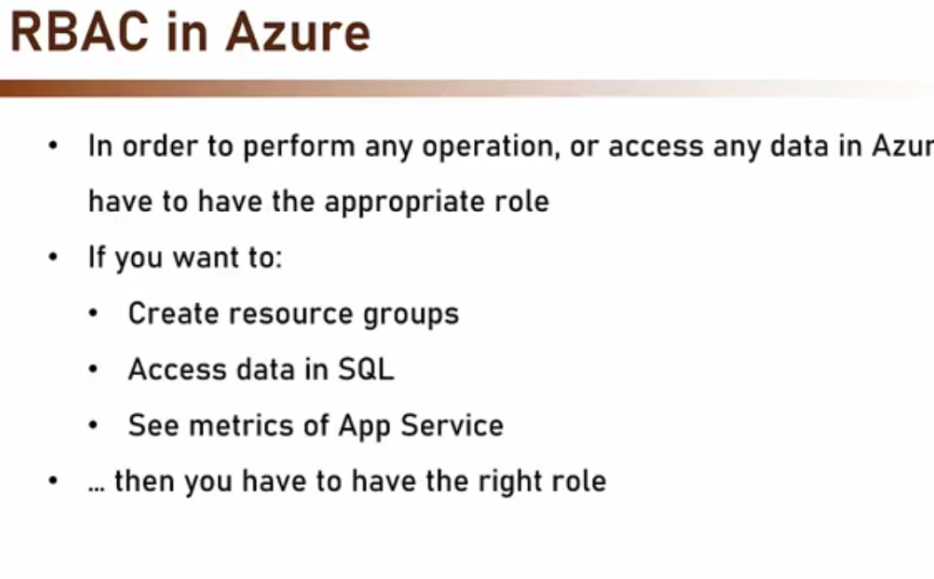
3 types of roles: Owner, Contributor, Reader.

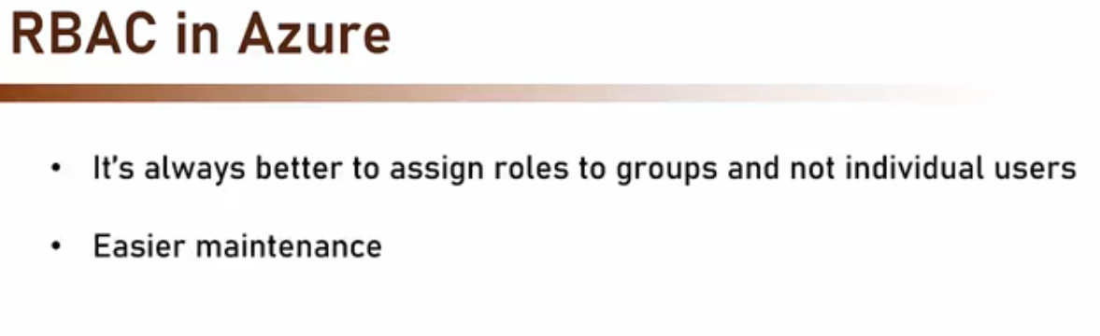
In every azure service, there is “Access Control(IAM)” where we create and manage roles.

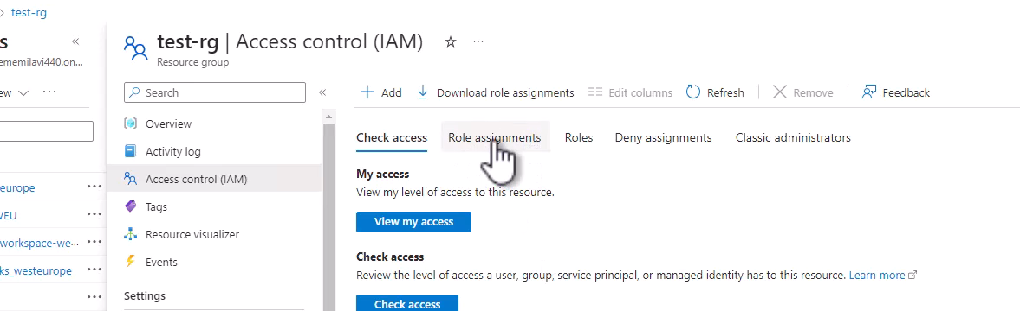

Managed Identities:

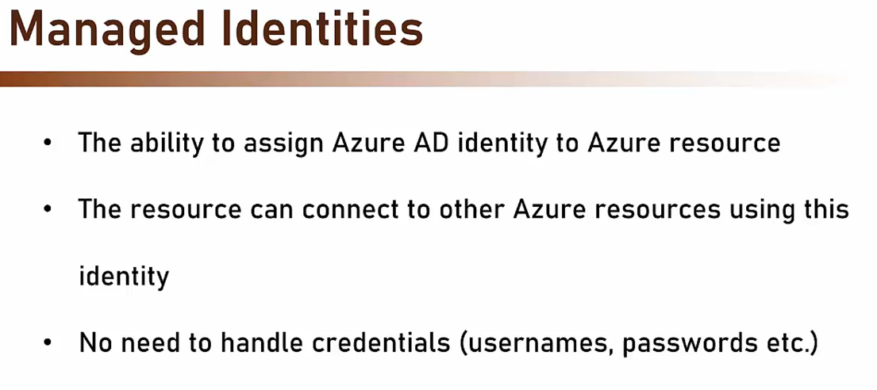

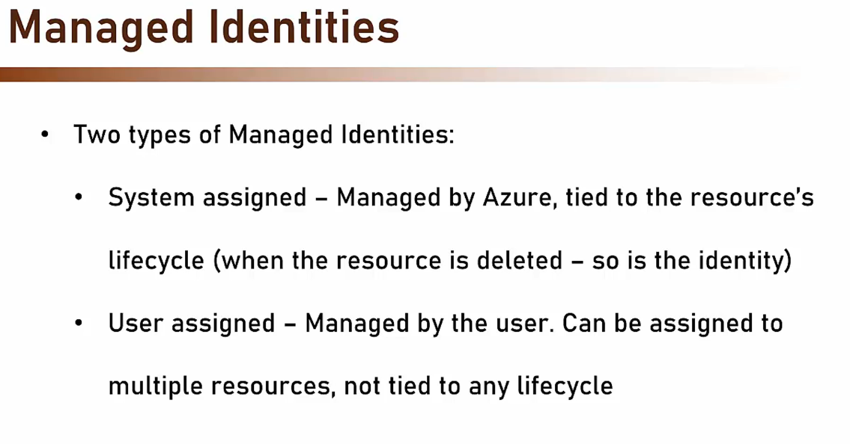

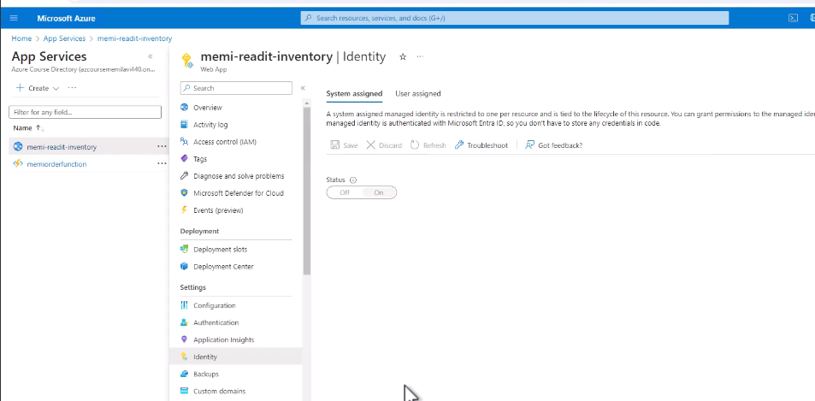

An identity for the web service will be created in azure AD.

Goto SQL service: In the below screenshot, we can add admin for our db.

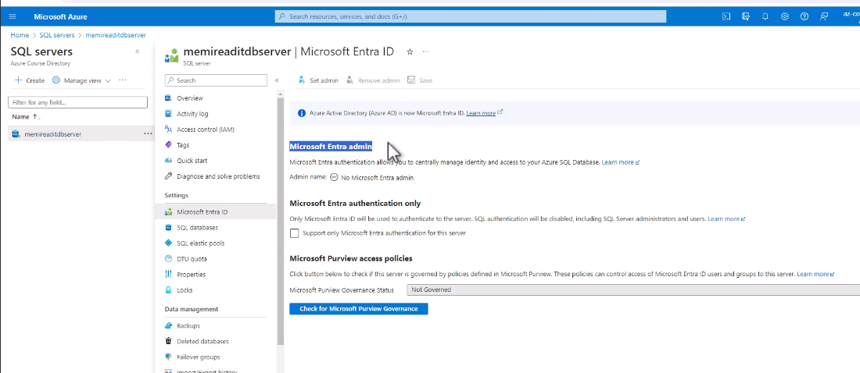

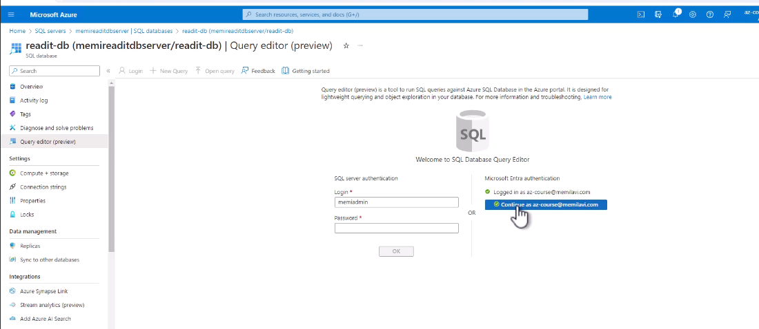
In the db query editor, we can login using “Microsoft Entra Authentication”.

Run below commands in query editor:

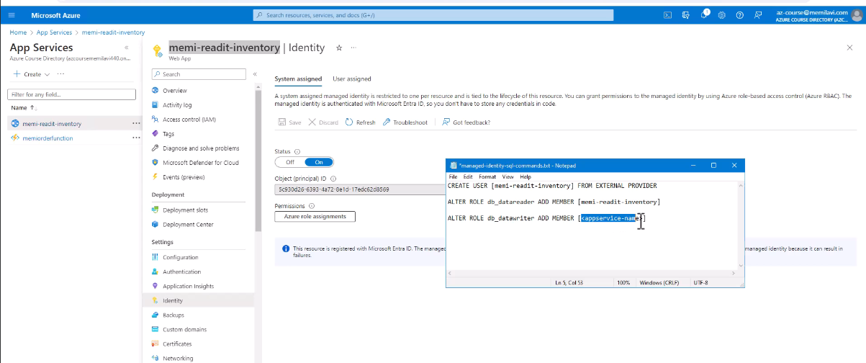
It will create user for app service “memi-readit-inventory” and this user will have roles(datareader and datawriter).

Now our app service user can connect to database and read and write data.

Goto app service and edit the connection string as below:

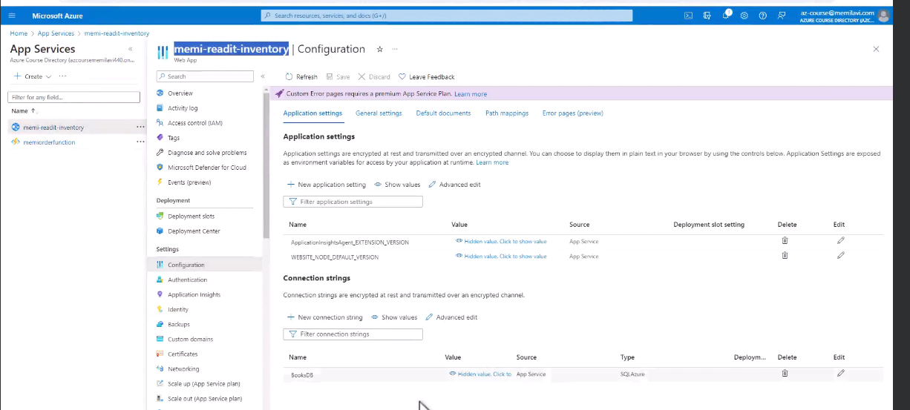
Currently, connectionstring has username/password. We will have to modify it like below:

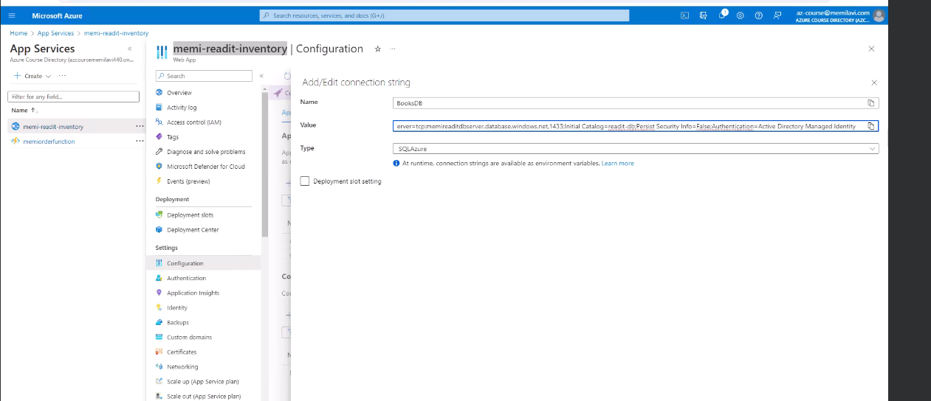
Now our app service can directly communicate with db without username/password.

Using Azure AD to authenticate our app:

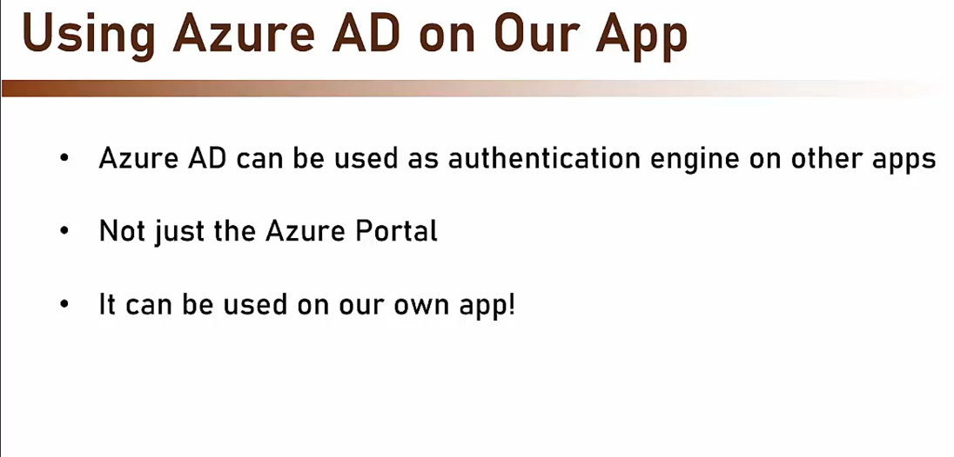

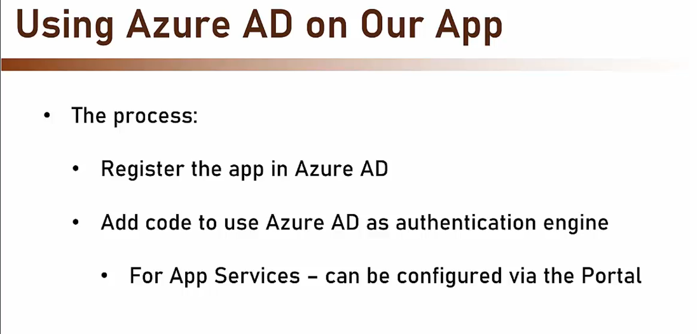

The authentication will use Oauth and JWT.

Configuring Authentication in App Service using Azure AD :

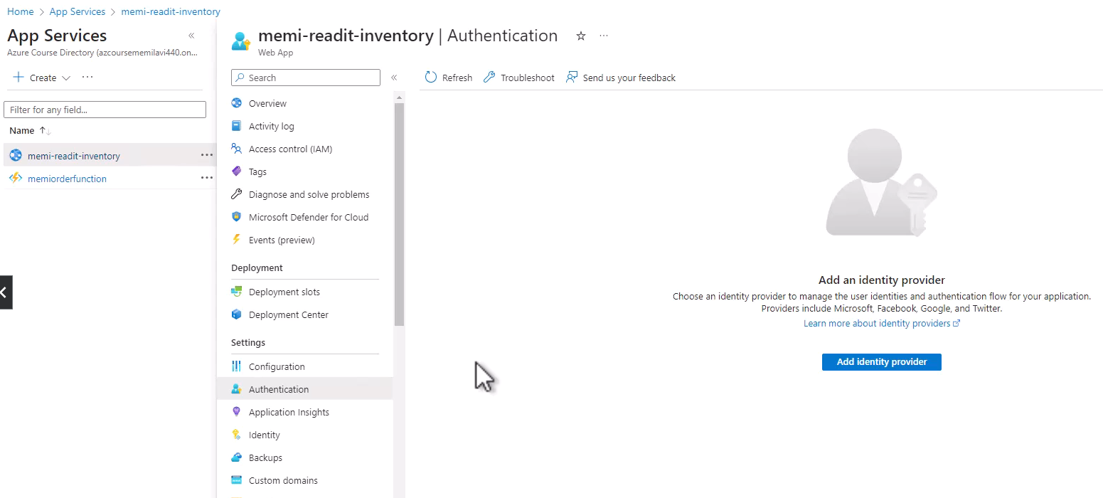

Click “Add Identity Provider”.

We can choose from multiple Identity Providers:

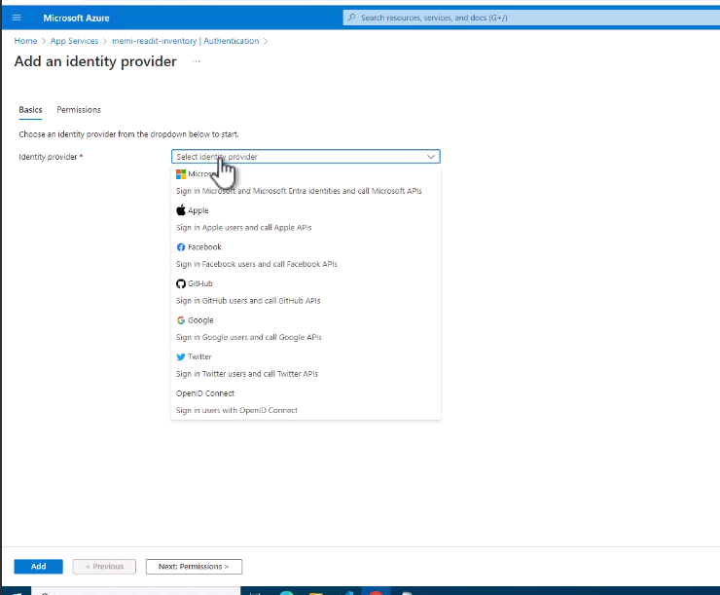

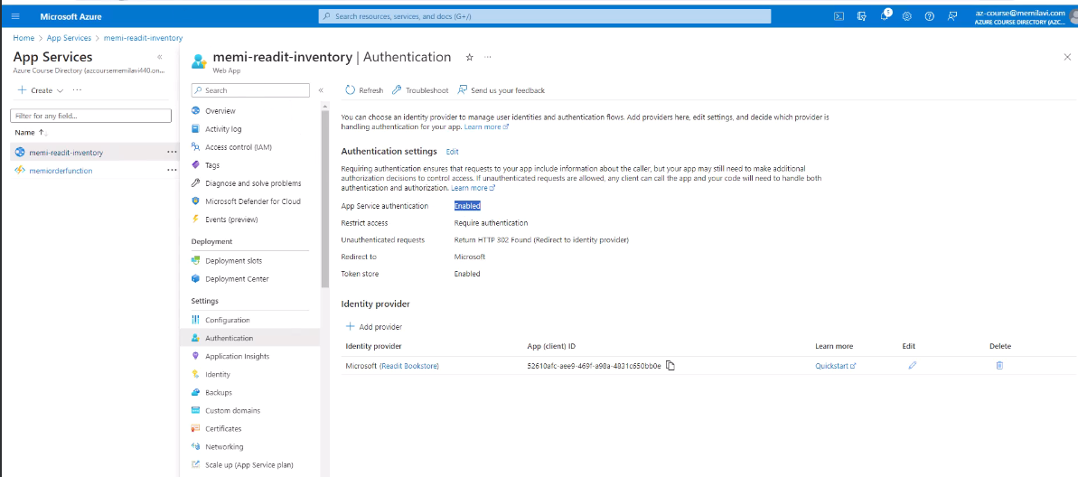

We can use Entra as Oauth Authentication server for our spring boot application if intended users are registered with it.

JavaInUse website:
https://www.youtube.com/watch?v=m6NH0DIuj9o

Azure AD B2C:
Identity as a service for your application.

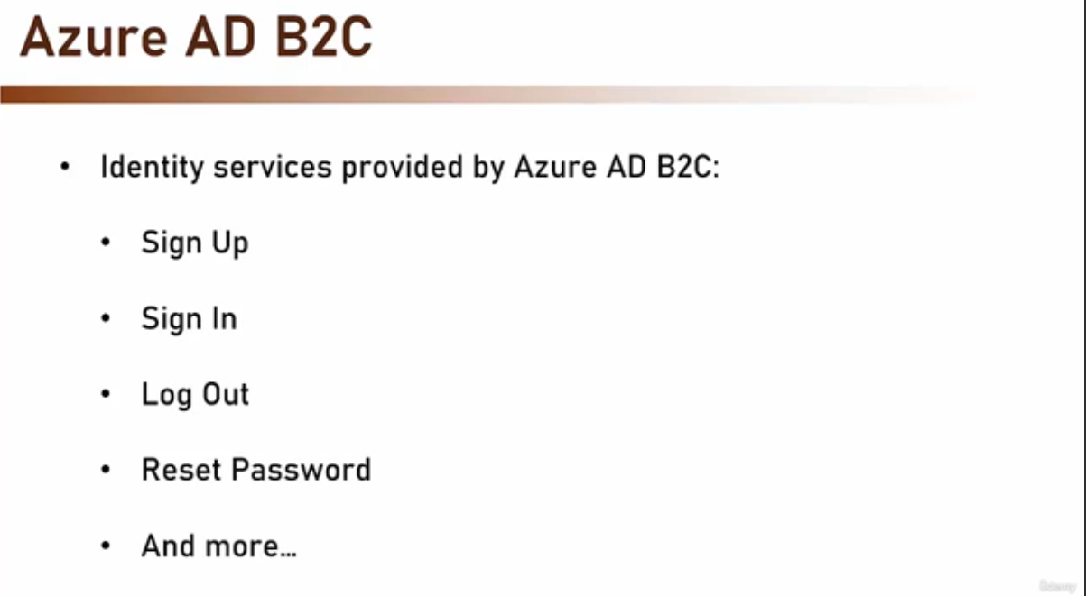

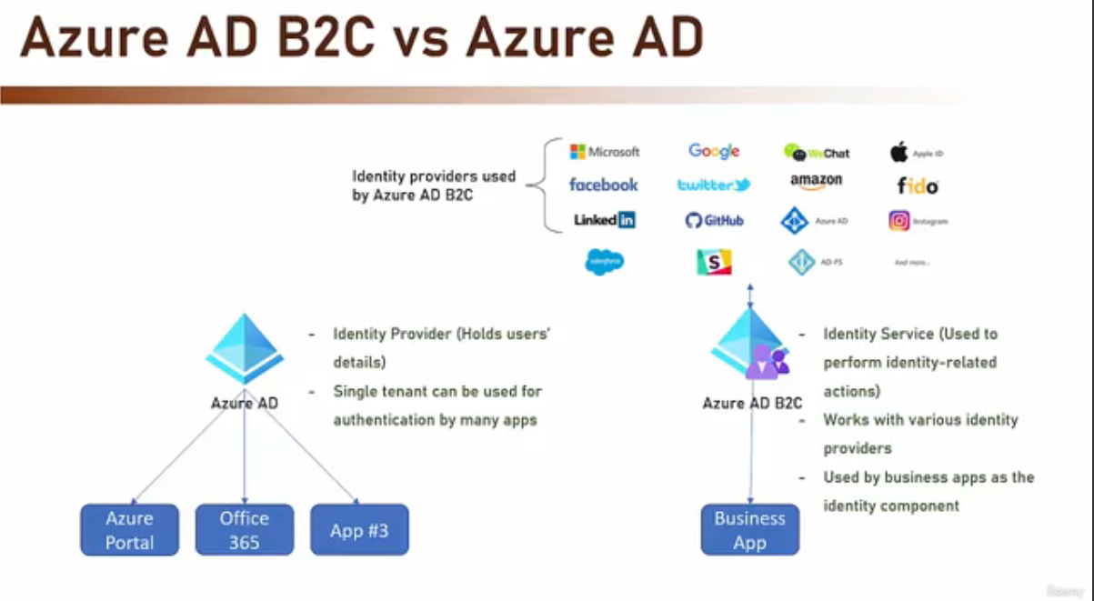
Azure AD B2C is a service and it does not hold any data of the users. It is not a provider.

Learn everything related to Azure and Spring Boot: https://learn.microsoft.com/en-us/azure/developer/java/spring-framework/configure-spring-boot-starter-java-app-with-azure-active-directory-b2c-oidc

https://learn.microsoft.com/en-us/azure/developer/java/spring-framework/

https://learn.microsoft.com/en-us/azure/developer/java/sdk/authentication/overview?source=recommendations

