Secure your REST API using Spring Cloud Azure
In the tenant(Instance of Entra ID), register our REST api.
Under manage, choose Expose An Api and then add scope and create Survey.User and Survey.ADMIN.

Next, enable the REST API protection with Spring Cloud Azure.
Add below dependencies;

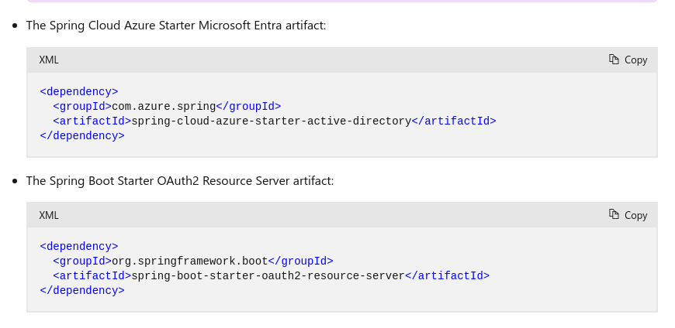

Authorize HTTP requests
To protect the survey REST APIs, add the annotation @PreAuthorize("hasAuthority('SCOPE_Survey.xxx')") with a concrete scope name to enable protection, as shown in the following example:

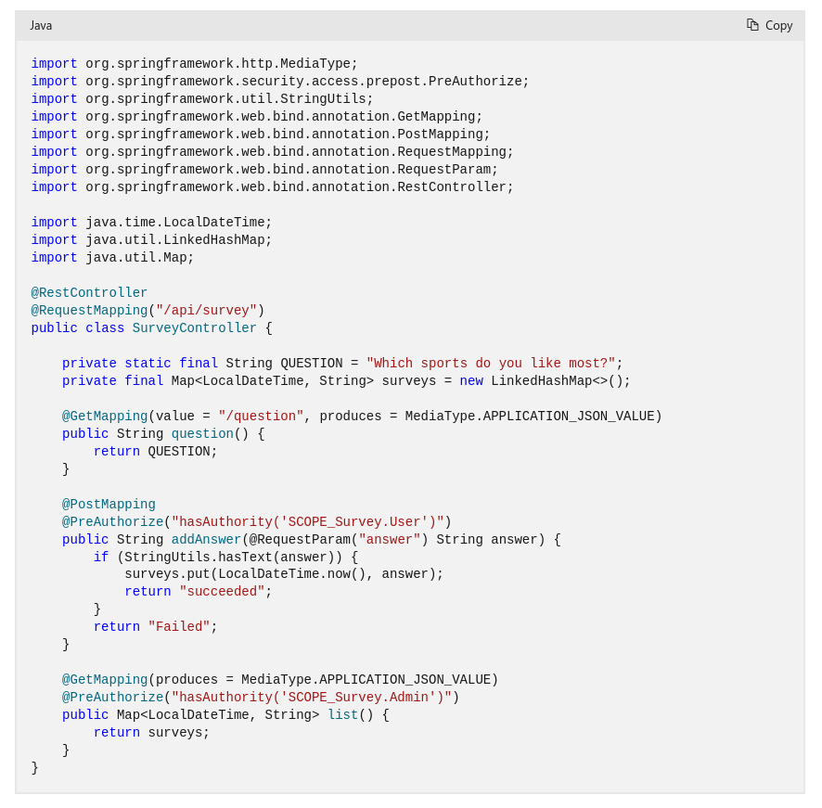

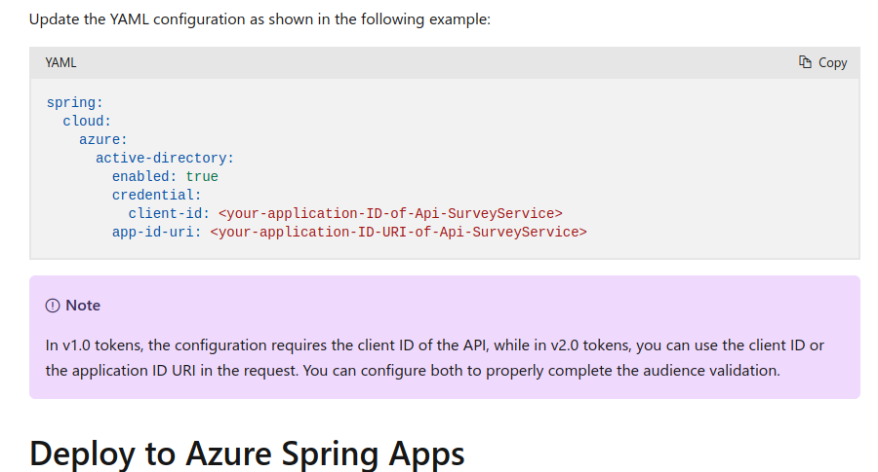

You can define the Application ID URI property under Expose an API for the application in the Azure portal. The format for the Application ID URI is api://fully-qualified-domain-name.com/{AppID}.

Spring Boot Oauth2 login using azure:
https://www.youtube.com/watch?v=V3uKh6oaJT8

