Upload a file to an Azure Blob Storage

Azure Blob Storage is Microsoft's object storage solution for the cloud. Blob storage is optimized for storing a massive amount of unstructured data, such as text or binary data.

Create a container
First, create a container named testcontainer by following the instructions in Quickstart: Upload, download, and list blobs with the Azure portal.

Upload and read blobs from Azure Storage account container
Now that you have an Azure Storage account and container, you can upload and read files from blobs with Spring Cloud Azure.

In pom.xml:

<dependency>
<groupId>com.azure.spring</groupId>
<artifactId>spring-cloud-azure-starter-storage-blob</artifactId>
</dependency>

application.properties:

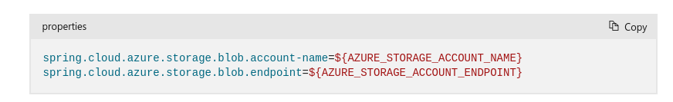
Controller:

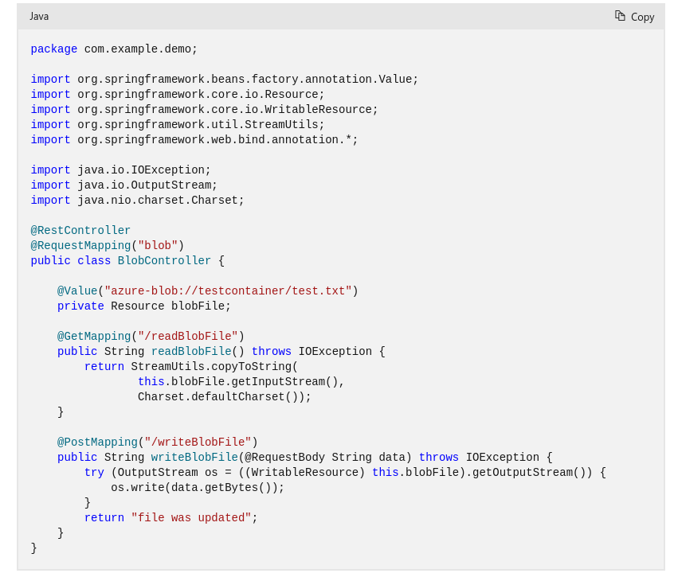

We can also use BlobClient to upload/download from blob storage:

