Jenkins freestyle project to read code from git and then deploy it to tomcat server:
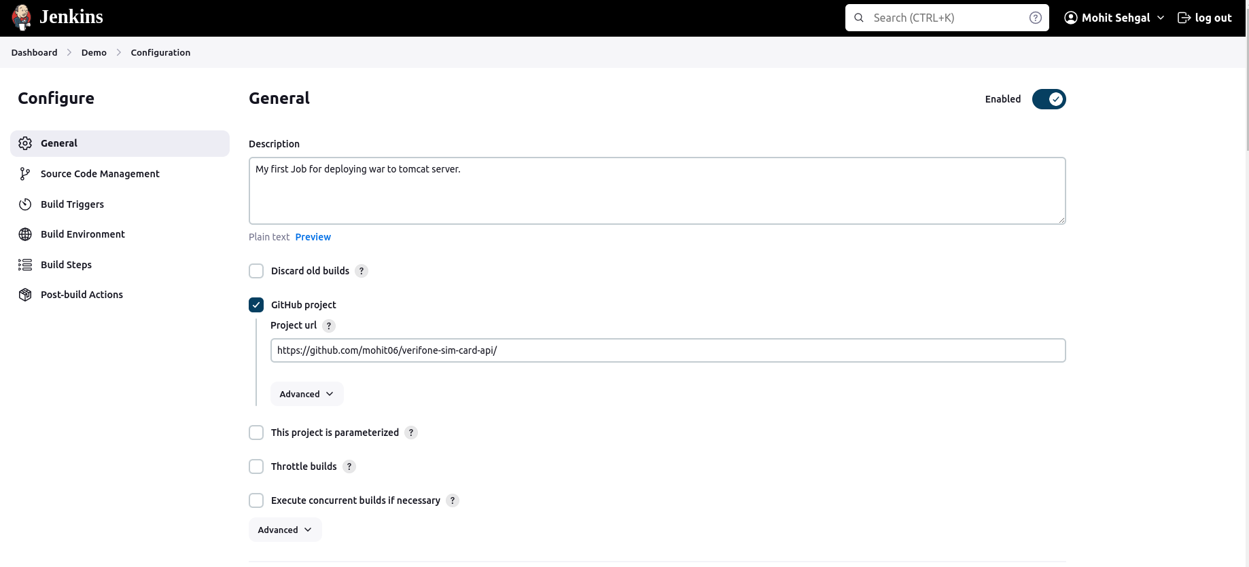
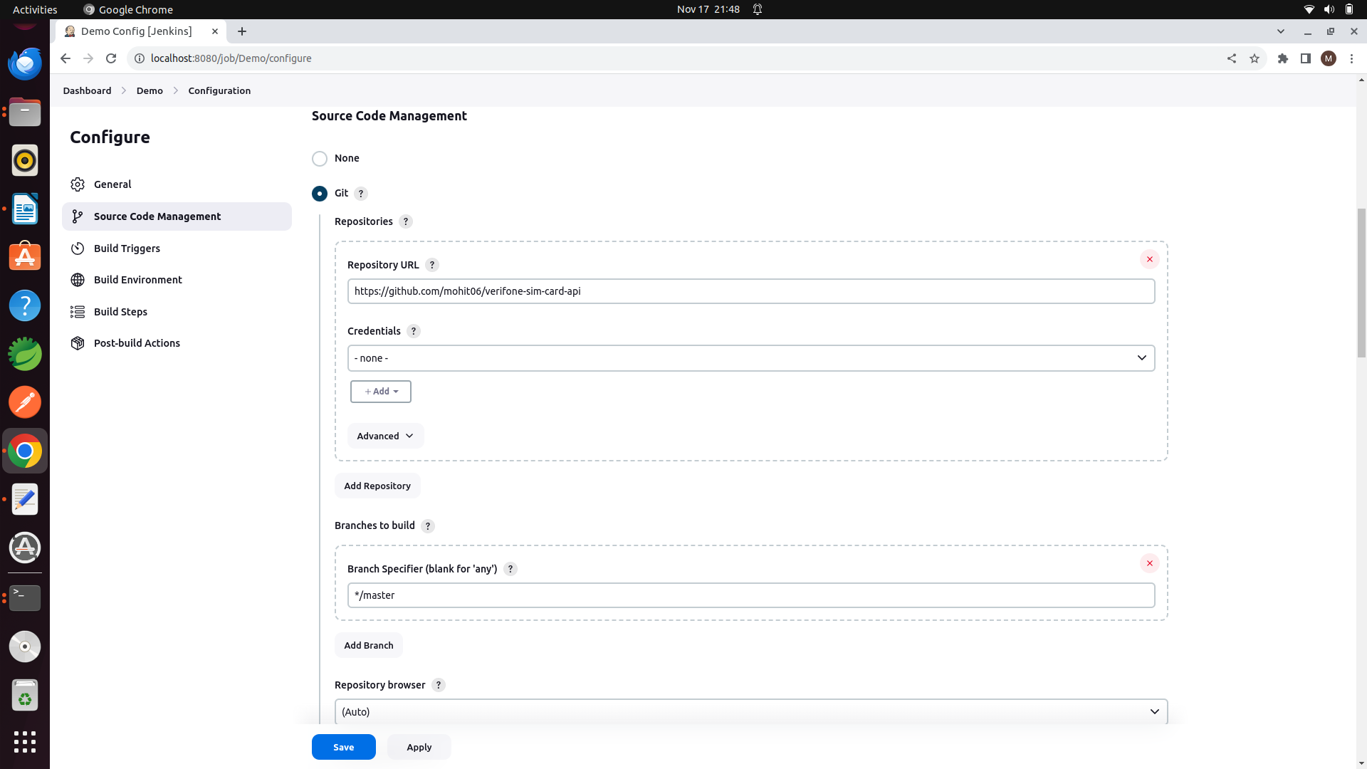
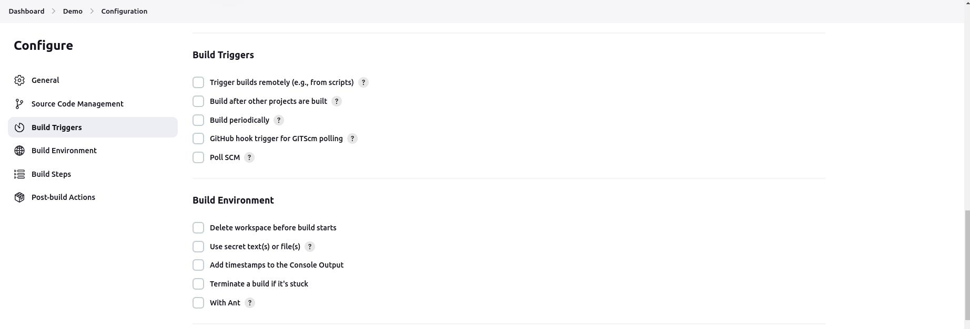
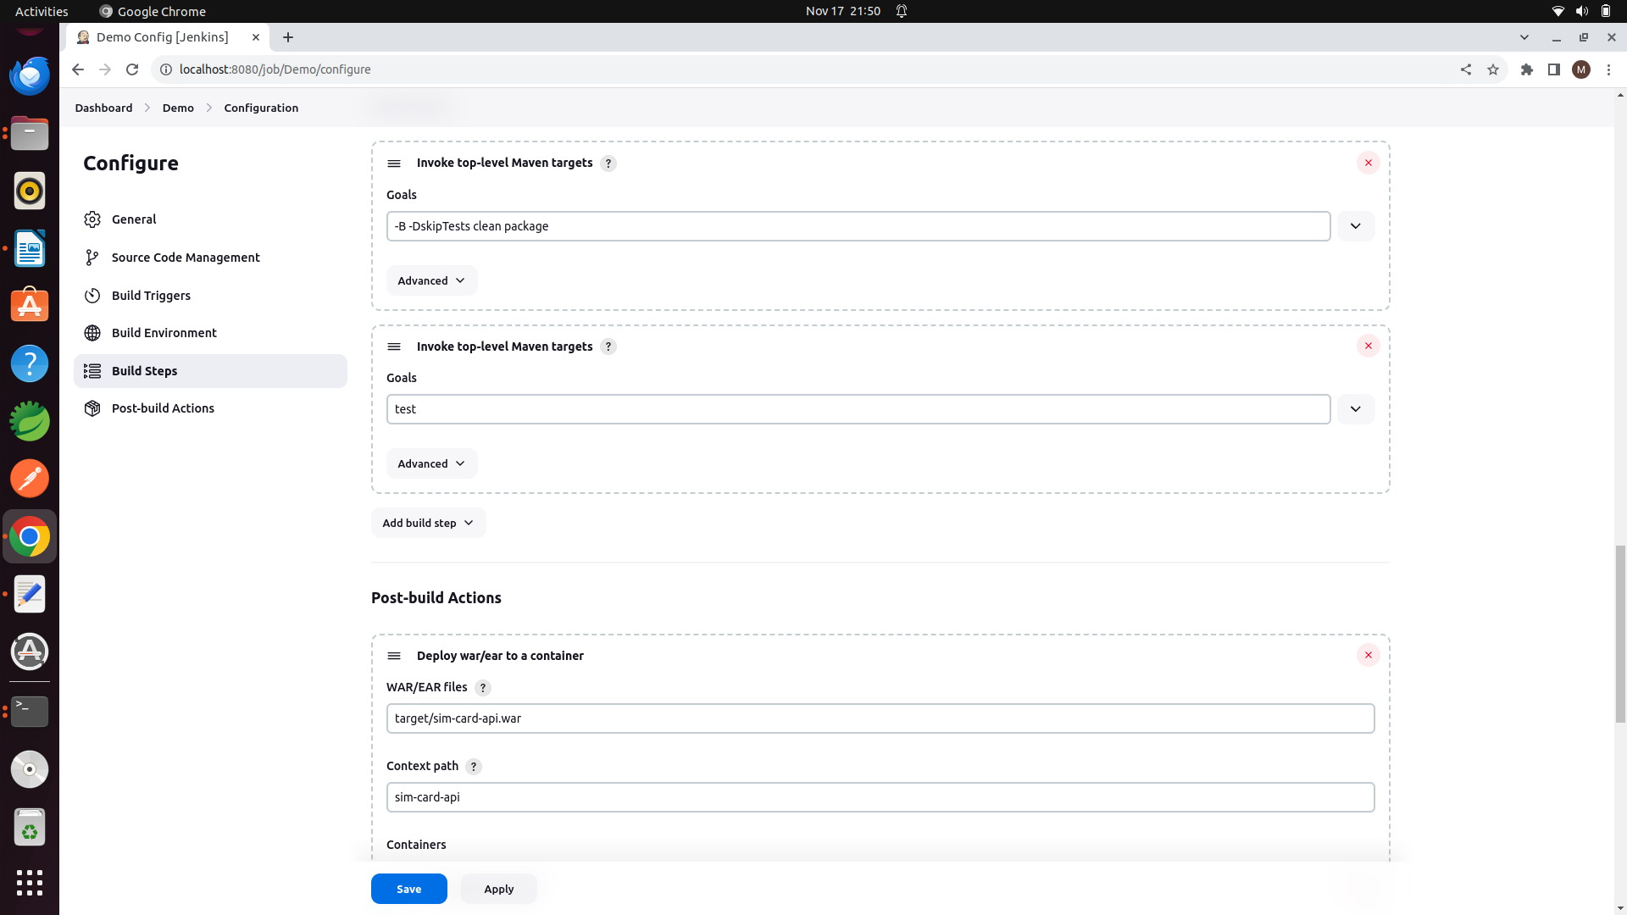
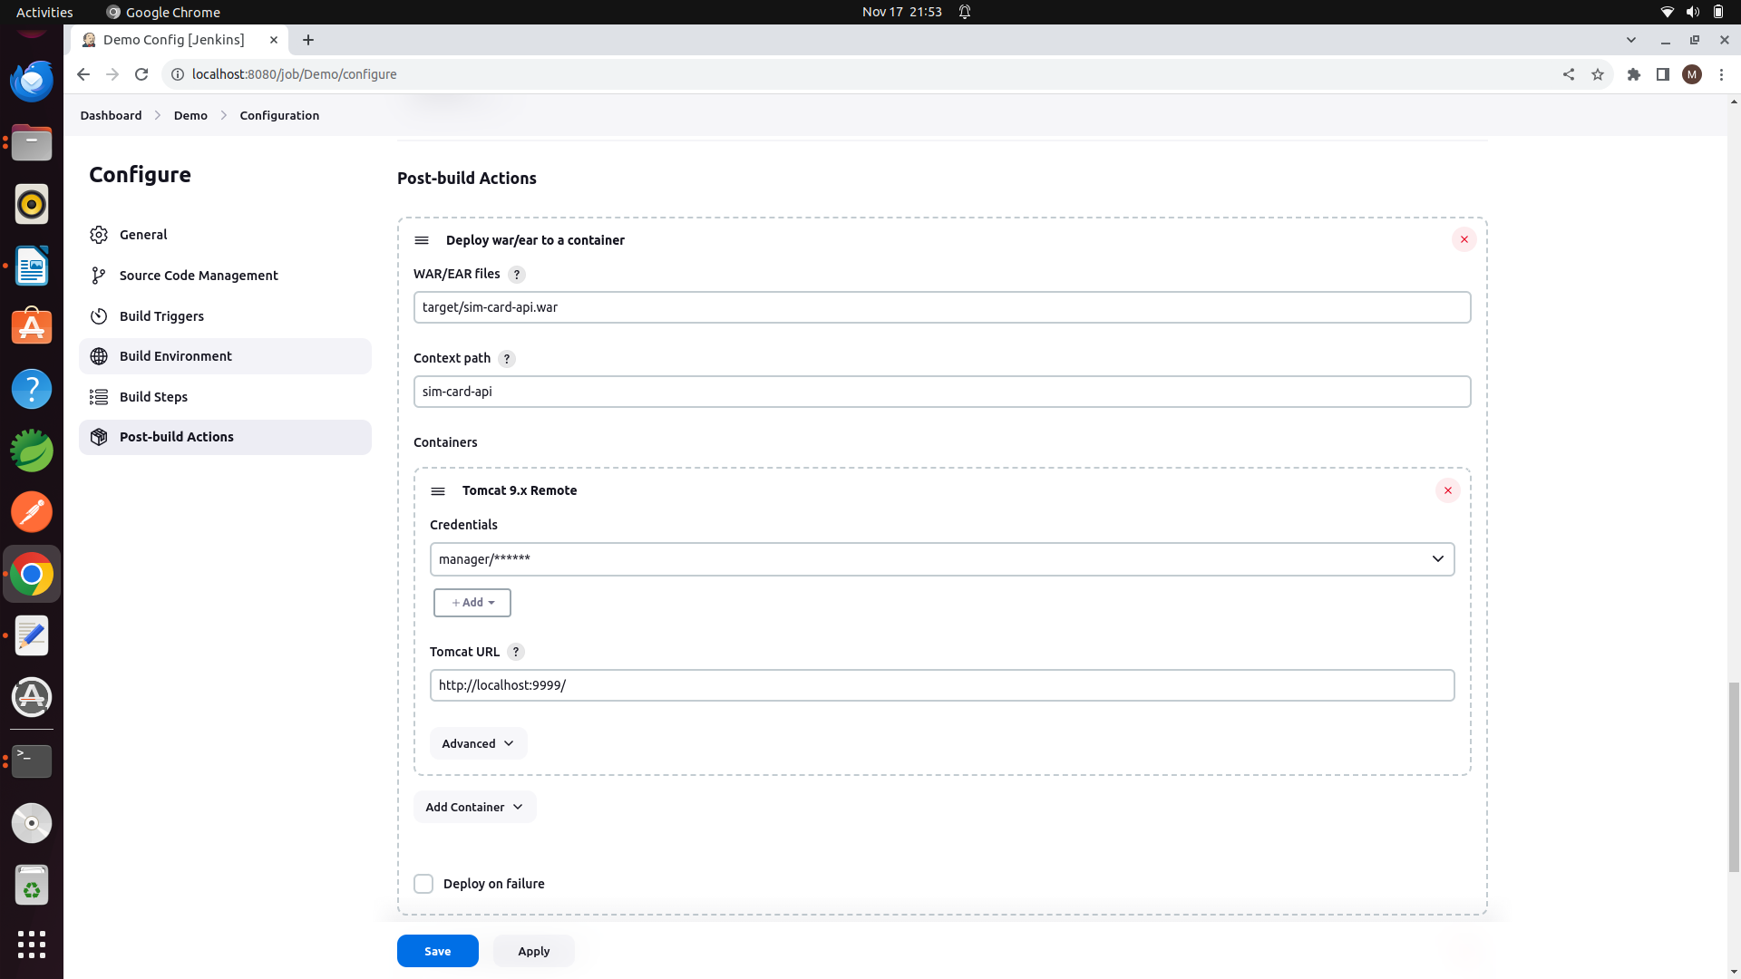

Install jenkins plugins as well:
maven, deploy to container plugin, git etc.
Configure jdk_home and maven path globally in jenkins.

Save the job.

In the spring boot application, make sure tomcat 10 version is compatible with 3.1.5.
extend main class with SpringBootServletInitializer and override configure method.

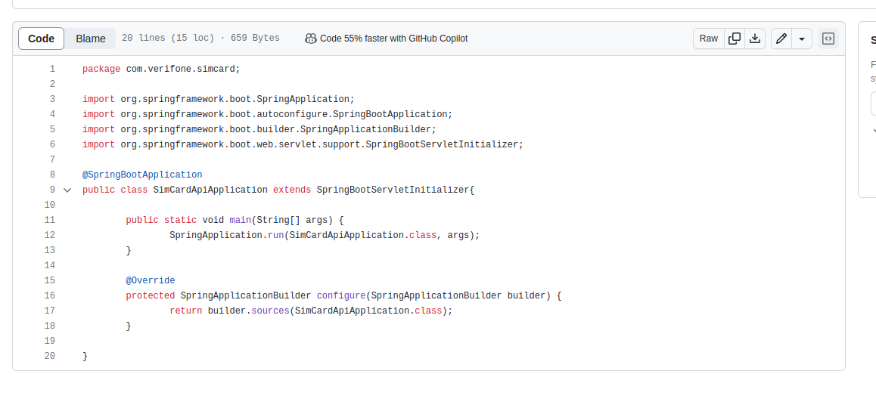

Jenkins Pipeline:
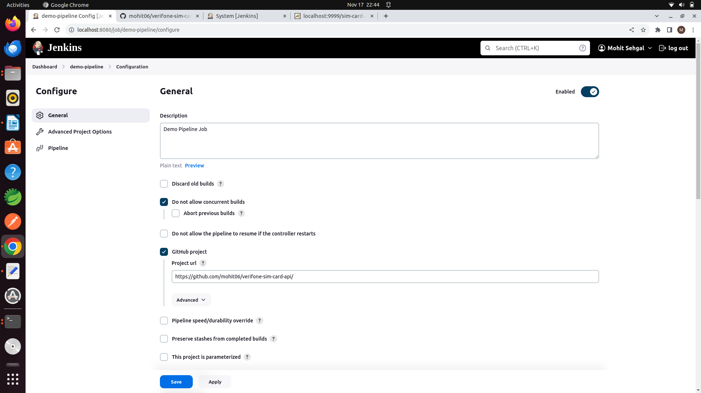
Jenkinsfile:
pipeline {
agent any

// tools {
// // Install the Maven version configured as "M3" and add it to the path.
// maven "M3"
// }

stages {
stage('Build') {
steps {
// Get some code from a GitHub repository
git 'https://github.com/mohit06/verifone-sim-card-api.git'

// Run Maven on a Unix agent.
sh "mvn clean package"

// To run Maven on a Windows agent, use
// bat "mvn -Dmaven.test.failure.ignore=true clean package"
}

post {
// If Maven was able to run the tests, even if some of the test
// failed, record the test results and archive the jar file.
success {
junit '**/target/surefire-reports/TEST-*.xml'
archiveArtifacts 'target/*.war'
}
}
}
stage('Deploy'){
steps{
deploy adapters: [tomcat9(credentialsId: 'manager_for_tomcat', path: '', url: 'http://localhost:9999')], contextPath: 'sim-card-api', onFailure: false, war: 'target/sim-card-api.war'
}
}
}
}

create credentials in System in manage plugins in jenkins.

To send any files(jar , etc..) to server, we can use ssh-agent plugin and ssh command to login into server and scp command to send the file to desired path.

pipeline {
agent any

// tools {
// // Install the Maven version configured as "M3" and add it to the path.
// maven "M3"
// }

stages {
stage('Build') {
steps {
// Get some code from a GitHub repository
git 'https://github.com/mohit06/verifone-sim-card-api.git'

// Run Maven on a Unix agent.
//sh "mvn clean package"

// To run Maven on a Windows agent, use
// bat "mvn -Dmaven.test.failure.ignore=true clean package"
}

// post {
// // If Maven was able to run the tests, even if some of the test
// // failed, record the test results and archive the jar file.
// success {
// junit '**/target/surefire-reports/TEST-*.xml'
// archiveArtifacts 'target/*.jar'
// }
// }
}
stage('Deploy'){

steps{
sshagent(['ssh-key-localhost']) {
sh 'ssh -o StrictHostKeyChecking=no mohit@localhost'
sh 'scp target/*.jar mohit@localhost:/home/mohit/'
}

}

}
}
}

we will need to save private key in the credentials in jenkins.

