SAGA Pattern

Problem: How to handle distributed transaction accross microservices such that if any failur event occurs at any microservice then the previous microservices should be able to revert there local transactions to maintain data consistency.

A saga is a sequence of transactions that updates each service and publishes a message or event to trigger the next transaction step.

Distributed Transactions:
There is a microservice to create the orders, one that processes the payment, another that updates the inventory and the last one that delivers the order.
Each of these microservices performs a local transaction to implement the individual functionalities:
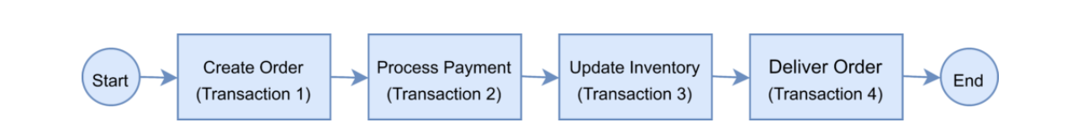
This is an example of a distributed transaction as the transaction boundary crosses multiple services and databases.
To ensure a successful order processing service, all four microservices must complete the individual local transactions. If any of the microservices fail to complete its local transaction, all the completed preceding transactions should roll back to ensure data integrity.

2 Key challenges of distributed transactions:
Maintaining ACID:
The first challenge is maintaining ACID. To ensure the correctness of a transaction, it must be Atomic, Consistent, Isolated and Durable (ACID). The atomicity ensures that all or none of the steps of a transaction should complete. Consistency takes data from one valid state to another valid state. Isolation guarantees that concurrent transactions should produce the same result that sequentially transactions would have produced. Lastly, durability means that committed transactions remain committed irrespective of any type of system failure. In a distributed transaction scenario, as the transaction spans several services, ensuring ACID always remains key.

Maintaining transaction isolation level:
The second challenge is managing the transaction isolation level. It specifies the amount of data that is visible in a transaction when the other services access the same data simultaneously. In other words, if one object in one of the microservices is persisted in the database while another request reads the data, should the service return the old or new data?

SAGA Architecture helps in addressing the challenges with distributed transactions.

The Saga architecture pattern provides transaction management using a sequence of local transactions.

A local transaction is the unit of work performed by a Saga participant. Every operation that is part of the Saga can be rolled back by a compensating transaction. Further, the Saga pattern guarantees that either all operations complete successfully or the corresponding compensation transactions are run to undo the work previously completed.
In the Saga pattern, a compensating transaction must be idempotent and retryable. These two principles ensure that we can manage transactions without any manual intervention.
An idempotent operation is a function or operation that produces the same result when executed multiple times, as it would have if it were executed only once.
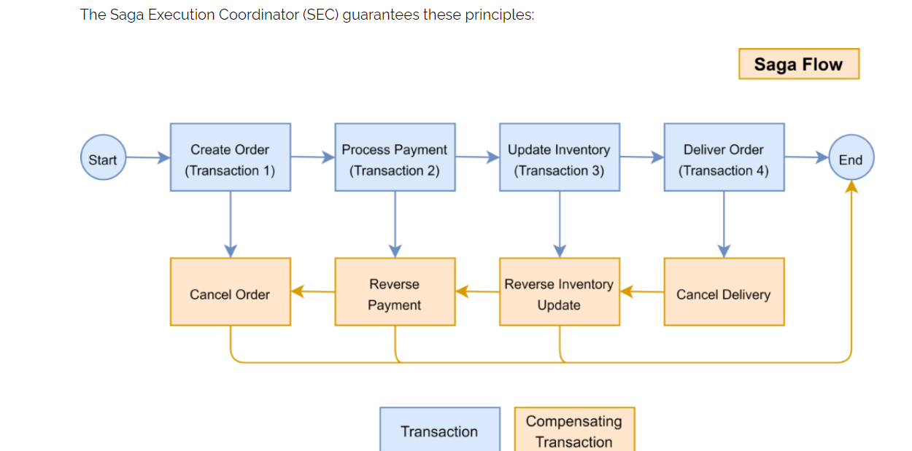

The Saga Execution Coordinator
The Saga Execution Coordinator is the central component to implement a Saga flow. It contains a Saga log that captures the sequence of events of a distributed transaction.
For any failure, the SEC component inspects the Saga log to identify the impacted components and the sequence in which the compensating transactions should run.
For any failure in the SEC component, it can read the Saga log once it’s coming back up.
It can then identify the transactions successfully rolled back, which ones are pending, and can take appropriate actions:
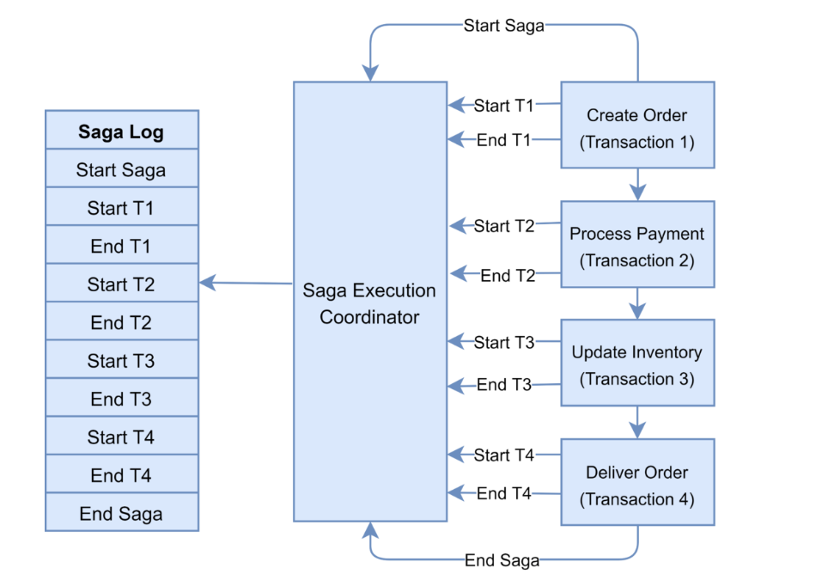
There are two approaches to implement the Saga pattern: choreography and orchestration.

In the Saga, choreography flow is successful if all the microservices complete their local transaction, and none of the microservices reported any failure.
The following diagram demonstrates the successful Saga flow for the online order processing application:
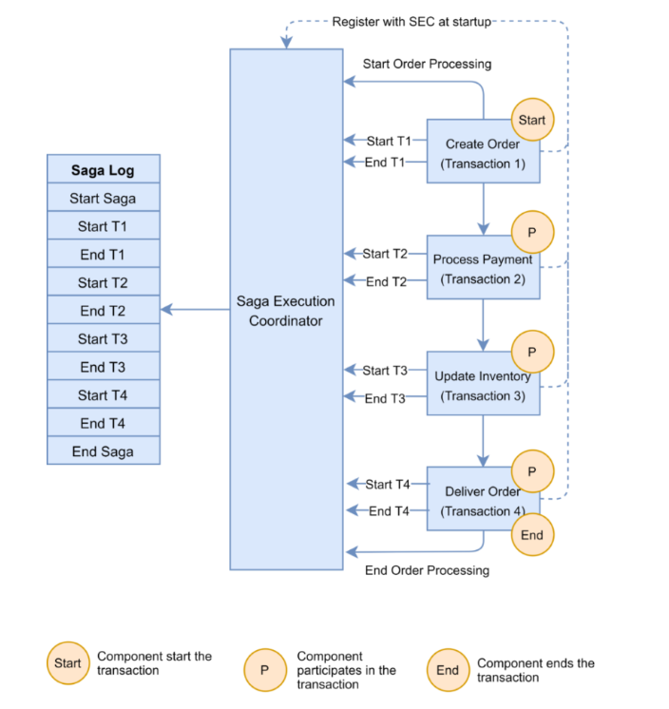
In the event of a failure, the microservice reports the failure to SEC, and it is the SEC’s responsibility to invoke the relevant compensation transactions:

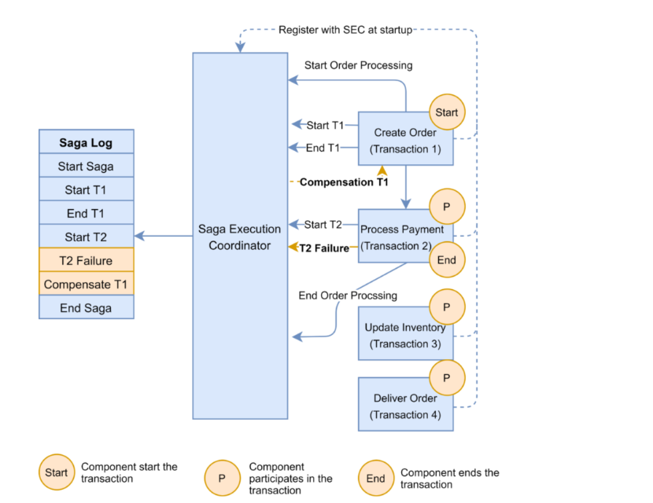
We can have a broker and every service will place the event on the broker the consumer service would pick the event and execute its local transaction.
If any service places a failure event on the broker, then all the microservices listening to the queue on the broker will initiate compensation transaction and place the event on the queue so the previous services in the chain would know that they need to revert the changes.
Adv :
Loose Coupling
Ease of maintainance
Decentralised control
Asynchronous communication.
Disadvantages of Choreography pattern:
Difficult to know which saga events are being listened by which service as in broker, we do not know which consumer is consuming from the queue.
Risk of cyclic dependency when saga participants needs to consume each others command.
Integration testing is difficult.

Orchestration Design Pattern:
Orchestration is the way to coordinate sagas where a centralised controller tells saga participants what local transaction to execute.
In the Orchestration pattern, a single orchestrator is responsible for managing the overall transaction status.

If any of the microservices encounter a failure, the orchestrator is responsible for invoking the necessary compensating transactions:
The orchestrator is responsible for :
execute saga request and store and interprets state of each task, handle failure recovery with compensating transactions.

Orchestrator will give the command and other microservices are not listening on anything. There can be a single point of failure.

Advantages:
Good with many participants or new participants added.
There is a control of orchestrator on the activities.
No cyclic dependencies.
Participants does not need to know about commands for other participants.

Disadv:
Complex logic needs to be implemented at orchestrator end.
Orchestrator manages the complete flow so this is a point of failure.

