Filters in spring Boot:

In order for Spring to recognize a filter, we need to define it as a bean with the @Component annotation.
Moreover, to have the filters fire in the right order, we need to use the @Order annotation.
A filter is an object used to intercept the HTTP requests and responses of your application. By using filter, we can perform two operations at two instances −
- Before sending the request to the controller
- Before sending a response to the client.

TransactionFilter.class
package com.filters.demo;

import java.io.IOException;

import org.slf4j.Logger;
import org.slf4j.LoggerFactory;
import org.springframework.core.annotation.Order;
import org.springframework.stereotype.Component;

import jakarta.servlet.Filter;
import jakarta.servlet.FilterChain;
import jakarta.servlet.ServletException;
import jakarta.servlet.ServletRequest;
import jakarta.servlet.ServletResponse;
import jakarta.servlet.http.HttpServletRequest;

@Component
@Order(1)
public class TransactionFilter implements Filter {

Logger logger = LoggerFactory.getLogger(TransactionFilter.class);

@Override
public void doFilter(ServletRequest request, ServletResponse response, FilterChain chain)
throws IOException, ServletException {
HttpServletRequest req = (HttpServletRequest) request;
logger.info("Starting a transaction for req : {}", req.getRequestURI());

chain.doFilter(request, response);
logger.info("RESPONSE is {} ", response.toString());
logger.info("Committing a transaction for req : {}", req.getRequestURI());

}

}

RequestResponseFilter.class
public class RequestResponseFilter implements Filter {

Logger logger = LoggerFactory.getLogger(RequestResponseFilter.class);

@Override
public void doFilter(ServletRequest request, ServletResponse response, FilterChain chain)
throws IOException, ServletException {

HttpServletRequest req = (HttpServletRequest) request;
HttpServletResponse res = (HttpServletResponse) response;
logger.info("Logging Request {} : {}", req.getMethod(), req.getRequestURI());

chain.doFilter(request, response);
logger.info("Logging Response :{}", res.getContentType());

}

}
Controller:
@SpringBootApplication
@RestController
public class FiltersDemoApplication {

Logger logger = LoggerFactory.getLogger(RequestResponseFilter.class);

public static void main(String[] args) {
SpringApplication.run(FiltersDemoApplication.class, args);
}

@GetMapping("/{name}")
public String getData(@PathVariable String name) {
logger.info("Get Request received.");
return "Hello "+name;
}

@GetMapping("v1/{name}")
public String getV1Data(@PathVariable String name) {
logger.info("V1: Get Request received.");
return "Hello "+name;
}

}

Configuration:
package com.filters.demo;

import org.springframework.boot.web.servlet.FilterRegistrationBean;
import org.springframework.context.annotation.Bean;
import org.springframework.context.annotation.Configuration;

@Configuration
public class EndpointSpecificFilterConfig {

@Bean
public FilterRegistrationBean<RequestResponseFilter> loggingFilter(){
FilterRegistrationBean<RequestResponseFilter> registrationBean
= new FilterRegistrationBean<>();

registrationBean.setFilter(new RequestResponseFilter());
registrationBean.addUrlPatterns("/v1/*");
registrationBean.setOrder(2);

return registrationBean;
}
}

2024-01-20T18:11:19.206+05:30[0;39m [32m INFO[0;39m [35m156274[0;39m [2m---[0;39m [2m[nio-8088-exec-1][0;39m [2m[0;39m[36mcom.filters.demo.TransactionFilter [0;39m [2m:[0;39m Starting a transaction for req : /TESTTTTTTT
[2m2024-01-20T18:11:19.259+05:30[0;39m [32m INFO[0;39m [35m156274[0;39m [2m---[0;39m [2m[nio-8088-exec-1][0;39m [2m[0;39m[36mcom.filters.demo.RequestResponseFilter [0;39m [2m:[0;39m Get Request received.
[2m2024-01-20T18:11:19.289+05:30[0;39m [32m INFO[0;39m [35m156274[0;39m [2m---[0;39m [2m[nio-8088-exec-1][0;39m [2m[0;39m[36mcom.filters.demo.TransactionFilter [0;39m [2m:[0;39m RESPONSE is org.apache.catalina.connector.ResponseFacade@6b1c7f1e
[2m2024-01-20T18:11:19.289+05:30[0;39m [32m INFO[0;39m [35m156274[0;39m [2m---[0;39m [2m[nio-8088-exec-1][0;39m [2m[0;39m[36mcom.filters.demo.TransactionFilter [0;39m [2m:[0;39m Committing a transaction for req : /TESTTTTTTT
[2m2024-01-20T18:11:19.398+05:30[0;39m [32m INFO[0;39m [35m156274[0;39m [2m---[0;39m [2m[nio-8088-exec-2][0;39m [2m[0;39m[36mcom.filters.demo.TransactionFilter [0;39m [2m:[0;39m Starting a transaction for req : /favicon.ico
[2m2024-01-20T18:11:19.400+05:30[0;39m [32m INFO[0;39m [35m156274[0;39m [2m---[0;39m [2m[nio-8088-exec-2][0;39m [2m[0;39m[36mcom.filters.demo.RequestResponseFilter [0;39m [2m:[0;39m Get Request received.
[2m2024-01-20T18:11:19.418+05:30[0;39m [32m INFO[0;39m [35m156274[0;39m [2m---[0;39m [2m[nio-8088-exec-2][0;39m [2m[0;39m[36mcom.filters.demo.TransactionFilter [0;39m [2m:[0;39m RESPONSE is org.apache.catalina.connector.ResponseFacade@3e9b461e
[2m2024-01-20T18:11:19.418+05:30[0;39m [32m INFO[0;39m [35m156274[0;39m [2m---[0;39m [2m[nio-8088-exec-2][0;39m [2m[0;39m[36mcom.filters.demo.TransactionFilter [0;39m [2m:[0;39m Committing a transaction for req : /favicon.ico
[2m2024-01-20T18:12:38.119+05:30[0;39m [32m INFO[0;39m [35m156274[0;39m [2m---[0;39m [2m[nio-8088-exec-5][0;39m [2m[0;39m[36mcom.filters.demo.TransactionFilter [0;39m [2m:[0;39m Starting a transaction for req : /v1/uuuu
[2m2024-01-20T18:12:38.119+05:30[0;39m [32m INFO[0;39m [35m156274[0;39m [2m---[0;39m [2m[nio-8088-exec-5][0;39m [2m[0;39m[36mcom.filters.demo.RequestResponseFilter [0;39m [2m:[0;39m Logging Request GET : /v1/uuuu
[2m2024-01-20T18:12:38.123+05:30[0;39m [32m INFO[0;39m [35m156274[0;39m [2m---[0;39m [2m[nio-8088-exec-5][0;39m [2m[0;39m[36mcom.filters.demo.RequestResponseFilter [0;39m [2m:[0;39m V1: Get Request received.
[2m2024-01-20T18:12:38.129+05:30[0;39m [32m INFO[0;39m [35m156274[0;39m [2m---[0;39m [2m[nio-8088-exec-5][0;39m [2m[0;39m[36mcom.filters.demo.RequestResponseFilter [0;39m [2m:[0;39m Logging Response :text/html;charset=UTF-8
[2m2024-01-20T18:12:38.130+05:30[0;39m [32m INFO[0;39m [35m156274[0;39m [2m---[0;39m [2m[nio-8088-exec-5][0;39m [2m[0;39m[36mcom.filters.demo.TransactionFilter [0;39m [2m:[0;39m RESPONSE is org.apache.catalina.connector.ResponseFacade@e1efcb9
[2m2024-01-20T18:12:38.130+05:30[0;39m [32m INFO[0;39m [35m156274[0;39m [2m---[0;39m [2m[nio-8088-exec-5][0;39m [2m[0;39m[36mcom.filters.demo.TransactionFilter [0;39m [2m:[0;39m Committing a transaction for req : /v1/uuuu
[2m2024-01-20T18:12:38.261+05:30[0;39m [32m INFO[0;39m [35m156274[0;39m [2m---[0;39m [2m[nio-8088-exec-6][0;39m [2m[0;39m[36mcom.filters.demo.TransactionFilter [0;39m [2m:[0;39m Starting a transaction for req : /favicon.ico
[2m2024-01-20T18:12:38.267+05:30[0;39m [32m INFO[0;39m [35m156274[0;39m [2m---[0;39m [2m[nio-8088-exec-6][0;39m [2m[0;39m[36mcom.filters.demo.RequestResponseFilter [0;39m [2m:[0;39m Get Request received.
[2m2024-01-20T18:12:38.274+05:30[0;39m [32m INFO[0;39m [35m156274[0;39m [2m---[0;39m [2m[nio-8088-exec-6][0;39m [2m[0;39m[36mcom.filters.demo.TransactionFilter [0;39m [2m:[0;39m RESPONSE is org.apache.catalina.connector.ResponseFacade@2bfbb769
[2m2024-01-20T18:12:38.274+05:30[0;39m [32m INFO[0;39m [35m156274[0;39m [2m---[0;39m [2m[nio-8088-exec-6][0;39m [2m[0;39m[36mcom.filters.demo.TransactionFilter [0;39m [2m:[0;39m Committing a transaction for req : /favicon.ico

we may sometimes want a filter to only apply to certain URL patterns.
In this case, we have to remove the @Component annotation from the filter class definition and register the filter using a FilterRegistrationBean.

Interceptors:
You can use the Interceptor in Spring Boot to perform operations under the following situations −
- Before sending the request to the controller
- Before sending the response to the client
To work with interceptor, you need to create @Component class that supports it and it should implement the HandlerInterceptor interface.

The following are the three methods you should know about while working on Interceptors −
- preHandle() method − This is used to perform operations before sending the request to the controller. This method should return true to return the response to the client.
- PostHandle() method − This is used to perform operations before sending the response to the client.
- AfterCompletion() method − This is used to perform operations after completing the request and response.

The purpose of HandlerMapping is to map a handler method to a URL. That way, the DispatcherServlet will be able to invoke it when processing a request.
As a matter of fact, the DispatcherServlet uses the HandlerAdapter to actually invoke the method.
In short, interceptors intercept requests and process them. They help to avoid repetitive handler code such as logging and authorization checks.
Now that we understand the overall context, let’s see how to use a HandlerInterceptor to perform some pre- and post-processing actions.

In order to use interceptors, we need to include the spring-web dependency in our pom.xml:
<dependency>
<groupId>org.springframework</groupId>
<artifactId>spring-web</artifactId>
<version>5.3.13</version>
</dependency>
Simply put, a Spring interceptor is a class that either extends the HandlerInterceptorAdapter class or implements the HandlerInterceptor interface.
Here’s a simple preHandle() implementation:
@Override
public boolean preHandle(
HttpServletRequest request,
HttpServletResponse response,
Object handler) throws Exception {
// your code
return true;
}Copy
Notice that the method returns a boolean value. It tells Spring to further process the request (true) or not (false).
Next, we have an implementation of postHandle():
@Override
public void postHandle(
HttpServletRequest request,
HttpServletResponse response,
Object handler,
ModelAndView modelAndView) throws Exception {
// your code
}Copy
The interceptor calls this method immediately after processing the request but before generating the view.

For example, we may use this method to add an avatar of a logged-in user into a model.
The final method we need to implement is afterCompletion():
@Override
public void afterCompletion(
HttpServletRequest request,
HttpServletResponse response,
Object handler, Exception ex) {
// your code
}Copy
This method allows us to execute custom logic after the completion of the request processing.
Moreover, it’s worth mentioning that we can register multiple custom interceptors. To do that, we can use DefaultAnnotationHandlerMapping.

Interceptors are part of Spring MVC framework.

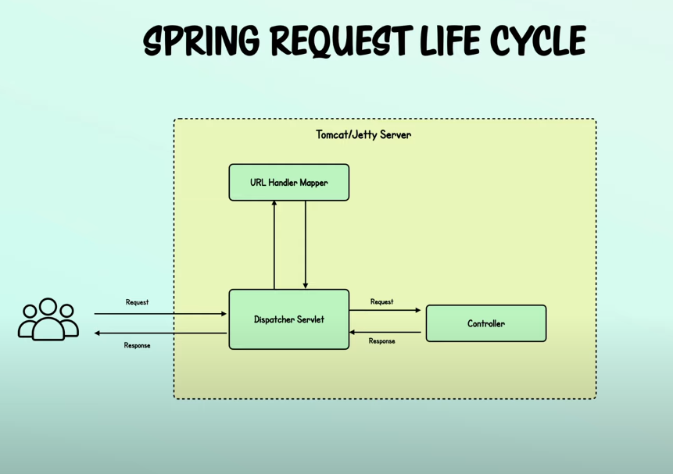
REST request lifecycle:
Request is received by Dispatcher servlet. It uses handler mapping to determine which controller to call. Once it knows, it calls the controller.

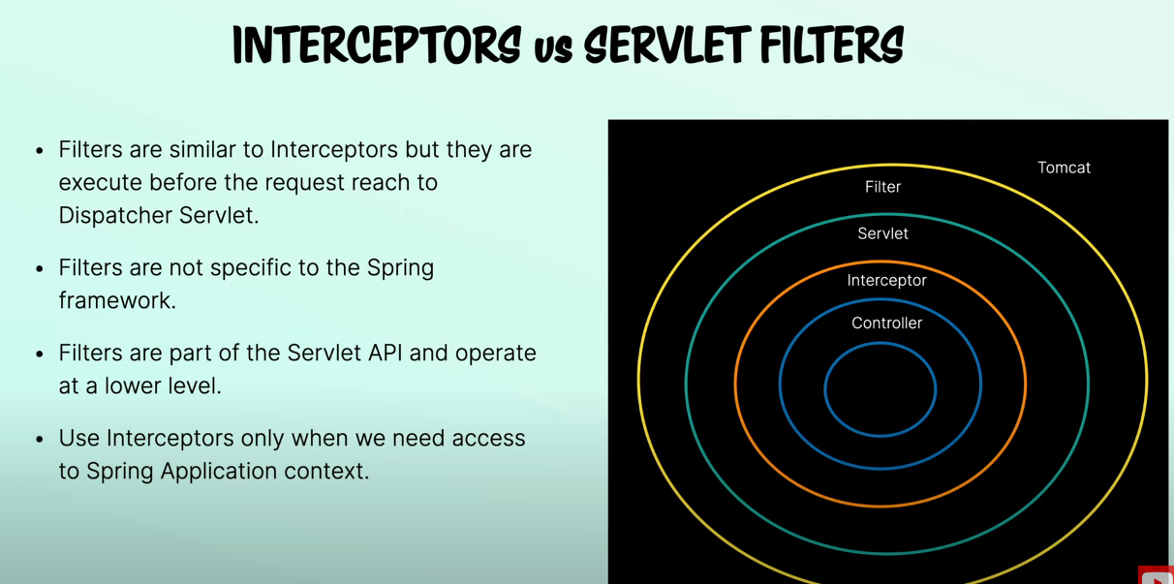

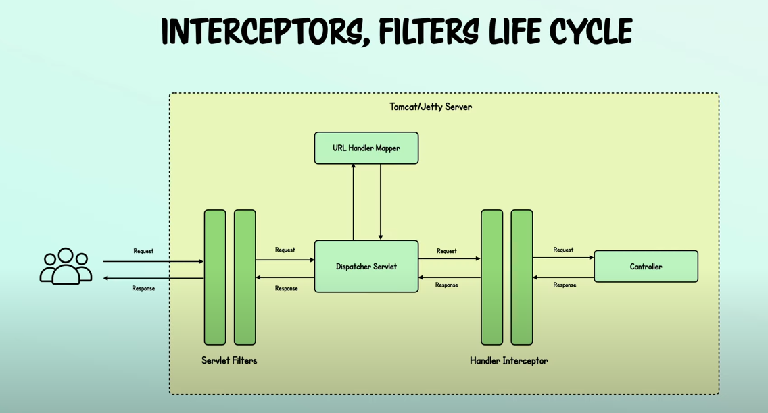
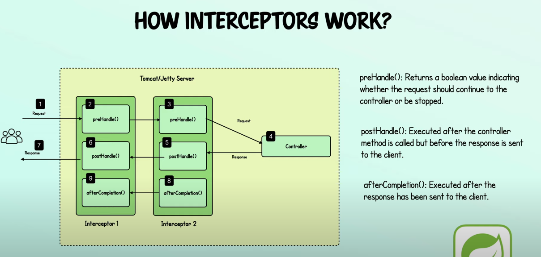
We need to register interceptor with spring boot application.

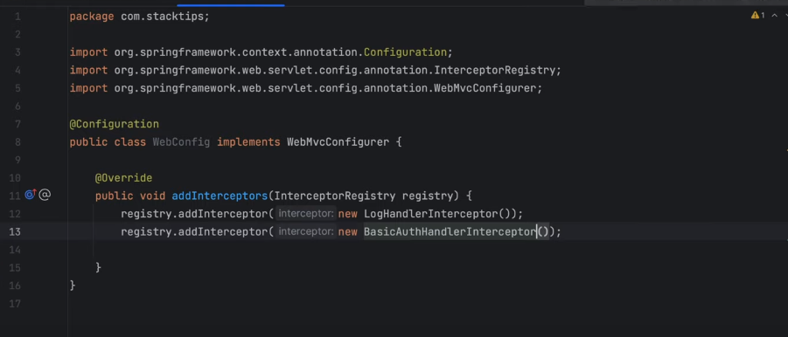
Above code will register our interceptor with InterceptorRegistry.
