Multithreading and concurrency:

Why multithreading?
Better utilisation of CPU.
Higher application responsiveness.

What is difference between multi-tasking, multiprocessing and multithreading?

Java Thread Pools:
A thread pool reuses previously created thread to execute current task.
Thread pool makes applications more responsive because thread creation time is eliminated.

In Executor framework , we have Executor Interface, ExecutorService ( it extends Executor interface) and ThreadPoolExecutor class.
We only have to implement runnable objects and send them to executor to execute the task.

We can focus on the task that the thread is going to perform.

To use thread pool, we create object of executor service and pass tasks to it.

New tasks are rejected if blocking queue is full.

Threadpool methods:

newFixedThreadPool(int): create a fixed size thread pool.
NewCachedThreadPool(): threadPool creates new threads as needed but will reuse existing threads when they are avaiable.
NewSingleThreadExecutor(): creates a single thread.

Risks in using thread pools:
Deadlock:
Thread Leakage: Thread picks a task and execute it and then it gets some exceptions and does not return back to thread pool.
Resource Thrashing: If the thread pool size is very large then time is wasted in context switching between threads. Having more threads than the optimal number may cause starvation problem leading to resource thrashing as explained.

Call shutdown() on the pool to end the executor.

Optimum Size of thread pool depends upon the number of processors and the nature of tasks.
On a N processor system for a queue of only computation type processes, a maximum thread pool size of N or N+1 will achieve the maximum efficiency.
But tasks may wait for I/O and in such a case we take into account the ratio of waiting time(W) and service time(S) for a request; resulting in a maximum pool size of N*(1+ W/S) for maximum efficiency.

Int coreCount = Runtime.getRuntime().availableProcessors();

submit()can return the result of computation because it has a return type of Future, but the execute() method cannot return anything because return type is void.

submit() method accepts both Runnable and callable as parameters Execute() takes only runnable.

Thread based multitasking is better than multiprocessing because threads have smaller context as compared to processes and so context switchig is fast.
Thread-based multitasking is better as multitasking of threads requires less overhead as compared to process multitasking because processes are heavyweight in turn requiring their own separate address space in memory while threads being very light-weight processes and share the same address space as cooperatively shared by heavyweight processes.

Running program is a process and threads are lightweight processes. A process can have multiple threads.

Which is better : implementing Runnable or extending thread class?
If we implement Runnable then we have option to extend some class as well but if we are extending from Thread then we can’t extend any other class.

we can't call the start() method twice otherwise it will throw an IllegalStateException whereas run() method can be called multiple times as it is just a normal method calling.

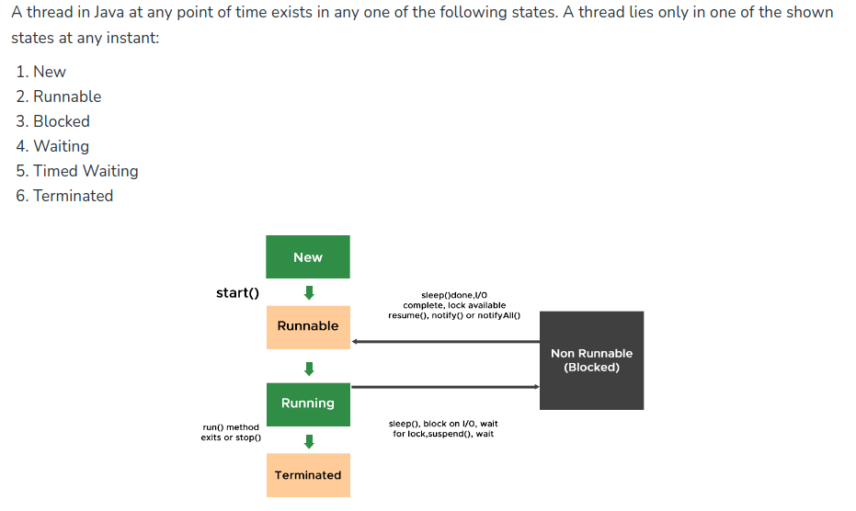
If multiple threads are waiting to execute then thread execution is decided by “ThreadScheduler” which is a part of JVM hence its vendor dependent resulting in unexpected execution of output order.

Yield():
A yield() method is a static method of Thread class and it can stop the currently executing thread and will give a chance to other waiting threads of the same priority. If in case there are no waiting threads or if all the waiting threads have low priority then the same thread will continue its execution.
yield does not have any synchronization semantic. If thread holds lock, it will continue to hold it.

yield() is a native method its implementation in java 6 has been changed as compared to its implementation java 5. As method is native it’s implementation is provided by JVM.
In java 5, yield() method internally used to call sleep() method giving all the other threads of same or higher priority to execute before yielded thread by leaving allocated CPU for time gap of 15 millisec.

But java 6, calling yield() method gives a hint to the thread scheduler that the current thread is willing to yield its current use of a processor. The thread scheduler is free to ignore this hint. So, sometimes even after using yield() method, you may not notice any difference in output.

Definition : yield() method when called on thread gives a hint to the thread scheduler that the current thread is willing to yield its current use of a processor. The thread scheduler is free to ignore this hint.

- Thread state : when yield() method is called on thread it goes from running to runnable state, not in waiting state. Thread is eligible to run but not running and could be picked by scheduler at the discretion of the implementation.

- Exception : yield() method doesn’t throws any exception.

- Waiting time : yield() method stops thread for unpredictable time.

- Static method : yield() is a static method, hence calling Thread.yield() causes currently executing thread to yield.

- Native method : implementation of yield() method is provided by JVM.
Let’s see definition of yield() method as given in java.lang.Thread -
public static native void yield();

- synchronized block : thread need not to to acquire object lock before calling yield() method i.e. yield() method can be called from outside synchronized block.

Notify():
The notify() method of thread class is used to wake up a single thread. This method gives the notification for only one thread which is waiting for a particular object.

If we use notify() method and multiple threads are waiting for the notification then only one thread get the notification and the remaining thread have to wait for further notification.

wait() and notify() should always be called from a synchronized block or method. This is because they require a lock on the object's monitor, and if the lock is not held, an IllegalMonitorStateException will be thrown.

A thread that goes into waiting for state by calling the wait() method will be in waiting for the state until any other thread calls either notify() or notifyAll() method on the same object.

Sr. No. | Key | notify() | notifyAll()
1 | Notifications | In the case of the multiThreading, notify() method sends the notification to only one thread among the multiple waiting threads which are waiting for the send lock. | While notifyAll() methods in the same context send notifications to all waiting threads instead of a single thread.
2 | Thread identifications | As in the case of notify() method, the notification is sent to a single thread among the multiple waiting threads, so it is sure that which of those waiting threads is going to receive the lock. | On the other hand, notifyAll() sends a notification to all waiting threads. Hence, it is not clear which of the thread is going to receive the lock.
3 | Risk factor | In the case of notify() method, the risk of thread missing is high as notification is sent only a single thread, and if it misses that, then no other thread would get a notification and hence the lock. | While in the case of notifyAll(), it sends a notification to all the waiting threads, and hence if any thread misses the notification, there are other threads to do the job. Hence the risk is less.
4 | Performance | Memory and CPU drain is less in notify() method as compared to notifyAll() method as notification is sent to single one thread so performance is better as compared to notifyAll(). | On the other hand, the cost of no notification is dropped and notification is sent to all waiting threads, the memory and CPU drain is more as compared to notify() and hence performance of notifyAll() is lesser.
5 | Interchangeable | In the case of the notify() method, only a single thread is in the picture hence no concept of thread Interchangeable is possible. | While we should go for notifyAll() if all your waiting threads are interchangeable (the order they wake up doesn’t matter).

sleep():
calling Thread.sleep() from a synchronized block is likely not a good idea.

Method Whenever Thread.sleep() functions to execute, it always pauses the current thread execution.
- If any other thread interrupts when the thread is sleeping, then InterruptedException will be thrown.
- If the system is busy, then the actual time the thread will sleep will be more as compared to that passed while calling the sleep method and if the system has less load, then the actual sleep time of the thread will be close to that passed while calling sleep() method.

https://www.youtube.com/watch?v=UTUyJFvXeK4
New -> Ready -> Running -> Waiting -> Terminated
suspend, sleep, wait methods will send thread to waiting state.

If any executing thread t1 calls join() on t2 i.e; t2.join() immediately t1 will enter into waiting state until t2 completes its execution.
- Giving a timeout within join(), will make the join() effect to be nullified after the specific timeout.

When wait() method is called, the calling thread stops its execution until notify() or notifyAll() method is invoked by some other Thread.

The suspend() method of thread class puts the thread from running to waiting state. This method is used if you want to stop the thread execution and start it again when a certain event occurs. This method allows a thread to temporarily cease execution. The suspended thread can be resumed using the resume() method.

interrupt() : When we call loop.interrupt(), an Interrupt status flag is set to true.
- interrupted() : It is static method and checks the interrupt status flag of current thread. When we call interrupted(), the flag is returned and immediately set to false.
An interrupt is an indication to a thread that it should stop what it is doing and do something else. It's up to the programmer to decide exactly how a thread responds to an interrupt, but it is very common for the thread to terminate

interrupted() | isInterrupted()
1 | The interrupted() is a static method in Thread class that determines if the current thread has been interrupted. | The isInterrupted() is an instance method that tests if this thread instance has been interrupted.
1 | "The interrupted status of the thread is cleared by this method". Therefore, if a thread was interrupted, calling interrupted() once would return true, while a second call to it would return false until the current thread is interrupted again. | "The interrupted status of the thread is unaffected by this method".

Every thread has a interrupt flag.

