Kubernetes

What is K8s?
It is open source container-orchestration engine or container management tool. It automates deploying, scaling, load balancing and managing containerised applications.

Components:
POD
NODE
CLUSTER
REPLICATION CONTROLLER REPLICA SET
SERVICE
DEPLOYMENT
SECRET
CONFIG MAP
ETCD

In K8s, we do not interact with containers directly, containers are wrapped into functional unit that is called POD. Pod can have single container or multiple containers. Each POD is associated with single IP address. That’s how 1 POD can talk to another POD.
A virtual or physical machine that have 1 or more than 1 pods is called NODE. Multiple Nodes form a cluster. A cluster can have single node or multiple node. Cluster has 1 master node and multiple worker nodes.
A ReplicaSet ensures that a specified number of pod replicas are running at any given time. If my pod crashes then that instace will be replaced by the replica from the replica set and a new IP will be assigned to it.
If one of the pod dies and other pod is trying to communicate to it then it wont be able to connect because IP keep getting changed. Each pod can associate to one service or multiple pod can group together into a single service with labels and selectors. Service will be provided static IP and DNS name. Service also plays the role of load balancer. It will balance the load among pods that are associated with the service.

Deployment are K8S objects that are used for managing pods. We can increase the number of running pods or update the running application using deployment object.

Secret and ConfigMap both are used to store sensitive information of application like keys, password. Secret store sensitive info in encrypted format while configmap stores sensitive info in plain text.

ETCD is the key-value database store. It stores configuration of K8S cluster. It stores all the secrets and configmap in etcd and maximum secret size can be 1 Mb.

A K8S cluster consists of Master Node and Worker Node. Master node will check if Worker Node is running smoothly or not. It will check whether all POD are running or not. If any pods are down then they will be replaced with new POD with new IP. If any node is down then all the pods will be assigned to new node.

In K8s, there must be atleast 1 cluster with 1 master node and 1 worker node.

Master Node: It has 4 components: API Server, Scheduler, Controller Manager, ETCD.
API Server acts as a Cluster Gateway. Any request coming to the cluster will be received by API Server. It provides API to access different operations going on inside cluster. We can access API Server using command line tool or UI.
If I want to check health of my pods and nodes, then we run the commnds:
Kubectl get nodes
Kubectl get pods

When we run the command, the request is intercepted by API Server and then API Server will check all the worker nodes and pods running inside nodes and then it will return the status.

Scheduler Schedules pods on nodes. Lets say we want to scale our application then we will need to create more pods, so Scheduler wil check all the worker nodes and it will create a pod on the node which is least utilised.

All the cluster info is fetched into ETCD. API Server get this info and share it with Scheduler.

Controller manager detects cluster state change like node and pod crash. So whenever a pod crash, controller manager will ask scheduler to schedule a new pod. It is divided into multiple components : Node Controller ( detacts the state change of nodes.), Replication Controller( monitor the state change of pods), Endpoints Controller ( manage all service and their communication), service Account and Token Controller(responsible for maintaining account, API access and namespace)
Basically , Controller manager keep monitoring the health of the cluster.

Worker Node has 3 components: kubelet, kube-proxy and Container runtime.
Kubelet is an agent running on worker node and it communicates with master using API Server. Kubelet works in terms of podSpec. A podSpec is a yaml or json object that describes about your pods. It makes sure containers are running in pods. It only check for container that are created by K8S.

Kube-proxy:kube-proxy is a network proxy that runs on each node in your cluster, implementing part of the Kubernetes Service concept. kube-proxy maintains network rules on nodes. These network rules allow network communication to your Pods from network sessions inside or outside of your cluster. It also communicates with master using api-server.

Container Runtime: A Container runtime also known as container engine and it helps to run container inside pods.

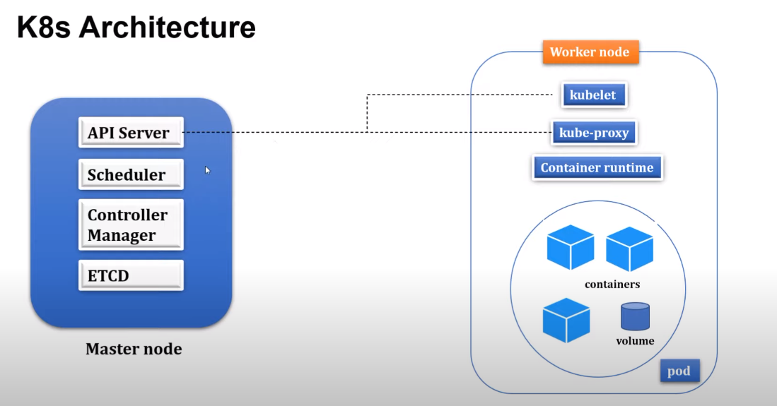
Kubectl is command-line tool and using this tool we can connect to kubernetes cluster.

Steps of deployment to K8S cluster :
1. create jar file of the code
2. create Dockerfile
3. build image
4. kubectl create deployment namingServer –image=<<imageName>> --port=8761
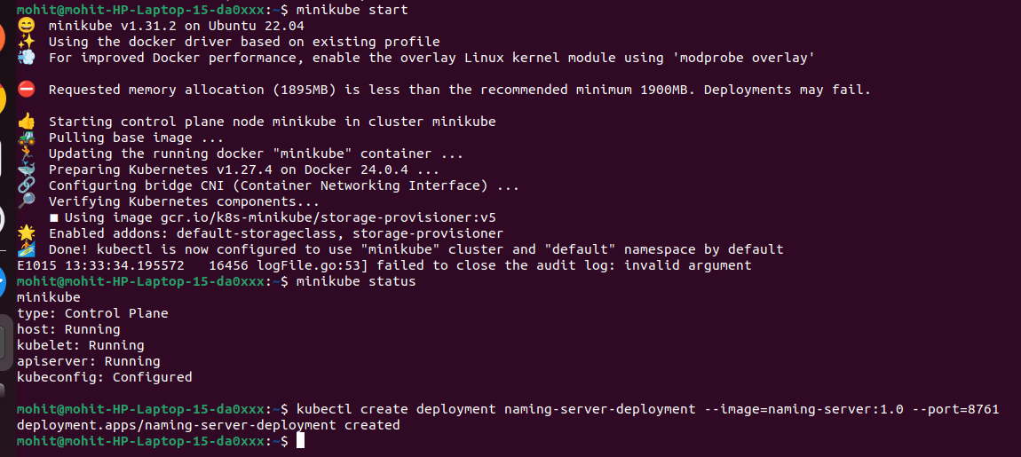

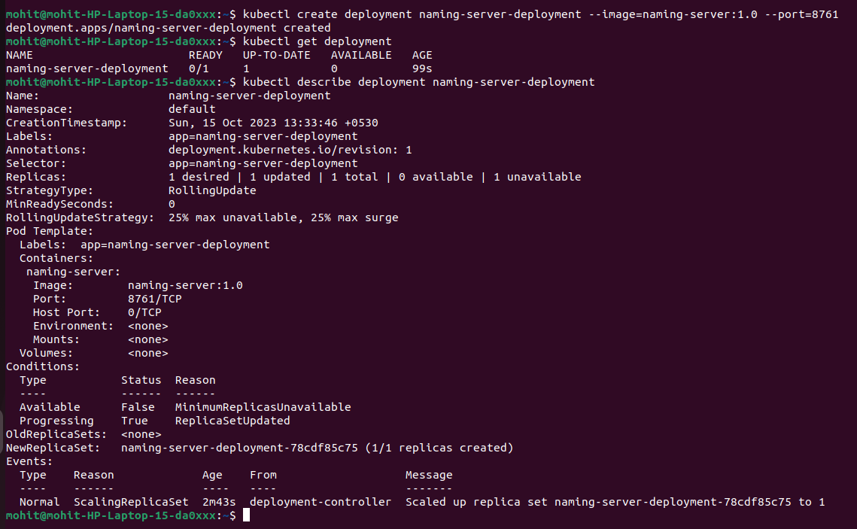
kubectl get deployment
kubectl describe deployment naming-server-deployment

One we create deployment object, our pods will be created as well and containers will start running in pods but to access the endpoints in the containers we need to expose the deployments as service.

What is a Kubernetes Service? The idea of a Service is to group a set of Pod endpoints into a single resource. You can configure various ways to access the grouping. By default, you get a stable cluster IP address that clients inside the cluster can use to contact Pods in the Service.

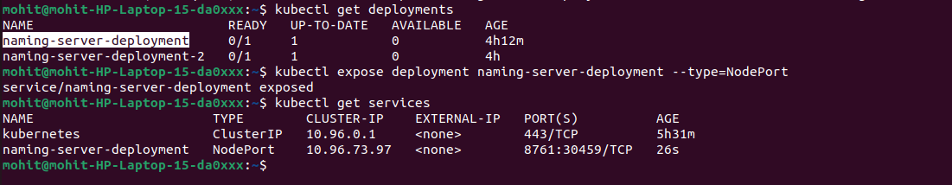
There are few service types that we can provide in –-type option.
All the traffic comes to services first and then it is forwarded to pods.
minikube service naming-server-deployment –url
This command will generate url that we can use to access endpoints in containers from outside.
Self-healing in k8s: if we kill any pods then k8s will start a new pod.
kubectl logs <<pod name>> : It will show the logs of the pod.

