Microservices Logging:

Centralized logging is the process of collecting logs from networks, infrastructure, and applications into a single location for storage and analysis.

Centralized Logging Components
A centralized logging solution is based on three main components.
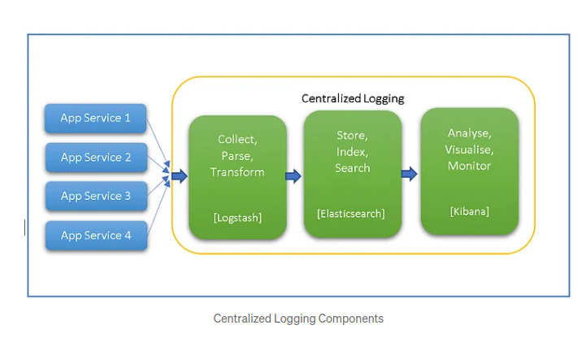
Collect, Parse, Transform:
The first component of the centralized logging mechanism is collecting incoming log data and parse it to a more structured format. Filters can also be used to extract relevant data.
Logstash is the most popular framework for this activity. Other alternatives are Fluentd, Flume. AWS Kinesis can also be used along with Cloud watch in place of Logstash.

Store, Index, Search:
The second component of the mechanism is storing the consolidated and filtered data so that it can be processed for analysis. Indexing is also applied to the data to make it searchable.
Elastic Search is the widely used search engine for centralized logging. It helps in providing speedy search results.

Analyse, Visualise, Monitor
The third component of the mechanism is to provide visualization to the processed data that can be analyzed and monitored from one interface. It provides single-point access to the logs of all the application services involved
Kibana is the popular choice and provides one dashboard to access all the data. Further, it supports different chart structure visualization of the events to provide better control over a large amount of data.

Best practices of centralized Logging
#Use Correlation Ids in services
Always use correlation or unique transaction Ids while working with microservices. Having a correlation Id will help in tracking the requests which are hopping to different services. And this will make debugging easier to find the failed request.
#Add structure to the log
Adding structure information to the logs and following the same pattern across the microservices help. It will give a clear view of all the data required in troubleshooting.
#Trigger error notification alerts
Setup auto error notification based on the level of error. This will help to resolve situations when services are down or not responding
#Include relevant details in logs
Adding only relevant details in the log and avoiding unrequired information will significantly reduce the log volume. That will improve the overall load on the server.
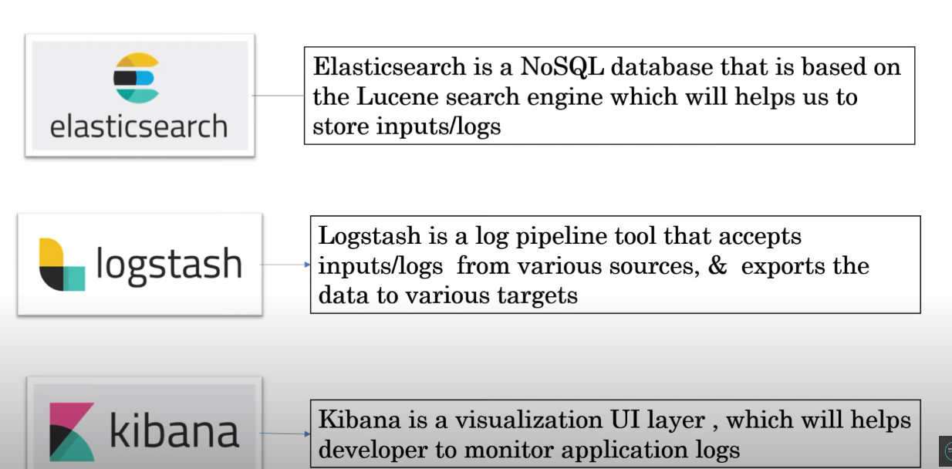
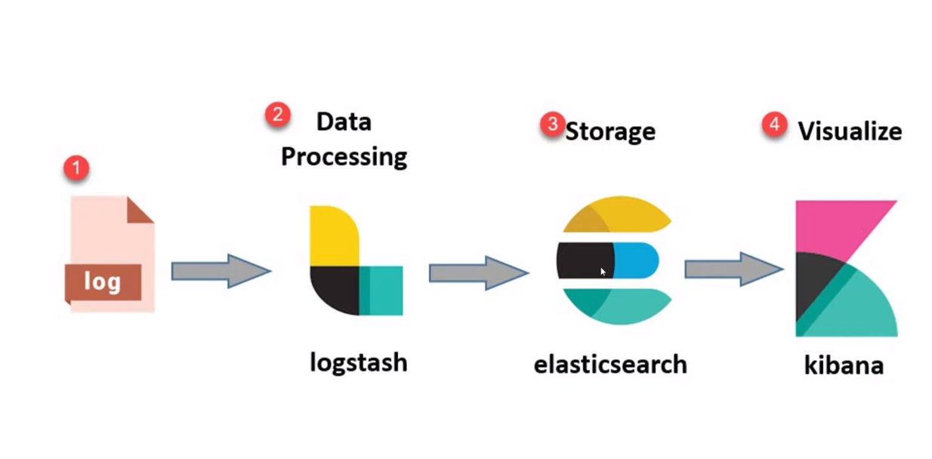

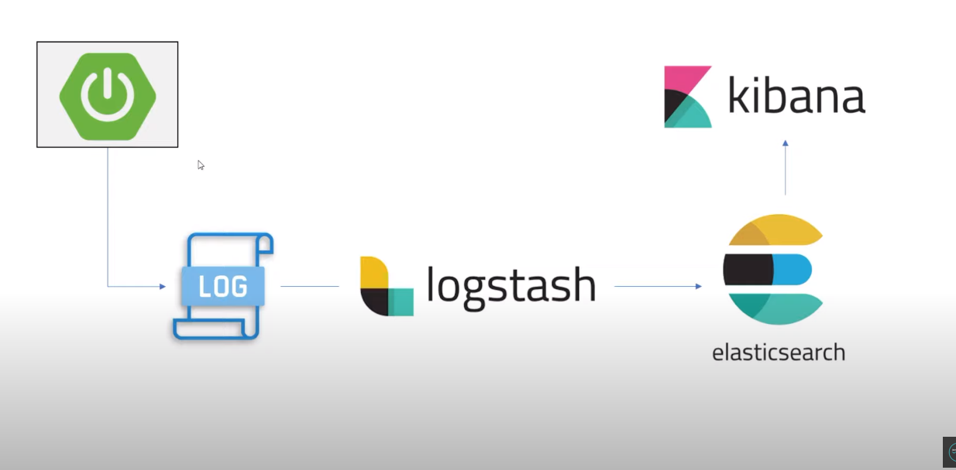

Implementing ELK:
Install ElasticSearch, Logstash and Kibana.
In Kibana, we can configure the url from where the eleastic search is installed.
Our application will produce logs normally.
We will create a yaml file for logstash and we will configure where is our logs stored and then logstash will pull the logs from there and provide them to elastic search.

