Manager round questions:

Agile means flexibility and adaptability.
Teams are self organising. And results are obtained by cross functional team collaborations.
Set of methods and practices that focuses on iterative development.
Different methodologies defined under Agile: Scrum, Kanban, Extreme Programming.
Adoption of continous changes in scenario in modern business environment.

Agile is iterative and wterfall is linear.
Agile is flexible but waterfall is rigid.
Development is divided into sprints in agile but in waterfall it is divided into phases.
Agile allows the changes in requirement but waterfall does not allow changes in requirement.

Principle of Agile Testing: Test Continuously and take feedback.

Agile metrics: code quality, code coverage, velocity, cycle time.

Agile tools: Github, Jira.

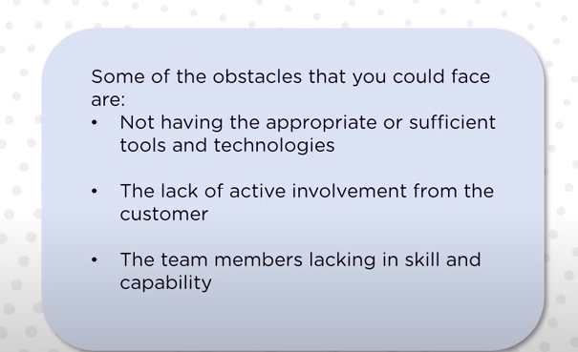

A user story is a short, informal description of a software feature from the perspective of the end user.The purpose of a user story is to explain how a piece of work will add value to the customer.

Important principle/parts of agile:
Customer Satisfaction, Welcome changes, Delivery frequently, Team Collaborations, Self Organized.

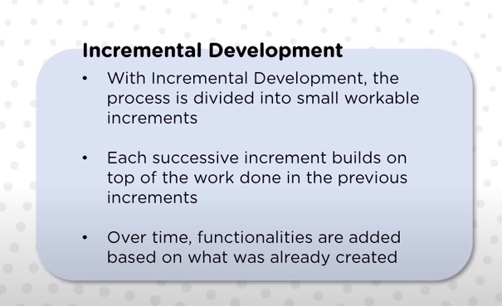

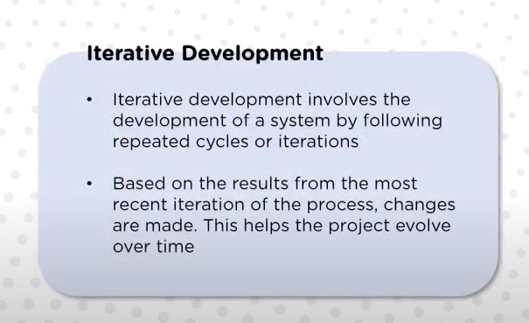

Agile is iterative + incremental.

JIRA:
Used for project management and issue tracking.
It helps by efficient planning, monitoring and organizing work.
We can create tasks, bugs, issues and user stories and prioritize them.
Key components: project, workflows, agile boards and reports.
Issue in jira can be a software bug, help desk ticket , project task.

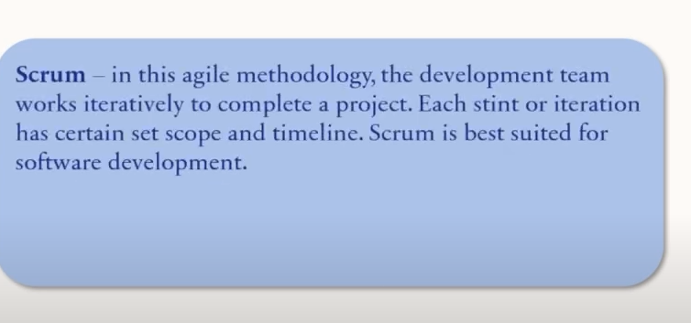
Epic takes months to complete while stories form a part of epic. Multiple stories together makes a epic.

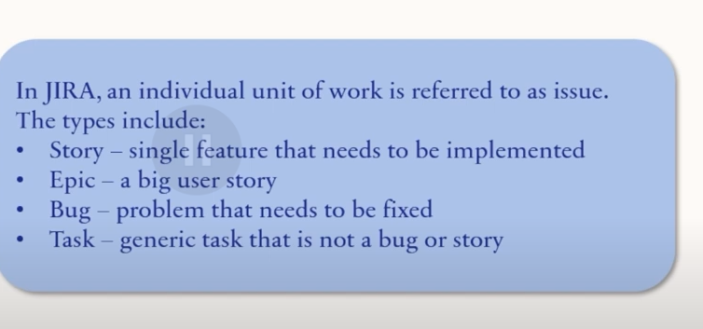

-> What is your role in a team?
* I work as a backend developer and sometimes also work on azure cloud services as I see that area where I would like to further expand. Other than my day to day tasks, I also discuss with team members and try to discuss the right approach to implement any feature. Also helps other members and discuss the issues whenever they are stuck. Ex: One of my teammate made some changes due to which our application resiliency was impacted. Then during code review , I identified it and informed the developer to do the changes before merging. The functionality was not known to other developer and hence I had to explain it to himand we also recoded it for others to know about it.

-> If you make a mistake, how do you fix it ?
* I will tell the team beforehand that there has been a mistake from my end due to this and that reason. So that we can take relevant action before the mistake creates chaos. Then I will try to fix it and if other stake holders needs to know about the fix then I will inform them timely as well. Ex: I deployed my changes in stage and shortly I noticed that stage become unstable and the root cause was my changes and due to this testing was impacted. So, I dropped a message in teams group that this unstability has occured and I am aware of the root cause and the fix also that I am going to place.

-> What are some of the workplace successes that make you proud?
* There was a new joinee in our team. He had like 2 years of experience. When people are busy and he tries to reach out to them then most of the time people do not reply. But I always take out some time like 15 minutes to point him to the right resources so he can understand better and sometimes explaining few things to him myself. Seeing him using them and collaborating in the team makes me really happy. Such small things keep the culture of the team joyful.

-> How do you resolve workplace conflicts?(conflict over review comment)
* There has been some cases of conflict. To tackle it, I try to understand there point and I collect more knowledge and try to produce some steps that answers their concern and try to explain in detail about my solution. I also ask for some alternative solution if they might have.
So, together with discussion, we solve the conflict. Ex: I implemented some logic in azure dashboard(Lp mismatch) and the client wanted to also add 1 extra feature(run the job if there is a mismatch) to dashboard that is not at all supported by Azure. Before answering him yes or no, I said to him that as per the knowledge , it is not supported by Azure. Please suggest if you are aware of any thing on how to do it on high level or if you know someone who could help. Then I also explained him the alternative approach of using Logic App instead of expecting it in dashboard. We can hit the job on scheduled basis like once a day to avoid any mismatches.

-> 5. If your team resists your idea, what would you do?(circuitbreaker reduced network calls)
* If I think that the idea is strong and team is still resisting then I will further take it forward to the team and try to explain how it will benefit us. May be create a small demo and show them. I will also ask their approach and together try to arrive at better approach.
Ex: There was a retry functionality already in our app. I further raised a point that we should use circuit breaker as well. Initially my team resisted it because it would take some time to implement it and there was no explicit need for it but then I showed them that in the current scenario, if other service is down then also we are retrying multiple times and making the network busy. Instead of that if we implement CircuitBreaker in our app then number of failed request to that service will go down.

-> What motivates you at work?
* Helping the team, discussing the issues with team members and learning about different approaches to fix a problem. This thing keeps me motivated. Sometimes, we are asked to implement some feature then researching a little bit about it how should it be implemented is what keeps me motivated.

-> Why are you seeking employment in our company?
* I have heared from some of the people in sapient that if you join saient then you will get to work in and out of the application, you will have more knowledge and sapient also follows startup culture and support new ideas as well. There is a lot of learning opportunity and location wise also, sapient considers employees needs as well. It is working in variety of domains like energy, retail etc.

-> What are your long-term career goals?
* In the long term, I want to see myself in the senior tech roles like Architect and I actually want to achieve that level of proficiency that I will be able to compare different architectural solutions and provide feedback like which one is better approach and why.

-> What are your strengths and weaknesses?
* searching inside out on the issues when I do not have any clue, that is one of my strength. I keep coming up with different approaches I can get more close to the solution. This is my strength. My weakness is that sometimes I do not eat lunch when I am involved in issues and that sometimes affect my health. I might not get sleep for a night or 2 until I have some conclusion on it.

-> Why do you believe you are a good fit for this position?
* I have near about 7 years of experience with software development and a will to learn more technologies as well. I think this is why I am best fit.

-> How do you react to sudden changes in the work you are doing?
* I usually analyse the amount of work that might need to be done again and accordingly I ask for more time.

-> Have you ever worked in a leadership position?
* Officially No. But during calls and discussion I sometime lead the team to the approach that we should take in order to achieve the goal when I see that team is going out of scope. For ex: We were getting multiple customer Ids for a given email from wholesaler. Team shortly discuss the issue and while checking our code the focus was changed to code review instead of finding the issue. So, I prepared the set of steps and share with the team. Like first we will check with wholesaler and then if we will confirm our implementation and then we will decide how it should be and then we will take the right approach to fix it. Sometimes we take decision as we are working independently.

-> How do you introduce new ideas or operations to teams?
* Yes. Resiliency in our app.

-> Why are you interested in leaving your current job?
Project is about to finish. My manager has confirmed that project might not go much longer. So I am looking at further opportunities.

-> How do you handle workplace pressures?
* I will try to manage my work properly by giving estimates with buffer times. Still if there is a lot of pressure then I might ask team to provide some support if you have some time. At worst, If I missed the deadline then I will tell my manager the reasons why I am not able to handle those many request. I will try to deliver quality work instead of quantity and so might take a day or two extra.

-> How do you typically react to criticisms about your work?
I keep a notepad handy and I write the points and if I see that they are making sense then I will try to take their feedback and demonstrate improvement on it.Ex:During my code reviews in the starting, I used to get a lot of criticism and slowly over time I have improved a lot.

