Aggregator Design Pattern:

Service will call more than one microservice based on the needs and collates the response.
Collates means: to collect, compare carefully in order to verify, and often to integrate or arrange in order

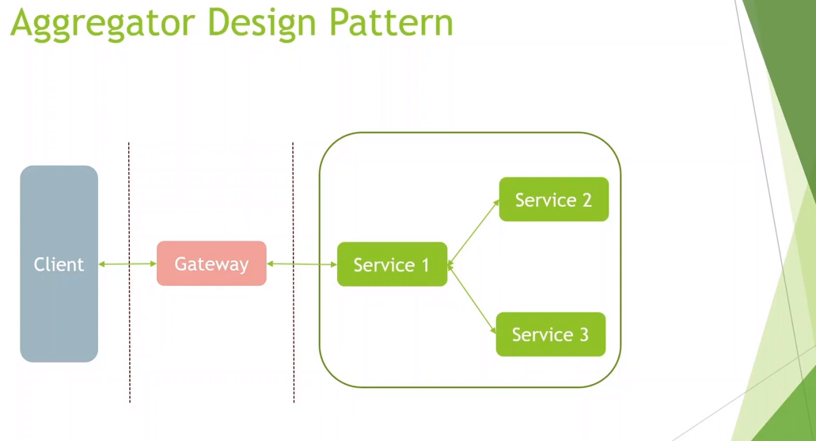
Service 1 is calling service 2 and 3 and then arranging the responses and then finally response back to client.

