Asynchronous Messaging

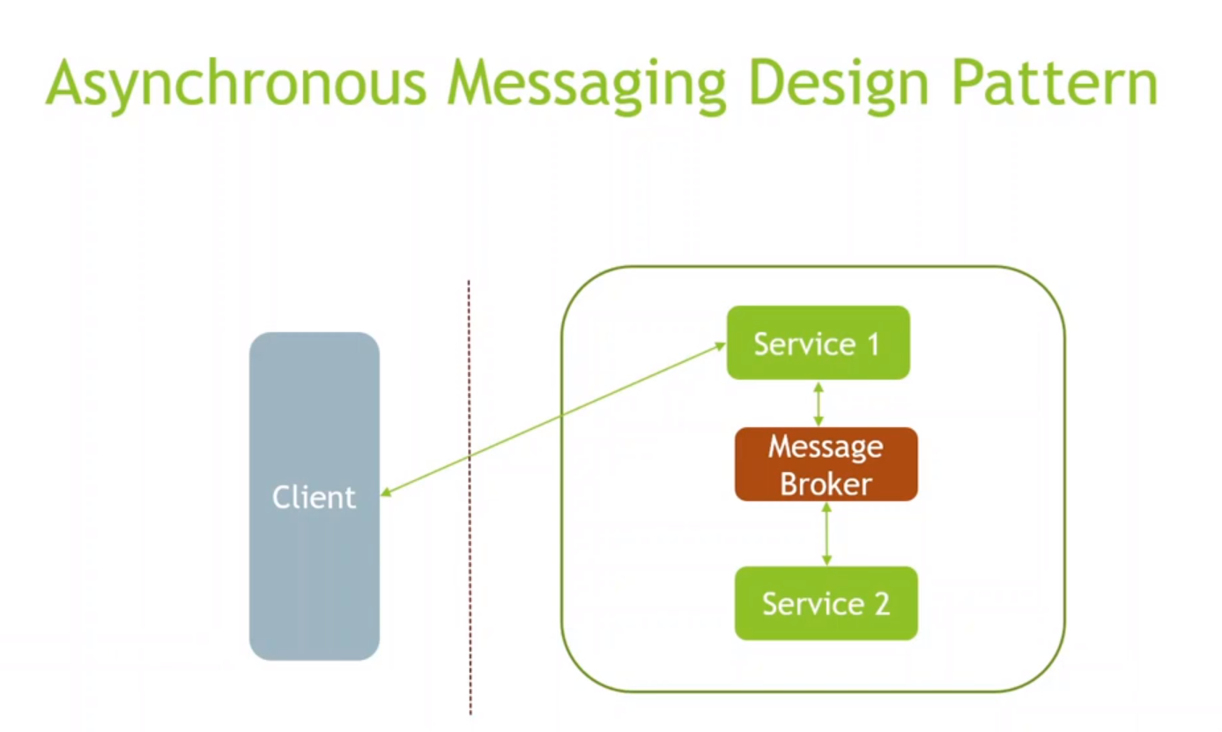

CQRS : Command Query Responsibility Segregation
We can not scale applications for read/write independently if same service is doing read/write operations.
This pattern clearly says that we should have seperate service for read and create/update/insert/delete.
For example, we have more read request for a product than the write request. So , we can have seperate microservice for read/write.
Using this pattern we can handle the read and write load independently.
Your read and write workloads have separate requirements for scaling, latency, and consistency. Eventual consistency is acceptable for the read queries.

If read operation is actually doing multiple restApi calls or using multiple joins then it will be a complex operation and it will be time consuming as well. CQRS adresses this issue as well by seperating Query and command.

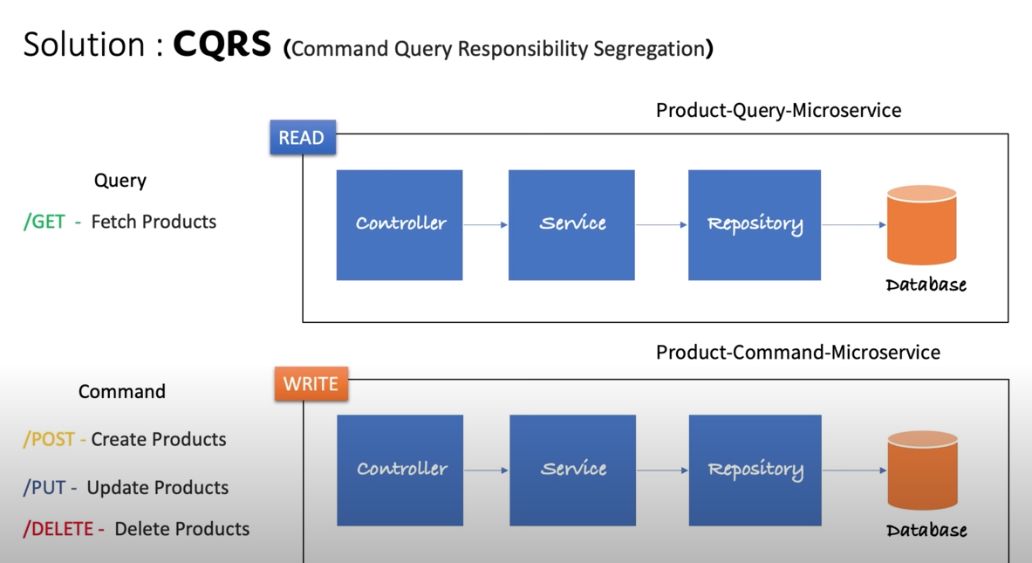

If we have seperate microservice then to synch the databases, we can use Kafka.

