Chained or Chain of responsibility design pattern:

Can be iplemented synchronously and asynchronously.
Never chain more number of services as client may have to wait.

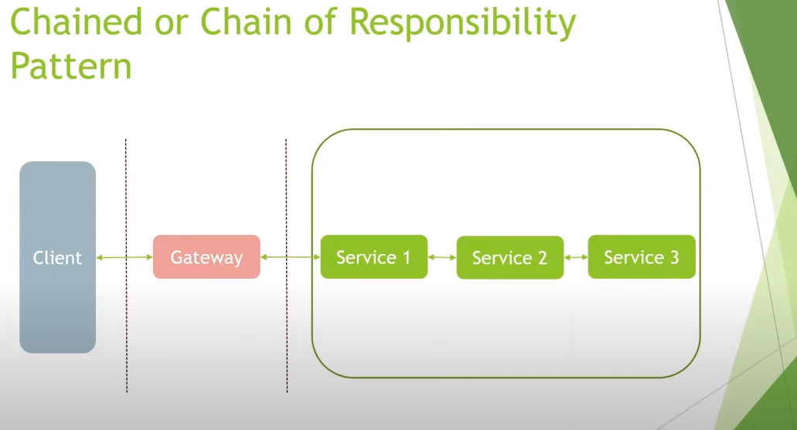
DDD (Domain Driven Design):
Domain: The context to which our application will be applied. Ex: Online shopping, banking etc.
Domain can be very large so we can break it into zones called Bounded Context. For each zone, we can have different experts as each zone operates in its own context.
Domain experts and developers collaborate to develop application.

