Bean life cycle:

@PreDestroy is used to cleanup the resources.
It will be called just before object is beig destroyed. It will be called only once during lifetime of the bean.

@PostConstruct: as soon as the instance of bean is created and you want to perform some operation or any initialization then @PostConstruct annotation will be used. Method annotated with @PostConstruct will be called only once in the lifecycle of the bean.

PreDestroy and PostConstruct will only work on singleton beans. They will not work for prototype beans.

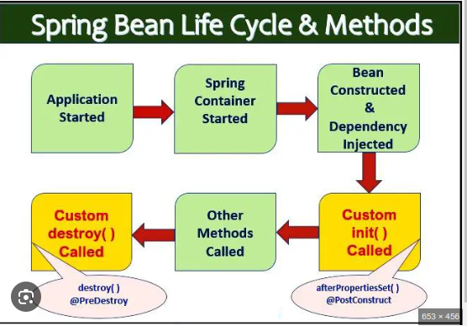

How to remove circular dependency?
https://www.baeldung.com/circular-dependencies-in-spring

@Component
public class CircularDependencyA {

@Autowired
private CircularDependencyB circB;

@PostConstruct
public void init() {
circB.setCircA(this);
}

public CircularDependencyB getCircB() {
return circB;
}
}Copy
@Component
public class CircularDependencyB {

private CircularDependencyA circA;

private String message = "Hi!";

public void setCircA(CircularDependencyA circA) {
this.circA = circA;
}

public String getMessage() {
return message;
}
}

