What is spring-boot-starter-parent ?
All spring boot projects use spring-boot-starter-parent as parent in pom.xml.
Parent POM manage following things for child projects:
- Controlls version of dependencies.(dependency management)
- Controls default java version.
- Controls default plugin configuration.
- Source encoding (UTF-8 etc)
POM for spring-boot-starter-parent uses spring-boot-dependencies as parent.

What is SpringApplication?
Class can launch spring application using run method from main method.
Default Bootstrapping steps:
- Create ApplicationContext instance.
- Register a CommandLinePropertySource to expose commandline args as spring properties.
- Loading singleton beans.
- Trigger CommandLineRunner beans.

In the Spring Framework, the BeanFactory and ApplicationContext are both IoC containers, but :
- BeanFactory
The basic IoC container that provides basic features like bean instantiation and dependency injection. It loads beans on-demand.
- ApplicationContext
A more advanced IoC container that builds on the BeanFactory and provides additional features. It loads all beans at startup

The BeanFactory is a basic IoC container that provides basic features such as bean instantiation and dependency injection. The ApplicationContext is a more advanced IoC container that builds on top of the BeanFactory and provides additional features such as event publishing, messaging, and internationalization.

What is @RestController ?
It is a stereotype annotation, it provides hints to people reading the code and to spring , it says that this class has specific role. This annotation comprised of two other annotations: @Controller and @ResponseBody.
When there is any web request then spring considers controller classes for handling it.
@ResponseBody says that the method return value should bound to response body.

@Controller is specialization of @Component , it tells spring container that this class will hold the mappings to web requests, @ResponseBody serialize the returning object into HttpResponse.

How to consume and produce xml in spring boot application?
Add dependency:
<dependency>
<groupId>com.fasterxml.jackson.dataformat</groupId>
<artifactId>jackson-dataformat-xml</artifactId>
</dependency>

@JacksonXmlRootElement
public class Customer {
public Customer() {
}
public Customer(String firstName, String lastName ) {
this.firstName = firstName;
this.lastName = lastName;
}
String firstName;
String lastName;
// Getters/Setters omitted for brevity
}

@RestController
public class MyController {
@RequestMapping(path = "/xml",
method = RequestMethod.POST, produces = MediaType.APPLICATION_XML_VALUE,
consumes = MediaType.APPLICATION_XML_VALUE)
public ResponseEntity<Customer> xml(@RequestBody Customer c) {
System.out.println("Received "+c);
c.setLastName("changed");
return new ResponseEntity<>(c, HttpStatus.OK);
}
}
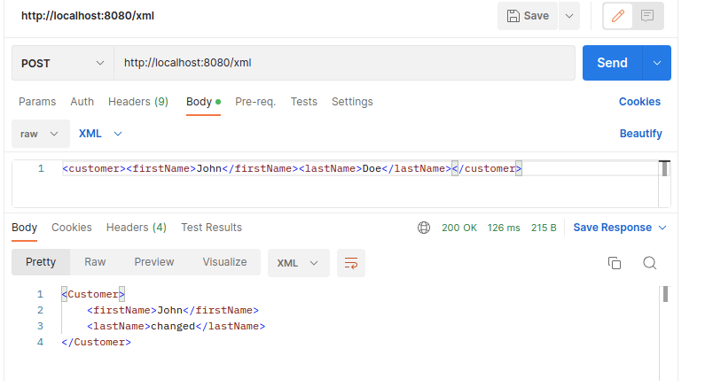

What is @RequestMapping ?
It provides routing information. It tells spting that any request coming to the configured path should be handled by this method.

What is @SpringBootApplication?
It consists of 3 annotation: @SpringBootConfiguration, @EnableAutoConfiguration and @ComponentScan.
@EnableAutoConfiguration(exclude = autoConfigClass.class) auto-configures beans that are available on the classpath. We can exclude any specific class from getting auto configured.
Ex:
@EnableAutoConfiguration(exclude = {AopAutoConfiguration.class, RSocketRequesterAutoConfiguration.class})

@Configuration tells spring that the class contains @Bean definition methods. So, spring can process the class and generate the beans to be used by application.

@SpringBootConfiguration has @Configuration internally. Indicates class provides @Configuration. Can be used alternatively with @SpringBootConfiguration.

@ComponentScan scan the package and sub-packages for beans.

@Component marks that the class is a bean. ComponentScan looks for @Bean methods and @Component classes and registers them with spring container as beans. In @Bean methods, we need to manually instantiate the class.

