JWT:
JSON Web Tokens

For the first time, user will provide username and password and then we will generate a token for the user and share the token with them. So for all other requests, user can share the token with request and it will be allowed to access the resource.

JWT token is of the format X.Y.Z
X = Header (algorithm for encryption and type of token)
Y = Payload ( username and time when the token will be expired)
Z = Verify signature( it takes header + payload + 256 bit secret to generate the signature)

Identity Service:
application.properties:

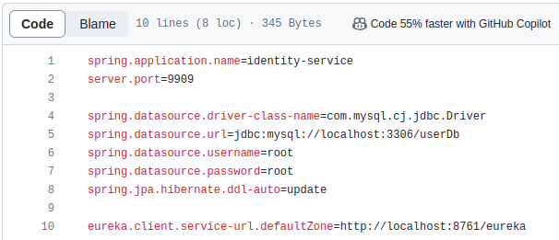

Creating controller to allow user to register and getToken after verified username/password.

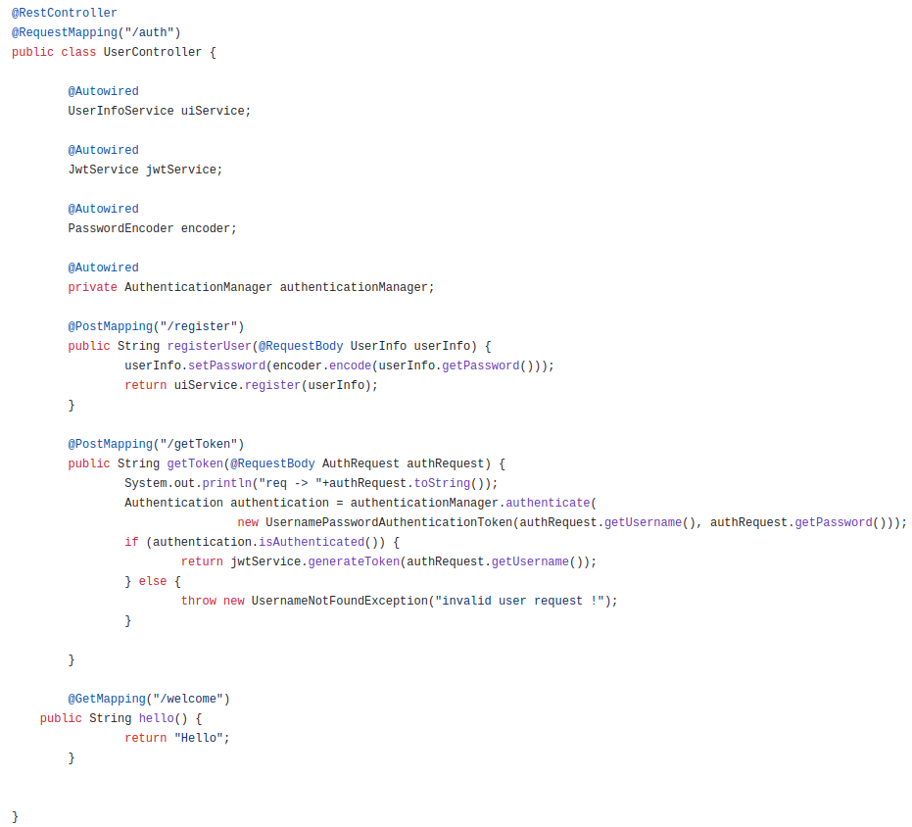
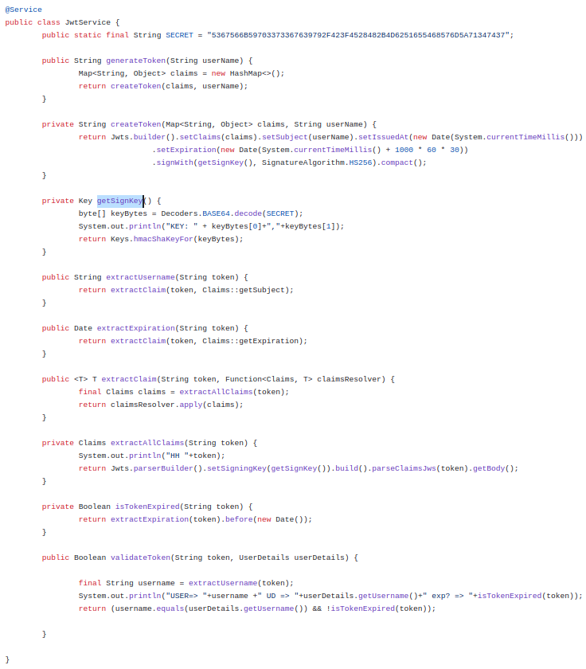
We need to have api, impl and jackson jwt dependencies for generating the token.

https://www.youtube.com/watch?v=NcLtLZqGu2M&t=1014s

Spring guarantees that the OncePerRequestFilter is executed only once for a given request.

Below filter will be executed once for every request and it will validate the token.

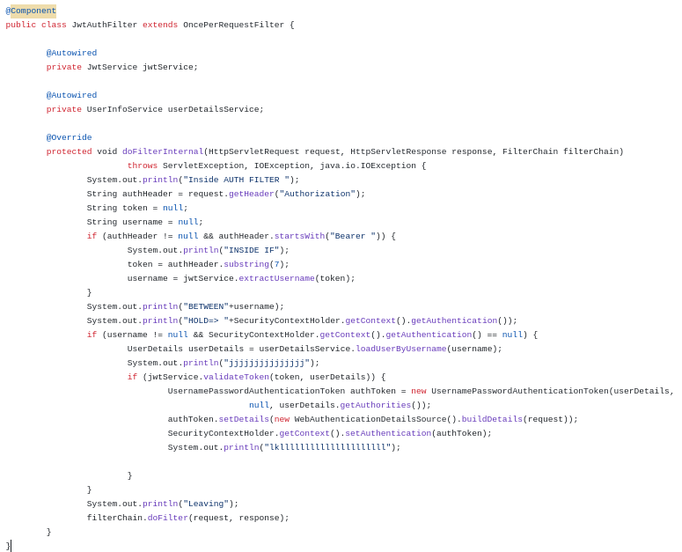

Other than this , we would need extra security config to allow no auth for register and getToken methods in controller.

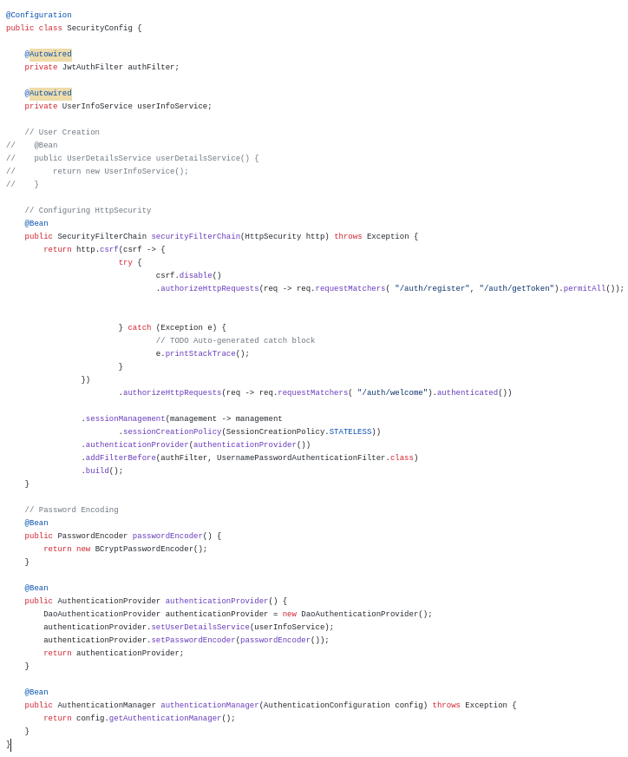
We need beans for passwordEncoder, AuthenticationProvider, AuthenticationManager.

Mark main class with @EnableWebSecurity.

For code: https://github.com/mohit06/matrimony-backend-demo/tree/main

We can create Identity service for register and token generation and keep the validation logic on the gateway.

