The multiple databases should have the same driver though. This means that you cannot connect to a MySql and Postgres SQL database. It has to be 2 MySql databases.
Not sure if it is true.

Connecting multiple databases to one microservice:

application.properties:

spring.datasource.jdbc-url=jdbc:mysql://localhost/testdb1 spring.datasource.username=root
spring.datasource.password=root
spring.datasource.driver-class-name=com.mysql.cj.jdbc.Driver
spring.seconddatasource.jdbc-url=jdbc:mysql://localhost/testdb2 spring.seconddatasource.username=root2 spring.seconddatasource.password=root2
spring.seconddatasource.driver-class-name=com.mysql.cj.jdbc.Driver

spring.jpa.database=default spring.jpa.properties.hibernate.dialect=org.hibernate.dialect.MySQL5Dialect
spring.jpa.show-sql=true
spring.jpa.hibernate.ddl-auto=update

Employee.java:
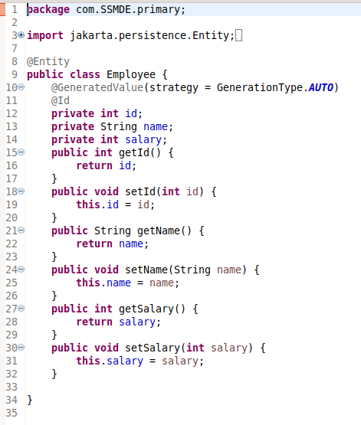

EmployeeRepository.java:

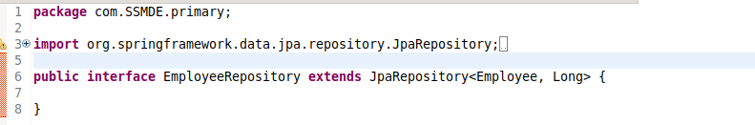
Created a primary package and kept Employee and EmployeeRepository in it.
Manager.java in Seconday package.

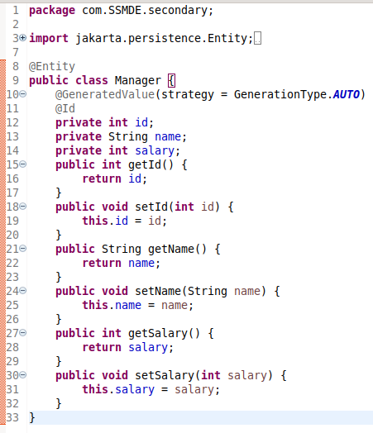

ManagerRepository.java: in secondary folder

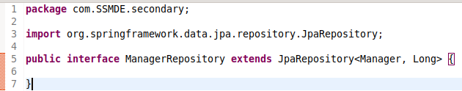

PrimaryDBConfig:

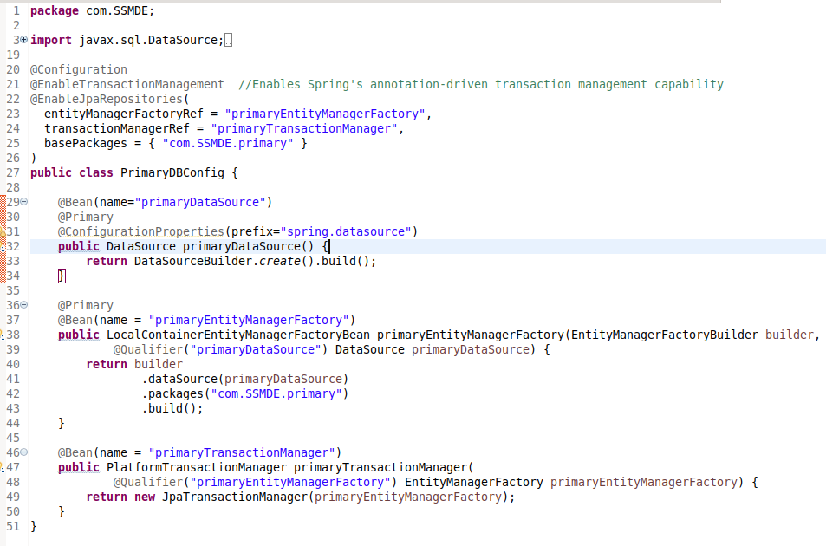
Create bean for DataSource and EntityManagerFactory and TransactionManager and use EnableTransactionMAnagement and EnableJPARepositories. Create similar config for Secondary DB.

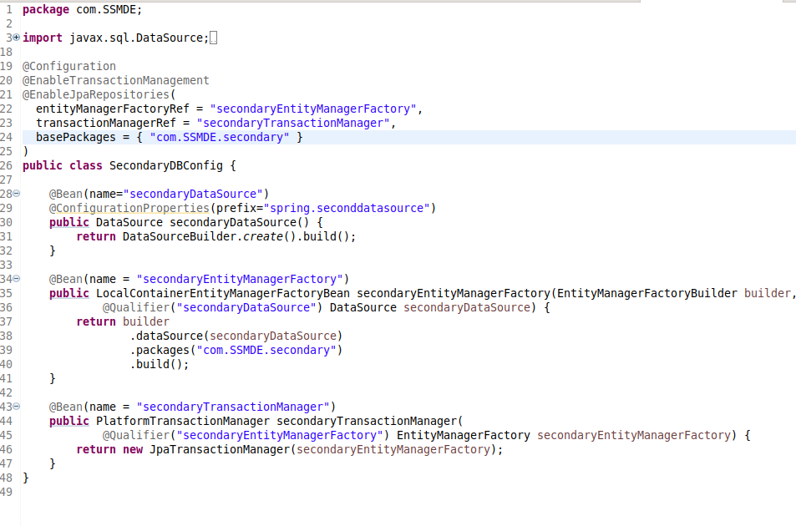

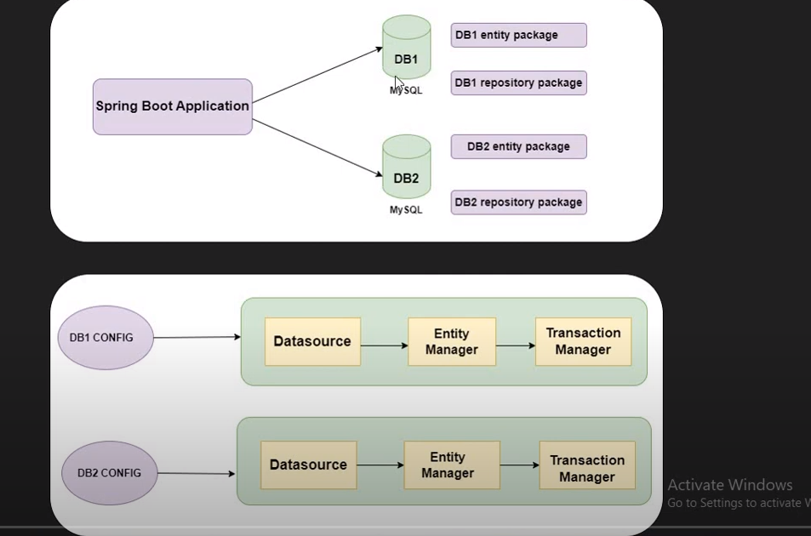
Automatically tables wont be created.
To automaticallyt create tables, use:
spring.jpa.generate-ddl=true

Steps:
- Create DB config in properties files: url, username, password
- create db1, db2,.. packages and keep entity and repos of db1 in db1 package and of db2 in db2 package and so on.
- Create Config classes for each DB.
- In config classes, we need to configure DataSource, EntityManagerFactory and TransactionManager.
- Mark the beans with @Primary annotations if and use @Qualifier for mentioning which beans are required explicitly.

