Spring Boot 3.0 Security:

https://spring.io/guides/topicals/spring-security-architecture/
https://docs.spring.io/spring-security/reference/servlet/authentication/passwords/form.html

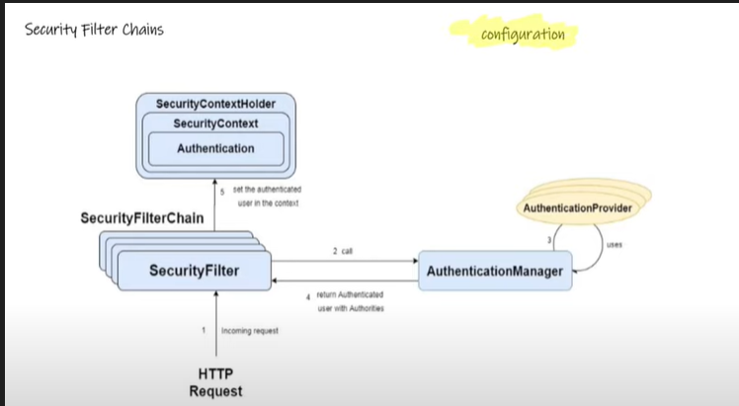

UserDetailsService is used by DaoAuthenticationProvider for retrieving a username, a password, and other attributes for authenticating with a username and password. Spring Security provides in-memory and JDBC implementations of UserDetailsService.

Username/Password Authentication in Servlet based application:

REDIRECTING TO LOGIN PAGE:
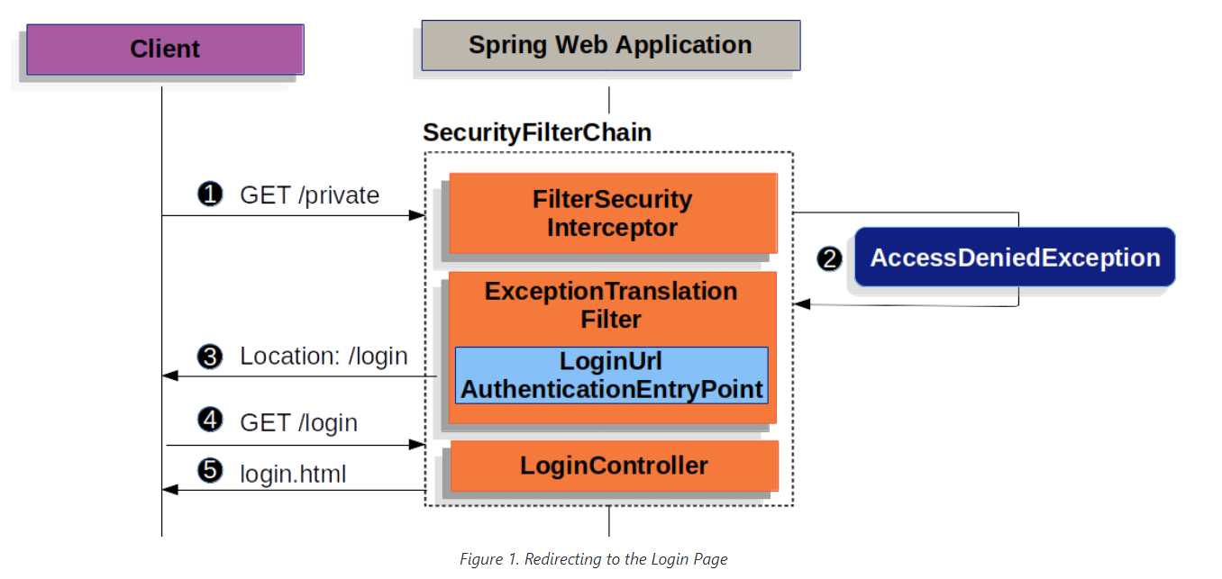

- First, a user makes an unauthenticated request to the resource (/private) for which it is not authorized.
- Spring Security’s FilterSecurityInterceptor indicates that the unauthenticated request is Denied by throwing an AccessDeniedException.
- Since the user is not authenticated, ExceptionTranslationFilter initiates Start Authentication and sends a redirect to the login page with the configured AuthenticationEntryPoint. In most cases, the AuthenticationEntryPoint is an instance of LoginUrlAuthenticationEntryPoint.
- The browser requests the login page to which it was redirected.
- Something within the application, must render the login page.

Authenticating UserNAme / Password:
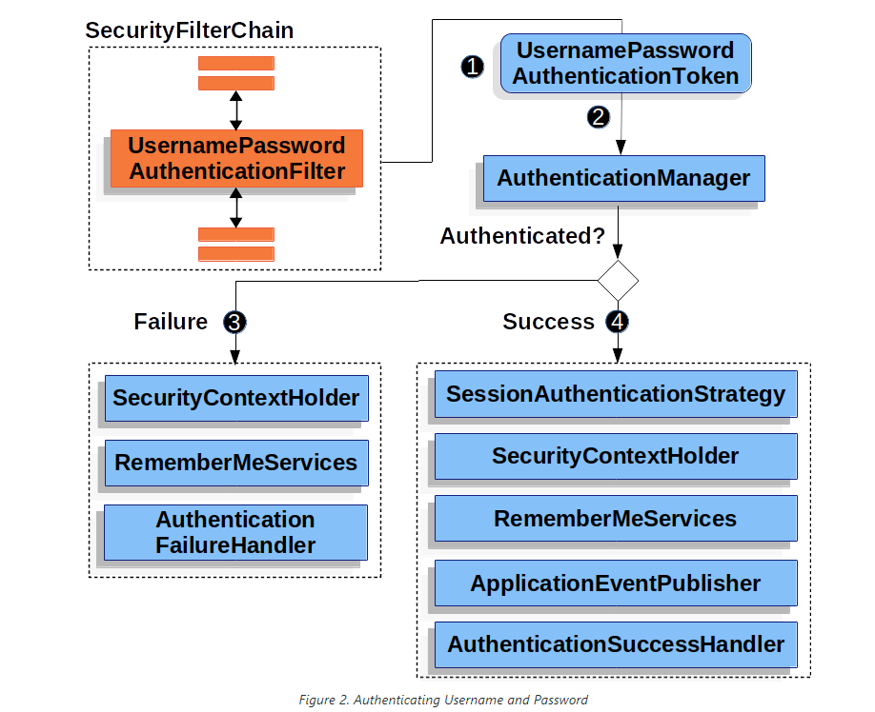

Code:

@Configuration
public class SecurityConfig {
@Autowired
DataSource ds;
@Autowired
UserRepository repo;
@Autowired
MyUserDetailsService serv;
@Bean
public SecurityFilterChain filterChain(HttpSecurity http) throws Exception {
http.formLogin(form -> form.loginPage("/login")
).authorizeHttpRequests().requestMatchers("/login").permitAll();
http.authorizeHttpRequests().requestMatchers("/").permitAll();
http.authorizeHttpRequests().requestMatchers("/home").authenticated();
http.authenticationProvider(provider());
return http.build();
}
@Bean
public WebSecurityCustomizer webSecurityCustomizer() {
return (web) -> web.ignoring().requestMatchers(new AntPathRequestMatcher("/h2-console/**"));
}
@Bean
PasswordEncoder encoder() {
return new BCryptPasswordEncoder();
}
@Bean
public JdbcUserDetailsManager userDetailsManager(DataSource dataSource) {
JdbcUserDetailsManager mgr = new JdbcUserDetailsManager();
mgr.setDataSource(dataSource); // (1)
User u = new User(5, "Maddy", encoder().encode("567"));
repo.save(u);
return mgr;
}
@Bean
AuthenticationManager auth(AuthenticationConfiguration conf) throws Exception {
return conf.getAuthenticationManager();
}
@Bean
DaoAuthenticationProvider provider() {
DaoAuthenticationProvider provider = new DaoAuthenticationProvider();
provider.setUserDetailsService(serv);
provider.setPasswordEncoder(encoder());
return provider;
}
}

Basic Auth:
@Bean
public SecurityFilterChain filterChain(HttpSecurity http) throws Exception {
http.authorizeHttpRequests()
.requestMatchers("/securityNone")
.authenticated()
.and()
.httpBasic()
.authenticationEntryPoint(authenticationEntryPoint);
return http.build();
}
-> Use Basic Auth mechanism to authenticate “/securityNone” endpoint.
-> Authentication Entry point : When wron username/password is received by our application, it calls the commence method and send “www-Authenticate” header to the client trying to login. Seeing this header in response, client should try to login again.

@Bean
public InMemoryUserDetailsManager userDetailsService() {
UserDetails user = User
.withUsername("user")
.password(passwordEncoder().encode("password"))
.roles("USER_ROLE")
.build();
return new InMemoryUserDetailsManager(user);
}
-> creates InMemory user.

@Component
public class MyBasicAuthenticationEntryPoint extends BasicAuthenticationEntryPoint {
@Override
public void commence(
HttpServletRequest request, HttpServletResponse response, AuthenticationException authEx)
throws IOException {
System.out.println("Message");
response.addHeader("WWW-Authenticate", "Basic realm=\"" + getRealmName() + "\"");
response.setStatus(HttpServletResponse.SC_UNAUTHORIZED);
PrintWriter writer = response.getWriter();
writer.println("HTTP Status 401 - " + authEx.getMessage());
}
@Override
public void afterPropertiesSet() {
setRealmName("mohit");
super.afterPropertiesSet();
}
}

