Spring Web MVC Framework:
Model-View-Controller. It lets us create @Controller/@RestController to handle web requests.
@RequestMapping helps to route http request to methods.
WebMvc.fn Functional endpoints: It will seperate out handling and rounting of webrequests in seperate files. For routing, we can create a seperate configuration class and for handling, we can create a seperate class.

HttpMessageConverters:
Objects can be automatically be converted to JSON/XML.We can provide our own custom conerters as well and they will be added to list of converters.

Content Negotiation:
Using Accept and Content-type headers, server sends response in the supported format/MIME Type.

ErrorController is a marker interface. @controller class implementing this interface can handle “/error” request and can be used to return custom errors.

@ControllerAdvice and @ExceptionHandler can handle errors globally.
ResponseEntityExceptionHandler class with ExceptionHandler annotations that handles Spring MVC exceptions.

Spring MVC Request/Response flow:
Request -> Servlet Container(TOMCAT) -> Filters -> SpringMVC( DispatcherServlet -> HandlerInterceptor -> Controller -> Service -> Database )

There is one thread per request in TOMCAT.

In Spring MVC, we follow traditional style of programming.
For Example: Suppose we have a rest-controller mapping that return Item object. Item has Price and Location variables. The controller method will try to fetch price first and then it will go to fetch location and then it will return Item object.
This approach is call imperative style and is blocking/synchronous by nature.
TOMCAT provided 1 thread per request and this thread is trying to fetch price and until we receive the price, it will remain in blocking state and once we receive the response, it will move to next statement.
Threads going into blocking state makes the system do in-efficient use of resources.
There is no back pressure compatibility as well.
Limited no. Of concurrent requests can be supported.

So, there are following flaws of traditional API designs:
-> Blocking/Sunchronous
-> Limited number of concurrent requests can be supported
-> No Back Pressure

RestTemplate is a synchronous client for making REST API calls over HTTP. - Deprecated.

Better API design would be Non-Blocking/Asynchronous, less threads would serve more requests, back pressure compatibility, Move away from thfread per request model.

Spring WebFlux:

What is Reactive Programming?
New programming paradigm.
It is asynchronous and non-blocking by design.
Data flows as event/message driven.
Functional style code(similar to stream API), and back pressure compatible.

Data Flow as an Event Driven Stream:
One event or message for every result item from data source.
Data source can be files, database, service etc.
One event/message for completion or error.

OnNext(item): Data stream event.
OnComplete(): completeion/Success
onError() : Error

Back Pressure: Application provide a feedback to server to say hey please slow down, you are sending too fast , I am unable to process.

Reactive Stream Specification:
Data flowing to application using event driven stream which is called Reactive stream.
The rules that a reactive stream should follow is called reactive specification.
There are 4 interfaces: Publisher, Subscriber, Processor, Subscription.

Publisher:
Publisher interface has one method subscribe that takes one parameter Subscriber and registers the subscribers.
Publishers are generally data source.

Subscriber :
It has 4 methods onNext(), onComplete(), onError(), onSubscribe()

Subscription():
2 methods: request(n) and cancel()

Processor Interface:
It extends Subscriber and publisher interfaces.

What is reactive library?
Library that implements Reactive Streams Specifications.
Ex: RxJava , Reactor etc.

Publisher/Subscriber event flow:
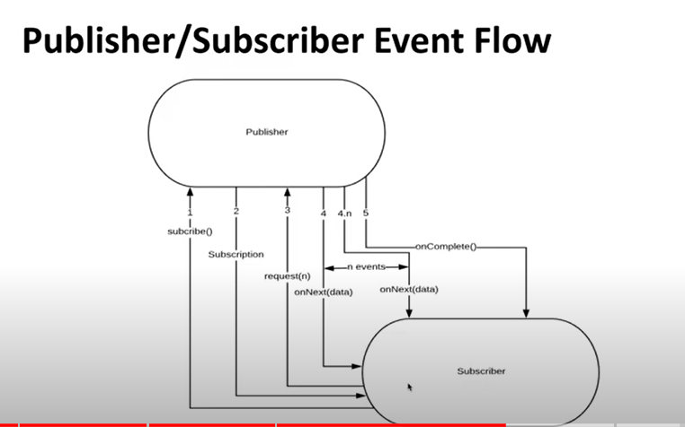

Flux and Mono are the implementation classes of Reactive Stream Specifications.
Flux represent 0 to N elements and Mono represent 0 to 1 elements.
Mono — A publisher that can emit 0 or 1 element. Flux — A publisher that can emit 0.. N elements.

WebClient: Reactive web client.
It is an interface representing main entry point for performing web request. It was created as part of Spring Web Reactive module and it will be replacing RestTemplate. WebClient in reactive and non-blocking. It offers both synchronous and non-synchronous operations.
We used restTemplates to call a api running on a different/same domain(IP:PORT).

WebClient.Builder builder = WebClient.builder();
String a = builder.build().get().uri(uri).retrieve().bodyToMono(String.class).block();

