SQL:

DDL(Data definition Language): define structure of databases. Ex: Create, drop, alter etc.

DML(Data Manipulation Language): Manipulates data. Ex: Insert, Delete, Update etc.

DQL(Data Query Language): Extract data from relations. Ex: SELECT

Aggregate functions: Sum, count, avg, min , max.

GROUP BY: Group by is used to group the tuples of a relation based on an attribute or group of attribute. It is always combined with aggregation function which is computed on group. e.g.;
SELECT ADDRESS, SUM(AGE) FROM STUDENT
GROUP BY (ADDRESS);

Schema: Logical representation.
Data is logically represented in tables.

Index:
It is used by the server to speed up the retrieval of rows by using a pointer.
An index helps to speed up select queries and where clauses, but it slows down data input, with the update and the insert statements. Indexes can be created or dropped with no effect on the data.

Creating an index:
CREATE INDEX index
ON TABLE (column1, column2,.....);
Unique Indexes:
Unique indexes are indexes that help maintain data integrity by ensuring that no rows of data in a table have identical key values. When you create a unique index for an existing table with data, values in the columns or expressions that comprise the index key are checked for uniqueness.
Data integrity is a concept and process that ensures the accuracy, completeness, consistency, and validity of an organization's data.

When should indexes be avoided:
- The table is small
- The columns are not often used as a condition in the query
- The column is updated frequently

Use drop command to drop an index:
drop index indexName;
To drop an index, you must be the owner of the index or have the DROP ANY INDEX privilege.
Renaming an index:You can use the system-stored procedure sp_rename to rename any index in the database.

Why Indexing?
When executing a query on a table having huge data ( > 100000 rows ), MySQL performs a full table scan which takes much time and the server usually gets timed out. To avoid this always check the explain option for the query within MySQL which tells us about the state of execution. It shows which columns are being used and whether it will be a threat to huge data. On basis of the columns repeated in a similar order in conditions, we can create an index for them in the same order to maximize the speed of the query.
We should also be careful to not make an index for each query as creating indexes also take storage and when the amount of data is huge it will create a problem. Therefore, it’s important to carefully consider which columns to index based on the needs of your application. In general, it’s a good practice to only create indexes on columns that are frequently used in queries and to avoid creating indexes on columns that are rarely used. It’s also a good idea to periodically review the indexes in your database and remove any that are no longer needed.
Indexes can also improve performance when used in conjunction with sorting and grouping operations. For example, if you frequently sort or group data based on a particular column, creating an index on that column can greatly improve performance. The index allows MySQL to quickly access and sort or group the data, rather than having to perform a full table scan.

Hash Table Index:
In hash table index, index will be created on the columns based on the hash function used on the column. That means, hash function will be applied on the column on which index has to be created and that result will be the location of the record stored. Hence, here in this method all the records will be scattered in the memory.
For example, consider that we have created hash index on PHONE_NUMBER column of the EMPLOYEES table. Let this hash function be any simple function to any complex function. Let us assume, in this case hash function be sum of all digits in the PHONE_NUMBER multiplied by 1000. Then if we need to search any particular phone number say, 546.897.231, then we will get it at the location 45000. Hence the pointer will go that location and retrieve required record details. If we need to see immediate next phone number details, then it will be at location 46000 which far away from previous phone number.

Disadvantages of Hash Table Index:

Hash indexes are created by creating a hash function on the column on which index needs to be created. Hence each column will have different non-contiguous memory locations allocated to it. Therefore, if we need to search any contiguous records with conditions like ‘less than’ or ‘greater than’, then hash index will not be able to get all the records in one shot. It has to search for the records at various locations to get all the records. Hence it is not efficient for such searches. It is good only if we have to search key-value pairs. That means query with WHERE clause with ‘=’ condition will have better performance.

Types of indexes:
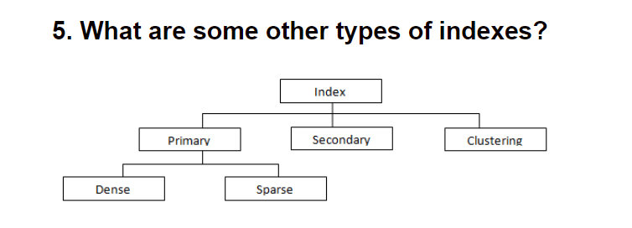

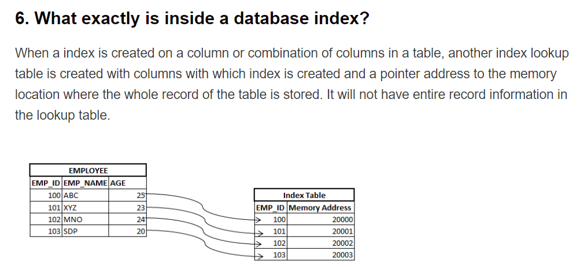

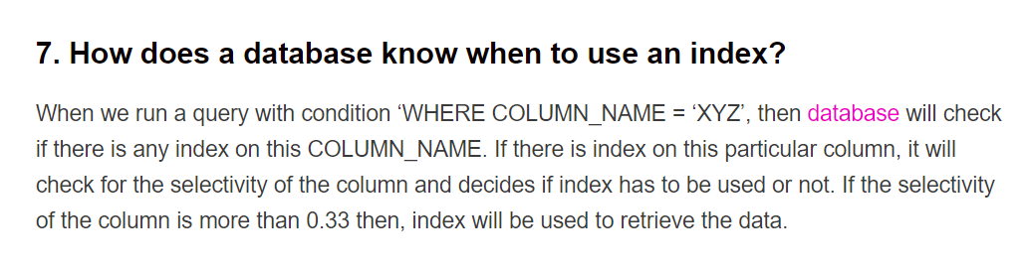

What are some tips on tuning SQL Indexes for better performance?
Don’t use too many indexes
When we create index, another lookup table will be created by the DB to store the column values and the pointer to the address location. Hence if we create lots of indexes, it will take lots of space to store these informations. In addition, it is duplicity of data. Apart from this, if we try to UPDATE or DELETE the record, we have to update all these index tables too. As the number of index increases, updating these index tables also increases which takes time. Hence the performance of the query degrades. That’s why create index which are actually required. Delete all unwanted indexes on the table.
- Try not to include columns that are repeatedly updated in an index.
- Creating indexes on foreign key column(s) can improve performance
- Create indexes for columns that are repeatedly used in predicates of your SQL queries
- Get rid of overlapping indexes
- Consider deleting an index when loading huge amounts of data into a table
- Ensure that the indexes you create have high selectivity: -Indexes with high selectivity will give better performance. Hence create indexes on column that has more selectivity. In general, any index with more than .33 selectivity, will give better performance. If a column has unique values then it will have selectivity of 1 – usually primary key column. Therefore, while creating index on column, check for its selectivity and then create the index.

Clustered Index:
In a typical table, records are sorted based on the Primary key of the table and stored in the disk. But when clustered index are created on the column of the table, then records are sorted based on clustered index column and stored in the disk. In other words, clustered index determines the order of the records stored in the disk.
Suppose we have created clustered index on the PHONE_NUMBER column in the EMPLOYEES table. Then all EMPLOYEES records are sorted based on the PHONE_NUMBER in the disk and then index mapping is created. So, now if we write any query to search some sequence of phone numbers of employee – say, less than or equal to, greater than or equal to, less than, greater than etc, then it will be easy to retrieve all the records. Because, once first record is fetched, rests of the records are present immediate next to it. We need not fetch again for rest of the records.

Disadvantage of clustered index:
When there is a new rows entered, for which indexed column has some in-between value, then in order to maintain the sorted order, entire records needs to be shifted. Similarly, when there is an update on the column on which clustered index is created, we need to move the records so that it maintains sorted order. Therefore, clustered indexes are created on primary key or foreign key columns, for which there very less like hood of update.

A table can have multiple non-clustered indexes, but only one clustered index. Why?
If a table has clustered index, then its records are sorted based on the column on which clustered index is created. Therefore, if we create multiple clustered index, we cannot sort the table record for all those columns. Only one time sorting based one column for which clustering are done is valid.

Primary Indexing:
A primary index is an ordered file whose records are of fixed length with two fields:
- The first field is the same as the primary key of data file.
- The second field is a pointer to the data block where the primary key is available.

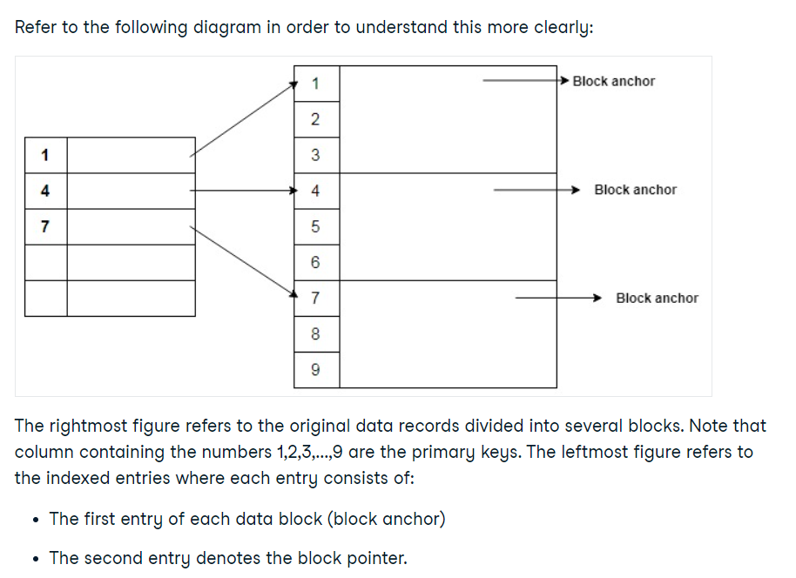
This is sparse index.

Clustering indexing:
A Clustering index is created on data file whose file records are physically ordered on a non-key field which does not have a distinct value for each record. This field is known as clustering field based on which the indexing is performed. Hence the name - clustering index.
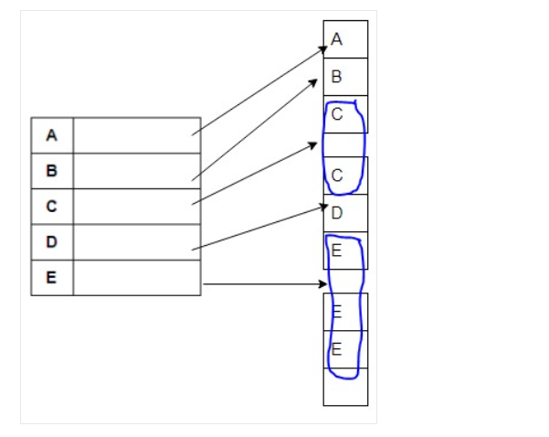
the original data records are ordered on a non-key attribute and for each distinct value of the non-key attribute, an index entry is created. This is sparse index.

Secondary Index:
Main file(original records) unsorted.
Can be done onkey/non-key.

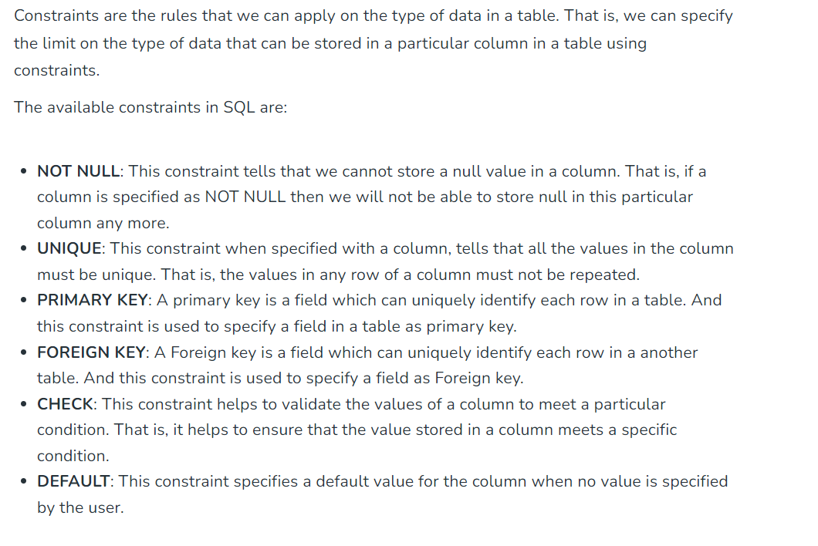
Views in SQL are kind of virtual tables. A view also has rows and columns as they are in a real table in the database. We can create a view by selecting fields from one or more tables present in the database. A View can either have all the rows of a table or specific rows based on certain condition.

Creating View:
CREATE VIEW view_name AS
SELECT column1, column2.....
FROM table_name
WHERE condition;

DROP VIEW view_name;

Inserting rows in a view:
INSERT INTO view_name(column1, column2 , column3,..)
VALUES(value1, value2, value3..);
DELETE FROM view_name
WHERE condition;
A view is a virtual table in SQL that functions similarly to a standard table, but does not need to be physically stored, i.e. it is only stored in memory and does not take up actual storage space.

WITH clause:

WITH clause allows you to give a sub-query block a name (a process also called sub-query refactoring), which can be referenced in several places within the main SQL query.

WITH totalSalary(Airline, total) as
(SELECT Airline, sum(Salary)
FROM Pilot
GROUP BY Airline),
airlineAverage(avgSalary) as
(SELECT avg(Salary)
FROM Pilot )
SELECT Airline
FROM totalSalary, airlineAverage
WHERE totalSalary.total > airlineAverage.avgSalary;
When a query with a WITH clause is executed, first the query mentioned within the clause is evaluated and the output of this evaluation is stored in a temporary relation. Following this, the main query associated with the WITH clause is finally executed that would use the temporary relation produced.

Joins:
Inner Joins:
SELECT Orders.OrderID, Customers.CustomerName, Orders.OrderDate
FROM Orders
INNER JOIN Customer ON Orders.CustomerID=Customers.CustomerID;

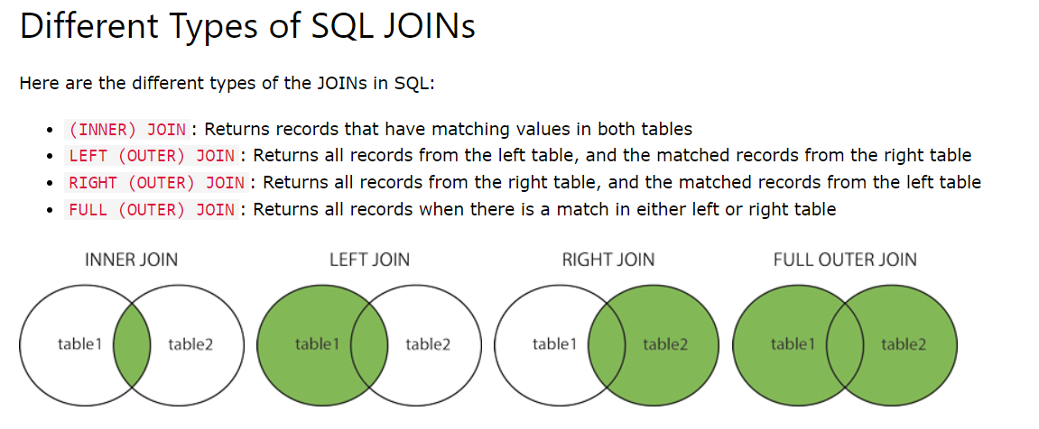

Stored Procedure:

CREATE PROCEDURE procedure_name
AS
sql_statement
GO;

CREATE PROCEDURE SelectAllCustomers @City nvarchar(30)
AS
SELECT * FROM Customers WHERE City = @City
GO;

Alter commands:
ALTER TABLE Persons
ADD DateOfBirth date;

ALTER TABLE Persons
DROP DateOfBirth;

Trigger:
Triggers cannot be manually invoked or executed.
- There is no chance that triggers will receive parameters.
- A transaction cannot be committed or rolled back inside a trigger.

Triggers are stored procedures that are automatically executed when some event occurs. Event can be:
DML events: Insert/Update/Delete
DDL: create, drop, alter
Logon/logoff/startup/shutdown etc

Triggers can be defined on tables/views/database.

Create or Replace Trigger T1
Before|After
INSERT|UPDATE|DELETE
ON Table Name
For each row
Declare
....declarations...
BEGIN
body
END

Trigger can be row level or table level.
For each row means trigger will be executed for each row affected. Table level trigger will execute once when sql statement is executed.

