Persisting data with containers:

How containers persists data in host file system ?
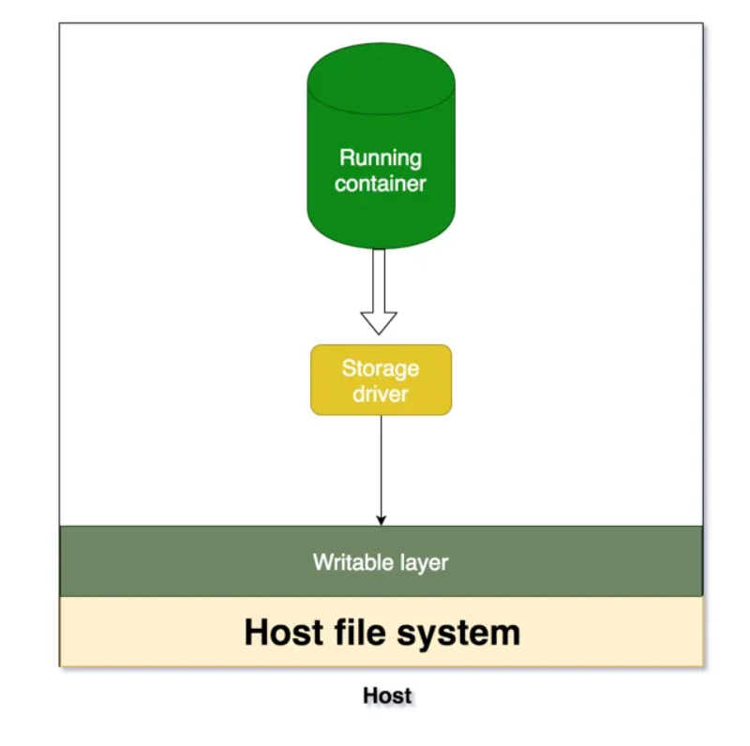
When you create a new container, you add a new writable layer on top of the underlying layers. This layer is often called the “container layer”. All changes made to the running container, such as writing new files, modifying existing files, and deleting files, are written to this thin writable container layer.

whenever running container wants to persist data, it actually put that data into the writable layer through storage driver.

What are the problems ?

- Data is no longer persisted and difficult to access if container stops.
- We have an extra layer of abstraction with a storage driver which reduces the performance.
- As we can see writable layer is tightly coupled with host filesystem and difficult to move the data.

If a container is stopped, its writable layer is still present and so if the container is restarted using docker start command, we can see the changes we made before stopping the container. But if we create a new container then this new container doesn't have access to our changes from earlier container.

If we want containers to share memory then we should use volumes.

Volumes are save in host file systems that are owned and maintained by docker. Any other non-docker process can't access it. Other docker processes can still access the data even when container is stopped.

How to create Volume?
-> docker volume create newVol

