Messaging in Azure:

Azure has 4 fully managed messaging services:

storage queue, service bus, event grid, event hub.

Storage Queue:
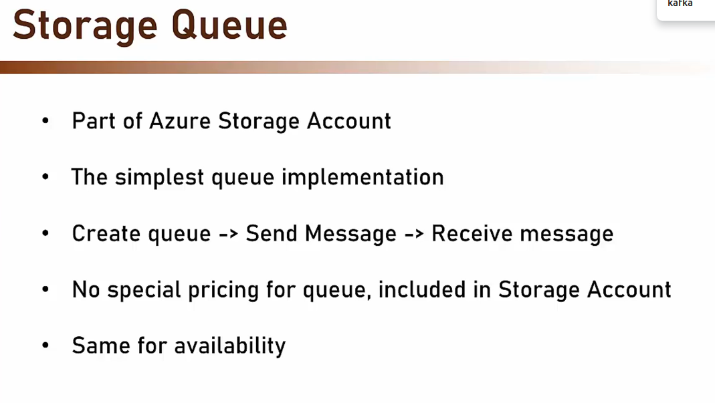
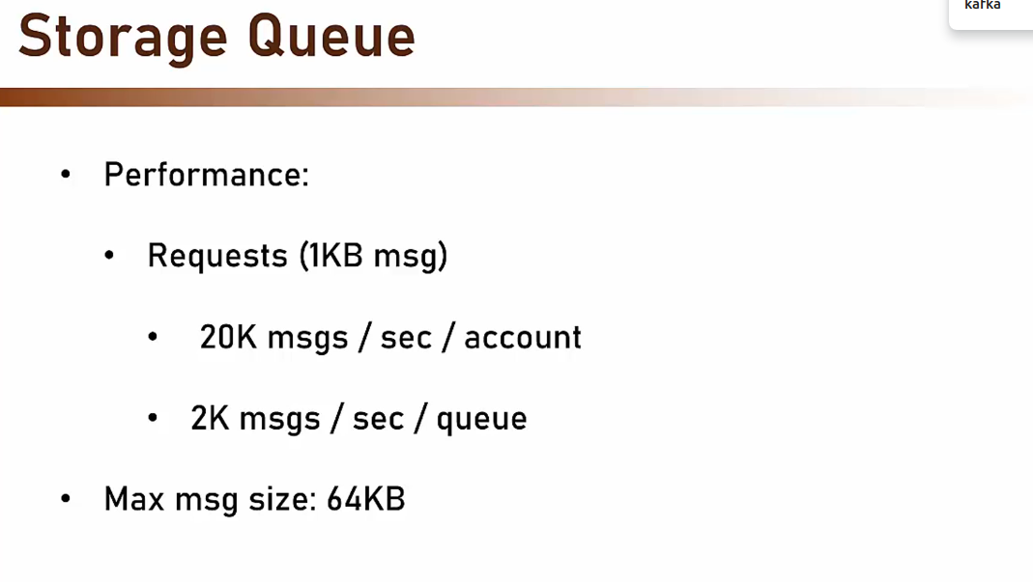

Using QueueClient , StorageQueueTemplate, we can send and receive messages in the queue.

In Azure Storage Queues, a publisher sends a message to a queue, and a single consumer receives it.

Azure Storage Queues is a cloud-based service that uses queues to maintain a list of messages. You can access a queue using a REST API or a client library.

In Azure Storage Queue, . However, multiple consumers can compete for messages in a queue. This is called the First In, First Out (FIFO) message delivery model, which means messages are received and processed in the order they were added to the queue.

Once consumed, message will be deleted from storage queue.

Event Grid:

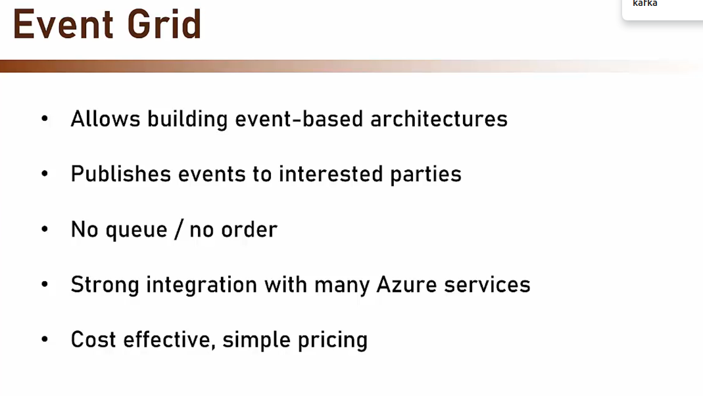

Azure Event Grid is a publish-subscribe messaging service that allows users to: Build data pipelines, Integrate applications, Create event-driven serverless solutions, and Deliver information in real time.

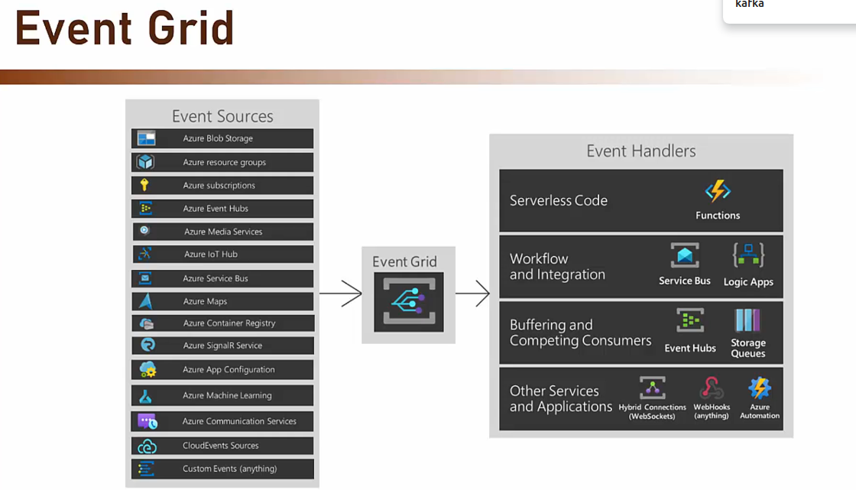

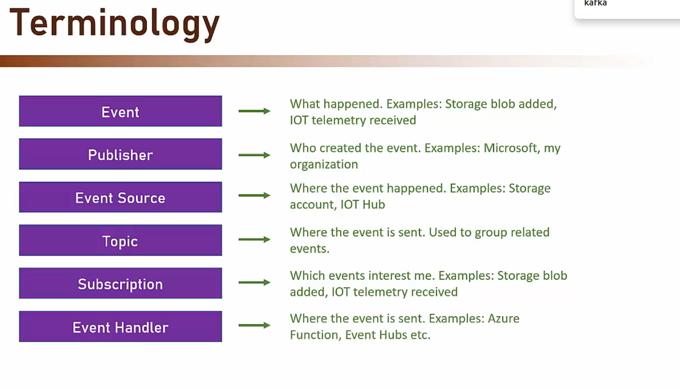

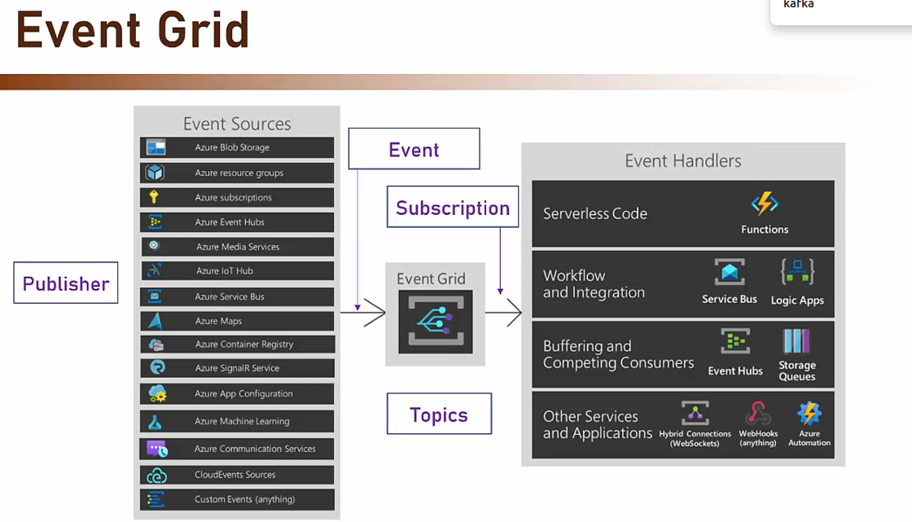
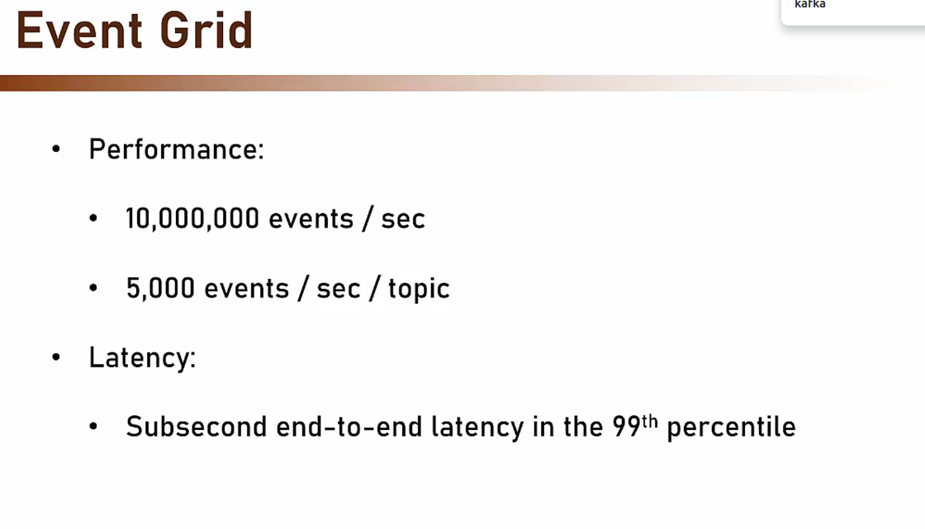
With an Azure Event Grid resource, you can send an event using Spring Cloud Azure Event Grid. With an Azure Service Bus Queue resource as an event handler, you can receive the event using Spring Cloud Azure Stream Binder for Service Bus.

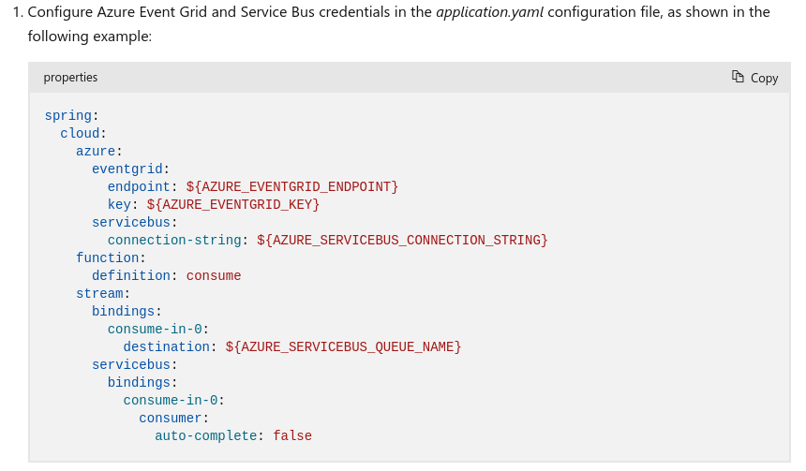

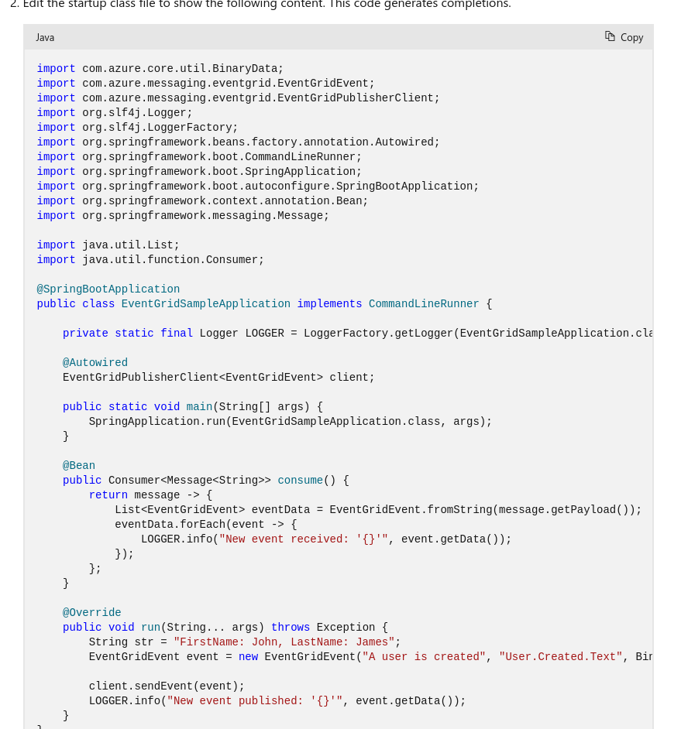

Yes, a function and a Service Bus can process the same event from Event Grid.
Multiple handlers can handle same event.

Azure Service Bus:

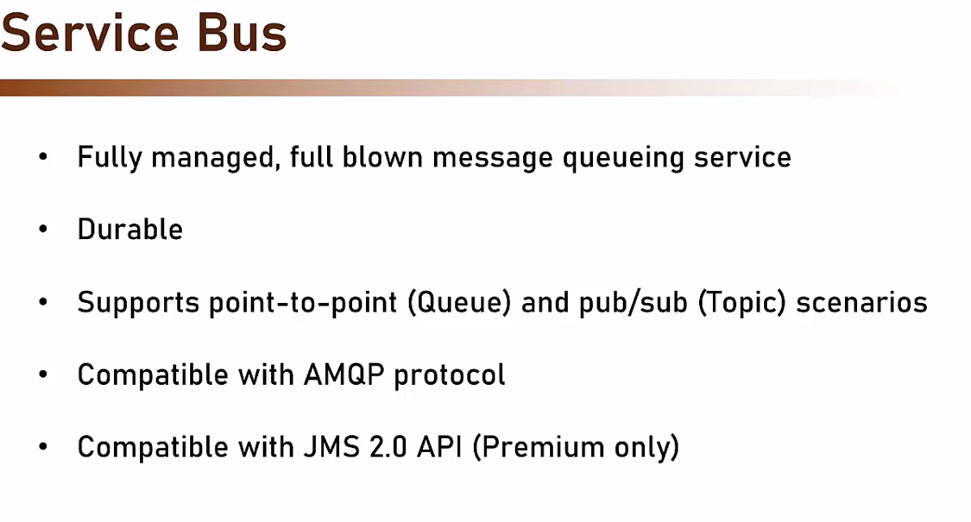

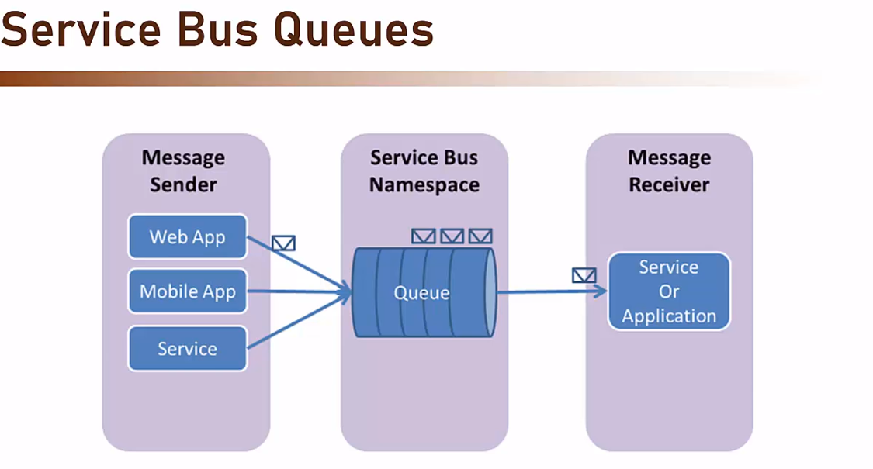
Note , only single receiver.

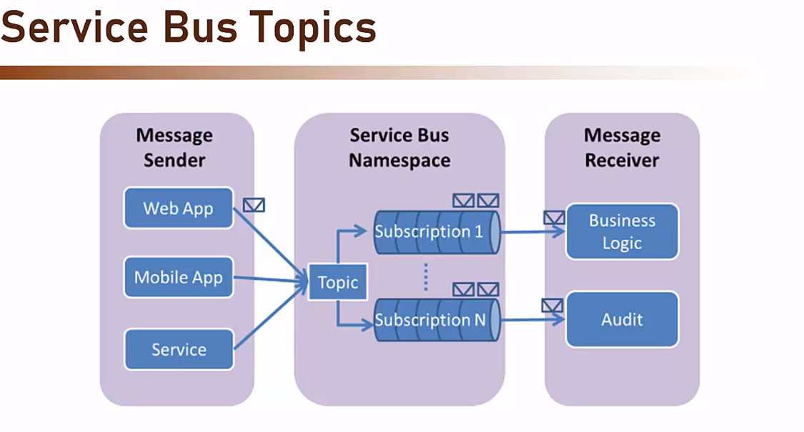

Yes, more than one receiver can listen to the same subscription in Azure Service Bus topics.

Yes, a message sent to an Azure Service Bus topic is made available to all subscriptions registered with the topic

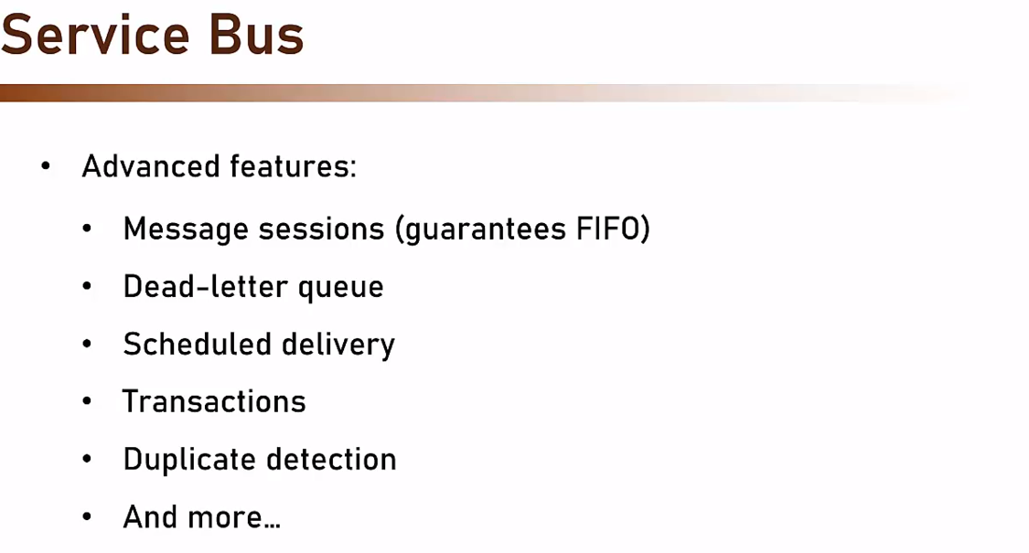

We can use JmsTemplate to send and receive messages.

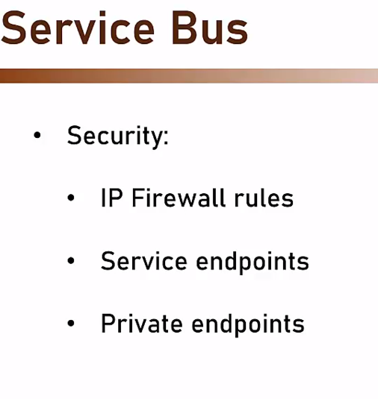

Yes, multiple receivers can listen to the same Azure Service Bus queue.
The first receiver that finishes reading a message removes it from the queue.

In our project, we are sending user registration and orders to service bus queue.

We have UserRegistrationRestController which has a method registerUser which takes @RequestBody @Valid UserDataDto.

We have a UserRegistrationProducer. This class has a property userRegistrationQueueName(populated using @Value(“${user-registration.queue.name}”). We have autowired JmsTemplate and we are using its convertandsend(userRegistrationQueueName, userDataDto).

We have UserRegistrationListener which is having a method registerQueueListener(userDataDto). It is annotated with @JmsListener(destination=”${user-registration.queue.name}”, containerFactory=”jmsListenerContainerFactory”) and @Async(“threadPoolTaskExecutor”)

We have a class @Configuration ThreadPoolConfiguration.

@Bean
public ThreadPoolTaskExecutor threadPoolTaskExecutor(){
var executor = new ThreadPoolTaskExecutor();
executor.setCorePoolSize(10);
executor.setMaxPoolSize(10);
executor.setWaitForTasksToCompleteOnShutdown(true);
executor.setRejectedExecutionHandler(new ThreadPoolExecutor.CallerRunsPolicy());
executor.setThreadNamePrefix(“worker-”);
executor.initialize();
return executor;
}

ScheduledExecutorService is used to rungiven task periodically or once after a given delay.

In application string, we have spring.jms.servicebus.connection-string=<<Environment variable>>

spring.jms.servicebus.pricing-tier=Standard

In pom.xml:
spring-cloud-azure-starter-servicebus-jms

Event Hubs:

