Azure Monitoring:

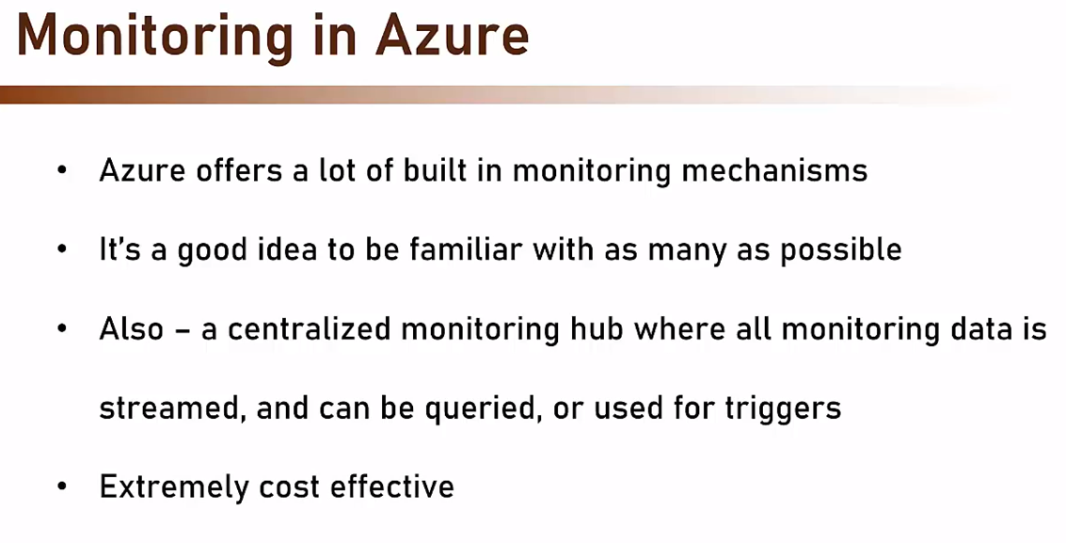
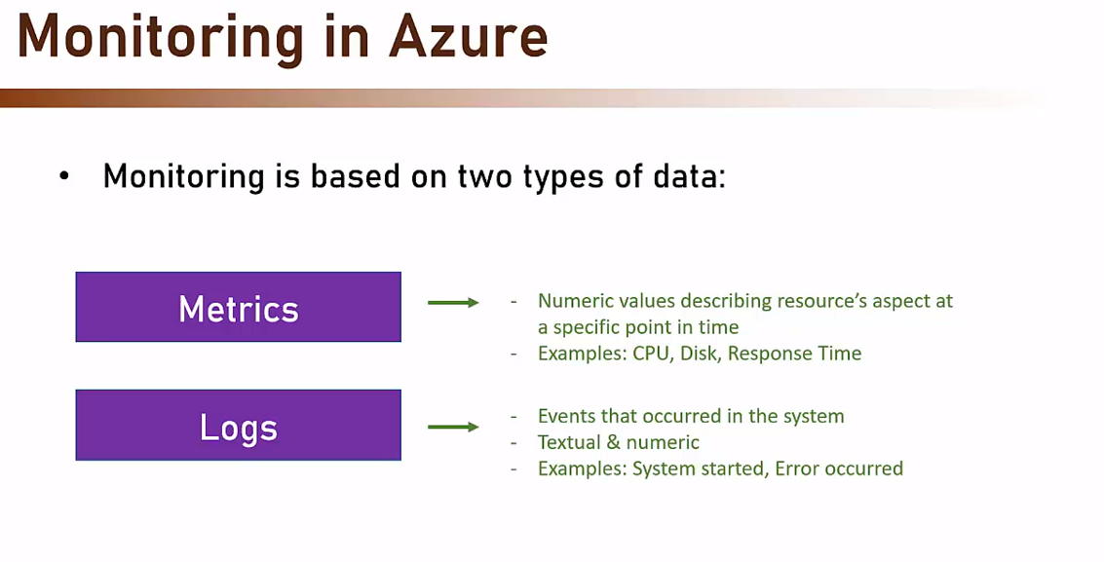
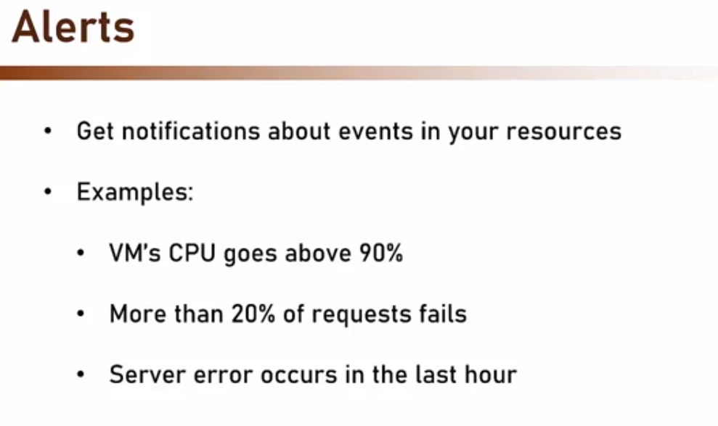
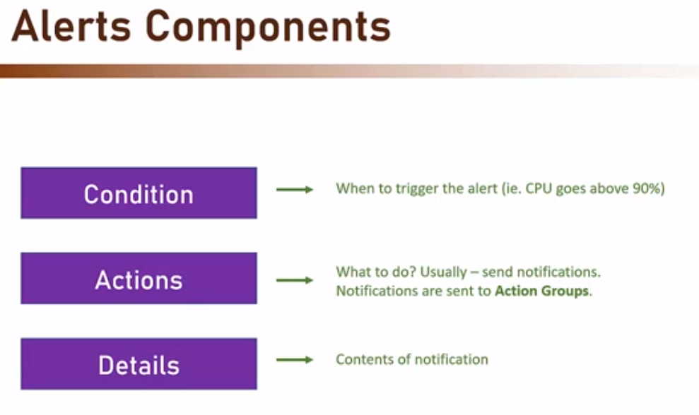

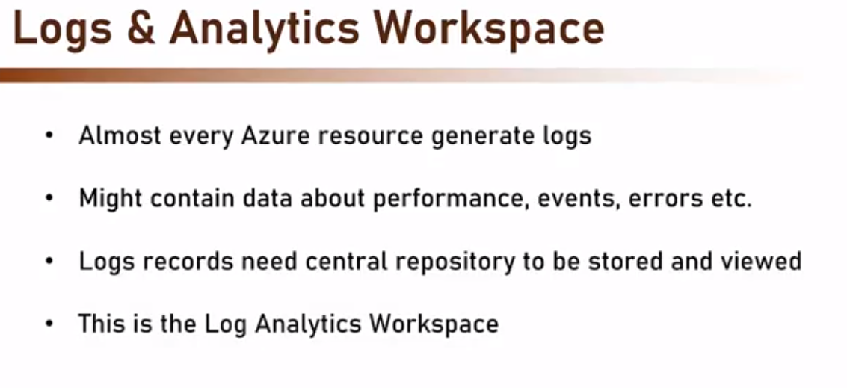
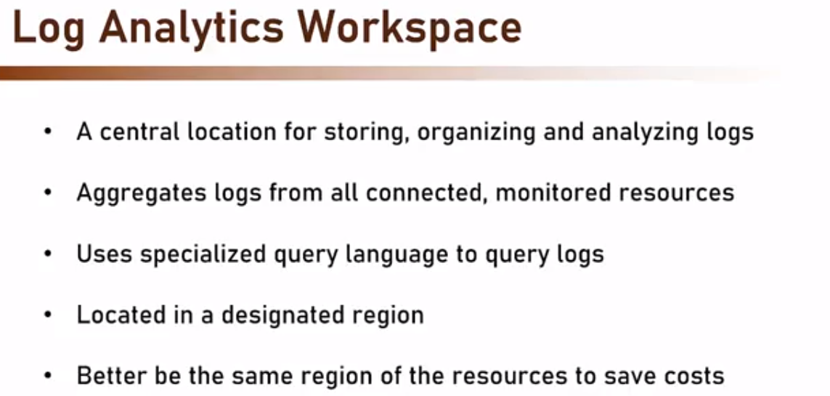
A Log Analytics workspace is data store into which you can collect any type of log data from all of your Azure and non-Azure resources and applications.

We can create alerts based on logs analytics query.

Log Stream does not show application logs by default. We have to enable it and install an extension to see the logs in log stream.

We can publish the logs to Log analytics workspace and create alerts.

Insights:

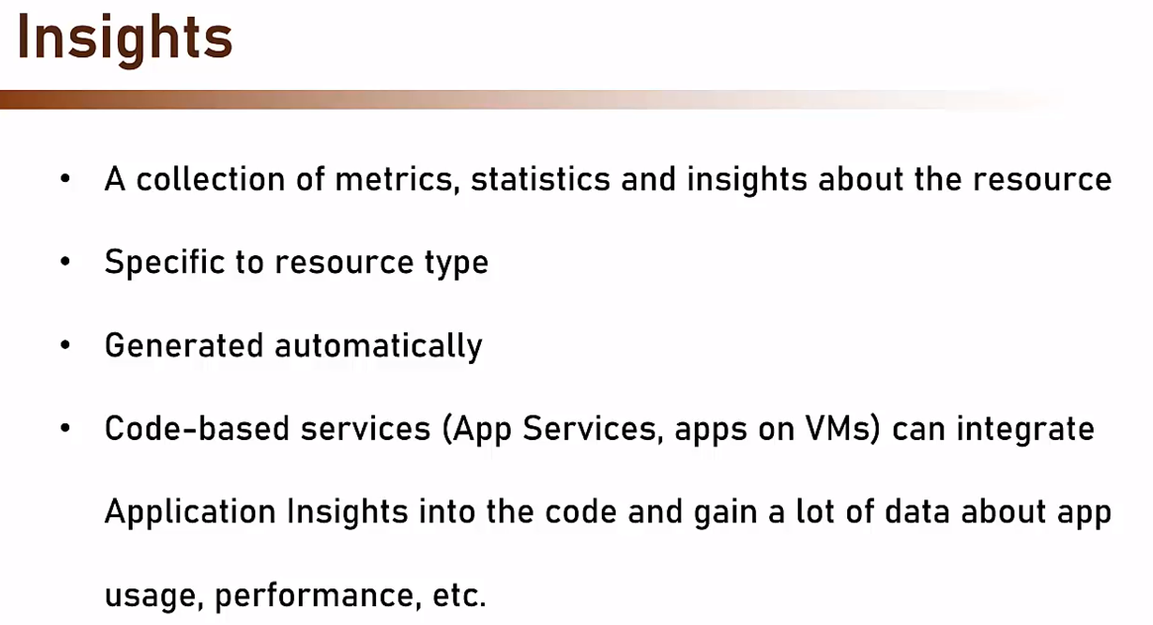
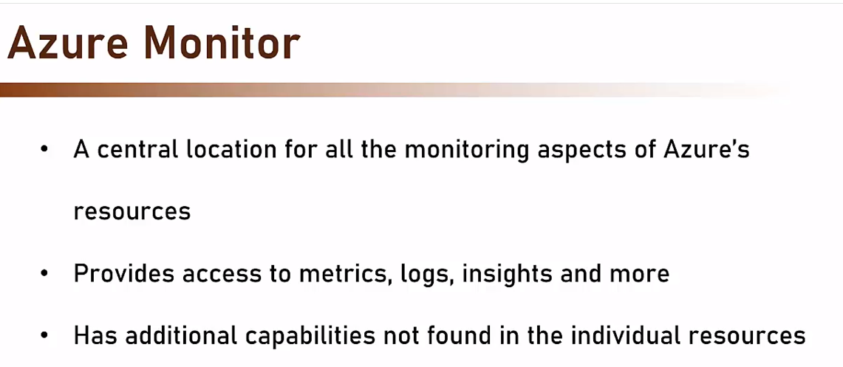

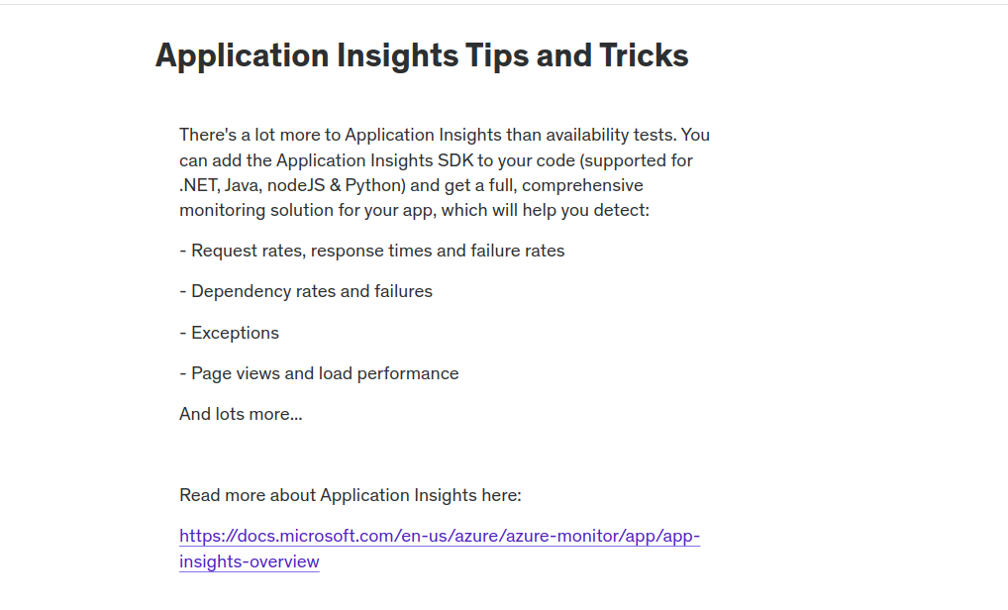

https://docs.microsoft.com/en-us/azure/azure-monitor/app/app-insights-overview

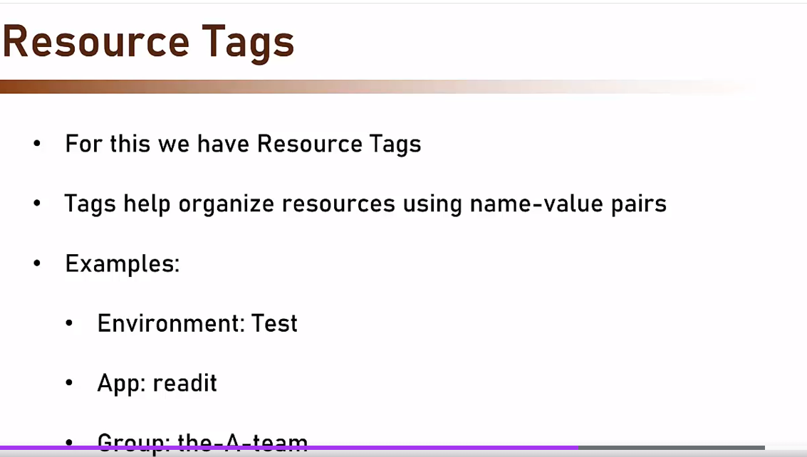

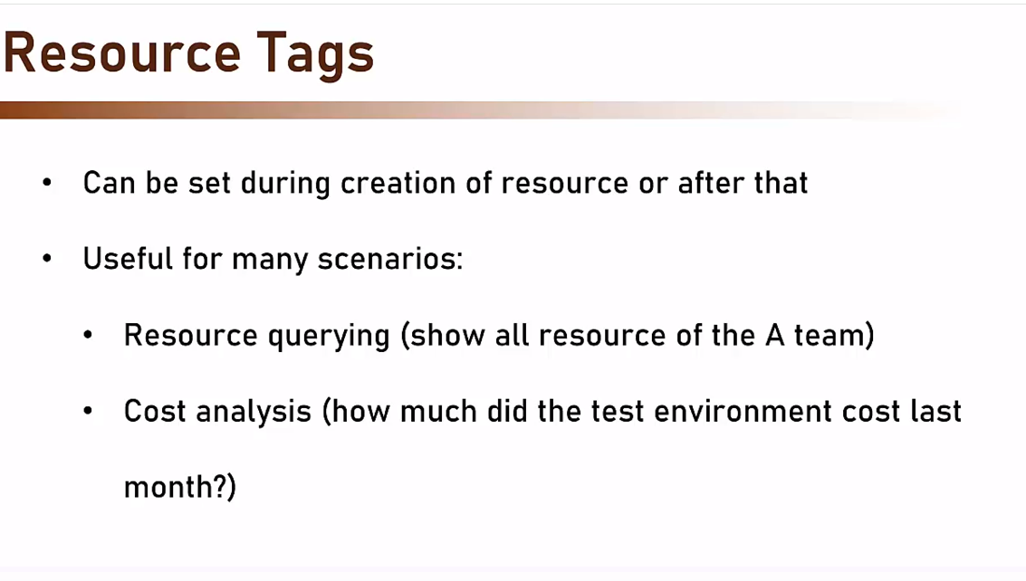

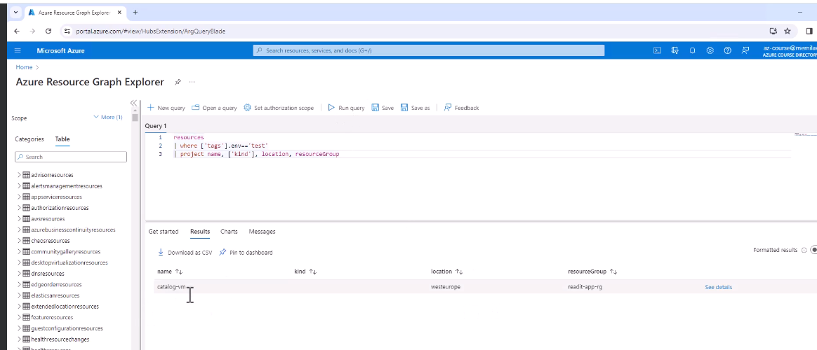

In app service, under Monitoring, there is Diagnostic settings.
We have created f1-stage-exception-logs-diagnostic-setting.

We are sending App Service Console Logs to Log Analytics Workspace(f1-stage-LAW).

In this workspace, there is Logs option on the left.
Open it and locate AppServiceConsoleLogs table under Logs Management. It will show all the logs.
Application Insights is related to workspace. It shows data based on which (Log Analytics Workspace)workspace it is attached to.
In Application Insights, we can investigate issues by viewing:
* Application Map
* Availability ( hits url and if response is 200 OK, the link/service is believed to be up and running).
* Failure: Shows which requests failed. And details about them.
* Performance: For Code optimization and profiling

