Recursion:

Basic Recursion Problems:

* Print name 5 times.
* Print linerly 1 to N
* Print from N to 1
* Print from 1 to N (using backtracking)
* Print N to 1 (using backtracking)
* Summation of first N numbers
* Summation of first N numbers(backtracking)
* Factorial N
* Reverse An Array using recursion
* Check if string is palindrome using recursion
* Nth Fibonacci Number
* Print all subsequences
* Print subsequencies whose sum is K
* Print any one subsequence whose sum is K without any flags
* Count subsequences with sum = K
* Josephus Problem(gfg)
* Divisor Game(gfg)
* Towers of Hanoi(Help the old man(gfg))
* Merge Sort
* Quick Sort
* Combination Sum
* N Queen(Backtracking)

Pattern for count all sequences with sum=K
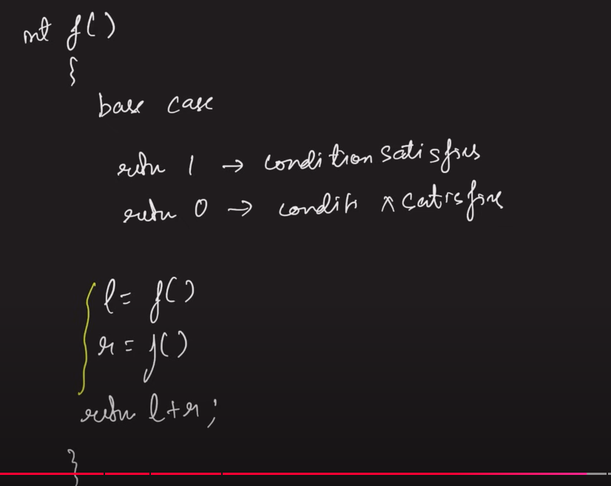

Pattern for print only 1 sequence with sum=K:
In the base condition return true if it is satisfied else return false;
while calling recursive function always check if(func() == true). If true, return true.
If not true then go ahead and execute other recursive function and put the check on it as well to avoid future recursive calls in case it returns true.
if(func()==true) return true;

