CompletableFuture:

CompletableFuture provides a powerful and flexible way to write asynchronous, non-blocking code.

CompletableFuture is a class in java.util.concurrent package that implements the Future and CompletionStage Interface. It represents a future result of an asynchronous computation. It can be thought of as a container that holds the result of an asynchronous operation that is being executed in a different thread. It provides a number of methods to perform various operations on the result of the async computation.
To create an instance of CompletableFuture, we can use the static method supplyAsync provided by CompletableFuture class which takes Supplier as an argument. Supplier is a Functional Interface that takes no value and returns a result.

class GFG {
public static void main(String[] args) throws Exception
{
CompletableFuture<String> greetingFuture
= CompletableFuture.supplyAsync(() -> {
// some async computation
return "Hello from CompletableFuture";
});

System.out.println(greetingFuture.get());
}
}

Output: Hello from CompletableFuture

Composing CompletableFuture
One of the powerful features of CompletableFuture is its ability to compose multiple asynchronous operations. We can use methods like thenApply, thenCombine, thenCompose to perform operations on the result of one CompletableFuture and create a new CompletableFuture as a result.

import java.util.concurrent.*;

class GFG {
public static void main(String[] args) throws Exception
{
CompletableFuture<String> helloFuture
= CompletableFuture.supplyAsync(() -> "Hello");
CompletableFuture<String> greetingFuture
= CompletableFuture.supplyAsync(() -> "World");

CompletableFuture<String> combinedFuture
= helloFuture.thenCombine(
greetingFuture, (m1, m2) -> m1 + " " + m2);

System.out.println(combinedFuture.get());
}
}

Output: Hello World

This creates two instances of CompletableFuture that return “hello” and “world”. And using thenCombine, the result of both the CompletableFutures are concatenated and returned as a final result.

import java.util.concurrent.*;

class GFG {
public static void main(String[] args) throws Exception
{
CompletableFuture<Integer> resultFuture
// java.lang.ArithmeticException: / by zero
= CompletableFuture.supplyAsync(() -> 10 / 0)
.exceptionally(ex -> 0);

// 0 - returned by exceptionally block
System.out.println(resultFuture.get());
}
}

Output: 0
Inside supplyAsync, when 10 is divided by 0, It will throw ArithmeticException and control will go to exceptionally block and which in turn returns 0.
The Future interface was added in Java 5 to serve as a result of an asynchronous computation, but it did not have any methods to combine these computations or handle possible errors.

Java 8 introduced the CompletableFuture class. Along with the Future interface, it also implemented the CompletionStage interface. This interface defines the contract for an asynchronous computation step that we can combine with other steps.

Why do we have completableFutures ?
Future: Primarily relies on blocking operations (get()) for retrieving the result of the asynchronous computation.
CompletableFuture: Encourages non-blocking programming. It allows us to process results with functions and actions that get applied asynchronously, thus enhancing the responsiveness of your application.
In Future, if we want to apply multiple functions then we will have to use get() method to get it and then call the other method which makes the system synchronous.
CompletableFuture has nonblocking functions like thenApply, thenAccept etc which does not require get().

Multiple Futures can not chained together.
Multiple Futures can not combined together.
No exception handling mechanism.

CompletableFuture.get() is a blocking call. We can do completableFuture.complete(“some dummy data”).

RunAsync() vs supplyAsync(): If we want to run some task asynchronously and does not want to return anything, we use runAsync(). It takes runnable as argument and return completableFuture<Void>. CompletableFuture.runAsync(Runnable).
CompletableFuture.runAsync(Runnable,Executor). If we want to return something then use supplyAsync.
CompletableFuture.supplyAsync(Supplier) -> Get the thread from forkJoin pool.
CompletableFuture.supplyAsync(Supplier, Executor) -> Get thread from executor and use it to execute supplier asynchronously.

ThenApply(Function), ThenAccept(Consumer) & ThenRun(Runnable):
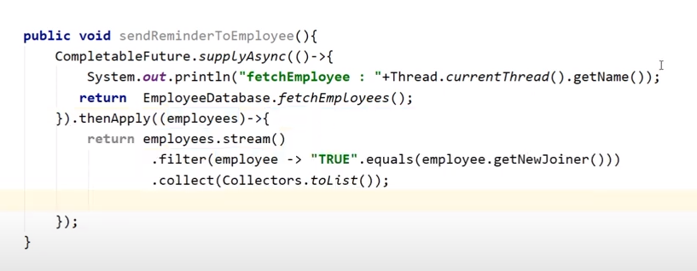
supplyAsync will return employeeList and it will be provided as an argument to thenApply and thenApply will return another filtered list of employees.
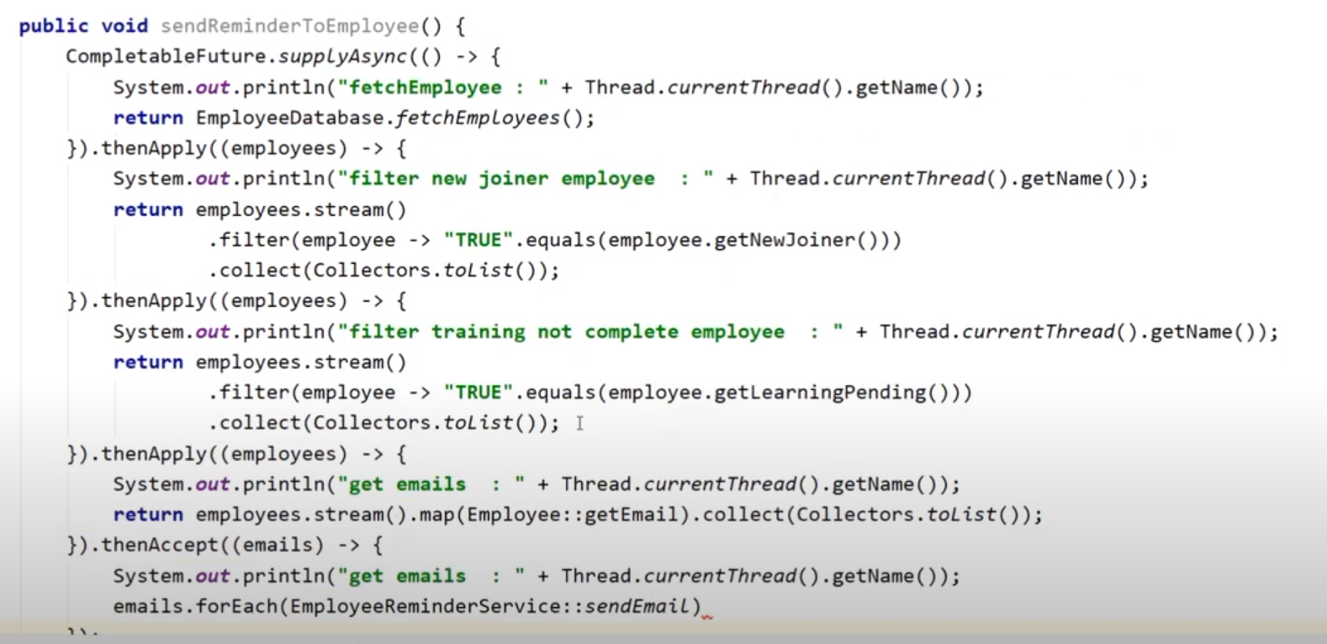
ThenAccept and ThenRun will not return anything.

The issue with above code is that everything is running in a single thread. From forkJoin pool, same thread is picked for running entire completablefuture thenapply, thenaccept etc.



If we want to run the code concurrently then go for thenApplyAsync, thenAcceptAsync etc.


thenApplyAsync(Function, Executor). These are also overloaded methods.

ThenCombine(like stream reduce), thenCompose(like stream flatmap).

create(2) return CompletableFuture<Integer>

allof():
allOf() will wait until all futures are completed. New future will be completed only if the other 4 futures(1,2,3,4) will be completed. If one of them is completed exceptionally then new future will be completed exceptionally.

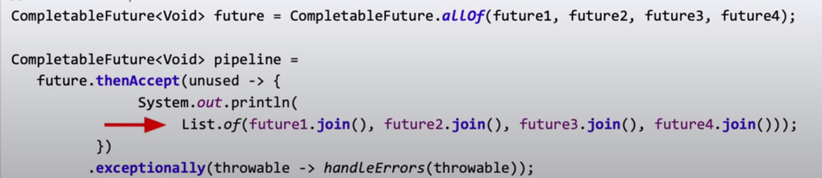
join() method and get() will return the result when future1,2,3,4 completes normally or exceptionally.
Join() will only throw runtime exceptions and get() will throw checked exception as well that we will need to handle.

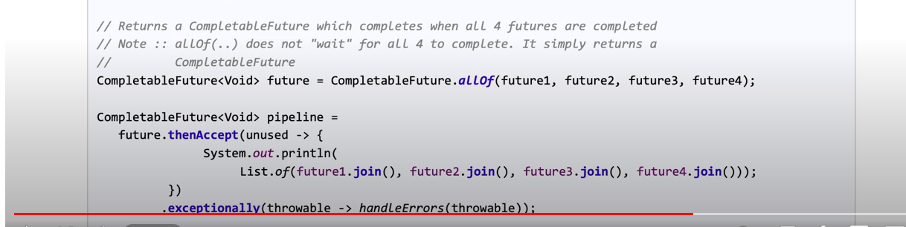
anyOf(): returned future will complete when any of the future completes.
