Comparable | Comparator
This interface has compareTo method. | This interface has compare method.
Used to implement Natural Sorting. | It helps in externally implementing the sorting logic.
int compareTo(Object o); | int compare(Object o1, Object o2);
Collections.sort(element) : Here Class of element should implement comparable interface otherwise we will get RunTime error.(Class can't be cast to Comparable) | Collections.sort(element,new sotingClass())

Code:
Comparable:
package org.example;
public class Employee implements Comparable<Employee>{
private String name;
private Integer salary;
private String deptName;
public Employee(String name, String deptName, Integer salary) {
this.name = name;
this.deptName = deptName;
this.salary = salary;
}
public Integer getSalary() {
return salary;
}
public String getName() {
return name;
}
public String getDeptName() {
return deptName;
}
public void setName(String name) {
this.name = name;
}
public void setSalary(Integer salary) {
this.salary = salary;
}
public void setDeptName(String deptName) {
this.deptName = deptName;
}
@Override
public String toString() {
return "Employee{" +
"name='" + name + '\'' +
", salary=" + salary +
", deptName='" + deptName + '\'' +
'}';
}
@Override
public int compareTo(Employee o) {
if(o.getSalary() > this.getSalary()){
return 1;
}else if(o.getSalary() < this.getSalary()){return -1;}
else{
return 0;
//return this.getDeptName().compareTo(o.deptName);
}
}
}

Comparator:
package org.example;
import java.util.Comparator;
public class EmpComparator implements Comparator<Employee>{
@Override
public int compare(Employee employee, Employee t1) {
return employee.getName().compareTo(t1.getName());
}
}

Main:
package org.example;
import java.util.ArrayList;
import java.util.Arrays;
import java.util.Collections;
import java.util.List;
import java.util.function.Consumer;
import java.util.function.Supplier;
public class Main {
public static void main(String[] args)
{
Employee e1 = new Employee("A","D1",10000);
Employee e2 = new Employee("B","D4",80000);
Employee e3 = new Employee("C","D1",50000);
Employee e4 = new Employee("D","D3",20000);
Employee e5 = new Employee("E","D3",80000);
System.out.println(e2.compareTo(e1)); //e2->e1,
List<Employee> list = Arrays.asList(e1,e2,e3,e4,e5);
System.out.println(list.toString());
Collections.sort(list);
System.out.println(list.toString());
Collections.sort(list, (a,b) -> a.getName().compareTo(b.getName()));
System.out.println(list.toString());
}
}

Output:
-1

[Employee{name='A', salary=10000, deptName='D1'}, Employee{name='B', salary=80000, deptName='D4'}, Employee{name='C', salary=50000, deptName='D1'}, Employee{name='D', salary=20000, deptName='D3'}, Employee{name='E', salary=80000, deptName='D3'}]

[Employee{name='B', salary=80000, deptName='D4'}, Employee{name='E', salary=80000, deptName='D3'}, Employee{name='C', salary=50000, deptName='D1'}, Employee{name='D', salary=20000, deptName='D3'}, Employee{name='A', salary=10000, deptName='D1'}]

[Employee{name='A', salary=10000, deptName='D1'}, Employee{name='B', salary=80000, deptName='D4'}, Employee{name='C', salary=50000, deptName='D1'}, Employee{name='D', salary=20000, deptName='D3'}, Employee{name='E', salary=80000, deptName='D3'}]

Garbage Collection in Java:
When Java programs run on the JVM, objects are created on the heap, which is a portion of memory dedicated to the program. Eventually, some objects will no longer be needed. The garbage collector finds these unused objects and deletes them to free up memory.

The main objective of Garbage Collector is to free heap memory by destroying unreachable objects.

The garbage collector is the best example of the Daemon thread as it is always running in the background.

Java garbage collection is an automatic process. Automatic garbage collection is the process of looking at heap memory, identifying which objects are in use and which are not, and deleting the unused objects. An in-use object, or a referenced object, means that some part of your program still maintains a pointer to that object. An unused or unreferenced object is no longer referenced by any part of your program. So the memory used by an unreferenced object can be reclaimed. The programmer does not need to mark objects to be deleted explicitly. The garbage collection implementation lives in the JVM.

Heap Generations for Garbage Collection in Java

New or Young Generation, Old Generation and Permanent Generation.

New Generation is divided into 3 parts: Eden Space, Survivor 1 and Survivor 2.

When an object is first created in the heap, memory gets allocated under a new generation inside Eden space and after subsequent minor garbage collection if an object survives so it gets moved to survivor 1 and then survivor 2. Minor garbage collections can be optimized assuming a high object mortality rate.

The Old Generation is used to store long-surviving objects. Typically, a threshold is set for the young generation object and when that age is met, the object gets moved to the old generation. Eventually, the old generation needs to be collected. This event is called a major garbage collection.Major garbage collection reclaimed the memory of the old generation.

Permanent Generation:
This space is reserved and used by JVM to store Metadata about classes and methods, String pool and Class level details. The permanent generation is populated by the JVM at runtime based on classes in use by the application.
Metaspace: It's located outside the Heap as part of the native memory provided by the OS,
MetaSpace:

Sr. No. | Key | PermGen | MetaSpace
1 | Basic | PermGen is the memory area for storing class data like static variable,byte code and etc | In Java 8, PermGen method area replaced with MetaSpace
2 | Default Memory Allocation | By default 64 Mb is allocated for PermGen | It can by default auto increases its size
3 | Tuned-up Memory Flag | It can be tuned by using -XXMaxPermSize. | We can restrict upper bound of the memory by -XX:MaxMetaspaceSize

Types of Activities in Java Garbage Collection
Two types of garbage collection activity usually happen in Java. These are:
- Minor or incremental Garbage Collection: It is said to have occurred when unreachable objects in the young generation heap memory are removed.
- Major or Full Garbage Collection: It is said to have occurred when the objects that survived the minor garbage collection are copied into the old generation or permanent generation heap memory are removed. When compared to the young generation, garbage collection happens less frequently in the old generation.

There are generally four ways to make an object eligible for garbage collection.
  - Nullifying the reference variable
  - Re-assigning the reference variable
  - An object created inside the method
  - Island of Isolation

Types of Garbage Collector:

Serial: Serial Garbage collector is well-matched for single-threaded environments. It uses the only thread for garbage collection. It works by holding all the threads of an application. It means that threads of the application freeze by the serial garbage collector during the garbage collection process and the process is known as stop the world event.

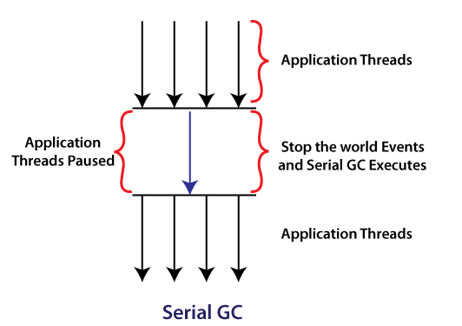
Parallel: Parallel Garbage Collector is the default GC used by the JVM. The working of the parallel garbage collector is the same as the serial garbage collector. The only difference between serial and parallel garbage collector is that serial garbage collector uses a single thread for garbage collection process while the parallel garbage collector uses multiple threads for the garbage collection. Parallel GC can use multiple CPUs to speed up the application throughput. So, it is also known as throughput collector. It is used if we want to execute a long process (like batch processing) and where long pauses are acceptable.

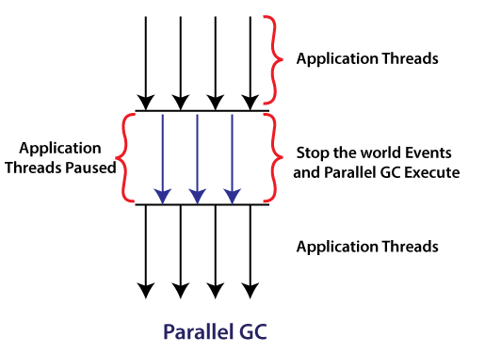

Concurrent Mark & Sweep: CMS uses multiple threads that scan the heap and during the scanning, it marks the instances for eviction, after scanning, it sweeps the marked instances. It does not freeze the application's threads during the garbage collection. GC threads concurrently execute with the application's threads. For this reason, it uses more CPU in comparison to other GC. It is also known as the concurrent low pause collector. It also freezes all the threads of the application only if it satisfies the following two scenarios:

- while marking the referenced objects in the old generation region.
- if any change is made to the heap memory in parallel during the garbage collection process.
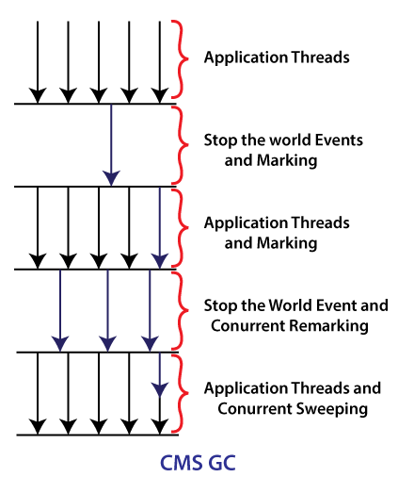

Garbage First: The G1 garbage collector is used if we have a large (more than 4GB) memory (heap space). It divides the heap into equal-sized (usually 1MB to 32MB) chunks, prioritizes them, and then performs the parallel garbage collection on that chunks based on the priority.

Names of Garbage Collector: Epsilon GC(no-op(do nothing)), Shenandoah, ZGC(ZGC is designed for applications that have low latency requirements and use large heaps. ZGC allows a Java application to continue running while it performs all garbage collection operations. ZGC was introduced in JDK 11u and improved in JDK 12.).

Shenandoah is the low pause time garbage collector (GC) that reduces GC pause times by performing more garbage collection work concurrently with the running Java program.

Ways for requesting JVM to run Garbage Collector
- Once we make an object eligible for garbage collection, it may not destroy immediately by the garbage collector. Whenever JVM runs the Garbage Collector program, then only the object will be destroyed. But when JVM runs Garbage Collector, we can not expect.
- We can also request JVM to run Garbage Collector. There are two ways to do it :
  - Using System.gc() method: System class contain static method gc() for requesting JVM to run Garbage Collector.
  - Using Runtime.getRuntime().gc() method: Runtime class allows the application to interface with the JVM in which the application is running. Hence by using its gc() method, we can request JVM to run Garbage Collector. Runtime is singleton class.
  - There is no guarantee that any of the above two methods will run Garbage Collector.
  - The call System.gc() is effectively equivalent to the call : Runtime.getRuntime().gc()

Finalization
- Just before destroying an object, Garbage Collector calls finalize() method on the object to perform cleanup activities. Once finalize() method completes, Garbage Collector destroys that object.
- finalize() method is present in Object class with the following prototype.
protected void finalize() throws Throwable
Based on our requirement, we can override finalize() method for performing our cleanup activities like closing connection from the database.
- The finalize() method is called by Garbage Collector, not JVM. However, Garbage Collector is one of the modules of JVM.
- Object class finalize() method has an empty implementation. Thus, it is recommended to override the finalize() method to dispose of system resources or perform other cleanups.
- The finalize() method is never invoked more than once for any object.
- If an uncaught exception is thrown by the finalize() method, the exception is ignored, and the finalization of that object terminates.
- Finalize methord is deprecated. Use Try-with-resources instead. It is not guaranteed that finalize method will be called or not during garbage collection.
- Try-with-resources automatically closes the resource. The resource should implement AutoClosable or closable interface. Finally becomes optional. If any exception is raised in try( here...){ or here2} then always the exception from try block (here2) will be thrown. In try-catch-finally, the exception of finally block will be returned by the method.

There might be situations where an application creates lots of objects and does not use them. Just because every objects has valid references, garbage collector in Java can’t destroys the objects. Such types of useless objects are called as Memory leaks. If allocated memory goes beyond limit, program will be terminated by rising OutOfMemoryError. Hence if an object is no longer required, it is highly recommended to make that object eligible for garbage collector. Otherwise We should use some tools that do memory management to identifies useless objects or memory leaks like:

- HP OVO
- HP J METER
- JProbe
- IBM Tivoli

JVM is Java Virtual Machine that is actually responsible for executing bytecode line by line.
JVM calls the main method and it is part of JRE.

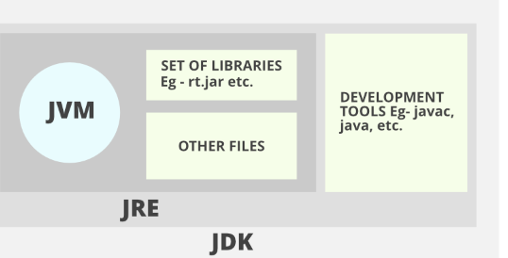

Working of JVM:
- .class file is loaded into method area by class loader
- JVM memory is dived into method area, heap area, stack area, PC Register and Native Method Stacks
- Method Area: In method area, all class level information like class name, immediate parent, methods, variables etc are stored including static variables. From Java 8, static variables are stored in heap area. It is a shared resource.
- When we create a static variable or method it is stored in a special area on the heap: PermGen(Permanent Generation), where it lays down all the data applying to classes(non-instance data).
Starting from Java 8 the PermGen became - Metaspace.
The difference is that Metaspace is an auto-growing space, while PermGen has a fixed Max size, and this space is shared among all of the instances. Plus the Metaspace is a part of a Native Memory and not JVM Memory.

- Heap Area: Objects are stored in Heap memory. It is a shared resource.
- Stack Area: For every thread, JVM creates one runtime stack. Every block of this thread is called a Frame/Activation record. Each record holds the method calls. So, each record has local variables stored in that respective record. It is not a shared resource.
- PC Registers: Store address of current execution instruction of a thread. It is not a shared resource.
- Native Method Stack: For every thread, a seperate native stack is created. It stored native method information.
- Execution Engine: It comprises of Interpreter, JIT and Garbage Collector. It executes byteCode line by line.
- JIT: It increases the efficiency of interpreter. Whenever interpreter sees repeated code, it reads the native code provide by JIT. JIT converts repeated code into native code. No re-interpretaion is required.
- Garbage Collector: Destroys Unreferenced Objects.
- Native Method Libraries: C/C++ libraries required by JVM.
- JNI(Java Native Interface): Allows JVM to call native code and to get called by native lib.

Class Loaders do : Loading , Linking, Initialization.
Loading: .class file into memory and an object is created in heap for this class of Type Class.
Linking: verify the files. Preperation->allocates memory to static data and initialise to default value. Resolution: It is the process of replacing symbolic references from the type with direct references. It is done by searching into the method area to locate the referenced entity.

Initialization: n this phase, all static variables are assigned with their values defined in the code and static block(if any). This is executed from top to bottom in a class and from parent to child in the class hierarchy.

What is Class Loader? Types of Class Loader?

Class loader reads .class file and stores in Method Area of JVM.
3 Types: Bootstrap, Extension and System Class Loader.
Bootstrap Loader: Loads all the packages from core Java API classes from bootstrap path: JAVA_HOME/lib. These are written in C/C++.
Extension Loader:It is child of Bootstrap loader and loads lib from JAVA_HOME/jre/lib/ext(Extension Path).
Application/System Class Loader:Loads classes from application classPath.

JVM follows the Delegation-Hierarchy principle to load classes. System class loader delegate load request to extension class loader and extension class loader delegate request to the bootstrap class loader. If a class found in the boot-strap path, the class is loaded otherwise request again transfers to the extension class loader and then to the system class loader. At last, if the system class loader fails to load class, then we get run-time exception java.lang.ClassNotFoundException.

What is Exception Propagation?
When an exception occur, JVM tries to find the handling code in the method where exception occur, if it is not handled there, then the calling methods are checked, then main method is checked and if it is not handled there then JVM throws the exception and terminates the program.

What is load factor in hashmap?
Load factor defines when would resizing of hashmap initiate. When would capacity of hashmap will increase. Default load factor is 75%. It means when map has 75% buckets full then it would copy the current buckets to a new memory with increased capacity for hashmap. Indexes will be recalculated.

How resize happen in hashmap?
Hashmap uses load factor to determine when to resize. All the existing buckets are copied into new resized map. Index are recalculated. Index for next element is calculated and then it is placed in map.

Size of HashMap : Number of key-value pairs stored in map.
Capacity of map: Max number of key-values that can be stored in a map.

Internal Working of HashMap in JAVA:

Hashing in Java uses HashCode() function to convert and object refernce to integer format and then this interger is used to calculate the index of the bucket where this object(key) will be stored.
Equals() method determines whether the objects are equal.

There is an array of bucket and more than one node can be stored in one bucket. Each node has a hashCode, key-value pair and a next pointer (pointer to next node).

HashMap map = new HashMap(); // New hashmap with default 16 buckets is created.

Map.put(key,value);

hashCode of key calculated. It can be a big integer so an index is calculated using some operation (modulus). A node is created and stored at the bucket present at index calculated above , if the bucket is empty. If some key is already present , then equals() and hashCode() is used to match if the key is an exact match. If same key is present in the bucket then its value is replaced. Otherwise, a node a created and the nextPtr stores the address to this new node and it becomes a linked list.

Map.get(key):

hashCode of key is used to calculate the index of the bucket where the value could be present. After, we reach the bucket, a linear search is performed on the linked list. If the key is found then its value is returned, else null is returned.

As a improvement in Java 8, Linked list is converted to binary tree once a threshhold is reached and vice-versa.

Array | ArrayList | Vector | LinkedList
It is static. Size must be defined at the time of creating the array. | It uses dynamic array. Capacity is increased by 50% once ArrayList is full and we try to insert an element. | It uses dynamic array. Capacity is doubled once Vector is full and we try to insert an element. | It is a doubly linked list internally.
It is fast. | It is slow as compared to static array. | It is thread-safe. It is slower than ArrayList. It is synchronised. | Manipulation is efficient (delete operation) but accessing an element is costly.
Premitive types and Objects are supported. | Premitive types are not supported. | Premitive types are not supported. | Premitive types are not supported.
Contiguous Alllocation | Contiguous Alllocation | Contiguous Alllocation | Non Contiguous Alllocation

Why is JAVA not 100% OOPS?
It supports premitive datatypes.

Why are pointers not used in Java?
- Pointers have the ability to directly access the memory that can be a security concern.
- Pointers takes extra memory.

Why is String immutable in JAVA?
In String pool, a string literal can be refered by many reference variables and if any refernece to it modifies the literal value then it will be modified for other reference varibles as well. To avoid this situation, strings are immutable.

String str = new String("Hello");
String str2 = new String("Hello");

String str3 = "Hello";
String str4 = "Hello";

System.out.println(str==str2);
System.out.println(str3==str4);
output: false
true

What is marker/tagging interface?
A marker interface is the one which does not have any body. No variables and methods. They provide a special meaning to the class where they are implemented. Ex: Serializable, Cloneable etc.

Can we override private and static methods in java?
Private methods are not available in child class so we can't override them.
Static methods calls are binded at compile time. Due to this, compiler already knows which method to call at compile time already. This becomes the case of method hiding.

If we have a Class A with static method m1() and we have a child class of A which is B and B also has m1(). Then B.m1() will call B’s static method. If B does not have m1() and we try to call B.m1() then A’s static method would be called.

The reference variable type decides which static method would be called.

Does finally always execute in JAVA?
No, System.exit(0) and a system failure won't allow finally block to execute.

How to make a class immutable?
- Make the class final so no inheritance will be there.
- Make the class variables private and final.
- Create only getters and no setters. Getters should return the deep copy instead of actual value.
- Parameterized constructor should initialize class variables by deep copying the values.
- Wrapper Classes (Integer, Character etc.) and String are immutable.
- Using a java.util.Date would be dangerous as it is a mutable class

// Java Program to Create An Immutable Class

// Importing required classes
import java.util.HashMap;
import java.util.Map;

// Class 1
// An immutable class
final class Student {

// Member attributes of final class
private final String name;
private final int regNo;
private final Map<String, String> metadata;

// Constructor of immutable class
// Parameterized constructor
public Student(String name, int regNo,
Map<String, String> metadata)
{

// This keyword refers to current instance itself
this.name = name;
this.regNo = regNo;

// Creating Map object with reference to HashMap
// Declaring object of string type
Map<String, String> tempMap = new HashMap<>();

// Iterating using for-each loop
for (Map.Entry<String, String> entry :
metadata.entrySet()) {
tempMap.put(entry.getKey(), entry.getValue());
}

this.metadata = tempMap;
}

// Method 1
public String getName() { return name; }

// Method 2
public int getRegNo() { return regNo; }

// Note that there should not be any setters

// Method 3
// User -defined type
// To get meta data
public Map<String, String> getMetadata()
{

// Creating Map with HashMap reference
Map<String, String> tempMap = new HashMap<>();

for (Map.Entry<String, String> entry :
this.metadata.entrySet()) {
tempMap.put(entry.getKey(), entry.getValue());
}
return tempMap;
}
}

// Class 2
// Main class
class GFG {

// Main driver method
public static void main(String[] args)
{

// Creating Map object with reference to HashMap
Map<String, String> map = new HashMap<>();

// Adding elements to Map object
// using put() method
map.put("1", "first");
map.put("2", "second");

Student s = new Student("ABC", 101, map);

// Calling the above methods 1,2,3 of class1
// inside main() method in class2 and
// executing the print statement over them
System.out.println(s.getName());
System.out.println(s.getRegNo());
System.out.println(s.getMetadata());

// Uncommenting below line causes error
// s.regNo = 102;

map.put("3", "third");
// Remains unchanged due to deep copy in constructor
System.out.println(s.getMetadata());
s.getMetadata().put("4", "fourth");
// Remains unchanged due to deep copy in getter
System.out.println(s.getMetadata());
}
}

What is singleton class?
A class whose atmost one object can be created. Ex: Runtime class.

How to make a class singleton and thread-safe?
- Create private constructor.
- Create public static class variable that will hold the object for this class.
- Create a public static method that will create object if object is null or return the already created object.
- Step 3 is the Lazy instantiation of the object. For Early Instantiation, initialise the class variable using new keyword.
//singleton class:

public class SingletonClass{

private static volatile SingletonClass mySingletonObject;
private SingletonClass(){}

public static getInstance(){
if(mySingletonObject == null){
synchronized(SingletonClass.class){
if(mySingletonObject == null){
mySingletonObject = new SingletonClass();
}
}
}
return mySingletonObject;
}
}

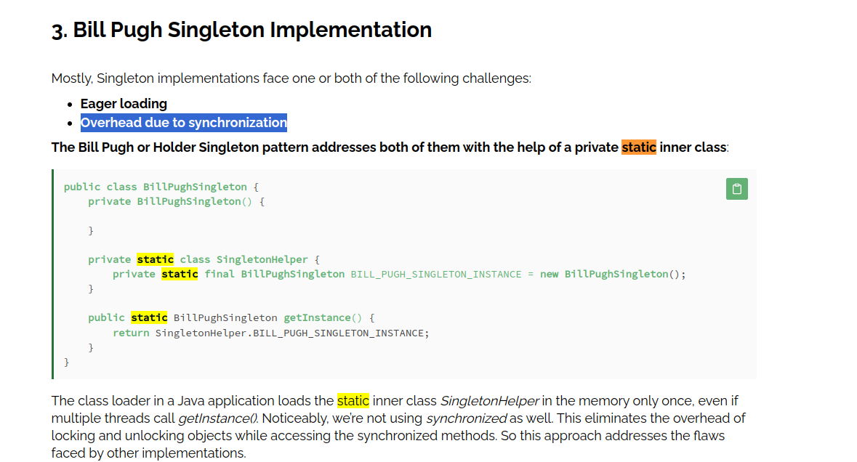

How can we break singleton nature of a class?
We can break it using Reflection, Serialization and cloning.
Using reflection, we can set the accessibility of private constructor to true and then we can use constructor.getInstance() and cast it to class. We can create as many objects as we want.

Overcome reflection issue: To overcome issues raised by reflection, enums are used because java ensures internally that the enum value is instantiated only once. Since java Enums are globally accessible, they can be used for singletons. Its only drawback is that it is not flexible i.e it does not allow lazy initialization.

Serialization:- Serialization can also cause breakage of singleton property of singleton classes. Serialization is used to convert an object of a byte stream and save in a file or send it over a network. Suppose you serialize an object of a singleton class. Then if you de-serialize that object it will create a new instance and hence break the singleton pattern.

Overcome serialization issue:- To overcome this issue, we have to implement the method readResolve() method.

private Object readResolve() throws ObjectStreamException { return INSTANCE; }

Cloning: Cloning is the concept to create duplicate objects. Using clone we can create copy of object. Suppose, we create clone of a singleton object, then it will create a copy that is there are two instances of a singleton class, hence the class is no more singleton.

class A implements Cloneable {
int i;
String s;

// A class constructor
public A(int i, String s)
{
this.i = i;
this.s = s;
}

// Overriding clone() method
// by simply calling Object class
// clone() method.
@Override
protected Object clone()
throws CloneNotSupportedException
{
return super.clone();
}
}

public class Test {
public static void main(String[] args)
throws CloneNotSupportedException
{
A a = new A(20, "GeeksForGeeks");

// cloning 'a' and holding
// new cloned object reference in b

// down-casting as clone() return type is Object
A b = (A)a.clone();

System.out.println(b.i);
System.out.println(b.s);
}
}

Overcome Cloning issue: To overcome this issue, override clone() method and throw an exception from clone method that is CloneNotSupportedException. Now, whenever user will try to create clone of singleton object, it will throw an exception and hence our class remains singleton.

What is Lambda Expression?
Lambda expression consists of argument list, arrow token and body of lambda expression.
It is used to define the behaviour of abstract method of functional interface.

What is functional interface?
Interface with only one abstract method and it can have many default and static methods. Runnable, Callable and Comparable are Functional interface.

What is method reference in Java? Types of method reference.
Sometimes lambda expression calls existing method. We can use method reference in this case so that it is easy to read. There are 3 types : Reference to Static Method, Reference to instance method and reference to constructor.
ClassName::staticMethod
ObjectName::instanceMethod
ClassName :: new
The method references can only be used to replace a single method of the lambda expression.

Why use interface when we have abstract class ?
Multiple interfaces can be implemented on a class but multiple abstract classes can't be extended in child class. Create interface if not all subclasses want to implement the methods of the interface and if all the subclasses want to implement it then create method in abstract class.
Ex: Vehicle super class has 3 child classes: Car, Aeroplane and Ship. Vehicle class can have a horn() abstract method which can be implemented in all of the vehicle. But fly() method should not be implemented in car and ship so we can keep it in a seperate interface.

What are default methods?
In Java, interfaces can have default methods. These methods are provided with default body, if our requirement is not satisfied by default implementation then we can override it as well. It was included to support backward compatibility of interfaces. If you want to enhance interface by adding more methods then you can do so by adding default methods. This way no code would break.

Can JAVA 8 default methods overrides equals(), hashCode() and toString() methods?
No. Class or Super class methods implementations have higher precedence as compared to interface default implementation s error if we try to do so.

If we try to override toString() method of object class in interface, I will get compilation error saying “default method toString in interface If1 overrides a member of java.lang.Object”.

If interface has a default method m2() and same m2() is present in super class A then if we try to call b.m2() then super class m2() will be called and default method won’t be called. B is an object of B extends A implements interfaceF1.

What if b is reference type of InterfaceF1 or A ? Then which m2() would be called?
Still A’s m1() will be called.

How to solve diamond problem raised due to default methods in interfaces ?
In the implementing class, specifically call the methods. Syntax: InterfaceName.super.methodName();

Why static methods were introduced in Java 8 interfaces?
If we do not want implementing classes to override the functionalities for specific methods then we make them static in interface.

What are predicates?
Predicate is a functional interface. It has abstract method test(T t) that takes one parameter and return boolean.

What is predicate joining?
If we want to apply multiple predicates then we use and(), or() and negate() methods or create complex predicates using binary operators.

boolean result = greaterThanTen.and(lowerThanTwenty).and(p3).negate().test(15);

What are function interface?
Functional Interface with abstract method R apply(T t).
Function<Integer,String> f1 = (b) -> {return "This is "+b;};
T = Integer, R = String

Differences between Function and Predicate.
Predicate | Function
Boolean test(T t) | R apply(T t)
Can be used to filter.(filter of java stream) | Can be used to do the transformation.(map of Java Stream)

What is function chaining?
If we want to call apply() method more than once then we can do so using andThen() or compose() function. They are opposite of each other.

What is Consumer functional interface?
It has void accept(T t) method. Takes one argument and return nothing.

What is consumer chaining?
AndThen() is used to call accept() method multiple times.

What is supplier interface?
It has R get() method. No input argument. No chaining.

What are BiPredicate, BiFunction and BiConsumer? Why dont we have BiSupplier?
It is same as Predicate, Function and Consumer but with two arguments/parameters.
No BiSupplier because it doesn't take any argument/parameter.

What are streams?
A stream is a sequence of objects that supports various methods which can be pipelined to produce desired results.
- It is not a data structure. Input is taken from collection, array, I/O channel.
- Original collection is never modified.
- Each intermediate operation is lazily executed and returns stream.
- Terminal operation mark the end of stream.

Streams | Collections
Data is not stored in streams. | Data is stored in collections.
Streams uses lambda/functional interface. | No functional interface.
Consumable. Create stream again and again if you want to traverse it multiple times. | Non-consumable.
Both sequentials and parallel processing. | Parallel processing
Non-modifiable | Modifiable

Difference b/w filter and map
Filter | Map
It takes predicate as input parameter. | It takes Function as input parameter.
It filters out elements based on the predicate passed to it. | It transforms all the elements in the stream.

map() | flatMap()
The function passed to map() operation returns a single value for a single input. | The function you pass to flatmap() operation returns an arbitrary number of values as the output.
One-to-one mapping occurs in map(). | One-to-many mapping occurs in flatMap().
Only perform the mapping. | Perform mapping as well as flattening.
Produce a stream of value. | Produce a stream of stream value.
map() is used only for transformation. | flatMap() is used both for transformation and mapping.

List<List<Integer> > number = new ArrayList<>();

// adding the elements to number arraylist
number.add(Arrays.asList(1, 2));
number.add(Arrays.asList(3, 4));
number.add(Arrays.asList(5, 6));
number.add(Arrays.asList(7, 8));

System.out.println("List of list-" + number);

// using flatmap() to flatten this list
List<Integer> flatList
= number.stream()
.flatMap(list -> list.stream())
.collect(Collectors.toList());

// printing the list
System.out.println("List generate by flatMap-"
+ flatList);
Output
List of list-[[1, 2], [3, 4], [5, 6], [7, 8]]
List generate by flatMap-[1, 2, 3, 4, 5, 6, 7, 8]

Intermediate Operations of Stream:
filter() : return stream of elements satifying predicate.
Map() : return stream after applying function on every element of stream.
Limit() : return stream containing first n elements.
Skip() : return stream after skipping first n elements
distinct() : return stream of unique elements
sorted() : return stream after sorting elements according to natural order.

Terminal operations of Stream:
foreach(): perform an action on all the elements of the stream.
ToArray(): returns array containing elements of stream.
reduce():perform reduction on stream elements using initial value and accumulator operation.
collect():return mutable container(List, set etc.) containg streams elements.
min():return min element wrapped in optional object.
max():return max element wrapped in optional object
count():return number of elements present in stream.

List<Integer> list = Arrays.asList(1,23,4,55,6,77);
long c = list.stream().count();
System.out.println(c);’
// 6 is the output
asList creates fixed size array.
If try to add or delete element, we will get unsupported operation exception. We can modify the data.

What is parallel stream?
Parallel stream utilises multiple cores of processor to generate the result. If tasks are independent then we can create parallel streams otherwise sequential streams would be preffered.
Parallel() method on stream and parallelStream() on collect generates a parallel stream.

Can we convert parallel stream to sequential and sequential stream to parallel?
Yes. Using parallel() and sequential() methods.

Collections hierarchy:
- Iterable is the parent of Collection interface. Ex: forEach, iterator methods.
- Collection Interface(add method) is parent of List, Set, Queue Interface.
- Implementation of List interface: ArrayList, Vector, LinkedList.
- Stack class extends Vector class.
- Queue is implemented extended by Dequeue ( double ended queue ) and implemented by PriorityQueue. Dequeue is implemented by LinkedList and ArrayDequeue.
- All collections except vector and hashtable are not thread-safe.
- Set is extended by SortedSet, implemented by HashSet, LinkedHashSet. SortedSet is implemented by TreeSet.
- Map interface does not implement collection interface. Map is extended by SortedMap and implemented by HashMap, LinkedHashMap.
- SortedMap is implemented by TreeMap.

The collection classes that are thread-safe in Java are Stack, Vector, Properties, Hashtable, etc.

PriorityQueue<E> pq = new PriorityQueue(int initialCapacity, Comparator<E> comparator);
PriorityQueue<E> pq = new PriorityQueue<E>(Comparator<E> c);

class PriorityQueueDemo {

// Main Method
public static void main(String args[])
{
// Creating empty priority queue
PriorityQueue<Integer> pQueue = new PriorityQueue<Integer>();

// Adding items to the pQueue using add()
pQueue.add(10);
pQueue.add(20);
pQueue.add(15);

// Printing the top element of PriorityQueue
System.out.println(pQueue.peek());

// Printing the top element and removing it
// from the PriorityQueue container
System.out.println(pQueue.poll());

// Printing the top element again
System.out.println(pQueue.peek());
}
}

Why does Map not extend Collection interface?
Collection is not compatible with Map. Map is a combination of key-value pair and Collection interface and its implementations allow us to deal with Values only.

Fail-Fast Iterator | Fail-safe Iterator
When multiple iterators are working on the collection, one is reading and other is trying to write/modify the collection then it will raise exception because same memory is involved in this case. (ConcurrentModificationException) | No exception will be here because iterator will work on the clone of the collection and not on original collection.
Iterator on ArrayList,Vector and HashMap are fail-fast iterator. | Iterator on ConcurrentHashMap, CopyOnWriteArrayList.
They do not require extra memory. | They require extra memory.

Iterators in java are used to iterate over the Collection objects.Fail-Fast iterators immediately throw ConcurrentModificationException if there is structural modification of the collection. Structural modification means adding, removing any element from collection while a thread is iterating over that collection. Iterator on ArrayList, HashMap classes are some examples of fail-fast Iterator.
Fail-Safe iterators don’t throw any exceptions if a collection is structurally modified while iterating over it. This is because, they operate on the clone of the collection, not on the original collection and that’s why they are called fail-safe iterators. Iterator on CopyOnWriteArrayList, ConcurrentHashMap classes are examples of fail-safe Iterator.

To know whether the collection is structurally modified or not, fail-fast iterators use an internal flag called modCount which is updated each time a collection is modified.Fail-fast iterators checks the modCount flag whenever it gets the next value (i.e. using next() method), and if it finds that the modCount has been modified after this iterator has been created, it throws ConcurrentModificationException.
What is blocking queue?
BlockingQueue is an interface. Null values are not allowed in queue. Block the thread when it queue is empty and thread is trying to read the queue and also when thread tries to write in queue and space is not available in queue then also it blocks the thread. Ex: LinkedBlockingQueue, PriorityBlockingQueue, ArrayBlockingQueue and SynchronousQueue etc.
BlockingQueue extends Queue Interface.
Yes, all implementations of BlockingQueue are thread safe

Synchronized Collections | Concurrent Collections
Entire collection is locked. | Only the required segment of a collection is locked.
Only 1 thread can work at once. | Multiple thread can work on different segment. One thread on one segment.
Less better performance | Better Performance

Is JAVA pass by value or pass by reference?
JAVA is pass by value.

Equals and HashCode Contract.
- If hashCode for two objects is same then it does not mean that objects are equal.
- If two objects are equal then there hashcode need to be same.
- HashCode should return same integer for same object for each calling.

“==” vs “equals”
“==” operator returns true if both variables refer to same memory location. This is called shallow comparison.
“equals” return true if two variables are logically same. We can override equals method to do deep comparison but if object class “equals” is used then it will be a shallow comparison only.
https://www.youtube.com/watch?v=AoUVdLWLFQw

Is restricted access to derived method is allowed?
No. The access modifier can only increase the access or keep it same but can't decrease the access.

Covariant Return Type
Return type can be the child of the return type used in parent class for this method signature.

Hierarchy of Exceptions:
- Throwable is the parent class. Ex: printStackTrace, getMessage, getCause etc.
- Exception and Error are extends of Throwable class.
- Exceptions that compiler complains to add throws keyword are compile time exceptions. Classes that directly inherit Throwable except Error and RunTimeExceptions are Checked exceptions. IOException, SQLException, ClassNotFound, FileNotFound etc.
- Exceptions that occur at runtime are called Unchecked exceptions. NullPointerException, ArrayIndexOutOFBounds etc.
- Error is considered as unchecked exception. OutOfMemory error, VirtualMachineError etc.
- Unchecked exceptions can be propagated in calling chain by default. Checked exceptions are not propagated by default.
https://medium.com/@basecs101/exceptions-checked-and-unchecked-exceptions-and-handling-methods-in-java-a-complete-guide-latest-fc07b0bc381

Difference between Exception and Error
Exception | Error
Can be checked and unchecked. | Unchecked only.
Can be recovered using try/catch. | Recovery is not possible.
Program is responsible for exception. Ex: IOException, CloneNotSupportedException, NullPointerException etc. | Errors are caused by the environment. Ex: StackOverflowError, OutOfMemoryError etc.

Can we write try block without catch block or finally block?
No. We need either catch block or finally block. Without catch or finally, we cant use try block.

Can we write any other statements between try and catch/finally?
No

Does remaining statements executes after exception occurs in try block?
No.

throw vs thows
Throw | throws
Used to throw an exception | Declares that the method can throw the exceptions or child of exceptions that are provided as comma seperated list in method sugnature
Only unchecked exceptions can be propagated by default. | Checked can be propagated using throws keyword.
We are allowed to throw only one exception. | We can declare multiple exceptions using throws.
Throw is used with instance of exception | Throws is used with multiple Exception class names

What happens when main method throws an exception?
JVM prints the exception in console and terminates the program.

Unreachable catch block error
When we create multiple catch block then most generic/super class exceptions should be declared at last and subclass and specific exception catch block should be declared at first.

Final Vs Finally Vs Finalize
Final: Used to create constant variables, stops inheritance for classes.
Finally: block is guaranteed to be executed after ty-catch for closing the file, session etc.
Finalize: just before destroying the object, garbage collector calls this method to cleanup the memory that is not being refereneced or used in program, it is called before destroying the object.

How collisions are handled in HashMap/LinkedHashMap/ConcurrentHashMap?
Balanced binary tree is formed instead of linkedlist.

Internal Working of HashSet.
- HashSet internally uses HashMap.
- Key the element of set and a dummy value is provided to value for that key.
- Put() method is used to write key-dummy_value into map.
- Put method returns old value for the key. If key is not present then K-V pair will be added and null will be returned else lacement , that value will be returned. This is how uniqueness is maintained in hashset.

Multitasking: It lets CPU perform multiple tasks simultaneously.
Multitasking is when a person or computer handles more than one task at once, while multiprocessing is when a computer uses multiple central processing units (CPUs) to run multiple programs at the same time.

Multi-threading: It lets multiple threads belonging to a process run simultaneously.

Multitasking | Multi-threading
Multiple process are scheduled to run simultaneously by CPU. | Multiple threads of a single process are scheduled to run simultaneously by CPU.
Processes do not share same memory. | Threads share same memory.
Each process is allocated different resource. | Each thread share the available resources.
Slower (Process has larger context ) | Faster (Thread is light weight)

Why object class has methods like wait(), notify(), notifyall() ?
These methods work on the locks and locks are associated with objects, that is why these are kept in object class.

Does spring bean provide thread safety?
Default scope is singleton and it is not related to thread safety. When we try to use the same bean in multiple threads then the simultaneous access can cause unexpected behaviour as it not thread safe.
Singleton is about creating object instance in IOC container. So when running multiple thread then it’s about runtime behaviour.
And the value of same object can be performed by both threads as there’s no restriction on it for multiple thread accesst.

Why process context switch takes more time than thread context switch?
The processes do not share memory (heap) whereas the threads share common heap memory. The process-context switching takes more time and is done by the operating system whereas thread-context switching takes less time and does not require an operating system call.
What is thread?
A thread is path of execution within process. A process can have multiple threads. Threads share memory space, resources etc. Process have seperate resources, memory.

Types of threads in Java?
User Level Threads and Daemon Threads
User Level Thread | Daemon Thread
Thread is created by application. JVM won't exit until user threads are completed. High priority. | Low priority threads whose only task is to serve User threads. JVM won't waith for daemon thread to finish. These are created by JVM. Always run in background. Perform garbage-collection and housekeeping tasks.
We can convert User thread to daemon thread using setDaemon(true) method of thread before starting the thread.
Thread created by Daemon thread is daemon thread and thread created by User thread is user thread.
Main thread created by JVM is user thread.

Start() method will create a thread and call the run() method. If we directly call run() method then it won't be multi-threading.

What would happen if we don't override run() method?
When we call start method, it internally calls run() with newly created thread. So if we dont override run(), thread will not be called and nothing will happen.

Can we overload run() ?
Yes. But start() will call no-args run() only.

Can we override start() ?
Yes. We must call super.start() in the thread. It will call run() automatically. Else it will not be called by thread.

Can we restart a thread?
No. IllegalThreadStateException will be raised.

How to set name of a thread?
SetName()

Can we change the name of the main thread?
Yes, Thread t = Thread.currentThread(); t.setName(“T1”);

Can two threads have same name?
Yes. System.out.println(
"Current Thread Name: "
+ Thread.currentThread().getName());

// gets the ID of the current thread
System.out.println(
"Current Thread ID: "
+ Thread.currentThread().getId());
ID is unique for every thread.

MIN_PRIORITY(1), NORM_PRIORITY(5) and MAX_PRIORITY(10)
Priority of main thread is 5 and we can change it using setPriority method.

Synchronized keyword can’t be used with constructor. We can not synchronize constructor. Constructors can have synchronised block. We can’t use synchronized keyword with variables, static initialisers or instance initializers.

Synchronizing block is better than synchronized method because the block improves the performance by allowing the method to be called by multiple threads and keeping only relevant things under the block that actually needs synchronization.

What is the difference between wait() and sleep() ?
Thread which calls wait() releases the lock it holds. Thread regains lock after other thread calls notify or notifyAll. Wait() must be called within synchronised block. Wait() is member of object class and sleep() method is member of thread class.
Threads which calls sleep() does not release lock it holds.

Thread life cycle:
States: NEW, RUNNABLE, RUNNING,WAITING,TERMINATED.

NEW: Thread will be in this state before calling start method. Once start() is called, thread moves to runnable state. Thread will be in waiting state if it wants to do IO or it wants to acquire some lock. When a thread is in actual execution then it is running state.
Notify() brings waiting thread into runnable state.

Can we call start() twice?
No. IllegalThreadStateException.

Volatile variables in java:
When we mark a variable volatile then the threads directly reads its value from the main memory and not from the cache.
When working with shared data, you should use synchronized or volatile depending on the situation and requirements. Generally, you should use synchronized when you need to ensure the atomicity and visibility of multiple statements or operations. On the other hand, volatile should be used when you need to ensure the visibility of a single variable that is accessed by multiple threads. It is best to avoid using both synchronized and volatile together, as it may cause performance issues. Where possible, it is preferable to use higher-level concurrency utilities, such as atomic classes, locks, or concurrent collections, which provide more functionality and flexibility than synchronized and volatile.

What is concurrentHashMap ? How it works internally?
It is enhancement of hashMap. HashMap is not good in performance with multiple threads.
ConcurrentHAshMap uses HashTable internally. It is thread-safe. Many threads can read without locking the map. It was not so in HashMAp. Object of ConcurrentHashMap is divided into segments and each segment can be locked by a thread for writing into the segment. Multiple thread can write on map by locking the segment they wan to write on. This is called Segment Locking.
Concurrency level shows how many threads can update the map.

- Define Concurrency-level, load-factor and initial capacity.
- Put method will calculate the hashcode for the key and then the calculate the index and once we know the index, we calculate the segment.
- Null key or value is not allowed.
- Delete the key by calling remove(key) , null value is sent in remove(key,value) call.

How to make list as readOnly?
Collections.unmodifiableList(list); It returns the readonly view of the list. We can modify the list but not its view.

How to make a list Immutable?
List<Integer> list = Arrays.asList(1,23,4,55,6,77);
List<Integer> l = List.copyOf(list);
l is immuatble list. Collections.immutableMap(map); Collections.immutableList(list);

If a user tries to modify the immutable List(add, delete and update elements in the List) then UnsupportedOperationException is thrown. Because you can’t modify an immutable List.

"final" and immutability have distinct characteristics in Java. The "final" keyword restricts the reassignment of object references but allows modifications to the object's state. In contrast, immutability prevents changes to an object's values but allows the reference to be reassigned.

Lock and ReEntrant Lock. Future, Completable Future,Callable,Runnable.

What is Java Reflection API?
Through reflection, we can invoke methods at runtime irrespective of the access specifier used with them.
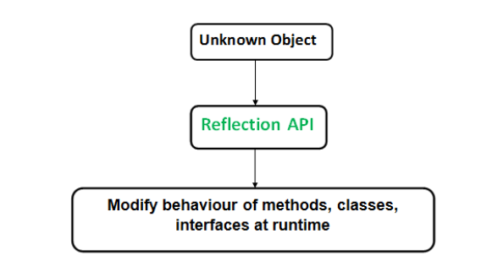

API that is used to examine and modify methods, classes and interfaces at runtime.
- Reflection API helps us to get information about the class to which the object belongs.
- It helps us to call methods of a class irrespective of the access modifiers at runtime.

Advantages of Reflection API:
- Inspection of classes, interfaces is possible at runtime. We can call the method and access private class variables and methods.
Debuggers use Reflection API to examine private members of a class.

Disadvantages of Reflection API:
- Exposure of Internals, abstraction is broken.
- Reflection API has slower performance.

Serialization: Process of converting object to bytes so that we can store them in files or transfer them over network. Create ObjectOuputStream/ObjectInputStream object. ObjectOutputStream have writeObject(object) method, it can do serialization and ObjectInputStream has readObject method, it can do deserialization. No constructor call is made during deserialization.
No use if we use transient keyword with final.

Java's transient keyword is used to denote that a field is not to be serialized, whereas JPA's @Transient annotation is used to indicate that a field is not to be persisted in the database.

No, static fields cannot be serialized using the Serializable interface, but they can be serialized using the Externalizable interface in Java.

Serializable | Externalizable
Marker Interface. | It has two methods: readExternal(ObjectInput) and writeExternale(ObjectOutput)
Responsibility of serialisation is passed to JVM and no controll of programmer over it. | Programmer has full control over serialization
Bad Performance | Better Performance of serialisation
No Args Contructor is not required. Reflection is used. | Public No args constructor is required because during deserialisation JVM creates a new object and then call readExternal over it.
Partial Object can't be saved and full object will be saved. | It allows to save partial object.
Transient keyword plays important role | Transient keyword won't play any role.

Static variables can't be serialised.

import java.io.*;

class Emp implements Serializable {
private static final long serialversionUID =
129348938L;
transient int a;
static int b;
String name;
int age;

// Default constructor
public Emp(String name, int age, int a, int b)
{
this.name = name;
this.age = age;
this.a = a;
this.b = b;
}

}

public class SerialExample {
public static void printdata(Emp object1)
{

System.out.println("name = " + object1.name);
System.out.println("age = " + object1.age);
System.out.println("a = " + object1.a);
System.out.println("b = " + object1.b);
}

public static void main(String[] args)
{
Emp object = new Emp("ab", 20, 2, 1000);
String filename = "shubham.txt";

// Serialization
try {

// Saving of object in a file
FileOutputStream file = new FileOutputStream
(filename);
ObjectOutputStream out = new ObjectOutputStream
(file);

// Method for serialization of object
out.writeObject(object);

out.close();
file.close();

System.out.println("Object has been serialized\n"
+ "Data before Deserialization.");
printdata(object);

// value of static variable changed
object.b = 2000;
}

catch (IOException ex) {
System.out.println("IOException is caught");
}

object = null;

// Deserialization
try {

// Reading the object from a file
FileInputStream file = new FileInputStream
(filename);
ObjectInputStream in = new ObjectInputStream
(file);

// Method for deserialization of object
object = (Emp)in.readObject();

in.close();
file.close();
System.out.println("Object has been deserialized\n"
+ "Data after Deserialization.");
printdata(object);

// System.out.println("z = " + object1.z);
}

catch (IOException ex) {
System.out.println("IOException is caught");
}

catch (ClassNotFoundException ex) {
System.out.println("ClassNotFoundException" +
" is caught");
}
}
}

Object has been serialized
Data before Deserialization.
name = ab
age = 20
a = 2
b = 1000
Object has been deserialized
Data after Deserialization.
name = ab
age = 20
a = 0
b = 2000

class Car implements Externalizable {
static int age;
String name;
int year;

public Car()
{
System.out.println("Default Constructor called");
}

Car(String n, int y)
{
this.name = n;
this.year = y;
age = 10;
}

@Override
public void writeExternal(ObjectOutput out)
throws IOException
{
out.writeObject(name);
out.writeInt(age);
out.writeInt(year);
}

@Override
public void readExternal(ObjectInput in)
throws IOException, ClassNotFoundException
{
name = (String)in.readObject();
age = in.readInt();
year = in.readInt();
}

@Override public String toString()
{
return ("Name: " + name + "\n"
+ "Year: " + year + "\n"
+ "Age: " + age);
}
}

public class ExternExample {
public static void main(String[] args)
{
Car car = new Car("Shubham", 1995);
Car newcar = null;

// Serialize the car
try {
FileOutputStream fo
= new FileOutputStream("gfg.txt");
ObjectOutputStream so
= new ObjectOutputStream(fo);
so.writeObject(car);
so.flush();
}
catch (Exception e) {
System.out.println(e);
}

// Deserialization the car
try {
FileInputStream fi
= new FileInputStream("gfg.txt");
ObjectInputStream si
= new ObjectInputStream(fi);
newcar = (Car)si.readObject();
}
catch (Exception e) {
System.out.println(e);
}

System.out.println("The original car is:\n" + car);
System.out.println("The new car is:\n" + newcar);
}
}

Output:
Default Constructor called
The original car is:
Name: Shubham
Year: 1995
Age: 10
The new car is:
Name: Shubham
Year: 1995
Age: 10

What is transient?
When we do not want to serialize a varibale, we mark it transient. Default value of that datatype is stored during serialization.

Object Level Lock: Every object has a lock. When we use synchronised keyword then only locking comes into picture. Thread acquired the lock first and then execute the code and then the lock is released. Whenever a thread tries to access non-static methods then object level lock will be used.

synchronized (this) {
}
Class Level Lock: If a thread wants to execute a static synchronised method.

synchronized (ClassLevelLockExample.class) {
}

What is synchronization?
It is capability to control thread's access to shared resources.
Synchronized keyword can be used with method signature or inside method body.

Inheritance rules with Serialization and Deserialization
- If super class is serializable then subClass is automatically serializable.
- If super class is not serialised then subClass can still be serialised.
- When superClass is not serializable but subClass is serializable then default values are taken for data based on data type for non serializable members. During deserialisation, default constructor is invoked and accordingly the value will be assigned to non serializable object.
- If super class is serializable but we dont want to make subClass serializable so we override readObject() and writeObject() methods and throw NotSerializableException.

For non serializable member from super class in subClass, default constructor will be called for super class.

De- Serialization: At the time of de-serialization, if any non-serializable superclass is present, then JVM will execute instance control flow in the superclass. To execute instance control flow in a class, JVM will always invoke the default(no-arg) constructor of that class.

// Java program to demonstrate
// how to prevent
// subclass from serialization

import java.io.FileInputStream;
import java.io.FileOutputStream;
import java.io.IOException;
import java.io.NotSerializableException;
import java.io.ObjectInputStream;
import java.io.ObjectOutputStream;
import java.io.Serializable;

// superclass A
// implementing Serializable interface
class A implements Serializable
{
int i;

// parameterized constructor
public A(int i)
{
this.i = i;
}

}

// subclass B
// B class doesn't implement Serializable
// interface.
class B extends A
{
int j;

// parameterized constructor
public B(int i,int j)
{
super(i);
this.j = j;
}

// By implementing writeObject method,
// we can prevent
// subclass from serialization
private void writeObject(ObjectOutputStream out) throws IOException
{
throw new NotSerializableException();
}

// By implementing readObject method,
// we can prevent
// subclass from de-serialization
private void readObject(ObjectInputStream in) throws IOException
{
throw new NotSerializableException();
}

}

// Driver class
public class Test
{
public static void main(String[] args)
throws Exception
{
B b1 = new B(10, 20);

System.out.println("i = " + b1.i);
System.out.println("j = " + b1.j);

// Serializing B's(subclass) object

//Saving of object in a file
FileOutputStream fos = new FileOutputStream("abc.ser");
ObjectOutputStream oos = new ObjectOutputStream(fos);

// Method for serialization of B's class object
oos.writeObject(b1);

// closing streams
oos.close();
fos.close();

System.out.println("Object has been serialized");

// De-Serializing B's(subclass) object

// Reading the object from a file
FileInputStream fis = new FileInputStream("abc.ser");
ObjectInputStream ois = new ObjectInputStream(fis);

// Method for de-serialization of B's class object
B b2 = (B)ois.readObject();

// closing streams
ois.close();
fis.close();

System.out.println("Object has been deserialized");

System.out.println("i = " + b2.i);
System.out.println("j = " + b2.j);
}
}

Optional Class:
It provides a way to deal with NULL values. Programs sometimes return NullPointerExceptions. To handle this , we have to do many null checks. Java 8 provide a better way to handle the situation. We can see Optional as a single value container that either contains a value or or doesn't(empty).
IsPresent() and isEmpty() methods allow us to handle the null scenarios.
Optional.of() helps to create object but return null pointer exception if null is passed as parameter to of(). We can use Optional.ofNullable() to deal with this situation. It does not return null exception but rather returns an empty optional object.
IfPresentOrElse(Consumer,Runnable);

Optional instances are final and immutable.

String vs String Builder Vs String Buffer

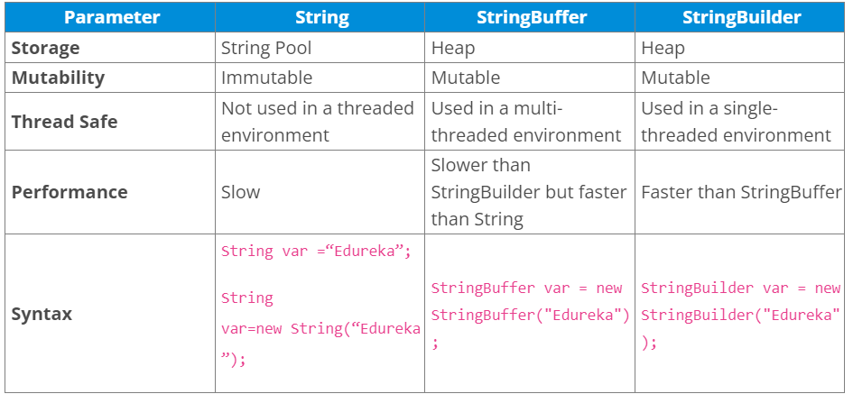
No Synchronization in String Builder.
String pool is some area on the heap dedicated to String literals only.

Access Modifiers:
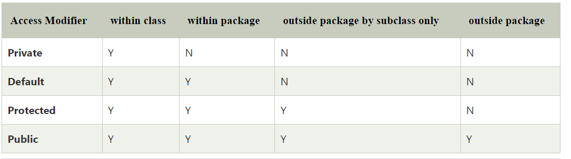
Private: The access level of a private modifier is only within the class. It cannot be accessed from outside the class.
- Default: The access level of a default modifier is only within the package. It cannot be accessed from outside the package. If you do not specify any access level, it will be the default.
- Protected: The access level of a protected modifier is within the package and outside the package through child class. If you do not make the child class, it cannot be accessed from outside the package.
- Public: The access level of a public modifier is everywhere. It can be accessed from within the class, outside the class, within the package and outside the package.

Return type of Lambda Expressions in java:
Lambda expression in java does not need to define the data type of input parameters and does not need to have a return type. Lambda expression in java implements the functional interface and it can be treated as any other java object.

Abstract Class Vs Interface:

Abstract class | Interface
1) Abstract class can have abstract and non-abstract methods. | Interface can have only abstract methods. Since Java 8, it can have default and static methods also. From Java 9, we can have private methods in interface as well.
2) Abstract class doesn't support multiple inheritance. | Interface supports multiple inheritance.
3) Abstract class can have final, non-final, static and non-static variables. | Interface has only static and final variables.
4) Abstract class can provide the implementation of interface. | Interface can't provide the implementation of abstract class.
5) The abstract keyword is used to declare abstract class. | The interface keyword is used to declare interface.
6) An abstract class can extend another Java class and implement multiple Java interfaces. | An interface can extend another Java interface only.
7) An abstract class can be extended using keyword "extends". | An interface can be implemented using keyword "implements".
8) A Java abstract class can have class members like private, protected, etc. | Members of a Java interface are public by default.
9)Example:  public abstract class Shape{  public abstract void draw();  } | Example:  public interface Drawable{  void draw();  }

When should we use abstract class and when should we use interface ?
If the functionality we are creating will be useful across a wide range of disparate objects, use an interface. Abstract classes should be used primarily for objects that are closely related, whereas interfaces are best suited for providing a common functionality to unrelated classes.
The short answer: An abstract class allows you to create functionality that subclasses can implement or override. An interface only allows you to define functionality, not implement it. And whereas a class can extend only one abstract class, it can take advantage of multiple interfaces.

Why multiple inheritance is not supported in Java?

In Java, a class cannot extend more than one class. Therefore following is illegal −

Example
public class extends Animal, Mammal{}
However, a class can implement one or more interfaces, which has helped Java get rid of the impossibility of multiple inheritances.
The reason behind this is to prevent ambiguity.
Consider a case where class B extends class A and Class C and both class A and C have the same method display(). Now java compiler cannot decide, which display method it should inherit. To prevent such situation, multiple inheritances is not allowed in java.
Why do we have private methods in interface?
An interface can have private methods since Java 9 version. These methods are visible only inside the class/interface, so it's recommended to use private methods for confidential code.

Why do we not have constructor in interface but we have them in abstract class?
A constructor is used to initializing non-static data members and as there are no non-static data members in the interface, there is no need of constructor.

The main purpose of the constructor is to initialize the newly created object. In abstract class, we have an instance variable, abstract methods, and non-abstract methods. We need to initialize the non-abstract methods and instance variables, therefore abstract classes have a constructor.
- Also, even if we don’t provide any constructor the compiler will add default constructor in an abstract class.
- The constructor inside the abstract class can only be called during constructor chaining i.e. when we create an instance of sub-classes. This is also one of the reasons abstract class can have a constructor.

Can you use both this() and super() in a constructor in Java?No, you cannot have both this() and super() in a single constructor.

ClassNotFoundException Vs NoClassDefFoundError
https://www.youtube.com/watch?v=8qWgGxEYsdM

- As the name suggests, ClassNotFoundException is an exception while NoClassDefFoundError is an error.
- ClassNotFoundException occurs when classpath does not get updated with required JAR files while error occurs when the required class definition is not present at runtime.
ClassNotFound is checked exception and NoClassDefFoundError is unchecked.

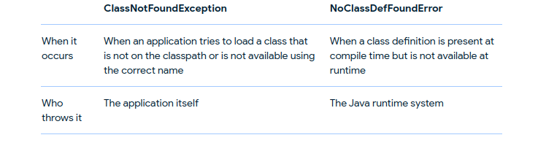

Why avoid comparing Integers in java using == ?
So when you compare two Integer objects using a == operator, Java doesn't compare them by value, but it does reference comparison that means even if the two integer has the same value, == can return false because they are two different objects in the heap

Autoboxing refers to the conversion of a primitive value into an object of the corresponding wrapper class is called autoboxing.
Unboxing on the other hand refers to converting an object of a wrapper type to its corresponding primitive value.

Java 5 introduced auto-boxing which automatically converts int to Integer and because of that many Java developers started writing code for comparing int variable to Integer object and Integer to Integer using == operator. You should avoid that because it can create subtle bugs in your program because it only works for a particular range of integers and not for all. There is another problem as well when you compare the int variable to the Integer object using == operator, the Integer object is converted to a primitive value. This can throw a null pointer exception if the Integer object is null, which can crash your program.
Now when you compare two Integer objects using a == operator, Java doesn't compare them by value, but it does reference comparison. When means even if the two integers have the same value, == can return false because they are two different objects in the heap.
There is one more point that makes things tricky, caching of integer objects by Integer.valueOf() method. What this means is that your program will work for some input but not for others.

This happens because autoboxing uses Integer.valueOf() method to convert Integer to int and since method caches Integer object for range -128 to 127, it returns same Integer object in heap, and that's why == operator return true if you compare two Integer object in the range -128 to 127, but return false afterward, causing a bug.
Before Java 1.4 that was not a problem because there was no autoboxing, so you always knew that == will check the reference in heap instead of value comparison.
Integer i1 = 128;
Integer i2 = 128;
System.out.println(i1==i2);
// Output => False

Integer i1 = 127;
Integer i2 = 127;
System.out.println(i1==i2);
// Output => True

For primitive types (int), you have to use ==, and it compares the values to two ints. (equals doesn't work because it's defined on objects only, which primitives are not by definition.)

Example of OOPs in java:
Abstraction: Interfaces and Abstract classes
Encapsulation: Class
Polymorphism: supplyAsync(supplier), supplyAsync(supplier, executor).

Should try-catch be placed inside or outside for-loop ?
Putting try-ctch outside for loop: The point where an exception occur inside loop, the loop will be terminated there itself.
Putting try-catch inside for loop: The point where an exception occur, that will be caught by catch block and loop will continue till the end. If try-ctach is placed inside for loop, then if multiple exception occur then a lot of memory is used.

