DNS (Domain Name System):

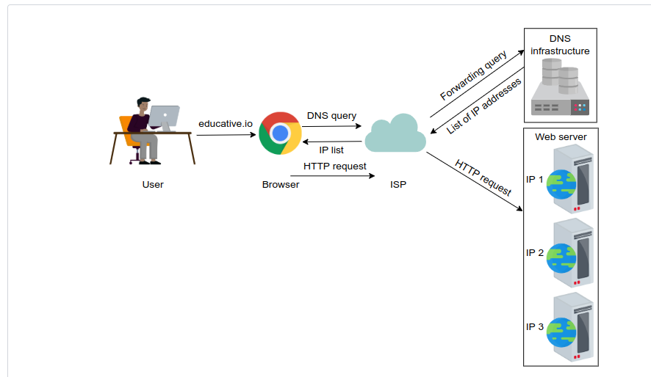

- User types website url in chrome.
- Chrome sends DNS query to ISP.
- ISP forwards query to DNS Infrastructure.
- DNS Infrastructure returns with list of IP addresses.
- ISP returns the list of IP addresses to chrome.
- Chrome sends HTTP request to the IP addresses via ISP.

DNS is like a dictionary that stores the IP addresses against the domain names.

Name Servers: There are multiple servers in DNS infrastructure. The servers that responds to users’ queries are called Name servers.

Resource Records: DNS database stores domain name to IP address mappings in the form of resource records. RR is the smallest unit of info that users request from name servers. There are different types of RR:

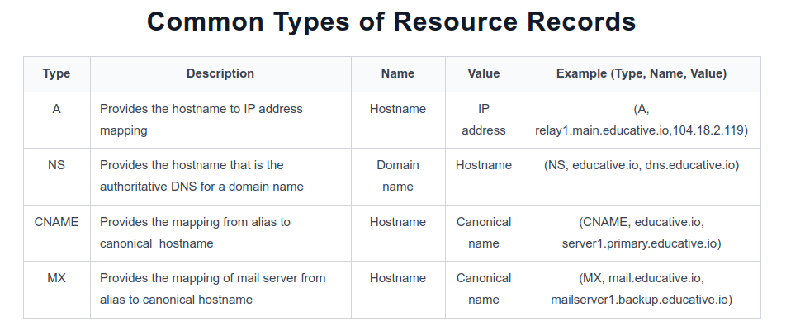

DNS uses caching at different layers to reduce latency. It also reduces load on DNS infra because it has to cater to the queries of the entire internet.

DNS Name servers are in hierarchical form. Due to this DNS is highly scalable.

DNS Hierarchy:

There are 4 types of servers in DNS hierarchy.:
- DNS Resolver: Resolver initiate the query sequenceand forward request to other DNS name servers. It lies within the premise of the user’s network. It can also reply to queries using caching techniques. These are also known as default or local servers.
- Root Level name servers: These servers receive requests from DNS Resolver. These servers maintain name servers based on top level domain names like .io, .com etc. For ex: When user requests the IP of educative.io then Root level name servers return all the top level domain name servers that holds IP addresses of .io domain.
- Top-Level-Domain Name servers: These servers hold the IP addresses of Authorative Domain name servers. The querying party will get a list of IP addresses that belong to the authoritative servers of the organization.
- Authorative Domain Name Servers: These are organisations’ domain name servers that provides IP of web or application servers.
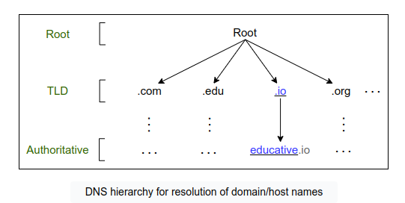

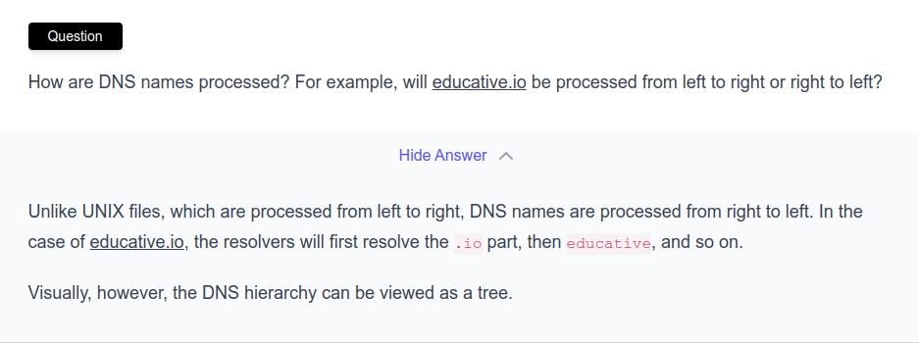

Iterative VS Recursive Query Resolution:

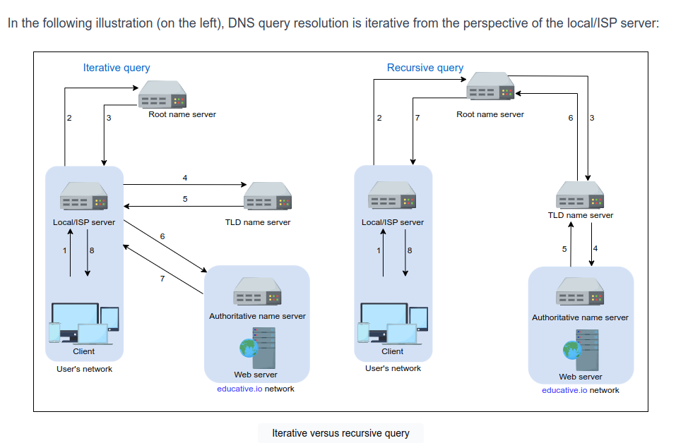

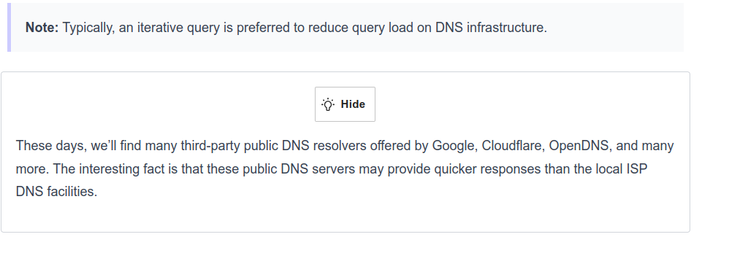
Caching IN DNS:
It is a temporary storage of resource records to reduce response time and decrease network traffic.
When we use caching at different hierarchies, it can reduce a lot of query burden on DNS. Caching can be implemented at browser, operating system, local name server within users’ network, ISPs DNS Resolver.

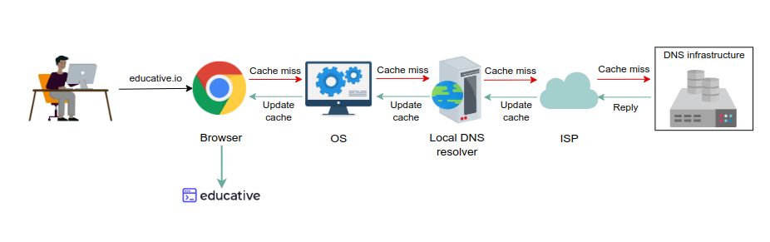
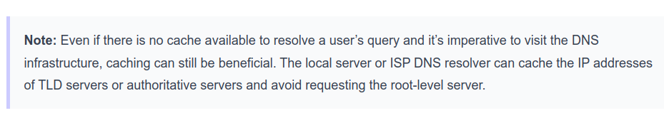

DNS is a distributed system. There are 13 root name servers(A to M) with many instances distributed throughout the globe.
These servers are managed by 12 different organisations.

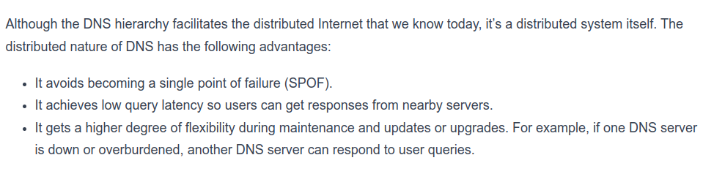

DNS is scalable, reliable and consistent.

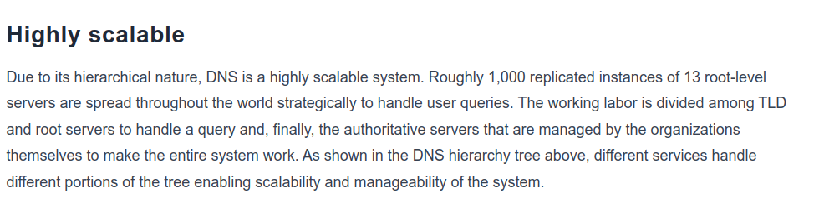
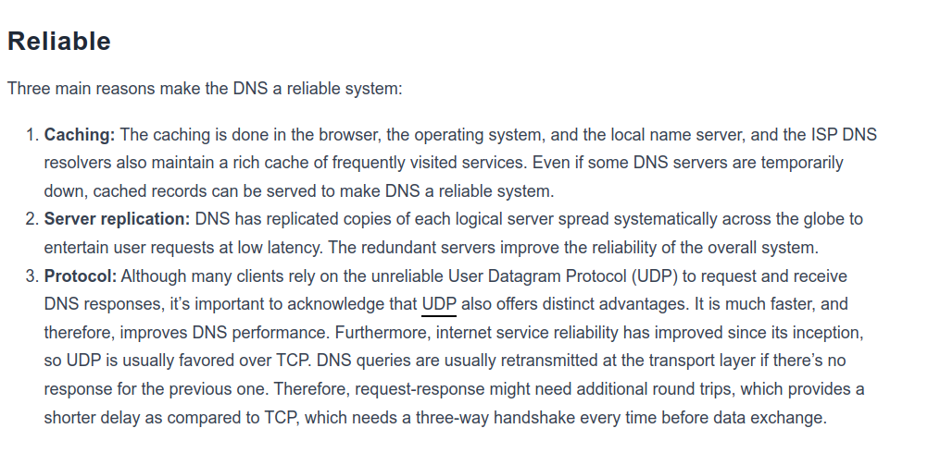


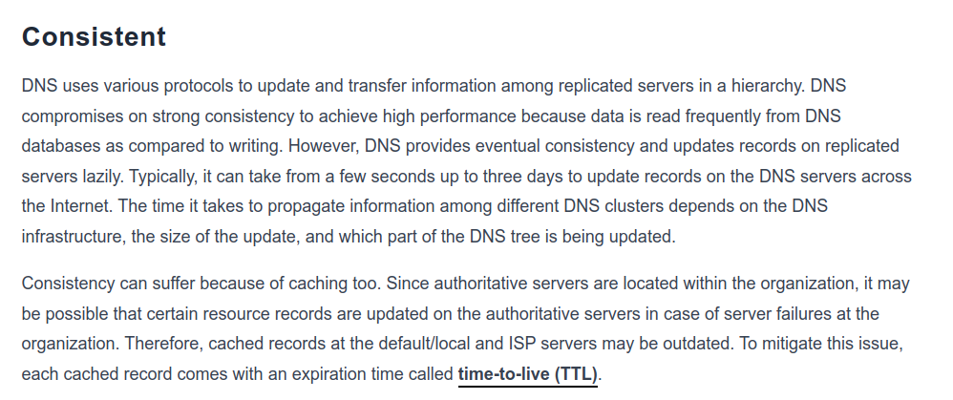

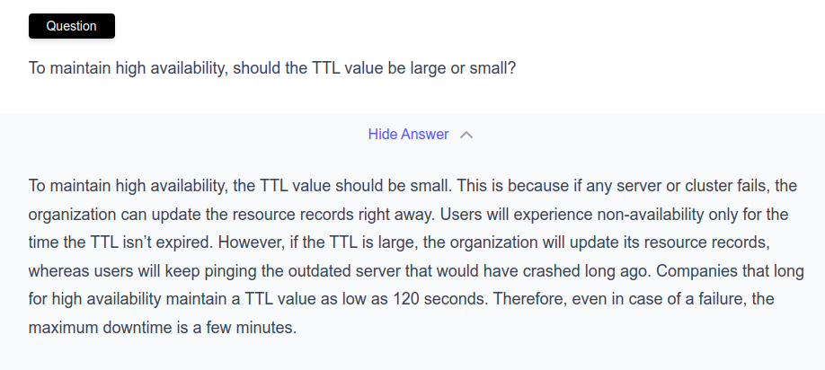
nslookup www.google.com
dig www.google.com

