Doc(s)Simplr

All docs need to classify !

Mohit R.Sojitra   
K. D. Patel Deaprtment of Information Technology  
Charusat , Changa .Gujrat , India  
17it109@charusat.edu.in

*Abstract*—When you throw a pile of Docs and resumes at us, we classify that docs into a proper manner to minimize your work while searching the perfect person of your demand. while doing so, you will be blessed with a properly arranged pile of docs available for download

# Introduction

This project is complete based on simplifying the PDF docs. Based on your need. Ease of Use We here at Doc(S)implr classifies a zip full of Resumes into the categories making things super easy for recruiters of the company. We at Doc(s)implr also email the results obtained by our algorithms concluding what’s your profile is upto or what are you good at! We classify that docs into a proper manner to minimize your work while searching. while doing so, you will be blessed with a properly arranged pile of docs available for download.

# Purpose

Main purpose of developing this project is to classifying the PDFs of resumes for the recruiter to easily classify that which of applicants are best for the job in company or call for interview.

That means our web application is remove to burden of recruiters for reading and analyzing every resume they got.

Recruiters just need to worry about where and when to take the interviews of the eligible candidates and not of the sorting phase.

# Technologies

We have created web application using Flask for frontend for backend we are using python libraries. Here there are some of the important libraries we used.

## Natural language processing

Natural language processing ​​are a line of linguistics, computer science, information engineering, and artificial intelligence that intersect with communication between computers and human languages, and especially how computers organize and process large amounts of natural language data.

## Flask

Flask is a lightweight WSGI application framework. It is designed to make implementation quick and easy, with the ability to scale access to complex applications. It started out as a simple wrapper around Werkzeug and Jinja and has become one of the most popular Python web application frameworks.

Flask offers suggestions, but does not use any dependencies or project formats. It is up to the developer to select the tools and libraries they want to use. There are many extensions provided by the community that make adding new functionality easier.

## PyPDF2

The Pure-Python library is built as a PDF tool. It can:

* extracting document information (title, author,…)
* to separate text page by page
* compiling a page of text by page
* plant pages
* combining multiple pages into one page
* encryption and encryption of PDF files
* and more!

Called Pure-Python, it should work on any Python platform without relying on external libraries. It can also work more perfectly on StringIO objects than on file streaming, which allows PDF manipulation in memory. It is therefore a useful tool for websites that manage or manage PDFs.

## SpaCy(en_core_web_sm)

SpaCy v2.0 has new neural models for tagging, syncing and business recognition. The models are designed and used from scratch at the start of spaCy, to give you an unparalleled balance of speed, size and accuracy. A novel blurring strategy with elements of subordinate structure is used to support large words in small tables. Variable layers with residual connection, solution implementation and maxout connection are used, which provides much better performance than the standard BiLSTM solution.

en_core_web_sm is a small English model trained on written web text (blogs, news, comments), that includes vocabulary, vectors, syntax and entities.

# Flow of web-app

TABLE I. USER-PROCESS FLOW

| Table Head | Doc-simplr website |
| --- | --- |
| Web-application flow |
| 1 | Upload your zip |
| 2 | Take a break |
| 3 | Results Generated |
| 4 | Results Emailed |

TABLE I. SYSTEM-PROCESS FLOW

| Table Head | Doc-simplr website |
| --- | --- |
| System Flow |
| 1 | HTTP site request |
| 2 | Respond from flask & apache web server |
| 3 | Upload zip of PDF by user and saved in web server |
| 4 | Python script triggered and result generated using NLP |
| 5 | Result saved in foam of charts and emailed to the particular user. |

# SCREEN SHOT OF UI

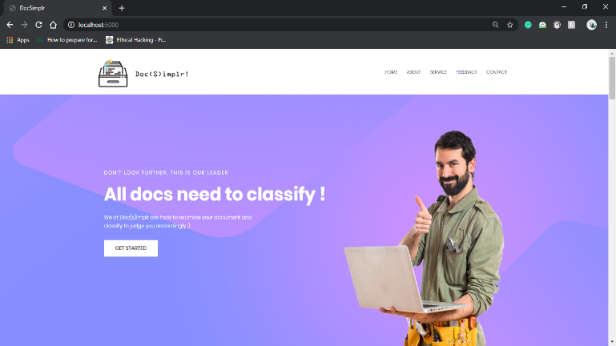5.0 INDEX PAGE

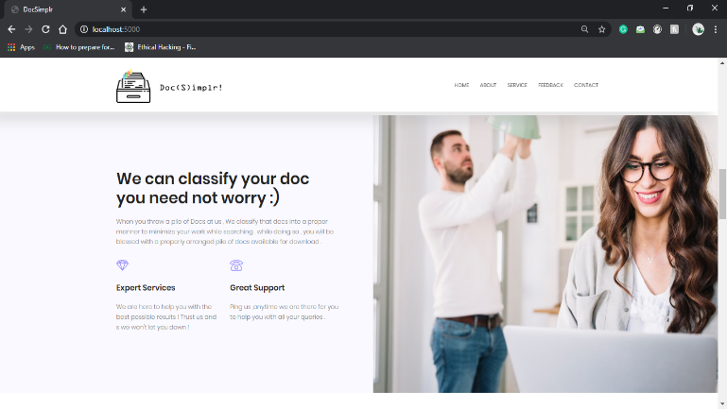5.1 ABOUT

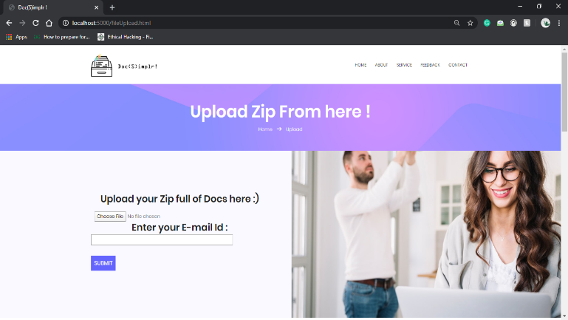5.2 UPLOAD

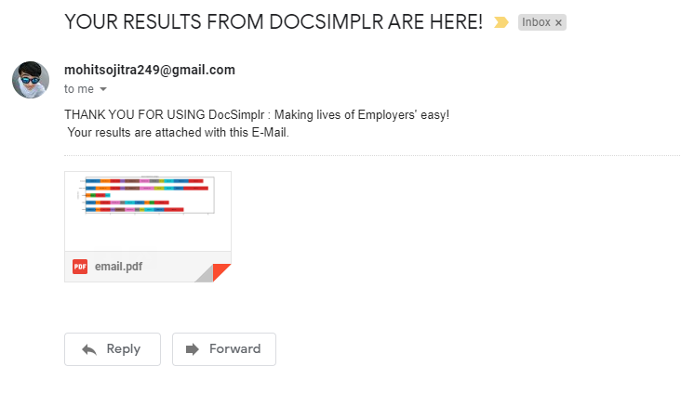

5.3 GETTING MAIL FROM OUR APP

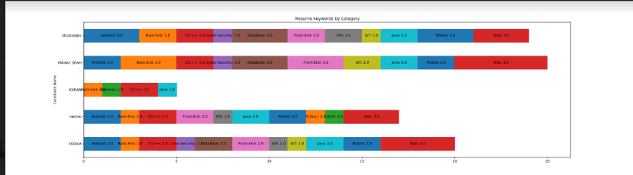5.4 CLASSIED RESULTS OF PDF

# Quality of applcation

* Easy to navigate, user friendly WebApp
* Available to users 24x7
* Proper classification of the docs
* Sending correct results to user
* Less Latency
* Sending results to correct user

# Future enhancement

Provide authentication for two types of users: Registered and Guest users, so that premium registered users can store their docs for any future reference

Provide option of tag selection (i.e. classifications based on which tag the users need in their results)

# Refrences

1. <https://pythonhosted.org/PyPDF2/>
2. <https://spacy.io/usage>
3. <https://flask.palletsprojects.com/en/1.1.x/>
4. <https://docs.python.org/3/library/zipfile.html>